

ANNUAL REPORT2025

Charting New Horizons

2

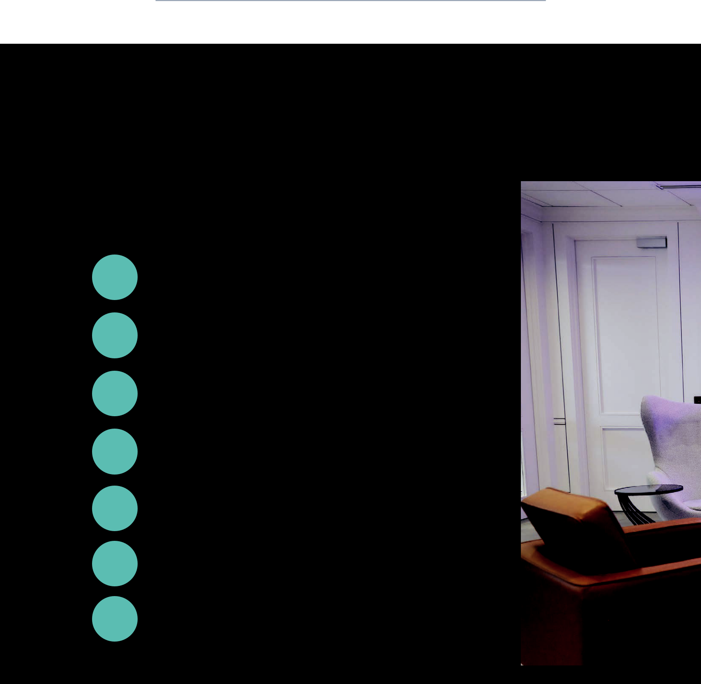

Contents

pg. | Shareholder Letter
04-07 | Shareholder Letter
pg. | 2025 At a Glance
08 | 2025 At a Glance
pg. | Financial Summary
09 | Financial Summary
pg. | Diversified & Balanced Portfolio
10-11 | Diversified & Balanced Portfolio
pg. | The Bionic Underwriter
12 | The Bionic Underwriter
pg. | Five Years of Community Impact
13 | Five Years of Community Impact
pg. | Skyward Group Leadership
14-15 | Skyward Group Leadership


2025 Annual Report


2025 Annual Report |  |  | 3


As we bring together Skyward Specialty’s capabilities with the strength and talent of our colleagues at Apollo under a new brand name, Skyward Group, I am inspired by the power of our combination. Together, we will remain true to our strategy to Rule Our NicheTM by leading with talent and technology, building distinctive defensible positions in each market we serve and delivering top quartile returns for our shareholders.


4 2025 Annual Report

Dear Shareholders,

Reflecting on 2025, I am both proud and energized by our remarkable achievements. This year, our team’s relentless drive and ingenuity propelled us to

new heights, surpassing ambitious goals, strengthening our market position, and reaffirming the enduring power of our strategic vision. In a market environment defined by intensifying competition, rising loss

costs, and emerging pricing pressure, we once again delivered exceptional results, which are a testament to our strategic clarity, disciplined execution, and the exceptional caliber of our people.

During the year, we continued our track record of consistent, quarter-over-quarter top-quartile performance while strengthening the quality and resilience of our portfolio. We again delivered impressive top-line growth of 24% driven by meaningful expansion across multiple business units. These results reflect not only strong market positioning but also the effectiveness of our operating model in balancing growth and profitability.


- 18.9% Return on Equity
- 20.9% Return on Tangible Equity
- 89.3% Combined Ratio
- 25.9% growth in Book Value per Share to $24.92

2025 was also a year of meaningful portfolio evolution. More than 58% of our business now is in short-tail liability lines. Additionally, nearly 50% of our overall portfolio is less exposed to traditional P&C market cycles. This strategic, intentional repositioning is delivering tangible results, with particularly notable growth in Agriculture and Credit (Re)insurance, Accident & Health, Surety, and Captives. All areas that are less P&C cycle exposed, and together further diversify our use of capital.

We launched a number of innovative solutions during the year, including our Life Sciences expansion within healthcare solutions, a first-of- its-kind EndWell Protection bond in Surety, and the announcement of affirmative AI coverage in professional lines,

Our people are our most durable competitive advantage. The expertise and discipline our teams bring to every part of our operations enable us to deliver consistent service to our distribution partners and produce sustainable results.

2025 Annual Report |  |  | 5


Through our Rule Our NicheTM strategy, we have focused on markets where talent, expertise, specialization, data, and innovation provide a sustainable competitive advantage.

positioning Skyward Specialty among the early carriers to explicitly address emerging AI risks. These initiatives underscore our commitment to building differentiated, future-ready products that respond to evolving market needs.

A core driver and a true differentiator of our success is our commitment to innovation and our technology DNA. Our bionic underwriting model, powered by advanced AI platforms, highly efficient processing and market-leading business intelligence, continues to differentiate Skyward Specialty. These tools and capabilities enhance decision-making, improve speed to market, and enable our teams to compete more effectively in an increasingly complex risk environment. Read more about the impact of our bionic underwriting on page 12.

Our performance in 2025 was further validated through meaningful external recognition. Skyward Specialty ranked seventh on S&P Global’s list of Top P&C Commercial Insurance Companies, improving from ninth last year. We were also named a Business Insurance “Best Places to Work in Insurance” for the third consecutive year and recognized by U.S. News

- World Report as a “Best Company to Work For” across three categories. In addition, we were included on Newsweek’s America’s Greatest Companies list

and TIME’s America’s Growth Leaders list of public companies for 2026. Finally, our underwriting work environment, SkyVUE (Skyward Visual Underwriting Experience), was once again recognized by Datos Insights for Best Core Systems Innovation.

A BRIGHT FUTURE, REALIZED

While 2025 certainly stands out as a defining year, it is part of a much larger trajectory of growth. Today, Skyward Specialty is a far stronger company than when we launched the brand five years ago, and stronger still than when we entered the public markets in 2023. With market-leading underwriting and claims talent, a leadership position in the use of advanced technology, and every division executing against clear strategic priorities, we are building a business designed for durability and top-quartile profitable growth.

For the past three years, we have delivered consistent double-digit growth every quarter, while fundamentally reshaping the mix of our business. Our strategy to build a diversified, defensible portfolio that performs across market cycles, supported by leading talent, advanced technology and disciplined capital deployment, continues to drive value for our distribution partners, customers, and shareholders.
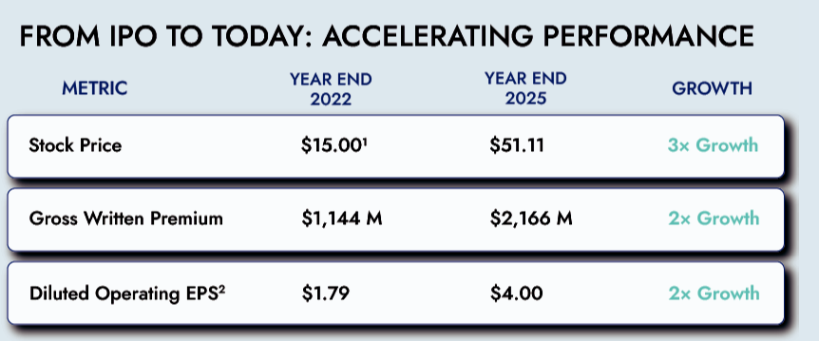

- Stock Price as of January 13, 2023
- Diluted Adjusted Operating Earnings Per Share; Indicates non-GAAP financial measure; see “Management’s Discussion and Analysis of Financial Condition and Results of Operations —Reconciliation of non-GAAP Financial Measures” included in this Annual Report for a reconciliation of the non-GAAP financial measures to their most directly comparable financial measures prepared in accordance with GAAP.

6 2025 Annual Report

Our success is a direct result of deliberate choices: | employees are empowered to make a meaningful
where to invest, which risks to pursue, when to lean | impact. Our culture continues to be a key driver
into expanding our position, and when to exercise | of Skyward Specialty’s strength and appeal as an
restraint. Through our Rule Our NicheTM strategy, we | employer of choice, with voluntary employee attrition
have focused on markets where talent, expertise, | of 4.2%, no doubt an industry best (compared to 10.4%
specialization, data, and innovation provide a | in 2021).
sustainable competitive advantage. | Looking ahead, we believe our ability to continue to
At the root of our excellent execution is our people.
At the root of our excellent execution is our people. | attract, develop and retain top-tier professionals will
From day one, we set out to build more than just a | be critical to unlocking new opportunities, advancing
high-performing organization, we set out to build a | our strategic ambitions, and ensuring that Skyward
distinctive culture designed to attract entrepreneurial, | Specialty remains a destination for the best talent in
innovative, collaborative, and deeply experienced | the industry.
professionals. Our talent is our most durable | CHARTING NEW HORIZONS
competitive advantage. The expertise our teams bring
to every part of our business enables us to evaluate | For three years as a public company, we have been
complex risks with discipline, deliver consistent
service to our distribution partners and produce | intentional, relentless and exacting in the execution
sustainable results. Simply put, our performance is | of our Rule Our NicheTM strategy. We have done this
a direct reflection of the quality, commitment, and | while continuing to diversify our portfolio, de-risk our
accountability of our people. | balance sheet, invest in exceptional talent and take a
 | leading position in the use of advanced technology and
Guided by our mantra “we’re building the company | data. These actions have firmly established Skyward
we always wanted to work for,” we remain deeply | Specialty as a market-leading, durable, high-performing
invested in developing and empowering our talent for | specialty insurer.
 |  | Our decision to acquire Apollo, a transaction
 |  | which closed on January 1, 2026, is both a
 |  | logical step in our progression as a Company
 |  | and it is also a bold, strategic move. It
 |  | meaningfully expands the breadth of our
 |  | portfolio of specialty businesses, strengthens
 |  | our talent pool, amplifies our innovation and
 |  | technology capabilities, and diversifies our
 |  | earnings profile, including adding meaningful
 |  | fee income.
 |  | Apollo operates through Lloyd’s of London
 |  | making it both uniquely attractive and a
 |  | natural complement to our business. Lloyd’s
 |  | is the preeminent global marketplace for
 |  | specialty insurance, particularly for U.S. risks.
 |  | Many classes of business that are difficult
 |  | to place in the U.S. are written principally
 |  | at Lloyd’s where the underwriting talent
 |  | with deep expertise in these areas is highly
 |  | concentrated. In aggregate, Lloyd’s is the
 |  | largest writer of U.S. excess and surplus (E&S)
Skyward Specialty Senior Leaders in Boston for the Annual Strategy Meeting |  | largest writer of U.S. excess and surplus (E&S)
 |  | business.
the long term. Our latest engagement scores reflect
the progress we have made: 97% of employees agree | Apollo’s portfolio is predominantly U.S. focused with
with the statement “Overall, I am very satisfied with | two thirds of its premiums derived from U.S. clients.
my employer,” up from 80% when we first surveyed | Less than 5% of the Apollo premium overlaps with
employees in 2021. This improvement reflects our | Skyward Specialty’s existing business, while more than
continued focus on creating an environment where | 50% comes from entirely new, hard-to-access niches,
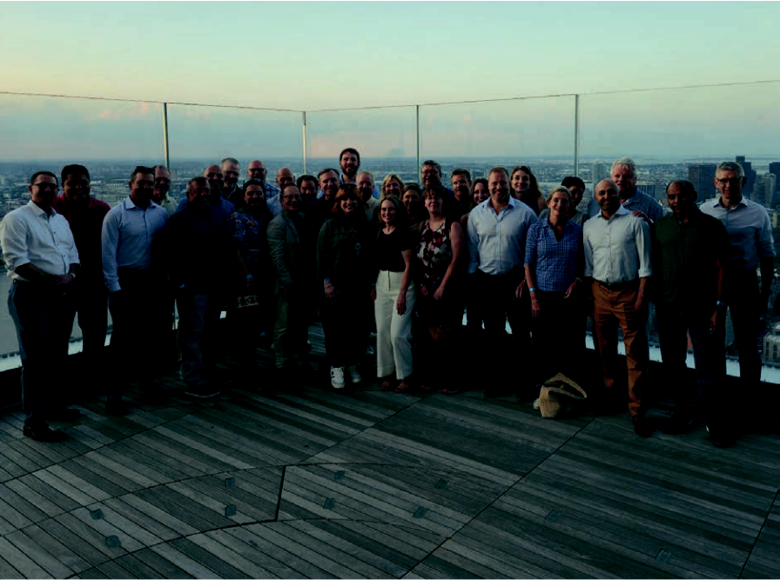

exceptional but also provides a solid foundation for our continued success together.
To wrap up, as I look back on 2025 and our last three years as a public company, I am immensely proud of the integrity in how our Company operates, the accomplishments of our Skyward team and the results we have delivered to our shareholders. I genuinely believe we are building an organization unlike any other in our industry.
As we bring together Skyward Specialty’s capabilities with the strength and talent of our colleagues at Apollo under a new brand name, Skyward Group, I am inspired by the power of our combination. Together, we will remain true to our strategy to Rule Our NicheTM by leading with talent and technology, building distinctive defensible positions in each market we serve and delivering top quartile returns for our shareholders.
To our employees, trading partners, customers and investors, thank you in advance for your support as we chart new horizons together.
Sincerely,
Andrew Robinson,
Chairman & CEO, Skyward Group
Skyward Specialty & Apollo team members at the Annual Broker Open House
at 2025 WSIA Annual Marketplace
7
2025 Annual Report

further expanding the breadth of our specialty capabilities. Like Skyward Specialty, Apollo is a high-growth, low-volatility, specialty-focused business with a track record of top-quartile underwriting. They, in nearly all respects, share our view and have similarly executed their own version of our Rule Our NicheTM strategy. Apollo’s focus is on building strong, leading, and defensible positions in niche markets.
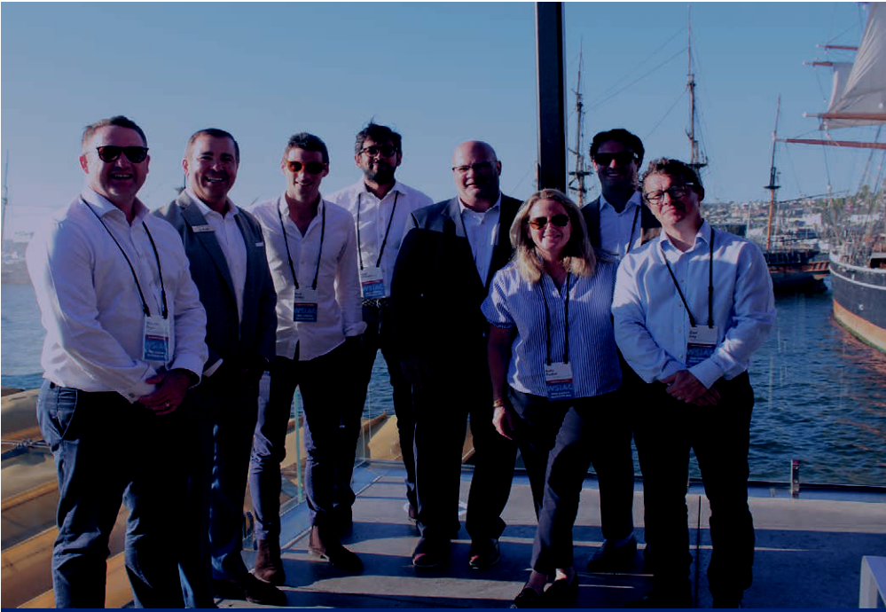

Strategically, our combination gives us access to highly attractive new specialty niches, including product recall, contingency, specie, political violence and political risk and a unique proposition serving the sharing economy, autonomy and electrification, and other new economy industries. Financially, the addition

of syndicate management fee-based income will meaningfully enhance Skyward Specialty’s earnings mix

over time and provide an option to transition to a more capital-light model. We have already identified considerable opportunities as a combined organization we intend to pursue that will begin to materialize in 2026.

Additionally, Apollo is the definitive leader in innovation and technology at Lloyd’s, having built a portfolio that is distinctive from other players in the Lloyd’s market. The addition of Apollo means that we are not only adding expertise and scale, we are reinforcing our ability to take a leading position in the use of advanced technology and data and increase the technology DNA of our organization.

Most importantly, bringing our two companies together is fundamentally about people and culture. The leadership team at Apollo shares our commitment to building an engaged talent pool that leans into the future and approaches their business like we do – with passion and creativity. There is genuine alignment in philosophy and ethos, and, quite simply, the quality and depth of talent are fully consistent with what we have built at Skyward Specialty.
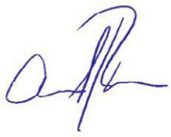

With the combination of our organizations, our team now includes nearly 950 employees, each sharing a passion for building a talent-led, performance-driven premier specialty company. This cultural alignment not only strengthens what already makes our organization

8 2025 Annual Report

2025 At a Glance

$2,166M 

89.3%

$170M

18.9%

$24.92

Gross Written Premiums

24.3% growth in GWP compared to
2024

Combined Ratio

3 point improvement compared to 2024 CR of 92.3%

Net Income

43.1% increase compared to 2024

Return on Equity

2.6 point increase over 2024

Book Value Per Share

25.9% increase from $19.79 in 2024

2025 Annual Report |  |  | 9

Financial Summary


 | 2025 | 2024 | 2023 | 2022 | 2021
($ in thousands, except per share
amounts)
Gross written premiums | $2,166,236 | $1,743,232 | $1,459,829 | $1,143,952 | $939,859
Net written premiums | $1,406,232 | $1,123,578 | $910,691 | $675,543 | $529,143
Net earned premiums | $1,304,505 | $1,056,722 | $829,143 | $615,994 | $499,823
Underwriting income(1) | $138,979 | $81,859 | $76,526 | $36,510 | $10,887
Net investment income | $83,619 | $80,600 | $40,340 | $36,931 | $24,646
Net income | $170,028 | $118,828 | $85,984 | $39,396 | $38,317
Adjusted operating income(1) | $167,372 | $126,582 | $80,861 | $58,574 | $36,062
Basic earnings per share | $4.21 | $2.97 | $2.34 | $1.24 | $1.21
Diluted earnings per share | $4.07 | $2.87 | $2.24 | $1.21 | $1.18
Diluted adjusted earnings per share | $4.00 | $3.06 | $2.11 | $1.79 | $1.11
Total assets | $4,791,852 | $3,729,478 | $2,953,435 | $2,363,439 | $2,118,212
Stockholders' equity | $1,009,565 | $793,999 | $661,031 | $421,662 | $426,080
Tangible stockholders' equity(1) | $921.525 | $706,651 | $572,596 | $331,792 | $334,744
Book value per share | $24.92 | $19.79 | $16.72 | $25.82 | $26.32
Fully diluted book value per share | $23.87 | $18.88 | $15.96 | $12.87 | $13.15
Return on equity | 18.9% | 16.3% | 15.9% | 9.3% | 9.4%
Return on tangible equity(1) | 20.9% | 18.6% | 19.0% | 11.8% | 11.9%
Adjusted return on tangible equity(1) | 20.6% | 19.8% | 17.9% | 17.6% | 11.2%
Combined ratio | 89.3% | 92.3% | 90.7% | 94.0% | 97.8%
Adjusted combined ratio(1) | N/A2 | 91.2% | 90.9% | 92.6% | 94.6%

- Indicates non-GAAP financial measure; see “Management’s Discussion and Analysis of Financial Condition and Results of Operations — Reconciliation of non-GAAP Financial Measures” included in this Annual Report for a reconciliation of the non-GAAP financial measures to their most directly comparable financial measures prepared in accordance with GAAP.

(2)Not applicable

10 2025 Annual Report

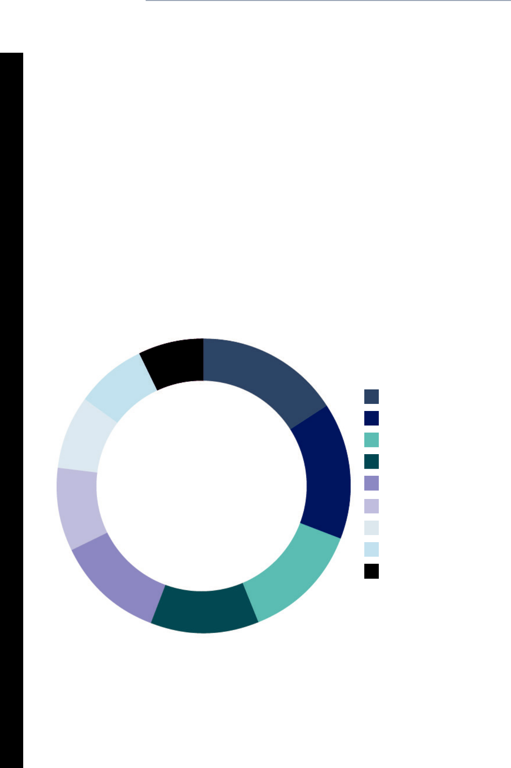

Diversified & Balanced Portfolio

For the past five years, we have intentionally reshaped our business mix, evolving nearly 50% of our portfolio toward less cyclical lines. At the same time, we have remained firmly committed to our Rule Our NicheTM strategy— attracting exceptional underwriting talent, investing in leading-edge technology, and building defensible positions in the specialty markets where we compete. This approach has allowed us to strengthen our competitive moat while delivering consistently strong financial results.

 | $149M | $346M
 | 7% | $346M
$168M | 7% | 16%
$168M |  | 16% |  | AGRICULTURE & CREDIT (RE)INSURANCE
8% |  |  |  | AGRICULTURE & CREDIT (RE)INSURANCE
$178M |  |  |  | SPECIALTY PROGRAMS
$178M | 2025 |  |  | CAPTIVES
8% | 2025 |  |  | CAPTIVES
8% | 2025 | $323M |  | CONSTRUCTION & ENERGY SOLUTIONS
$198M | GWP | 15% |  | ACCIDENT & HEALTH
$198M | $2,166 M |  |  | TRANSACTIONAL E&S
9% |  |  |  | GLOBAL PROPERTY
 |  | $276M |  | SURETY
$254M |  | $276M |  | PROFESSIONAL LINES
12% |  | 13%
$274M

12%

2025 Annual Report |  |  | 11

Our largest | 48% of our | Global Ag &
portfolio makes | portfolio is | Credit (Re)
up only 16% of | comprised of | Insurance
our premium | business lines less | achieved triple
 | exposed to the | digit growth in
 | P&C cycle | 2025
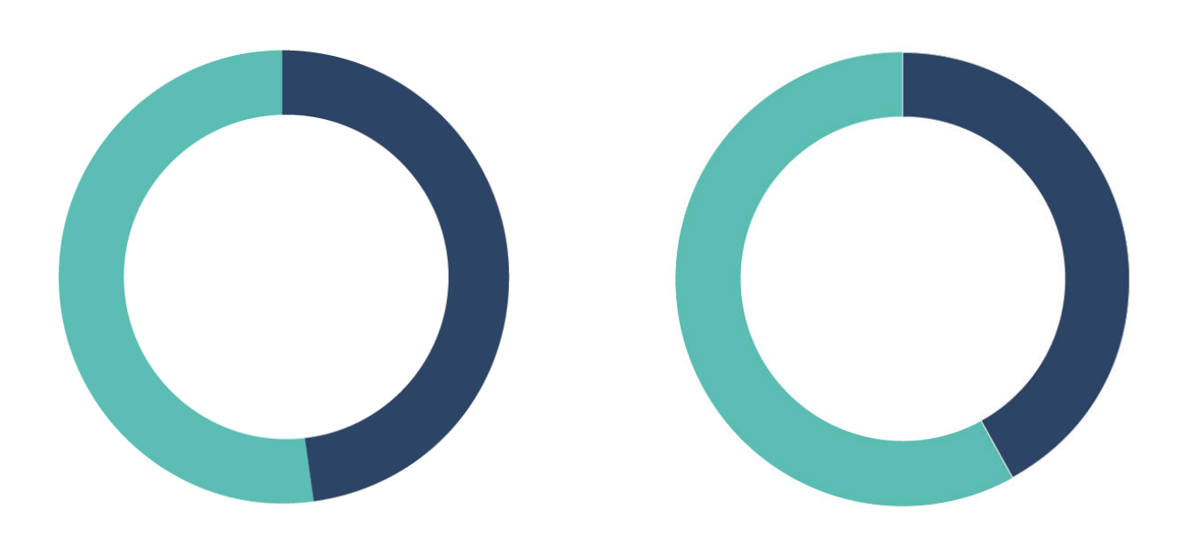

52% | 58%

BY P&C CYCLE | BY
SENSITIVITY | DURATION
48% | 42%

HIGH SENSITIVITY (Construction & Energy Solutions, Professional |  | SHORT TAIL |  | MEDIUM TAIL
Lines, Specialty Programs, Transactional E&S, Global Property)
LOW SENSITIVITY (A&H, Agriculture & Credit (Re)insurance,
Captives, Surety)


The outstanding construction & diversification of our portfolio follows our clear strategy to lessen exposure to traditional P&C market fluctuations.

12

The Bionic Underwriter

2025 Annual Report

Bionic underwriting is the next evolution of specialty insurance, where superior expertise is amplified by advanced technology to unlock scale, speed & smarter decision-making. For us, this is not about replacing the judgment of our people. We fuse our deep underwriting talent with AI-driven insights & automation to eliminate traditional human constraints so we can operate with greater precision & consistency.

 | INGESTION |  |  | AUGMENTATION
 | Our proprietary platform, IntakeHub, uses |  |  | Data is enriched by blending third-party data,
AI and machine learning to rapidly process |  |  |  | public sources & analytics with internal data.
large volumes of structured and unstructured |  |  |  | The goal is to augment, not replace, the human
submission data,automatically populating key |  |  |  | underwriter, ensuring the technology amplifies
 | systems and triaging information before it |  |  | expertise while driving efficiency.
 | reaches the underwriter
 | 40% Faster |  |  | Augmented data
 | Submission |  |  | powered 80%
 | Delivery to |  |  | of underwritten
 | Underwriter |  |  | GWP in 2025
 | Predictive |  |  | 35% improvement
 | analytics |  |  | in Time to Quote
influenced 47% |  |  |  | through Agentic
 | of GWP |  |  | Underwriting
 | in 2025
 | AMPLIFY OUR INSIGHT |  |  | AGENTIC UNDERWRITING
SkyBI and SkyVUE provide real-time insight into |  |  |  | AI pre-processes submissions & generates
portfolio performance, win/loss rates, pricing |  |  |  | data-driven recommendations, including
effectiveness, and the actions that drive better |  |  |  | prioritization, risk summarization/narration,
 | results. |  |  | risk assessment & scoring. Underwriters then
 |  |  |  | apply their judgment and expertise to make final
 |  |  |  | decisions, ensuring quality outcomes
 |  |  |  | & feedback.


2025 Annual Report |  |  | 13

Five Years of Community Impact


2025 was not just a record year of growth for the Company, but also a record giving year by our employees in partnership with the Skyward Foundation. We have reached nearly $1 million in contributions by our employees & the Skyward Foundation in just five years.

$202,550 _{$91,350}
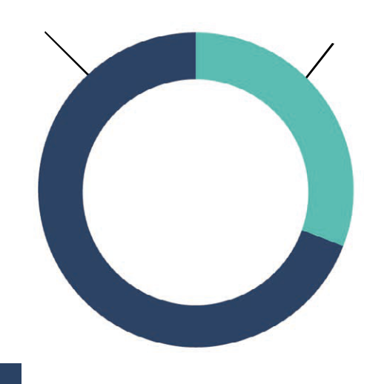

2025 | 184 Individual Matching Gift Requests
2025 | 503 Total Donation Requests
Giving | 503 Total Donation Requests
Giving | $479 Average Donation Per Employee
$293,900 | $479 Average Donation Per Employee

SKYWARD |  | EMPLOYEE | Largest Campaign
FOUNDATION |  |  | in Foundation History!


 | $38k |  | $71k |  | $37k |  | $27k
 | GIVEN FOR |  | RAISED FOR |  | DONATED |  | BENEFITING
 | CALIFORNIA |  | VICTIMS OF |  | IN ONE DAY |  | FEEDING
 | WILDFIRE |  | CENTRAL TEXAS |  | FOR GIVING |  | AMERICA DUE TO
 | RELIEF |  | FLOOD IN JULY |  | TUESDAY |  | GOVERNMENT
 |  |  |  |  |  |  | SHUTDOWN

We support causes that mean the most to our employees.

$916,000* RAISED | 210 ORGANIZATIONS
Employees + Foundation Donations | Selected by Employees

*since 2020

14 2025 Annual Report

Skyward Group Leadership


Executive Leaders

Andrew Robinson, | Mark Haushill, | John Burkhart,
Chairman & CEO, | Chief Financial Officer, | President,
Skyward Group | Skyward Group | US Property Casualty,
 |  | Skyward Specialty

David Ibeson, | Shakoor Khan, | Taryn McHarg,
Chief Executive Officer, | Chief Strategy & | Chief Financial Officer,
Apollo | Corporate Development | Apollo & Deputy CFO,
 | Officer, Skyward Group | Skyward Group

Patricia Ryan | Tom Schmitt, | James Slaughter,
Chief Legal Officer, | Chief People Officer, | Chief Underwriting
Skyward Group | Skyward Group | Officer, Apollo

2025 Annual Report |  |  | 15
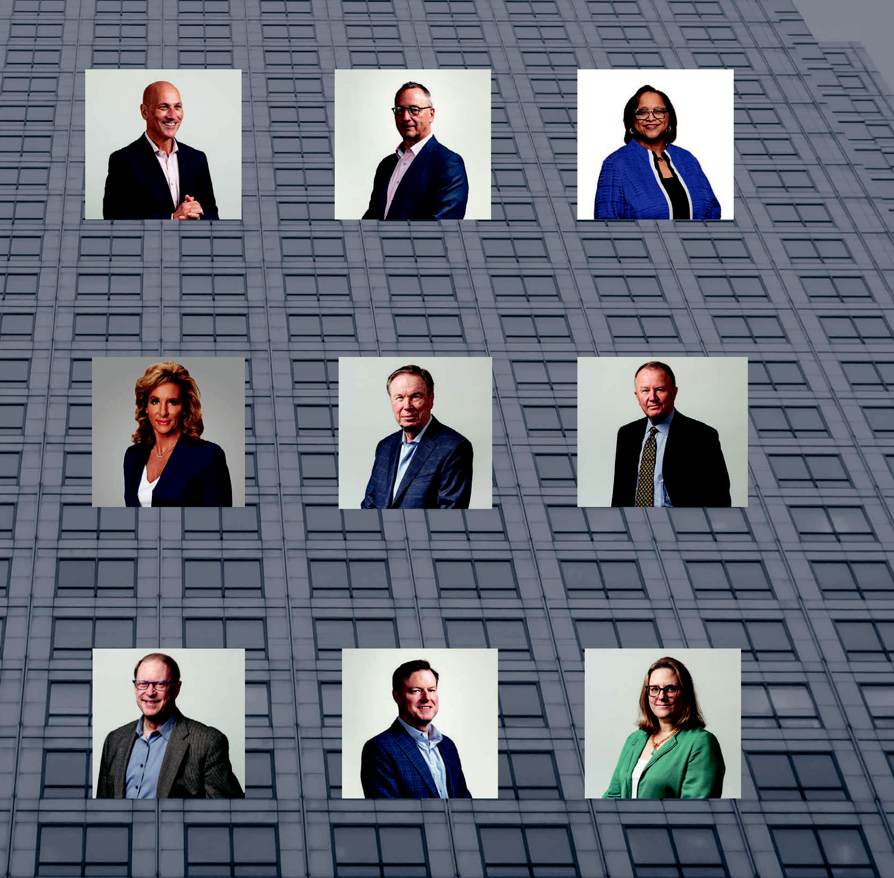

Board of Directors

Andrew Robinson, | Tony J. Kuczinski, | Gena Ashe,
Chairman & CEO, | Lead Independent | Board Member
Skyward Group | Director

Marcia Dall, Robert Creager, Jim Hays,

Board Member Board Member Board Member

Mike Morrissey, Christopher L. Peirce, Kate Terry,

Board Member Board Member Board Member

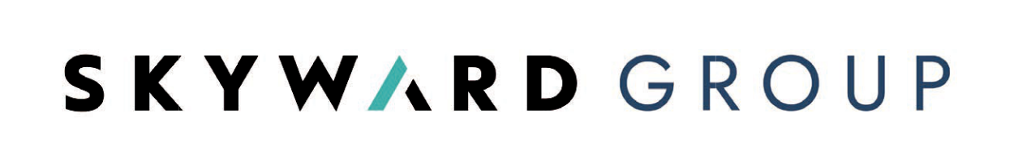

UNITED STATES
SECURITIES AND EXCHANGE COMMISSION
Washington, D.C. 20549

__________________________________________

FORM 10-K
__________________________________________

(Mark One)

- ANNUAL REPORT PURSUANT TO SECTION 13 OR 15(d) OF THE SECURITIES EXCHANGE ACT OF 1934

For the fiscal year ended December 31, 2025

OR

- TRANSITION REPORT PURSUANT TO SECTION 13 OR 15(d) OF THE SECURITIES EXCHANGE ACT OF 1934
For the transition period from _________ to _________

Commission file number 001-41591

SKYWARD SPECIALTY INSURANCE GROUP, INC.

(Exact name of registrant as specified in its charter)

Delaware |  |  |  |  | 14-1957288
(State or other jurisdiction of incorporation or organization) |  |  |  |  | (I.R.S. Employer
 |  |  |  |  | Identification No.)
800 Gessner Road, Suite 600 |  |  |  |  | 77024-4284
Houston, Texas |  |  |  |  | 77024-4284
(Address of Principal Executive Offices) |  |  |  |  | (Zip Code)
 |  |  | (713) 935-4800
Registrant's telephone number, including area code
Securities registered pursuant to Section 12(b) of the Act:
Title of each class |  |  | Trading Symbol(s) |  | Name of each exchange on which registered
Common stock, par value $0.01 |  |  | SKWD |  | The Nasdaq Stock Market LLC

Securities registered pursuant to section 12(g) of the Act: None

Indicate by check mark if the registrant is a well-known seasoned issuer, as defined in Rule 405 of the Securities Act. Yes o No ☒

Indicate by check mark if the registrant is not required to file reports pursuant to Section 13 or Section 15(d) of the Act. Yes o No ☒

Indicate by check mark whether the registrant: (1) has filed all reports required to be filed by Section 13 or 15(d) of the Securities Exchange Act of 1934 during the preceding 12 months (or for such shorter period that the registrant was required
to file such reports); and (2) has been subject to such filing requirements for the past 90 days. Yes o No ☒

Indicate by check mark whether the registrant has submitted electronically every Interactive Data File required to be submitted pursuant to Rule 405 of Regulation S-T (§232.405 of this chapter) during the preceding 12 months (or for such
shorter period that the registrant was required to submit such files). Yes ☒ No o

Indicate by check mark whether the registrant is a large accelerated filer, an accelerated filer, a non-accelerated filer, a smaller reporting company, or an emerging growth company. See the definitions of “large accelerated filer,” “accelerated filer”, “smaller reporting company” and “emerging growth company” in Rule 12b-2 of the Exchange Act.

Large accelerated filer | ☒ | Accelerated filer | o
Non-accelerated filer | o | Smaller reporting company | o
 |  | Emerging growth company | o

If an emerging growth company, indicate by check mark if the registrant has elected not to use the extended transition period for complying with any new or revised financial accounting standards provided pursuant to Section 13(a) of the

Exchange Act. o

1

Indicate by check mark whether the registrant has filed a report on and attestation to its management’s assessment of the effectiveness of its internal control over financial reporting under Section 404(b) of the Sarbanes-Oxley Act (15 U.S.C. 7262(b)) by the registered public accounting firm that prepared or issued its audit report. ☒

If securities are registered pursuant to Section 12(b) of the Act, indicate by check mark whether the financial statements of the registrant included in the filing reflect the correction of an error to previously issued financial statements. o

Indicate by check mark whether any of those error corrections are restatements that required a recovery analysis of incentive-based compensation received by any of the registrant’s executive oﬃcers during the relevant recovery period

pursuant to §240.10D-1(b). o

Indicate by check mark whether the registrant is a shell company (as defined in Rule 12b-2 of the Act). Yes o No ☒

Aggregate market value of shares of the registrant’s common stock held by non-affiliates as of June 30, 2025 was approximately $2,165,161,643.

Number of shares of the registrant’s common stock outstanding at February 26, 2026 was 44,467,084.

DOCUMENTS INCORPORATED BY REFERENCE

Portions of the Registrant’s Proxy Statement relating to the 2026 annual meeting of stockholders (the “2026 Proxy Statement”), which will be filed within 120 days of December 31, 2025, are incorporated by reference into Part III of this Form 10-K.

2

 |  |  | TABLE OF CONTENTS
Form 10-K Item and Description |  |  |  | Page
Part I
 | Item 1. Business |  |  | 7
 | Item 1A. Risk Factors |  |  | 20
 | Item 1B. Unresolved Staff Comments |  |  | 38
 | Item 1C. Cybersecurity |  |  | 39
 | Item 2. Properties |  |  | 40
 | Item 3. Legal Proceedings |  |  | 40
 | Item 4. Mine Safety Disclosures |  |  | 40
Part II
 | Item 5. Market for Registrant's Common Equity, Related Stockholder Matters and Issuer |  |  | 41
 | Purchases of Equity Securities |  |  | 41
 | Item 6. [Reserved] |  |  | 42
 | Item 7. Management's Discussion and Analysis of Financial Condition and Results of Operations |  |  | 43
 | Item 7A. Quantitative and Qualitative Disclosures About Market Risk |  |  | 56
 | Item 8. Financial Statements and Supplementary Data |  |  | 57
 | Item 9. Changes in and Disagreements With Accountants on Accounting and Financial |  |  | 107
 | Disclosures |  |  | 107
 | Item 9A. Controls and Procedures |  |  | 107
 | Item 9B. Other Information |  |  | 108
 | Item 9C. Disclosure Regarding Foreign Jurisdictions that Prevent Inspections |  |  | 108
Part III
 | Item 10. Directors, Executive Officers and Corporate Governance |  |  | 108
 | Item 11. Executive Compensation |  |  | 108
 | Item 12. Security Ownership of Certain Beneficial Owner and Management and Related |  |  | 108
 | Stockholder Matters |  |  | 108
 | Item 13. Certain Relationships and Related Transactions, and Director Independence |  |  | 108
 | Item 14. Principal Accounting Fees and Services |  |  | 108
Part IV
 | Item 15. Exhibits, Financial Statement Schedules |  |  | 109
Signatures |  |  |  | 121
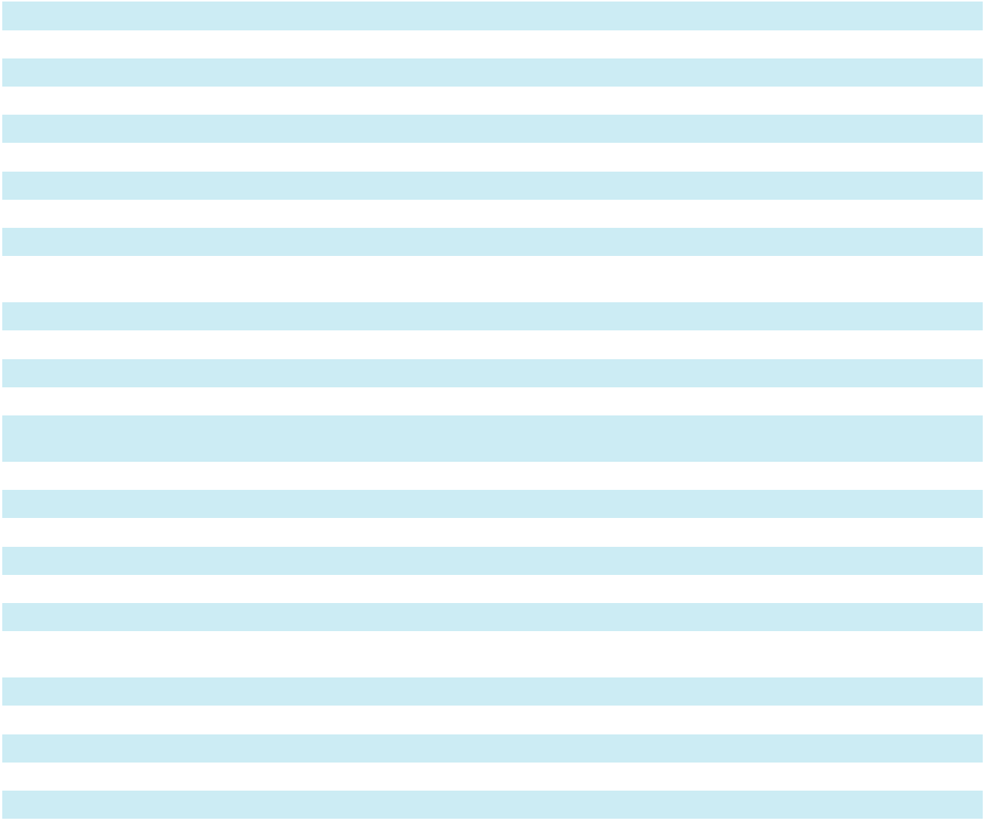

Where You Can Find More Information

In this Annual Report on Form 10-K for the fiscal year ended December 31, 2025 (this “Form 10-K”), “we,” “our,” “us,” “Skyward Group,” “Skyward Specialty,” or “SKWD” refer to Skyward Specialty Insurance Group, Inc. and its subsidiaries. We file annual, quarterly, and current reports, proxy statements and other information with the United States Securities and Exchange Commission (the “SEC”). General information about us can be found at https:// investors.skywardinsurance.com/. Our Form 10-K, Quarterly Reports on Form 10-Q and Current Reports on Form 8-K, as well as any amendments to those reports, are available free of charge through our website at https:// investors.skywardinsurance.com/ as soon as reasonably practicable after we file them with, or furnish them to, the SEC. The SEC also maintains a website at www.sec.gov that contains reports, proxy statements, and other information regarding SEC registrants, including Skyward Specialty.

We use our investor relations website, https://investors.skywardinsurance.com/, as a means of disclosing information which may be of interest or material to our investors and for complying with disclosure obligations under Regulation FD. Accordingly, investors should monitor our investor relations website, in addition to following our press releases, SEC filings, public conference calls, webcasts, and social media channels. Information contained on or accessible through, including any reports available on, our website or social media channels is not a part of, and is not incorporated by reference into, this Form 10-K or any other report or document we file with the SEC. Any reference to our website in this Form 10-K is intended to be an inactive textual reference only.

3

Forward-Looking Statements

All statements, other than statements of historical facts, included in this Form 10-K, or incorporated herein by reference, including, without limitation, statements regarding Skyward Specialty’s future financial position, business strategy, budgets, projected costs, goals and plans and objectives of management for future operations, are forward-looking statements within the meaning of the Private Securities Litigation Reform Act of 1995. Forward-looking statements generally can be identified by the use of forward-looking terminology such as “may,” “will,” “expect,” “intend,” “estimate,” “anticipate,” “project,” “believe” or “continue” or the negative thereof or variations thereon or similar terminology. Forward-looking statements speak only as the date the statements were made. Although Skyward Specialty believes that the expectations reflected in forward-looking statements have a reasonable basis, it can give no assurance that these expectations will prove to be correct. Forward-looking statements are subject to risks and uncertainties that could cause actual events or results to differ materially from those expressed in or implied by the statements. For a discussion of the most significant risks and uncertainties that could cause Skyward Specialty’s actual results to differ materially from those projected, see “Risk Factors” in Item 1A of this Form 10-K. Except to the limited extent required by applicable law, Skyward Specialty undertakes no obligation to update or revise any forward-looking statements, whether as a result of new information, future events or otherwise.

Select Insurance and Financial Terms

Gross written premiums

Gross written premiums are the amounts received, or to be received, for insurance policies written or assumed by us during a specific period of time without reduction for policy acquisition costs, reinsurance costs or other deductions. The volume of our gross written premiums in any given period is generally influenced by new business submissions, binding of new business submissions into policies, renewals of existing policies, and average size and premium rate of bound policies.

Ceded written premiums

Ceded written premiums are the amount of gross written premiums ceded to reinsurers. We enter into reinsurance contracts to limit our exposure to potential large losses. Ceded written premiums are earned over the reinsurance contract period in proportion to the period of risk covered. The volume of our ceded written premiums is impacted by the level of our gross written premiums and any decision we make to increase or decrease retention levels, policy limits and co-participation.

Net written premiums

Net written premiums are gross written premiums less ceded written premiums.

Net earned premiums

Net earned premiums represent the earned portion of our net written premiums. Our insurance policies generally have a term of one year and premiums are earned pro rata over the term of the policy.

Commission and fee income

Commission and fee income consists of commissions and fees earned on policies placed with third party insurance companies. In certain instances, the fee income relates to placement of business which is part of our packaged solutions. We recognize commission and fee income on the effective date of the policies.

Net investment gains (losses)

Net investments gains (losses) represent the total investment-related gains and losses recognized in earnings during the period. These amounts include net realized investment gains (losses) and net unrealized gains (losses) of equity securities, mortgage loans, and other investments.

Net realized investment gains (losses)

Net realized investment gains (losses) are a function of the difference between the amount received by us on the sale of a security and the security’s cost basis, mark-to-market adjustments, as well as any credit impairments recognized in earnings.

4

Net unrealized investment gains (losses)

Net unrealized investment gains (losses) represent the changes in the fair market value of investment securities that have not yet been sold or settled.

Losses and LAE

Losses and loss adjustment expenses (“LAE”) represent the costs incurred for insured losses, such as losses under a policy, whether paid or unpaid, as well as expenses of settling claims, including settlements, attorneys’ fees, investigation, appraisal, adjustment, defense costs, and the portion of general expenses allocated to claim resolution. Losses and LAE include a provision for claims that have occurred but have not yet been reported to the insurer. These expenses are a function of the amount and type of insurance contracts we write, and the loss experience associated with the underlying coverage. In general, our losses and LAE are affected by:

- the occurrence, frequency and severity of claims associated with the particular types of insurance contracts that we write;

- the reinsurance agreements we have in place at the time of a loss;

- the mix of business written by us;

- changes in the legal or regulatory environment related to the business we write;

- trends in legal defense costs; and

- inflation in the cost of claims including inflation related to wages, medical costs, building materials and automobile repairs.

Losses and LAE are based on actual paid losses and expenses, as well as an actuarial analysis of the estimated losses, including losses incurred during the period and changes in estimates from prior periods. Losses and LAE may be paid out over a period of years.

Catastrophe losses

We generally define catastrophe losses as any single loss, or group of losses, related to a single Property Claim Services (“PCS” a Verisk company) designated catastrophe event. PCS has defined catastrophes in the United States, Puerto Rico, and the U.S. Virgin Islands as events that cause $25.0 million or more in direct insured losses to property and affect a significant number of policyholders and insurers.

Underwriting, acquisition and insurance expenses

Underwriting, acquisition and insurance expenses include policy acquisition costs and other underwriting and insurance expenses. Policy acquisition costs consist of commissions we pay retail agents and brokers, program administrators, captive managers and third-party administrators, net of ceding commissions we receive from reinsurers on business ceded under certain of our reinsurance contracts. In addition, acquisition expenses include premium-related taxes and other fees. Our policy acquisition costs vary with, and are directly related to, the successful production of new or renewal business. Acquisition expenses related to each policy we write are deferred and amortized to expense in proportion to the premium earned over the term of the policy. Other underwriting and insurance expenses represent the general and administrative expenses of our insurance operations including employee compensation and benefits, and corporate functions such as technology costs, office rent, depreciation and professional service fees including legal, accounting, and actuarial.

Impairment charges

Impairment charges represent reductions in the carrying value of goodwill and intangible assets.

Key Operating and Financial Metrics

We discuss certain key metrics, described below, which provide useful information about our business and the operational factors underlying our financial performance. These metrics are generally standard among insurance companies and help to provide comparability with our peers.

Net retention, expressed as a percentage, is the ratio of net written premiums to gross written premiums.

Underwriting income (loss) is a non-GAAP financial measure defined as income (loss) before income taxes excluding net investment income, net realized and unrealized gains and losses on investments, impairment charges, interest expense, amortization expense and other income and expenses.

Loss and LAE ratio, expressed as a percentage, is the ratio of losses and LAE to net earned premiums.

5

Expense ratio, expressed as a percentage, is the ratio of underwriting, acquisition and insurance expenses less commission and fee income to net earned premiums.

Combined ratio is the sum of loss ratio and expense ratio. A combined ratio under 100% indicates an underwriting profit. A combined ratio over 100% indicates an underwriting loss.

Adjusted loss and LAE ratio, expressed as a percentage, is a non-GAAP financial measure defined as the ratio of losses and LAE, excluding losses and LAE related to the loss portfolio transfer (“LPT”) and all development on reserves covered by the LPT through December 31, 2024, to net earned premiums. The LPT was commuted effective January 31, 2025.

Adjusted combined ratio is a non-GAAP financial measure defined as the sum of the adjusted loss ratio and the expense ratio.

Adjusted operating income (loss) is a non-GAAP financial measure defined as net income excluding the net impact of the LPT, net realized and unrealized gains or losses on investments, transaction costs, goodwill impairment charges and other income and expenses.

Return on equity is net income as a percentage of average beginning and ending stockholders’ equity.

Adjusted return on equity is a non-GAAP financial measure defined as adjusted operating income as a percentage of average beginning and ending stockholders’ equity.

Tangible stockholders’ equity is a non-GAAP financial measure defined as stockholders’ equity less goodwill and intangible assets.

Return on tangible equity is a non-GAAP financial measure defined as net income as a percentage of average beginning and ending tangible stockholders’ equity during the applicable period.

Adjusted return on tangible equity is a non-GAAP financial measure defined as adjusted operating income as a percentage of average beginning and ending tangible stockholders’ equity during the applicable period.

6

PART I

Item 1. Business

Who We Are

Skyward Specialty was formed as a Delaware corporation on January 3, 2006 as an insurance holding company. We operated under the name Houston International Insurance Group, Ltd. until we re-branded as Skyward Specialty in November 2020. References to “the Company,” “we,” “our,” “us” or like terms refer to the business of Skyward Specialty Insurance Group, Inc. and its subsidiaries.

We are a growing specialty insurance company delivering commercial insurance products and solutions on a non-admitted (or E&S) and admitted basis, predominantly in the United States. We focus our business on markets that are underserved, dislocated and/or for which standard insurance coverages are insufficient or inadequate to meet the needs of businesses, including our customers and prospective customers operating in these markets. Our customers typically require highly specialized, customized underwriting solutions and claims capabilities. As such, we develop and deliver tailored insurance products and services to address each of the niche markets we serve.

Our portfolio of insured risks is highly diversified—we insure customers operating in a wide variety of industries; we distribute through multiple channels; we write multiple lines of business, including general liability, excess liability, professional liability (including cyber and media liability insurance), commercial auto, group accident and health, property, agriculture, credit, surety and workers’ compensation; we insure both short and medium duration liabilities; and our business mix is principally primary insurance and balanced between E&S and admitted markets. A portion of our business is specialty reinsurance (principally property, agriculture and credit) which is similarly focused on attractive specialty classes where we believe it is more efficient to approach these classes through reinsurance given factors such as cost of entry, including the costs of geographic expansion. All of these factors enable us to respond to market opportunities and dislocations by deploying capital where we believe we can consistently earn attractive risk-adjusted returns. We believe this diversification, which includes businesses not typically aligned with traditional P&C pricing cycles, combined with our underwriting and claims expertise, will more consistently produce strong growth and profitability across all insurance pricing cycles.

We are led by an entrepreneurial executive management team with decades of insurance leadership experience spanning multiple aspects of the global P&C industry. Our leadership is supported by an experienced team with a broad skill set and aligned around our strategy. We believe our high-quality leadership and underwriting and claims teams, technology DNA, advanced analytics capabilities, diversified book of business, and strong competitive position in each of our chosen market niches position us to continue to profitably grow our business. We aim to deliver long-term value for our shareholders by generating best-in-class underwriting profitability and book value per share growth across P&C market cycles.

All of our insurance company subsidiaries are group rated and have financial strength ratings of “A” (Excellent) from the A.M. Best Company (“A.M. Best”) with stable outlook.

Apollo Acquisition

On September 2, 2025, we entered into two share purchase agreements (the "Apollo Majority SPAs") with institutional and management shareholders, respectively, of Apollo Group Holdings Limited ("Apollo") (the "Majority Sellers"). Pursuant to the Apollo Majority SPAs, in accordance with the terms and subject to the conditions therein, we agreed to acquire all of the issued shares of Apollo held by the Majority Sellers, representing approximately 87% of the issued share capital of Apollo. In addition, closing of the transaction ("Closing") was conditioned upon our acquiring 100% of the issued share capital of Apollo (the “Acquisition”) at Closing pursuant to additional short-form share purchase agreements (the "Apollo Minority SPAs" and together with the Apollo Majority SPAs, the "Apollo SPAs") with the remaining minority shareholders of Apollo (the "Minority Sellers" and together with the Majority Sellers, the "Sellers"). The Acquisition closed on January 1, 2026. The consideration for the transaction was satisfied by the issuance of common stock of the Company to certain sellers and the remainder in cash.

Apollo is a leading U.S. centric specialty underwriting platform operating at Lloyd’s of London that is low volatility, high growth and employs a capital light business model. The business has grown gross written premium consistently since its formation in 2010. Through Syndicate 1969, Apollo underwrites a multi-class specialty insurance portfolio. Through Syndicate 1971, Apollo delivers a unique, innovative platform liability product for the digital and sharing economy. Apollo provides capital to syndicates 1969 and 1971 in exchange for a pro-rata share of the underwriting income, with the remainder of the capital provided by third parties. Additionally, Apollo earns managing agency fees and profit commissions for being the managing agent to both its own syndicates, as well as to innovative third-party syndicates, known as platform partners.

7

We believe the acquisition is exceptionally well aligned to Skyward Specialty’s strategy, bringing new specialty niches, a distinctive new economy offering, accelerating innovation, and adding Apollo’s advanced technology capabilities. Continuing to lead Apollo’s growth as a subsidiary of Skyward Specialty will be David Ibeson, who will continue as CEO of Apollo, along with Apollo’s entrepreneurial and dynamic management team.

Our Business and Our Strategy

We have one reportable segment through which we offer a broad array of insurance coverages to a number of market niches. Each of our nine distinct underwriting divisions has dedicated underwriting leadership supported by high-quality technical staff with deep experience in their respective niches. We believe this structure and expertise allow us to serve the needs of our customers effectively and be a value-add partner to our distributors, while earning attractive risk-adjusted returns. For the year ended December 31, 2025, 41% of our gross written premiums were written on an admitted basis and 59% were non-admitted.

Our Underwriting Divisions

Accident & Health: Our Accident & Health (“A&H”) underwriting division provides medical stop loss to employers who self-insure their employee benefits, as well as covering group and single-employer captives. Our A&H captives program provides tailored medical stop-loss and reinsurance solutions for group and single-employer captive arrangements, supported by dedicated underwriting and proactive claims oversight. Our approach for managing medical costs, combined with our claims oversight, enables us to partner with select distribution partners. We target and serve a segment of the small and medium sized enterprise market that is actively seeking to take control of their healthcare costs by self-insuring a portion of their healthcare insurance. We write these products on an admitted basis and distribute primarily through retail brokers and wholesale broker partners.

Agriculture and Credit (Re)insurance: Our Agriculture and Credit (Re)insurance underwriting division provides specialty risk-transfer solutions across a diversified global portfolio, spanning agriculture, dairy and livestock revenue protection, mortgage and credit product lines. We support insurers, MGAs, and other risk originators by delivering tailored treaty protection using proportional and excess of loss structures. Our global agriculture book provides coverage for weather and natural peril driven volatility and other production and yield risks, helping clients manage catastrophe exposure and seasonal earnings variability across regions. The mortgage portfolio supports government sponsored entities and private mortgage insurers against default and loss severity volatility typically due to macroeconomic stress, structured to manage tail risk and protect against adverse cycle turns. Our credit portfolio provides protection against losses driven by default risk covering single obligors and multi-buyer trade credit across a diverse portfolio across regions and industries.

Our dairy and livestock business provides producers with revenue protection against price volatility in milk, cattle, and hog markets. We utilize derivative instruments, primarily put options and futures, to mitigate commodity price risk associated with our exposure to cattle, hog and milk prices. These instruments are used solely to manage exposure to adverse price movements, and positions are adjusted throughout the year in response to changes in market conditions and our risk profile. See Note 8, “Derivatives” to our consolidated financial statements included in Item 8 of this Form 10-K for additional information regarding derivatives.

Captives: Our Captives underwriting division provides group captive solutions by drawing on our underwriting and claims expertise from other underwriting divisions to create group captives for companies seeking to self-insure. By leveraging our underwriting, claims, technology, and analytical expertise across our Company, we are able to broaden our market reach and write additional profitable business with limited additional expense. Our captive underwriting division writes property, general liability, commercial auto, excess liability, and workers’ compensation lines of business on an E&S and an admitted basis. We often administer this business through partnerships with third-party captive managers.

Construction & Energy Solutions: Our Construction and Energy Solutions underwriting division focuses on high-severity exposures that our experienced underwriting and claims teams address with tailored and often multi-line solutions, including general liability, excess liability, commercial auto, and workers’ compensation. We distribute these products through retail agents, brokers, and a select network of wholesalers.

Global Property: Our Global Property underwriting division provides comprehensive property insurance and reinsurance solutions for a broad spectrum of commercial clients worldwide. Our offerings are designed to protect against physical loss or damage to assets, including buildings, equipment, and inventory, due to natural catastrophes and other insured perils, supporting clients across diverse industries with managing exposures and maintaining operational resilience.

Professional Lines: Our Professional Lines underwriting division includes three underwriting units: management liability, professional liability (which includes cyber), and allied health (which includes life sciences). Management/ Professional liability and allied health provide primary and excess claims-made liability products, on an E&S and admitted basis, distributed through both wholesale and retail brokers, depending on the product.

8

Specialty Programs: Our Specialty Programs underwriting division partners with program administrators focused on certain markets that align with our expertise and strategy. We believe partnering with a program administrator in certain circumstances is the optimal way for us to participate profitably or extend our reach in certain markets. Typically, the program administrators possess a competitive advantage (owing to their scale in a particular market niche and/or proprietary technology) that we believe would be difficult for us to replicate on our own. For example, certain of our program administrator partners have developed proprietary technology to optimize risk selection and pricing in specific markets. We believe the combination of our underwriting and claims expertise with their scale and/or technology creates a more powerful partnership than either party could present to the market on its own. Our Specialty Programs underwriting division writes property, general liability, commercial auto liability, excess liability and workers’ compensation lines of business on an E&S and an admitted basis.

Surety: Our Surety underwriting division provides contract, commercial and transactional surety solutions to a range of trade and services organizations requiring bonding. We principally focus on small to medium sized enterprises with aggregate bond programs up to approximately $100.0 million for contract and $125.0 million for commercial and transactional. We write this business on an admitted basis and distribute through retail agents and brokers.

Transactional E&S: Our Transactional E&S underwriting division provides primary and excess non-catastrophe prone property and general liability solutions, with particular emphasis on risks that are considered hard to place because of the complexity of the underlying exposure, loss history, and/or limited operating history (for example, start up and newer businesses). Success in our target market is determined by technical underwriting, thoughtful coverage provisions and pricing, and high-quality broker service. We access the market in this division exclusively through wholesale brokers.

In addition to our continuing business, there are business units and lines of business that we previously exited and placed into run-off. We refer to these lines and businesses as our “exited business”.

Our Strategy

We seek to lead in our chosen market niches and establish sustainable, competitive positions in these markets. The following key elements underpin our strategy and approach to our business:

- Providing differentiated products, services and solutions that meet the unique needs of our target markets;

- Attracting and retaining exceptional underwriting and claims talent and incentivizing our professionals in a manner that aligns with our organization and corporate goals;

- Amplifying the expertise of our people with advanced technology and analytics that enable superior risk selection, pricing and claims management;

- Empowering our underwriting and claims teams with considerable authority to make decisions and apply their expertise; and

- Fostering a culture that promotes nimbleness and responsiveness to market opportunities and dislocation.

We refer to this strategy as “Rule Our Niche” and it forms the basis of our approach to building a strong defensible market position, creating a competitive moat, and winning in our chosen markets. We believe that the principles underlying our strategy are key to achieving and sustaining best-in-class underwriting results through P&C insurance pricing cycles. We consistently strive for excellence in risk selection, pricing, and claims outcomes, and to amplify these critical functions with the use of advanced technology and analytics.

Our Competitive Strengths

We believe that our competitive strengths include:

Focus on profitable niches of the market that require technical underwriting and claims management as barriers to entry.

We believe that the niche areas of the commercial lines P&C markets we have selected are a highly attractive subset of the P&C insurance market and present an opportunity to generate attractive risk-adjusted returns. We actively target markets that are underserved, dislocated or for which standard, commoditized products are insufficient or inadequate to meet the needs of our customers. The unique characteristics of the risks within our core markets require each account to be efficiently and individually underwritten, in order for us to generate an acceptable, sustainable underwriting profit. Many carriers have chosen to reject businesses that they deem to be too complex, or that require thoughtful individual underwriting; or, alternatively, have focused on simple account risks for which more automated underwriting can be effective. Instead, we have chosen to build our underwriting divisions around deeply experienced underwriters who we empower with appropriate authority to make underwriting decisions. This structure enables us to offer innovative and unique products and solutions to our distribution partners and customers, regardless of how challenging or complex a risk

9

may be. Further, we augment our underwriters’ experience with data and predictive analytics that are intended to differentiate risk selection and pricing decision-making while enhancing efficiency.

Highly skilled underwriters.

We focus on hiring and retaining underwriting and technical staff who help differentiate our company through their expertise and experience. Our underwriting teams are knowledgeable, experienced, and empowered — characteristics which are critical to operate successfully in the markets we serve, especially since many of the risks we underwrite are particularly difficult to automate. We do not impose strict underwriting rules (for example, we are not “box” underwriters), but rather allow our professionals the freedom to use their expertise and judgment when evaluating and pricing risks. Simply put, we give our people the tools and appropriate authority to make decisions and do what they do best — profitably underwrite complex risks.

Superior Claims Staff and Operations.

We have cultivated a best-in-class and highly specialized team of claims professionals who are highly knowledgeable about the niches we serve and the lines of business we write. Our claims professionals systematically address first party claims with fair and equitable solutions and third-party claims with holistic and comprehensive responses, in each case seeking to ensure consistent and early loss recognition of indemnity and loss adjustment expenses (“LAE”).

We respond quickly when a claim is submitted with specialized adjusters, who are armed with expertise, advanced technology and analytics, to assist them in the claims resolution process. We embed technology deeply into our claims process and leverage our technology-enabled platform and tools from first notice of loss to investigation to settlement. Our analytics capabilities used by our senior leadership and claims teams include real-time, detailed information on open claims and benchmarks against closed claims. We believe that our industry expertise, nimble culture, and technology-embedded claims processes enable us to reach fair and appropriate claims outcomes for our customers.

Superior business intelligence platform.

SkyBI, our business intelligence platform, focuses on providing our senior leadership, as well as our technical teams, with real-time intelligence to drive superior decision making. SkyBI reflects the best practices our management team has learned from its extensive experience across the P&C insurance and technology sectors. We developed SkyBI, our single, comprehensive enterprise-wide data repository, as our foundation for reporting, business intelligence, analytics, and other advanced data capabilities. It provides our organization information and performance metrics across the Company in an easy-to-consume visualized format. The data can be filtered by many categories, including distributor, customer segment, line of business, specific industry, individual underwriter, and specific risk feature among others. SkyBI aids in establishing clear line of sight to objectives as well as facilitating our decision-making processes.

Advanced technology and new risk data for underwriting and claims.

We fundamentally believe that every underwriting and claims decision can be augmented with the use of new types of risk data and advanced technology. While our underwriting decisions are backed by reliable historical data and in-depth evaluation of risks resulting from intentional investment in data collection and processing capabilities, we amplify our underwriting and claims prowess by combining this data with new forms of risk data and predictive analytics. We also utilize generative artificial intelligence in our underwriting and claims handling where doing so can aid in our effectiveness and efficiencies while still relying upon the expertise of our employees.

Diversified business that allows us to respond to, and capitalize on, changes in market conditions across P&C cycles.

We have been successful in building a diversified group of underwriting divisions spanning multiple product lines, industries, geographies and distribution channels, including business that is not typically aligned with traditional P&C cycles. We aim to evolve with, and adapt to, the market growing certain lines of business when market conditions are favorable and limiting our exposure to certain markets when conditions are less favorable. We believe the diversity of our book allows us to respond to, and capitalize on, market opportunities and dislocations across insurance market and pricing cycles resulting in a durable insurance franchise.

Attractive and winning culture.

As evidenced by our internal surveys, public information such as that available on Glassdoor and LinkedIn, and our selection as a “Best Places to Work in Insurance,” we have built a distinctive winning culture. Key to our culture and operating approach is a flat structure of communication and decision-making. We trust our staff to make decisions that produce or exceed our desired financial results, and we support our staff with a clear system of measurement to gauge performance. We have chosen to adopt a hybrid work schedule which provides our employees with the flexibility for remote working. We pride ourselves on maintaining an entrepreneurial environment that encourages and rewards a proactive approach to capitalize on market disruption. This environment is not only consistent with our identity as a

10

specialty insurer but also a foundation for our success in attracting great talent and our objective of delivering best-in-class results.

High-quality, experienced leadership team that is aligned with our shareholders.

Led by our Chairman and CEO, Andrew Robinson, we have an experienced, innovative and entrepreneurial executive leadership team with a track record of success in senior management roles at industry leading property and casualty companies as well as in starting and building new businesses in our industry.

Our entire senior leadership’s compensation is carefully constructed to ensure alignment with our shareholders. Each of our leaders have a material portion of their compensation in the form of long-term and short-term incentives tied to delivering sustainable, best-in-class underwriting returns. Our executive leadership team have additional long-term incentive targets tied directly to growth in book value per share.

Our Strategy in Action

With everything we do, from recruiting to marketing to underwriting to loss adjusting and claims resolution, we seek to follow the core tenets of our “Rule Our Niche” strategy, as described above. We believe our “Rule Our Niche” strategy will help us achieve our goal of generating best-in-class underwriting profitability for our niches while creating superior long-term shareholder value through growth in book value per share. The core tenets of our “Rule Our Niche” strategy include:

Attract and retain blue-chip underwriting and claims talent to expand and enhance our market position.

We seek to hire and retain the most talented technical underwriting professionals who have long-standing industry relationships with distribution partners and claims professionals with expertise in the niches we write. These relationships are key to getting steady access to our preferred business. We believe that we have become a company of choice for the best talent in our industry and, as such, we will continue to grow our market position by bringing on world-class talent in our chosen markets.

Leverage our technology DNA to further distance ourselves from the competition.

We have demonstrated a differentiated ability to utilize new forms of risk data and advanced technology within the more complex, higher severity risk categories of the specialty P&C insurance market. SkyBI gives us the ability to promptly sense and quickly respond to market changes, while our core operating platforms allow us to move into new markets efficiently and without the complexity of burdensome systems. We believe our technological advantage positions us for profitable growth and expansion into additional specialty market niches where we can establish a strong and defensible market position.

Profitably grow existing lines of business and expand with new underwriting divisions.

We believe that we are well-positioned to take advantage of several trends impacting our customers in the United States and globally. One such trend is the continued rise in demand for specialized insurance solutions because of increasing risks, as well as the complexity of risks, due to climate change/increased frequency of severe weather events, supply chain uncertainty, financial inflation risk, cyber risk, emergence of novel health risks, increased level of litigation, attorney involvement and jury awards, and healthcare delivery and cost. Another such notable market trend is the emergence of “micro cycles and micro dislocations” where different pockets of the P&C insurance market experience hardening and softening at different times. We have demonstrated our ability to react quickly in response to these trends by launching new underwriting units, including many not typically aligned with P&C cycles, entering underserved markets, partnering with others with advanced technology, and launching new captive solutions. We believe our gross written premium growth and profitability are indicative of our momentum and provides a powerful reference for the positioning of our Company to continue to expand and grow in the markets we seek to serve.

Differentiate on daily excellence to drive best-in-class underwriting performance.

We believe that our ability to meet our long-term goals, including achieving best-in-class underwriting returns and growth in book value per share, relies on how well we execute our day-to-day operations across all of our functional departments, including but not limited to underwriting, product management, and claims management. SkyBI provides the foundation by which our senior management can monitor our performance, whether it is renewal rates, new business pricing and portfolio performance for an individual underwriter, or claims aging and reserving practices and outcomes by claims adjusters. Our focus on the fundamentals that drive underwriting excellence is at the center of our strategy. Furthermore, our cross functional collaboration ensures that our underwriting, claims, actuarial and product management teams regularly review performance and trends so that portfolio, pricing and coverage changes can be implemented quickly.

11

Use our balance sheet to capture a larger part of the market we serve.

We are committed to establishing and maintaining a strong balance sheet, starting with conservative loss reserves and strong capitalization ratios. We believe this is imperative to maintain the confidence of customers, distribution partners, reinsurers, regulators, rating agencies and shareholders. Our claims case reserves practices aim to reserve to the expected ultimate loss within 90 days of the first notice of loss. In addition, our practice is to maintain a level of incurred but not reported reserves (“IBNR”) that, together with our case reserves, is above our actuarial central estimate. We maintain loss reserves that represent our best estimate of ultimate losses.

Marketing and Distribution

Our approach to marketing and distribution mirrors our approach to underwriting and is a key facet of our “Rule Our Niche” strategy. Our underwriting teams, as well as the Company as a whole, have strong and well-established relationships with our distribution partners and equally strong reputations that provide a foundation to establish affiliations with new distribution partners. We believe we win with distribution partners because of our deep expertise in niche markets, high caliber underwriters, culture of innovation, thoughtful product line-up and product design, and speed and quality of responsiveness, among other factors. All of our underwriting divisions invest meaningful time and effort into sustaining and expanding distribution partner loyalty and long-term relationships.

Just as we tailor underwriting to the individual needs of the insureds, we tailor our choice of distribution partners to access the particular business we seek to write. Accordingly, we distribute our products, through retail agents, wholesale brokers, select program administrators, and captive managers. This approach allows us to access the business we target effectively and efficiently based on the needs and dynamics of a particular market niche.

Underwriting

Our approach to underwriting is deeply embedded in our “Rule Our Niche” strategy and is core to how we win in the market. Within the nine divisions, we further specialize underwriting teams with a focus on specific niches within the markets the nine divisions serve.

Our underwriting approach is underpinned by hiring highly experienced, best-in-class and diverse teams of technical underwriters with established track records in specific specialty niche markets. We then amplify our underwriters’ skill sets with advanced technology and data analytics and empower them with appropriate authority to make decisions. We believe this approach is key to superior risk selection and pricing and producing sustainable best-in-class underwriting results across market cycles.

We strive to augment the capabilities and experience of our underwriting professionals using new forms of data and analytics for risk selection and pricing. Our underwriting data is captured in our business intelligence platform, SkyBI. This comprehensive data repository forms the foundation of our reporting, analytics, and other data capabilities and is a key tool for our senior management team and business leaders. See the section entitled “Technology” below for more information on SkyBI.

We are highly selective in the policies we choose to bind. If our underwriters cannot reasonably expect to bind coverage at the combination of premium and coverage terms that meet our standard, we encourage them to move on quickly to other prospective opportunities.

When accepting risks, we are careful to establish terms and price that are suited to the underlying exposure. When writing in the admitted market, we endeavor to ensure that our approved forms and filed rates are appropriate and adequate for the risks we are accepting while also allowing us the flexibility to address specific and/or unique exposures. When writing in the E&S market, we use our freedom of rate and form to ensure risk and coverage are appropriate to the unique needs and exposure that are presented in this market. We endeavor to craft policies that offer affordable and appropriate protection to address our insureds’ exposures while also constructing coverage such that potential losses are more predictable and claims cost can be best managed.

Underwriting teams are supported by active engagement and collaboration with our Claims, Actuarial, Product Management, Legal and Compliance and Finance departments so that trends in the business, legal and tort developments, and competitor and regulatory actions are analyzed, shared, and acted upon in a timely manner. We view our underwriters as the center of our company and all support functions are incented and measured to support the achievement of our underwriting profitability targets. This structure serves to surface both opportunities and issues early and forms a key part of our nimbleness and ability to take advantage of market disruptions. Finally, our underwriting controls and procedures are regularly reviewed to ensure our underwriters are acting with clear line of sight to profitably underwrite each of the markets we serve.

12

Claims Management

Skyward’s claims department is guided by the following principles: (1) prompt and comprehensive claim investigations, considering all aspects of each loss, and using advanced analytics and technology to improve efficiency, accuracy and speed of response; (2) providing our customers with quality claims handling service while engaging customers through the entire claims resolution process; (3) promptly establishing reserves reflective of our best estimate of ultimate loss; (4) effectively pursuing contribution and subrogation where appropriate and warranted; (5) detecting and preventing fraud activity throughout the claims handling process using a variety of tools; and (6) disciplined litigation management to provide our customers with a superior legal defense while closely monitoring legal costs. To this end, we provide continuous training to our claim staff on claim evaluation, strategy, litigation management, good-faith claims handling and best practices. Our ultimate goal is to achieve timely and optimal claim outcomes.

We handle the majority of our claims in-house. In certain instances, we utilize Third Party Administrators (TPAs), to handle claims on Skyward’s behalf, when needed. Specifically, we may utilize TPAs for programs, captives, occupational accident, workers compensation and runoff claims. We actively manage and oversee our TPAs and monitor their individual claims-handling activities, to be in accordance with our claims handling and reserving guidelines and general best practices. We regularly audit our TPAs to ensure compliance with these guidelines and practices.

When the retention of counsel is warranted for a liability claim made against an insured, we retain independent legal counsel to defend and represent an insured. We select defense counsel based on their geographical location and expertise to ensure that they have the requisite experience and legal knowledge to defend our insureds effectively and efficiently. We have developed carefully crafted litigation guidelines for both our claims professionals and our outside counsel to follow. Adherence to these guidelines ensures that counsel is providing the appropriate defense to our insureds. Finally, to ensure that legal costs are reasonable, and customary within the respective defense counsel’s geography and practice area, we employ a legal spend management solution to analyze legal invoices for adherence to case handling and billing practice standards.

We are leveraging technology to gain efficiencies in the claims-handling process. For example, we created and implemented a Claims Development Severity Predictor. This predictive model trains on key phrases to identify claims that are more likely to lead to large loss development, allowing early identification, proactive claims management and summarization to help us understand why development will occur. This model has been integrated into our claims review and management workflow.

Additionally, we are always looking for opportunities to resolve our claims as efficiently and effectively as possible. For example, for commercial auto, we have implemented a “quick strike” program to respond to claim reports. This program involves deploying experienced investigators and other appropriate vendors to the scene of a reported auto accident, ideally within two hours of the accident, regardless of the location. This quick response assists us in evaluating the facts and circumstances of the accident to begin our investigation as quickly as possible. If appropriate, our program aids us in resolving any third-party claims as quickly as possible.

Finally, our claims handlers and managers are organized by line of business to ensure that the right expertise is brought to bear in handling claims. The managers and adjusters work very closely with their underwriting partners to keep them apprised of legal trends and emerging claims issues of note. The goal is to educate our underwriters on emerging areas of loss experience to assist them in their risk selection processes.

Technology

Our technology is at the heart of everything we do and every decision we make, helping us to win over the long-term.

We deploy technology across our organization to drive competitive advantages in three primary functional ways:

- Superior Business Intelligence Platform. SkyBI, our business intelligence platform, focuses on providing our senior leadership, as well as our technical teams, with real-time intelligence to drive superior decision making. SkyBI reflects the best practices our management team has learned from its extensive experience across the P&C insurance and technology sectors. We developed SkyBI, our single, comprehensive enterprise-wide data repository, as our foundation for reporting, business intelligence, analytics, and other advanced data capabilities. It provides our organization with information and performance metrics across the Company in an easy-to-consume visualized format. The data can be filtered by many categories, including distributor, customer segment, line of business, specific industry, individual underwriter, and specific risk feature among others. SkyBI aids in establishing clear line of sight to objectives as well as facilitating our decision-making process.

- Predictive Analytics Technology. We strive to augment the capabilities of our employees daily using new forms of risk data and the use of predictive analytics including artificial intelligence for risk selection, pricing and claims

13

handling. Within every underwriting division, our actions are intentional to “Rule Our Niche.” We aim to innovate constantly, and our actions are specific to each of the divisions/markets we serve.

- Core Transactional Platforms. Our core operating platforms, including our policy administration, underwriting workbench, billing and claims systems, are intentionally designed to enable nimble scaling and expansion of our business. We generally use third-party vendor developed core operating applications that we have customized for our company. Our core platform organization is used for all business except for accident & health, global property, agriculture and credit (re) insurance, and surety as the unique features of these underwriting divisions require select dedicated core processing components. Data gathered from our core operating platforms from all divisions flows to our SkyBI platform with comparable data quality and granularity regardless of underwriting division.

Our use of advanced technology for underwriting and claims, SkyBI and core operating platforms provide our business with a flywheel effect allowing our underwriters to better select risk, our claims professionals to better adjudicate claims, our unit leaders to better communicate with reinsurance and third-party partners, and our senior leadership team to better evaluate trends in our business. These tools also have the added advantage of allowing us to communicate with our distribution partners, reinsurers, and other third-party partners more accurately, effectively, and efficiently.

Like other companies, we face external threats to our information technology systems, including the possibility of system failure, attempts to steal our customer data, and ransomware attacks. We designed our technology infrastructure to function through almost any major disruption. We replicate our data in real time to a third-party cloud disaster recovery site for use in the event of a major system failure. We also back-up our data daily for system restoration if needed. Additional actions we take to prevent disruptions to our systems and data include: actively monitoring Cybersecurity and Infrastructure Security Agency’s (“CISA”) cybersecurity directives, taking immediate action on any vulnerability identified in a directive; conducting monthly vulnerability scans on all network attached devices, at all locations, with patching applied whenever needed; requiring two-factor authentication for access to any of our systems; conducting monthly security training for all employees; implementing endpoint detection agents for threat detection and response; performing desktop scenarios to practice responses to breaches involving our cybersecurity insurance partners and retained security consultants; and performing annual penetration testing. We constantly review our security breach posture and regularly implement updated processes, best practices and tools.

Reinsurance

We strategically purchase reinsurance from third parties which enhances our business by protecting capital from severity events (either large single event losses or catastrophes) and reducing volatility in our earnings. Our reinsurance contracts are predominantly one year in length and renew annually throughout the year, primarily in January and June. At each annual renewal, we consider several factors that influence any changes to our reinsurance purchases, including any plans to change the underlying insurance coverage we offer, updated loss activity, the level of our capital and surplus, changes in our risk appetite and the cost and availability of reinsurance treaties.

We purchase quota share reinsurance, excess of loss reinsurance, and facultative reinsurance coverage to limit our exposure from losses on any one occurrence. The mix of reinsurance purchased considers efficiency, cost, our risk appetite and specific factors of the underlying risks we underwrite.

- Quota share reinsurance refers to a reinsurance contract whereby the reinsurer agrees to assume a specified percentage of the ceding company’s losses arising out of a defined class of business in exchange for a corresponding percentage of premiums, net of a ceding commission.

- Excess of loss reinsurance refers to a reinsurance contract whereby the reinsurer agrees to assume all or a portion of the ceding company’s losses for an individual claim or an event in excess of a specified amount in exchange for a premium payable amount negotiated between the parties, which includes our catastrophe reinsurance program.

- Facultative coverage refers to a reinsurance contract on individual risks as opposed to a group or class of business. It is used for a variety of reasons, including supplementing the limits provided by the treaty coverage or covering risks or perils excluded from treaty reinsurance.

14

The following is a summary of our reinsurance programs as of December 31, 2025:

Line of Business | Maximum Company Retention
Accident & Health | $0.90 million per occurrence
Commercial Auto⁽¹⁾ | $1.00 million per occurrence
Excess Casualty⁽¹⁾⁽²⁾ | $2.25 million per occurrence
General Liability⁽¹⁾ | $1.50 million per occurrence
Ocean Marine⁽²⁾ | $3.00 million per occurrence
Professional Lines⁽²⁾ | $5.25 million per occurrence
Property⁽³⁾ | $3.50 million per occurrence
Representation and Warranty | $3.25 million per occurrence
Surety⁽²⁾ | $5.00 million per occurrence
Workers’ Compensation⁽²⁾ | $2.33 million per occurrence
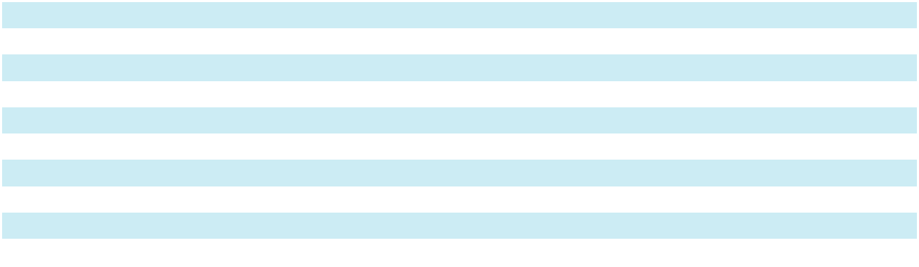
- Legal defense expenses can force exposure above the maximum company retention for Excess Casualty, Commercial Auto and General Liability.

- Reinsurance is subject to a loss ratio cap or aggregate level of loss cover that exceeds a modeled 1:250-year PML event.

- Catastrophe loss protection is purchased up to $36.0 million in excess of $12.0 million retention, which provides cover for a 1:250-year PML event.

For the year ended December 31, 2025, property insurance represented 34% of our gross written premiums. We actively manage and continuously monitor our aggregation of property writings by geographic area to limit our potential for aggregation of loss resulting from severe events such as hurricanes, convective storms, and earthquakes. We buy catastrophe reinsurance to further mitigate an aggregation of property losses due to a single event or series of events. To inform our purchase of catastrophe reinsurance, we use third-party stochastic and our own deterministic models to analyze the risk of aggregation of losses from such events. These models provide a quantitative view of PML events, which is an estimate of the level of loss we would expect to experience once in a given number of years (referred to as the return period). Based upon our modeling, it would take an event beyond our 1 in 250-year PML to exhaust our $36.0 million property catastrophe coverage. Additionally, we seek to expose no more than 3.0% of our stockholders’ equity to a catastrophic loss that is less than a 1 in 250-year event. We believe our current reinsurance program provides coverage well in excess of our theoretical losses from any recorded historical event.

We seek to purchase reinsurance from reinsurers that are rated at least “A-” (“Excellent”) or better by A.M. Best. As of December 31, 2025, 98% of our reinsurance recoverables were either derived from reinsurers rated “A-” (Excellent) by A.M. Best, or better, or were collateralized for our reinsurance recoverable by the reinsurer. While we only select reinsurers whom we believe to have acceptable credit and A.M. Best ratings, if our reinsurers are unable to pay the claims for which they are responsible, we ultimately retain primary liability to our policyholders. Hence, failure of the reinsurer to honor its obligations could result in losses to us, and therefore, we establish allowances for amounts considered uncollectible. At December 31, 2025 and 2024, our allowance for uncollectible reinsurance was $2.3 million.

15

The following table sets forth our most significant reinsurers by amount of reinsurance recoverables, as well as the reinsurers A.M. Best rating, if applicable, as of December 31, 2025:

($ in thousands)
 |  | Reinsurance
Reinsurer |  | Recoverables |  | AM Best Rating
eMaxx Capitves⁽¹⁾ | $ | 197,989 |  | n/r
Everest Reinsurance Co. |  | 123,925 |  | A+
General Reinsurance Corp |  | 70,355 |  | A++
Partner Reinsurance Co. of the US |  | 65,446 |  | A+
ACE (Chubb Property & Casulty Ins Company) |  | 48,344 |  | A+
RGA Reinsurance Company |  | 43,043 |  | A+
Lloyds Syndicate 4711 |  | 35,860 |  | A+
Swiss Reinsurance America Corp |  | 26,152 |  | A+
Lloyds Syndicate 2987 |  | 25,301 |  | A+
Aspen Insurance UK Limited |  | 24,715 |  | A
Top 10 Total |  | 661,130
All Others |  | 458,750
Total | $ | 1,119,880
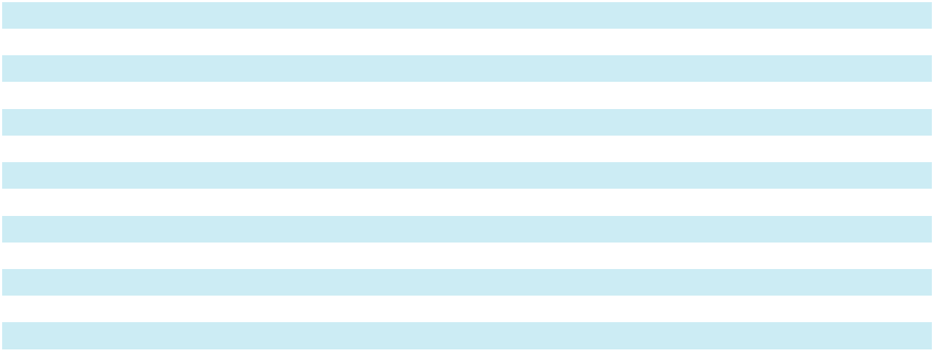

- This reinsurer facilitates our eMaxx captive. At December 31, 2025, we held collateral in a statutory trust of $235.2 million on our net reinsurance recoverables.

Enterprise Risk Management

Our enterprise risk management (“ERM”) is embedded in nearly every aspect of our company and guides our day-to-day activities. At the highest level, our approach to ERM is to ensure we achieve an acceptable risk adjusted return for our shareholders while maintaining a strong foundation of trust and reliability for those we serve; as such we are intentional in our underwriting and asset portfolio construction. As an example, we aim to balance liability duration and market cyclicality of our underwriting portfolio, and we use reinsurance to manage volatility outside of our risk tolerances. Our investment strategy is similarly set out to have a diversified target portfolio that balances portfolio yield, liquidity, volatility, and potential for principal loss.

Our Senior Vice President (“SVP”), Chief Financial Officer (“CFO”) & Head of ERM - US Operations, oversees several critical ERM processes as well as chairing our cross-functional corporate ERM Committee. We formalize our own view of risk and solvency in terms of potential economic loss using our Economic Capital Model (“ECM”). We use the output of our ECM to measure potential earnings and capital loss for a range of scenarios. These outputs are measured against risk tolerances that are set out and updated annually by the ERM Committee and discussed with the Risk Committee of our Board of Directors. More specifically, our ECM provides a probabilistic modeled view of earnings and capital loss that brings together the potential loss from catastrophes, reserving, underwriting, market, credit risk, strategic and operational risks.

Aside from maintaining our ECM and overseeing our risk tolerance framework, our SVP, CFO & Head of ERM works with our ERM Committee to review and maintain a comprehensive risk register with accountabilities to ensure appropriate mitigations are in place and are monitored for any change. The top 10 risks are further identified and quantified by the SVP, CFO & Head of ERM and the ERM Committee and reviewed every quarter. The SVP, CFO & Head of ERM and the ERM Committee submit these reports to the Risk Committee on a regular basis.

We construct our operational processes and controls with a view to identify, assess and manage key risks on an ongoing basis. For example, our Underwriting Committee is responsible for overseeing changes in risk appetite, and product line and division expansion. Within Claims, we diligently monitor our claims handling practices against guidelines through regular internal audits, conduct monthly large loss reviews, and maintain and monitor a watchlist of potential high severity claims. Within Actuarial, we perform quarterly reserve studies, and our Reserve Committee meets each quarter to review and respond to trends in loss emergence. Any key observations are subsequently discussed with the CEO. Monthly and quarterly our underwriting divisions assess rate change and retention on existing business, new business quality and pricing adequacy, and loss emergence as compared to expected. Our SkyBI platform provides real-time portfolio, underwriting, claims and actuarial analytics which is critical to ensuring that the above processes achieve the desired outcome.

16

Altogether, our ERM is at the center of our decision making and our day-to-day activities. It is a central component to our strategy to achieve market leading risk adjusted returns for our shareholders and to reinforce a culture of accountability, transparency, and sound judgment across the organization.

Reserves

We maintain reserves for specific claims incurred and reported, IBNR reserves and reserves for uncollectible reinsurance when appropriate. Our ultimate liability may be greater or less than the current reserves. In the insurance industry, there is always the risk that reserves may prove inadequate. We continually monitor reserves using new information on reported claims and a variety of statistical analyses. Anticipated inflation is reflected implicitly in the reserving process through analysis of cost trends and the review of historical development. We do not discount our reserves for losses and LAE to reflect estimated present value.

When a claim is reported, we establish a case reserve for the estimated amount of the ultimate payment after an appropriate assessment of coverage, damages and other investigation, as applicable. The estimate is based on our reserving practices and on the claims adjuster’s experience and knowledge of the nature and value of the specific type of claim. Case reserves are revised periodically based on subsequent developments associated with each claim. See the section entitled “Claims Management” included in this Item 1 for more information.

We establish IBNR reserves in accordance with industry practice to provide for (i) the estimated amount of future loss payments on incurred claims not yet reported, and (ii) potential development on reported claims. IBNR reserves are estimated based on generally accepted actuarial reserving techniques that take into account quantitative loss experience data and, where appropriate, qualitative factors.

We regularly review our loss reserves using a variety of actuarial techniques. We also update the reserve estimates as historical loss experience develops, additional claims are reported and/or settled and new information becomes available. A reserve can be increased or decreased over time as claims move towards settlement, which can impact earnings in the form of either adverse development or reserve releases. For additional information regarding our loss reserves, see Item 7 of this Form 10-K, “Management’s Discussion and Analysis of Financial Condition and Results of Operations - “Results of Operations - Losses and LAE” and “Critical Accounting Policies.”

Investments

We seek to maintain a balanced investment portfolio predominantly composed of investments that generate predictable and stable returns, augmented by select strategic investments that generate attractive risk-adjusted returns. Our investment allocation strategy utilizes an Enterprise Based Asset Allocation model. This model, which is embedded in our Economic Capital Model (see ERM discussion included in this Item 1), allows us to understand the impact of our investment allocation decisions on our capital, liquidity and risk profile across a range of market scenarios.

We actively manage and monitor our investment risk to balance the goals of stable growth and liquidity with our need to comply with the insurance regulatory and rating agency frameworks within which we operate. Our portfolio is mainly comprised of cash and cash equivalents and investment-grade fixed-maturity securities, supplemented by additional investments that fit our risk appetite.

The Investment Committee of our Board of Directors reviews and approves our investment policy and strategy. This committee meets quarterly to review and consider investment activities, tactics, and new investment opportunities. The portfolio is directed internally and includes both self-managed investments and portfolios managed by select third-party investment management firms.

For additional discussion regarding our investments, including the market risks related to our investment portfolio, see Item 7 of this Form 10-K, “Management’s Discussion and Analysis of Financial Condition and Results of Operations— Investments.”

Competition

The specialty lines property & casualty insurance market consists of many markets and sub-markets. Each market is characterized by distinct customer needs and product and services to meet those needs, and specific economic and structural features. We face competition in our underwriting divisions from other specialty and standard insurers as well as program administrators. Competition is based on many factors including pricing of coverage, the general reputation and perceived financial strength of the company, relationships with brokers, terms and conditions of products offered, ratings assigned by independent rating agencies, speed and reputation of claims payment, and the experience and reputation of the members of the underwriting and claims teams. Given the diversity of our underwriting divisions, our competition is broad and certain competitors may be specific to only a subset of our divisions. Some of our notable competitors include: Markel Corporation; W.R. Berkley Corporation; American Financial Group Inc.; Tokio Marine Holdings, Inc.; CNA Financial

17

Corporation; Hiscox, Ltd.; RLI Corp.; Intact Finance Corporation; Kinsale Capital Group, Inc; Arch Capital Group; and AXIS Capital Holdings, Ltd.

Our Structure

We conduct our operations principally through four insurance companies: Great Midwest Insurance Company (“GMIC”), our largest insurance subsidiary, underwrites multiple lines of insurance on an admitted basis in all 50 states and the District of Columbia and is a certified surety bond company listed with the Department of the Treasury. Houston Specialty Company (“HSIC”), a subsidiary of GMIC, underwrites multiple lines of insurance on a surplus lines basis in 50 states, the District of Columbia and select foreign countries. Imperium Insurance Company (“IIC”), a subsidiary of HSIC, underwrites on an admitted basis in all 50 states and the District of Columbia. Oklahoma Specialty Insurance Company (“OSIC”), a subsidiary of IIC, is an approved surplus lines company in 49 states and the District of Columbia. Effective December 31, 2024, we restacked our insurance company subsidiaries into the aforementioned organizational structure, which allowed us to provide our growing surety business with the capital it needed to operate more effectively within the surety T-listing market.

The following table sets forth the geographic distribution of our gross written premiums for the year ended

December 31, 2025:

 | 2025
Texas | 10.7 %
Pennsylvania | 7.6
Florida | 7.2
California | 7.1
New York | 6.3
Louisiana | 6.1
Illinois | 4.1
New Jersey | 4.1
Georgia | 3.8
Delaware | 3.1
All other states and countries | 39.9
Total | 100.0 %
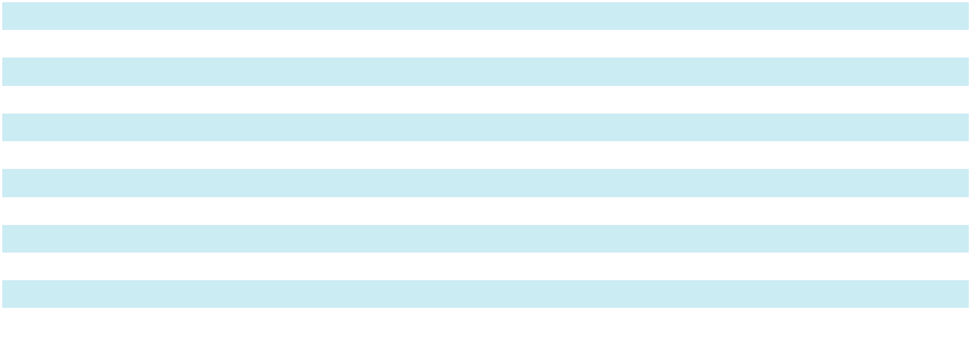

In addition to our primary insurance companies, we also own Skyward Re, a wholly-owned captive reinsurance company domiciled in the Cayman Islands that was incorporated on January 7, 2020. Skyward Re was established to facilitate the LPT which was commuted effective January 31, 2025. We also operate three non-insurance companies: Skyward Underwriters Agency, Inc., a licensed agent, managing general agent and reinsurance broker, Skyward Service Company, which provides various administrative services to our subsidiaries and Skyward Specialty No. 1 Limited Company, a UK company which is an authorized Lloyd’s corporate member.

18

Our organizational structure at December 31, 2025 is set forth below. Each entity is wholly-owned by its immediate parent:

SKYWARD SPECIALTY INSURANCE GROUP, INC.

(Delaware corporation)

SKYWARD SERVICE |  |  | GREAT MIDWEST |  |  |  | SKYWARD |  |  | SKYWARD SPECIALTY |  |  | SKYWARD RE
COMPANY |  |  | INSURANCE COMPANY |  |  |  | UNDERWRITERS |  |  | NO. 1 LIMITED |  |  | (Cayman Islands
(Delaware corporation) |  |  | (Texas stock insurance company) |  |  |  | AGENCY, INC. |  |  | (United Kingdom company) |  |  | corporation)
 |  |  |  |  |  |  | (Texas corporation)
 |  |  | HOUSTON SPECIALTY
 |  |  | INSURANCE COMPANY
 |  |  | (Texas stock insurance company)



IMPERIUM

INSURANCE COMPANY

(Texas stock insurance company)

OKLAHOMA SPECIALTY

INSURANCE COMPANY

(Oklahoma insurance corporation)

Ratings

Our insurance group, Skyward Specialty Insurance Group, Inc. currently has a rating of “A” (Excellent) with stable outlook from A.M. Best, which rates insurance companies based on factors of concern to policyholders. A.M. Best currently assigns 13 ratings to insurance companies, which currently range from “A++” (Superior) to “D” (Poor). The “A” (Excellent) rating is the third highest rating. In evaluating a company’s financial and operating performance, A.M. Best reviews a company’s profitability, leverage, and liquidity, as well as its book of business, the adequacy and soundness of its reinsurance, the quality and estimated market value of its assets, the adequacy of its losses and loss expense reserves, the adequacy of its surplus, its capital structure, the experience and competence of its management and its market presence. A.M. Best’s ratings reflect its opinion of an insurance company’s financial strength, operating performance, and ability to meet its obligations to policyholders. These ratings are based on factors relevant to policyholders, agents, insurance brokers and intermediaries and are not specifically related to securities issued by the company.

Regulation

Insurance Regulation

We are regulated by insurance regulatory authorities in the states in which we conduct business. State insurance laws and regulations generally are designed to protect the interests of policyholders, consumers and claimants rather than stockholders or other investors. The nature and extent of state regulation varies by jurisdiction, and state insurance regulators generally have broad administrative power relating to, among other matters, setting capital and surplus requirements, licensing of insurers and insurance producers, review and approval of product forms and rates, establishing standards for reserve adequacy, prescribing statutory accounting methods and the form and content of statutory financial reports, regulating certain transactions with affiliates and prescribing types and amounts of investments.

Regulation of insurance companies constantly changes as governmental agencies and legislatures react to real or perceived issues. In recent years, some state legislatures have considered or enacted laws that alter and, in many cases, increase, state authority to regulate insurance companies and insurance holding company systems, as a protection against federal involvement. Further, the National Association of Insurance Commissioners (“NAIC”) and some state insurance regulators are re-examining existing laws and regulations specifically focusing on issues relating to the solvency of insurance companies, interpretations of existing laws and the development of new laws. In addition, although the federal

19

government does not directly regulate the business of insurance, federal initiatives often affect the insurance industry in a variety of ways, such as treatment of federal subsidiaries, regulations of quasi-governmental entities and regulations issued by federal governmental departments.

Insurance Holding Company Regulation

We operate as an insurance holding company system and are subject to the insurance holding company laws of the State of Texas, the state in which our primary insurance companies are domiciled, as well as those of Oklahoma. These statutes require that each insurance company in the system register with the insurance department of its state of domicile and furnish information concerning the operations of companies within the holding company system that may materially affect the operations, management or financial condition of the insurers within the system and domiciled in that state. These statutes also provide that all transactions among members of a holding company system must be fair and reasonable. Transactions between insurance subsidiaries and their parents and affiliates generally must be disclosed to the state regulators, and notice to or prior approval of the applicable state insurance regulator generally is required for any material or extraordinary transaction.

Intellectual Property

We have applied for various trademark registrations in the United States at both federal and state levels. We will pursue additional trademark registrations and other intellectual property protection to the extent we believe it would be beneficial and cost effective.

In addition, we monitor our trademarks and service marks and protect them from unauthorized use as necessary. Employees and Human Capital
As of December 31, 2025, we had approximately 611 employees. Our employees are not subject to any collective bargaining agreement, and we are not aware of any current efforts to implement such an agreement. We believe we have good working relations with our employees. We aim to be an employer of choice, and not just for insurance. As such, we strive to create a culture committed to fostering a rich diversity of thought, background and perspective.

We strive to cultivate an exceptional workforce to perpetuate our ownership culture and continue to achieve superior business results. Our goal is to attract, develop and retain the best talent from diverse backgrounds, while promoting a culture where different viewpoints are valued and individuals feel respected, are treated fairly and have an opportunity to excel in their chosen careers.

Compensation and Benefits

We offer and maintain a competitive benefits package designed to support the well-being of our employees, including, but not limited to, medical, dental and vision insurance, a 401(k) plan, paid time off, family leave, employee assistance programs as well as an employee stock purchase plan available to all employees. We also emphasize the training and development of our employees and provide opportunities to further their education and professional development. We know that we cannot win at our business unless we first win with our people.

Item 1A. Risk Factors

Investing in our common stock involves a high degree of risk. You should carefully consider the risks and uncertainties described below, together with all of the other information in this report, including our consolidated financial statements and related notes, as well as in our other filings with the SEC, in evaluating our business and before investing in our common stock. The risks and uncertainties described below are not the only ones we face. Additional risks and uncertainties that are not expressly stated, that we are unaware of, or that we currently believe are not material, may also become important factors that affect us. If any of the following risks occur, our business, operating results, financial condition and prospects could be materially harmed. In that event, the price of our common stock could decline, and you could lose part or all of your investment.

Summary of Material Risk Factors

Our business is subject to numerous risks and uncertainties of which you should be aware. Among others, these risks relate to:

- our financial condition and results of operations could be materially adversely affected if we do not accurately assess our underwriting risk;

- competition for business in our industry is intense;

20

- because our business depends on insurance retail agents and brokers, wholesalers and program administrators, we are exposed to certain risks arising out of our reliance on these distribution channels that could adversely affect our results;

- we may be unable to purchase third-party reinsurance in amounts we desire on commercially acceptable terms or on terms that adequately protect us, and this inability may materially adversely affect our business, financial condition and results of operations;

- our losses and loss expense reserves may be inadequate to cover our actual losses, which could have a material adverse effect on our financial condition, results of operations and cash flows;

- a decline in our financial strength rating may adversely affect the amount of business we write;

- unexpected changes in the interpretation of our coverage or provisions, including loss limitations and exclusions, in our policies could have a material adverse effect on our financial condition and results of operations;

- our reinsurers may not reimburse us for claims on a timely basis, or at all, which may materially adversely affect our business, financial condition and results of operations;

- our failure to accurately and timely pay claims could materially and adversely affect our business, financial condition, results of operations, and prospects;

- adverse economic factors, including recession, inflation, periods of high unemployment or lower economic activity could result in the sale of fewer policies than expected or an increase in the frequency of claims and premium defaults, and even the falsification of claims, or a combination of these effects, which, in turn, could affect our growth and profitability;

- the insurance business is historically cyclical in nature, which may affect our financial performance and cause our operating results to vary from quarter to quarter and may not be indicative of future performance;

- we are subject to extensive regulation, which may adversely affect our ability to achieve our business objectives; failure to comply with these regulations could subject us to penalties, including fines and suspensions, which may adversely affect our financial condition and results of operations;

- we could be adversely affected by the loss of one or more key personnel or by an inability to attract and retain qualified personnel;

- if we fail to achieve and maintain effective internal controls, our operating results and financial condition could be impacted and the market price of our common stock may be negatively affected;

- our costs will increase significantly as a result of operating as a public company, and our management will be required to devote substantial time to complying with public company regulations.

- our use of derivatives to mitigate exposure to market price volatility may subject us to risks such as hedge ineffectiveness, basis risk, collateral and margin call liquidity pressures, and valuation uncertainty inherent in futures and options markets, any of which could adversely affect our financial condition; and

- the integration of Apollo may present unforeseen challenges, including potential difficulties in integrating technology systems, business processes, and risk management frameworks, which could result in operational disruptions, increased costs, or delays in realizing anticipated strategic benefits from the acquisition.

Risks Related to Our Business and Industry

Our financial condition and results of operations could be materially adversely affected if we do not accurately assess our underwriting risk.

Our underwriting success is dependent on our ability to accurately assess the risks associated with the business we write and retain. We rely on the experience of our underwriting staff in assessing those risks. If we misunderstand the nature or extent of the risks, we may fail to establish appropriate premium rates which could adversely affect our financial results. In addition, our employees, including members of management and underwriters, make decisions and choices in the ordinary course of business that involve exposing us to risk.

Competition for business in our industry is intense.

We face competition from other specialty insurance companies, standard insurance companies and underwriting agencies. In particular, competition in the insurance industry is based on many factors, including price of coverage, the general reputation and perceived financial strength of the company, relationships with distribution partners, terms and conditions of products offered, ratings assigned by independent rating agencies, speed of claims payment and reputation,

21

and the experience and reputation of the members of our underwriting team in the particular lines of insurance and reinsurance we seek to underwrite. In recent years, the insurance industry has undergone increasing consolidation, which may further increase competition. In addition, a number of new, proposed or potential industry or legislative developments could further increase competition in our industry.

We may not be able to continue to compete successfully in the insurance markets. Increased competition in these markets could result in a change in the supply and demand for insurance, affect our ability to price our products at risk-adequate rates and retain existing business, or underwrite new business on favorable terms. If this increased competition so limits our ability to transact business, our operating results could be adversely affected.

Because our business depends on insurance retail agents, brokers, wholesalers and program administrators, we are exposed to certain risks arising out of our reliance on these distribution channels that could adversely affect our results.
Substantially all of our products are ultimately distributed through independent retail agents and brokers who have the principal relationships with policyholders. Retail agents and brokers generally own the “renewal rights,” and thus our business model is dependent on our relationships with, and the success of, the retail agents and brokers with whom we do business. Further, we are also dependent on the relationships our wholesalers and program administrators maintain with the agents and brokers from whom they source their business.

Our relationship with our retail agents, brokers, wholesalers and program administrators may be discontinued at any time. Even if the relationships do continue, they may not be on terms that are profitable for us. For example, as insurance distribution firms continue to consolidate, their ability to influence commission rates may increase as may the concentration of business we have with a particular broker. Further, certain premiums from policyholders, where the business is produced by brokers, are collected directly by the brokers and remitted to us. In certain jurisdictions, when the insured pays its policy premium to its broker for payment on behalf of our insurance subsidiary, the premium might be considered to have been paid under applicable insurance laws and regulations. Accordingly, the insured would no longer be liable to us for those amounts, whether or not we have actually received the premium from that broker. Consequently, we assume a degree of credit risk associated with the brokers with which we work. Although the failure by any of our brokers to remit premiums to us has not been material to date, there may be instances where our brokers collect premiums but do not remit them to us and we may be required under applicable law to provide the coverage set forth in the policy despite the related premiums not being paid to us. Similarly, if we are limited in our ability to cancel policies for non-payment, our underwriting profits may decline and our financial condition and results of operations could be materially and adversely affected.

We review the financial condition of potential new brokers before we agree to transact business with them, and we periodically review the agencies, brokers, wholesalers and program administrators with whom we do business to identify those that do not meet our profitability standards or are not aligned with our business objectives. Following these periodic reviews, we may restrict such distributors’ access to certain types of products or terminate our relationship with them, subject to applicable contractual and regulatory requirements that limit our ability to terminate agents or require us to renew policies. Even through the utilization of these measures, we may not achieve the desired results.

Because we rely on these distributors as our sales channel, any deterioration in the relationships with our distributors or failure to provide competitive compensation could lead our distributors to place more premium with other carriers and less premium with us. In addition, we could be adversely affected if the distributors with whom we do business exceed their granted authority, fail to transfer collected premium to us or breach the obligations that they owe to us. Although we routinely monitor our distribution relationships, such actions could expose us to liability.

Also, if insurance distribution firm consolidation continues at its current pace or increases in the future, our sales channels could be materially affected in a number of ways, including loss of market access or market share in certain geographic areas. Specifically, we could be negatively affected due to loss of talent as the people most knowledgeable about our products and with whom we have developed strong working relationships exit the business following an acquisition, or increases in our commission costs as larger distributors acquire more negotiating leverage over their fees. Any such disruption that materially affects our sales channel could have a negative impact on our results of operations and financial condition.

As the speed of digitization accelerates, we are subject to risks associated with both our distributors and their ability to keep pace. In an increasingly digital world, distributors who cannot provide a digital or technology-driven experience risk losing customers who demand such an experience, and such customers may choose to utilize more technology-driven distributors.

22

We may be unable to purchase third-party reinsurance in amounts we desire on commercially acceptable terms or on terms that adequately protect us, and this inability may materially adversely affect our business, financial condition and results of operations.

We strategically purchase reinsurance from third parties which enhances our business by protecting capital from severity events (either large single event losses or catastrophes) and reducing volatility in our earnings. Reinsurance involves transferring, or ceding, a portion of our risk exposure on policies that we write to another insurer, the reinsurer, in exchange for a cost. If we are unable to renew our expiring contracts, enter into new reinsurance arrangements on acceptable terms or expand our coverage, our loss exposure could increase, which would increase our potential losses related to loss events. If we are unwilling to bear an increase in loss exposure, we may need to reduce the level of our underwriting commitments, both of which could materially adversely affect our business, financial condition and results of operations.

There are situations in which reinsurers may exclude certain coverages from, or alter terms in, the reinsurance contracts we enter into with them. As a result, we, like other insurance companies, could write insurance policies which to some extent do not have the benefit of reinsurance protection. These gaps in reinsurance protection expose us to greater risk and greater potential losses.

Our losses and loss expense reserves may be inadequate to cover our actual losses, which could have a material adverse effect on our financial condition, results of operations and cash flows.

Our success depends on our ability to accurately assess the risks related to the businesses and people that we insure. We establish losses and LAE reserves for the best estimate of the ultimate payment of all claims that have been incurred, or could be incurred in the future, and the related costs of adjusting those claims, as of the date of our financial statements. Reserves do not represent an exact calculation of liability. Rather, reserves represent an estimate of what we expect the ultimate settlement and administration of claims will cost us, and our ultimate liability may be greater or less than our estimate.

As part of the reserving process, we review historical data and consider the impact of such factors as:

- claims inflation, which is the sustained increase in cost of raw materials, labor, medical services and other components of claims cost;

- claims development patterns by line of business, as well as frequency and severity trends;

- pricing for our products, including the impact of hedging activities to protect against commodity price volatility;

- legislative activity;

- social and economic patterns; and

- litigation, judicial and regulatory trends.

These variables are affected by both internal and external events that could increase our exposure to losses, and we continually monitor our loss reserves using new information on reported claims and a variety of statistical techniques and modeling simulations. This process assumes that past experience, adjusted for the effects of current developments, anticipated trends and market conditions, is an appropriate basis for predicting future events. There is, however, no precise method for evaluating the impact of any specific factor on the adequacy of loss reserves, and actual results may deviate, perhaps substantially, from our reserve estimates. For instance, the following uncertainties may have an impact on the adequacy of our reserves:

- When a claim is received, it may take considerable time to appreciate fully the extent of the covered loss suffered by the insured and, consequently, estimates of loss associated with specific claims can increase over time. Consequently, estimates of loss associated with specified claims can change as new information emerges, which could cause the reserves for the claim to become inadequate.

- New theories of liability are enforced retroactively from time to time by courts. The failure of any of the loss limitations or exclusions we employ, or changes in other claims or coverage issues, could have a material adverse effect on our financial condition or results of operations.

- Volatility in the financial markets, economic events and other external factors may result in an increase in the number of claims and/or severity of the claims reported. In addition, elevated inflationary conditions would, among other things, cause loss costs to increase. Adverse economic factors, including recession, inflation, periods of high unemployment or lower economic activity could result in the sale of fewer policies than expected or an increase in frequency or severity of claims and premium defaults or both, which, in turn, could affect our growth and profitability.

23

- Increased cost due to “social inflation,” including continued increase of medical and material costs, more costly technology in vehicles, supply chain disruptions, more involvement of attorneys in claims matters, third-party financing of litigation, lawsuit abuse and other factors, all of which could increase the frequency and severity of claims and affect the adequacy of our loss reserves.

- If claims were to become more frequent, even if we had no liability for those claims, the cost of evaluating and handling such potential claims could escalate beyond the amount of the reserves we have established. As we enter new lines of business, or as a result of new theories of claims, we may encounter an increase in claims frequency and greater claims handling costs than we had anticipated.

If any of our reserves should prove to be inadequate, we will be required to increase our reserves resulting in a reduction in our net income and stockholders’ equity in the period in which the deficiency is identified.

Future loss experience substantially in excess of established reserves could also have a material adverse effect on our future earnings and liquidity and our financial rating.

A decline in our financial strength rating may adversely affect the amount of business we write.

Participants in the insurance industry use ratings from independent ratings agencies, such as A.M. Best, as an important means of assessing the financial strength and quality of insurers. In setting its ratings, A.M. Best performs quantitative and qualitative analysis of a company’s balance sheet strength, operating performance and business profile. A.M. Best financial strength ratings range from “A++” (Superior) to “F” for insurance companies that have been publicly placed in liquidation. As of the date of this filing, A.M. Best has assigned a financial strength rating of “A” (Excellent) with stable outlook to us. A.M. Best assigns ratings that are intended to provide an independent opinion of an insurance company’s ability to meet its obligations to policyholders and is not an evaluation directed to investors and is not a recommendation to buy, sell or hold our common stock or any other securities we may issue. A.M. Best’s analysis includes comparisons to peers and industry standards as well as assessments of operating plans, philosophy and management. A.M. Best periodically reviews our financial strength rating and may revise it downward at its discretion based primarily on its analyses of our balance sheet strength, operating performance and business profile. There are specific building blocks A.M. Best reviews, including capital adequacy, operating performance, operating profile and ERM, as well as other factors that could affect its analyses such as:

- if we change our business practices from our organizational business plan in a manner that no longer supports A.M. Best’s rating;

- if unfavorable financial, regulatory or market trends affect us, including excess market capacity;

- if our losses exceed our loss reserves;

- if we have unresolved issues with government regulators;

- if we are unable to retain our senior management or other key personnel;

- if our investment portfolio incurs significant losses or our liquidity is limited; or

- if A.M. Best alters its capital adequacy assessment methodology in a manner that would adversely affect our rating.

These and other factors could result in a downgrade of our financial strength rating. A downgrade or withdrawal of our rating could result in any of the following consequences, among others:

- causing our current and future distribution partners and insureds to choose other, more highly-rated competitors;

- increasing the cost or reducing the availability of reinsurance to us; or

- severely limiting or preventing us from writing new and renewal insurance contracts.

In addition, in view of the earnings and capital pressures experienced by many financial institutions, including insurance companies, it is possible that rating organizations will heighten the level of scrutiny that they apply to such institutions, will increase the frequency and scope of their credit reviews, will request additional information from the companies that they rate or will increase the capital and other requirements employed in the rating organizations’ models for maintenance of certain ratings levels. We can offer no assurance that our rating will remain at its current level. It is possible that such reviews of us may result in adverse ratings consequences, which could have a material adverse effect on our financial condition and results of operations.

24

Unexpected changes in the interpretation of our coverage or provisions, including loss limitations and exclusions, in our policies could have a material adverse effect on our financial condition and results of operations.

There can be no assurances that loss limitations or exclusions in our policies will be enforceable in the manner we intend. As industry practices and legal, judicial, social, and other conditions change, unexpected and unintended issues related to claims and coverage may emerge. For example, many of our policies limit the period during which a policyholder may bring a claim, which may be shorter than the statutory period under which such claims can be brought against our policyholders. While these limitations and exclusions help us assess and mitigate our loss exposure, it is possible that a court or regulatory authority could nullify or void a limitation or exclusion or legislation could be enacted modifying or barring the use of such limitations or exclusions. These types of governmental actions could result in higher than anticipated losses and LAE, which could have a material adverse effect on our financial condition or results of operations. In addition, court decisions, such as the 1995 Montrose decision in California could read policy exclusions narrowly so as to expand coverage, thereby requiring insurers to create and write new exclusions.

These issues may adversely affect our business by either broadening coverage beyond our underwriting intent or by increasing the frequency or severity of claims. In some instances, these changes may not become apparent until sometime after we have issued insurance contracts that are affected by the changes. As a result, the full extent of liability under our insurance contracts may not be known for many years after a contract is issued.

Our reinsurers may not reimburse us for claims on a timely basis, or at all, which may materially adversely affect our business, financial condition and results of operations.

The reinsurance contracts that we enter into to help manage our risks require us to pay premiums to the reinsurance carriers who will in turn reimburse us for a portion of covered policy claims. In many cases, a reinsurer will be called upon to reimburse us for policy claims many years after we paid insurance premiums to the insurer. Although reinsurance makes the reinsurer liable to us to the extent the risk is transferred or ceded to the reinsurer, it does not relieve us (the ceding insurer) of our primary liability to our policyholders. Our current reinsurance program is designed to limit our financial risk. However, our reinsurers may not pay claims we incur on a timely basis, or they may not pay some or all of these claims. For example, reinsurers may default in their financial obligations to us as the result of insolvency, lack of liquidity, operational failure, political and/or regulatory prohibitions, fraud, asserted defenses based on agreement wordings or the principle of utmost good faith, asserted deficiencies in the documentation of agreements or other reasons. Any disputes with reinsurers regarding coverage under reinsurance contracts could be time consuming, costly, and uncertain of success. These risks could cause us to incur increased net losses, and, therefore, adversely affect our financial condition. As of December 31, 2025, we had $1,119.9 million of reinsurance recoverables.

Our failure to accurately and timely pay claims could materially and adversely affect our business, financial condition, results of operations, and prospects.

We must accurately and timely evaluate and pay claims that are made under our policies. Many factors affect our ability to pay claims accurately and timely, including the training and experience of our claims representatives, including our TPAs, the effectiveness of our management, and our ability to develop or select and implement appropriate procedures and systems to support our claims functions and other factors. Our failure to pay claims accurately and timely could lead to regulatory and administrative actions or material litigation, undermine our reputation in the marketplace and materially and adversely affect our business, financial condition, results of operations, and prospects.

In addition, if we do not manage our TPAs effectively, or if our internal staff or TPAs are unable to effectively handle our volume of claims, our ability to handle an increasing workload could be adversely affected. In addition to potentially requiring that growth be slowed in the affected markets, our business could suffer from decreased quality of claims work which, in turn, could adversely affect our operating margins.

Severe weather conditions, including the effects of climate change, catastrophes, pandemic, as well as man-made events may adversely affect our business, results of operations and financial condition.

Our business is exposed to the risk of severe weather conditions, earthquakes and man-made catastrophes. Catastrophes can be caused by various events, including natural events such as severe winter weather, severe convective storms/tornadoes, windstorms, earthquakes, hailstorms, severe thunderstorms and fires, or man-made events such as explosions, war, terrorist attacks and riots. Over the past several years, changing weather patterns and climatic conditions, such as global warming, have added to the unpredictability and frequency of natural disasters in certain parts of the world, including in areas that have not historically been exposed to natural disasters and in the markets in which we operate. Climate change may increase the frequency and severity of extreme weather events. This effect has led to conditions in the ocean and atmosphere, including warmer-than-average sea-surface temperatures and low wind shear that increase hurricane activity, as well as drought conditions that increase wildfire risks. The occurrence of a natural disaster or other catastrophe loss could materially adversely affect our business, financial condition, and results of operations. This may include

25

catastrophes even where we do not insure against the loss, such as the 2025 California wildfires, as homes and businesses lost or damaged due to catastrophe may otherwise cancel our policies following such event. Additionally, any increased frequency and severity of such weather events, including hurricanes or convective storms (which are difficult to model with current tools), could have a material adverse effect on our ability to predict, quantify, reinsure and manage catastrophe risk and may materially increase our losses resulting from such catastrophe events.

The extent of losses from catastrophes is a function of both the frequency and severity of the insured events and the total amount of insured exposure in the areas affected. The incidence and severity of catastrophes and severe weather conditions are inherently unpredictable. We manage our exposure to losses by analyzing the probability and severity of the occurrence of loss events and the impact of such events on our overall underwriting and investment portfolio. However, we may be impacted indirectly in instances where businesses we insure are impacted by catastrophes that we have no direct exposure to but as a result they are unable or unwilling to continue paying premiums on our other product offerings. In addition, our inability to obtain reinsurance coverage at reasonable rates and in amounts adequate to mitigate the risks associated with severe weather conditions and other catastrophes could have a material adverse effect on our business and results of operations.

Our business is also exposed to the risk of pandemics, outbreaks, public health crises, and geopolitical and social events, and their related effects. While policy terms and conditions in the lines of business written by us would be expected to preclude coverage for virus-related claims, court decisions and governmental actions may challenge the validity of any exclusions or our interpretation of how such terms and conditions operate.

Additionally, changes in domestic and international programs and initiatives with respect to climate policy as well as federal, state, and local legislation and regulation based on concerns about climate change cannot be predicted but could have a material adverse effect on our business, operational results and financial results.

Because we provide our program administrators with specific quoting and binding authority, if any of them fail to comply with pre-established guidelines, our results of operations could be adversely affected.

We market and distribute certain of our insurance products through program administrators that have limited quoting and binding authority, and they in turn, sell our insurance products to insureds through retail agents and brokers. These program administrators can bind certain risks without our initial approval. If any of these program administrators fail to comply with our underwriting guidelines and the terms of their appointments, we could be bound on a particular risk or number of risks that were not anticipated when we developed the insurance products or estimated losses and LAE. Such actions could adversely affect our results of operations.

If actual renewals of our existing contracts or new business from repeat insureds do not meet expectations, our written premium in future years and our future results of operations could be materially adversely affected.

Most of our contracts are written for a one-year term and are renewable. We also have certain insurance contracts which themselves do not renew, but the insureds are repeat insureds with regular new insurance contracts. In our financial forecasting process, we make assumptions about the rates of renewal of our prior year’s contracts and business from repeat insureds. The insurance and reinsurance industries have historically been cyclical businesses with intense competition, often based on price. If actual renewals and repeat business do not meet expectations or if we choose not to write renewals or accept repeat business because of pricing conditions, our written premium in future years and our future operations would be materially adversely affected.

Increased public attention to environmental, social and governance matters may expose us to negative public perception, cause reputational harm, impose additional costs on our business or impact our stock price.

Recently, more attention is being directed towards publicly traded companies regarding environmental, social and governance (“ESG”) matters. A failure, or perceived failure, to respond to investor or customer expectations related to ESG concerns could cause harm to our business and reputation. Alternatively, there could be backlash by investors or customers relating to ESG related topics which could cause harm to our business and reputation. Damage to our reputation as a result of our provision of policies to certain insureds could result in decreased demand for our insurance products and could have a material adverse effect on our business, operational results and financial results, as well as require additional resources to rebuild our reputation, competitive position and brand strength.

Changes in accounting practices and future pronouncements may materially affect our reported financial results.

Developments in accounting practices may require us to incur considerable additional expenses to comply, particularly if we are required to prepare information relating to prior periods for comparative purposes or to apply the new requirements retroactively. The impact of changes in current accounting practices and future pronouncements cannot be predicted but may affect the calculation of net income, shareholder’s equity and other relevant financial statement line items.

26

Our insurance subsidiaries are required to comply with statutory accounting principles, or SAP. SAP and various components of SAP are subject to constant review by the NAIC and its task forces and committees, as well as state insurance departments, in an effort to address emerging issues and otherwise improve financial reporting. Various proposals are pending before committees and task forces of the NAIC, some of which, if enacted and adopted on a state level, could have negative effects on insurance industry participants. The NAIC continuously examines existing laws and regulations. We cannot predict whether or in what form such reforms will be enacted and, if so, whether the enacted reforms will positively or negatively affect us.

Our use of derivatives to mitigate exposure to market price volatility may subject us to risks such as hedge ineffectiveness, basis risk, collateral and margin call liquidity pressures, and valuation uncertainty inherent in futures and options markets, any of which could adversely affect our financial condition.

Our use of derivatives to mitigate exposure to market price volatility subjects us to risks that could adversely affect our financial condition and results of operations. These risks include hedge ineffectiveness due to imperfect correlation between derivatives and the underlying exposures, a recognized limitation in commodity market hedge theory; basis risk, where futures prices do not move in line with cash market prices relevant to our business; and liquidity pressures arising from margin call or collateral requirements associated with futures positions during adverse market movements. Additionally, reliance on market based models introduces valuation uncertainty that may cause hedges to perform differently than expected. Together, these factors may prevent our hedging strategies from effectively reducing volatility and could materially adversely impact our financial results.

Risks Related to the Market and Economic Conditions

Adverse economic factors, including recession, inflation, periods of high unemployment or lower economic activity could result in the sale of fewer policies than expected or an increase in the frequency of claims and premium defaults, and even the falsification of claims, or a combination of these effects, which, in turn, could affect our growth and profitability.

Factors, such as business revenue, economic conditions, the volatility and strength of the capital markets, and inflation can affect the business and economic environment. These same factors affect our ability to generate revenue and profits. In an economic downturn that is characterized by higher unemployment, declining spending, and reduced corporate revenue, the demand for insurance products is generally adversely affected, which directly affects our premium levels and profitability. Negative economic factors may also affect our ability to receive the appropriate rate for the risk we insure with our policyholders and may adversely affect the number of policies we can write, and our opportunities to underwrite profitable business. In an economic downturn, our customers may have less need for insurance coverage, cancel existing insurance policies, modify their coverage or not renew the policies they hold with us. Existing policyholders may exaggerate or even falsify claims to obtain higher claims payments. In addition, if certain segments of the economy, such as the construction, credit markets or energy production and servicing segments (which would affect several of our underwriting divisions at one time) were to significantly collapse, it could adversely affect our results. These outcomes would reduce our underwriting profit to the extent these factors are not reflected in the rates we charge.

The insurance business is historically cyclical in nature, which may affect our financial performance and cause our operating results to vary from quarter to quarter and may not be indicative of future performance.

Historically, insurance carriers have experienced significant fluctuations in operating results due to competition, frequency and severity of catastrophic events, levels of capacity, adverse litigation trends, regulatory constraints, general economic conditions, and other factors. The supply of insurance is related to prevailing prices, the level of insured losses and the level of capital available to the industry that, in turn, may fluctuate in response to changes in rates of return on investments being earned in the insurance industry. As a result, the insurance business historically has been a cyclical industry characterized by periods of intense price competition due to excessive underwriting capacity (soft market cycle) as well as periods when shortages of capacity increased premium levels (hard market cycle). Demand for insurance depends on numerous factors, including the frequency and severity of catastrophic events, levels of capacity, the introduction of new capital providers and general economic conditions. All of these factors fluctuate and may contribute to price declines generally in the insurance industry.

Although an individual insurance company’s financial performance depends on its own specific business characteristics, the profitability of most P&C insurance companies tends to follow this cyclical market pattern with higher gross written premium growth and improved profitability during hard market cycles. Further, this cyclical market pattern can be more pronounced in the E&S market than in the standard insurance market. When the standard insurance market hardens, the E&S market typically hardens, and growth in the E&S market can be significantly more rapid than growth in the standard insurance market. Similarly, when conditions begin to soften, many customers that were previously driven into the E&S market may return to the admitted market, exacerbating the effects of rate decreases on our financial results.

27

Finally, the market may experience “micro cycles” where certain areas of the market harden or soften independently of the market as a whole, and perhaps at a more drastic rate. As a result, our operating results are subject to fluctuation and have historically varied from quarter to quarter. We expect our quarterly results will continue to fluctuate in the future due to a number of factors, including the general economic conditions in the markets where we operate, the frequency of occurrence or severity of catastrophe or other insured events, fluctuating interest rates, claims exceeding our loss reserves, competition in our industry, deviations from expected premium retention rates of our existing policies and contracts, adverse investment performance, and the cost of reinsurance coverage.

Performance of our investment portfolio is subject to a variety of investment risks that may adversely affect our financial results.

Our results of operations depend, in part, on the performance of our investment portfolio. We seek to hold a diversified portfolio of investments that is managed by professional investment advisory management firms in accordance with our investment policy and routinely reviewed by our Investment Committee. However, our investments are subject to general economic conditions and market risks as well as risks inherent to specific securities. Our primary market risk exposures are to changes in interest rates and equity prices. See the section entitled “Management’s Discussion and Analysis of Financial Condition and Results of Operations - Investments - Market Risk.”

A significant amount of our investment portfolio is invested in fixed maturity securities, or separately managed accounts and limited partnerships invested primarily in fixed maturity securities. Interest rates rose materially during 2022 and 2023. Should interest rates decline, including as a result of steps taken by the federal government to slow inflation, such as the recent rate cuts and the passage of the Inflation Reduction Act of 2022, a low interest rate environment would place pressure on our net investment income, particularly as it relates to these securities and short-term investments, which, in turn, may adversely affect our operating results. Recent and future increases in interest rates could cause the values of our fixed income securities portfolios to decline, with the magnitude of the decline depending on the duration of securities included in our portfolio and the amount by which interest rates increase. Some fixed income securities have call or prepayment options, which create possible reinvestment risk in declining rate environments. Other fixed income securities, such as mortgage-backed and other asset-backed securities, carry prepayment risk or, in a rising interest rate environment, may not prepay as quickly as expected.

All of our fixed maturity securities, including those held in separately managed accounts and limited partnerships, are subject to credit risk. Credit risk is the risk that certain investments may default or become impaired due to deterioration in the financial condition of one or more issuers of the securities we hold, or due to deterioration in the financial condition of an insurer that guarantees an issuer’s payments on such investments. Downgrades in the credit ratings of fixed maturity securities (where rated) could also have a significant negative effect on the market valuation of such securities.

We also invest in marketable preferred and common equity securities and exchange traded funds. These securities are carried on the balance sheet at fair market value and are subject to potential losses and declines in market value.

The above market and credit risks could reduce our net investment income and result in realized investment losses. Our investment portfolio is subject to increased valuation uncertainties when investment markets are illiquid, as is the case with our fixed maturity securities held to maturity, separately managed accounts, and limited partnership investments. The valuation of investments is more subjective when markets are illiquid, thereby increasing the risk that the estimated fair value (i.e., the carrying amount) of the securities we hold in our portfolio do not reflect prices at which actual transactions would occur.

Risks for all types of securities are managed through the application of our investment policy, which establishes investment parameters that include but are not limited to, maximum percentages of investment in certain types of securities and minimum levels of credit quality, which we believe are within applicable guidelines established by the NAIC, the Texas Department of Insurance, and the Oklahoma Department of Insurance. In addition, our Investment Committee periodically reviews our Enterprise Based Asset Allocation models to assist in overall risk management.

Although we seek to preserve our capital, we cannot be certain that our investment objectives will be achieved, and results may vary substantially over time. In addition, although we seek to employ investment strategies that are not correlated with our insurance and reinsurance exposures, losses in our investment portfolio may occur at the same time as underwriting losses and, therefore, exacerbate the adverse effect of the losses on us.

We could be forced to sell investments to meet our liquidity requirements.

We invest the premiums we receive from our insureds until they are needed to pay policyholder claims. Consequently, we seek to manage the duration of our investment portfolio based on the duration of our losses and LAE reserves to provide sufficient liquidity and avoid having to liquidate investments to fund claims. Risks such as inadequate losses and LAE reserves or unfavorable trends in litigation could potentially result in the need to sell investments to fund these

28

liabilities. We may not be able to sell our investments at favorable prices or at all. Sales could result in significant realized losses depending on the conditions of the general market, interest rates and credit issues with individual securities.

Risks Related to the Regulatory Environment

We are subject to extensive regulation, which may adversely affect our ability to achieve our business objectives. In addition, if we fail to comply with these regulations, we may be subject to penalties, including fines and suspensions, which may adversely affect our financial condition and results of operations.

Our primary insurance subsidiaries, GMIC, HSIC and IIC, are subject to extensive regulation in Texas, their state of domicile, and to a lesser degree, the other states in which they operate. Most insurance regulations are designed to protect the interests of insurance policyholders, as opposed to the interests of investors or stockholders. These regulations generally are administered by a department of insurance in each state and relate to, among other things, capital and surplus requirements, investment and underwriting limitations, affiliate transactions, dividend limitations, changes in control, solvency and a variety of other financial and non-financial aspects of our business. Significant changes in these laws and regulations could further limit our discretion or make it more expensive to conduct our business. State insurance regulators also conduct periodic examinations of the affairs of insurance and reinsurance companies and require the filing of annual and other reports relating to financial condition, holding company issues and other matters. These regulatory requirements may impose timing and expense constraints that could adversely affect our ability to achieve some or all of our business objectives.

Our insurance subsidiaries are part of an “insurance holding company system” within the meaning of applicable Texas statutes and regulations. As a result of such status, certain transactions between our insurance subsidiaries and one or more of their affiliates may not be affected unless the insurer has provided notice of that transaction to the Texas Department of Insurance. These prior notification requirements may result in business delays and additional business expenses. If our insurance subsidiaries fail to file a required notification or fail to comply with other applicable insurance regulations in Texas, we may be subject to significant fines and penalties and our working relationship with the Texas Department of Insurance may be impaired.

In addition, state insurance regulators have broad discretion to deny or revoke licenses for various reasons, including the violation of regulations. In some instances, where there is uncertainty as to applicability, we follow practices based on our interpretations of regulations or practices that we believe generally to be followed by the industry. These practices may turn out to be different from the interpretations of regulatory authorities. If we do not have the requisite licenses and approvals or do not comply with applicable regulatory requirements, state insurance regulators could preclude or temporarily suspend us from carrying on some or all of our activities in their state or could otherwise penalize us. This could adversely affect our ability to operate our business. Further, changes in the level of regulation of the insurance industry or changes in laws or regulations themselves or interpretations by regulatory authorities could interfere with our operations and require us to bear additional costs of compliance, which could adversely affect our ability to operate our business.

Our insurance subsidiaries are subject to risk-based capital requirements, based upon the “risk based capital model” adopted by the NAIC, and other minimum capital and surplus restrictions imposed under Texas law. These requirements establish the minimum amount of risk-based capital necessary for a company to support its overall business operations. It identifies property and casualty insurers that may be inadequately capitalized by looking at certain inherent risks of each insurer’s assets and liabilities and its mix of net written premium. Insurers falling below a calculated threshold may be subject to varying degrees of regulatory action, including supervision, rehabilitation or liquidation. Failure to maintain our risk-based capital at the required levels could adversely affect the ability of our insurance subsidiary to maintain regulatory authority to conduct our business and our A.M. Best Rating.

We may become subject to additional government or market regulation, which may have a material adverse impact on our business.

Our business could be adversely affected by changes in laws, including those relating to asset and reserve valuation requirements, surplus requirements, limitations on investments and dividends, enterprise risk and risk-based capital requirements. The U.S. federal government generally has not directly regulated the insurance industry except for certain areas of the market, such as insurance for flood, nuclear and terrorism risks, but could consider legislation in several areas that may affect the insurance industry, including privatization of government entities such as Freddie Mac or Fannie Mae, reduction in federal subsidiaries for certain businesses, such as agriculture, tort reform, corporate governance and the taxation of reinsurance companies.

29

Changes to the U.S. tax laws and implementation of new tax policies could have a significant negative impact on the overall economy and our business.

Legislative or other actions relating to taxes could have a negative effect on us, our investments, or our stockholders. The rules dealing with U.S. federal income taxation are constantly under review by persons involved in the legislative process and by the IRS and the U.S. Department of the Treasury. We cannot predict with certainty how any changes in the tax laws might affect us, our stockholders, or our portfolio investments. New legislation and any U.S. Treasury regulations, administrative interpretations or court decisions interpreting such legislation could have other adverse consequences. Stockholders are urged to consult with their tax advisors regarding tax legislative, regulatory, or administrative developments and proposals and their potential effect on an investment in our securities.

For example, on July 4, 2025, H.R. 1, the “One Big Beautiful Bill Act” (the “OBBBA”) was signed into law in the United States. Among other changes, the OBBBA modifies key business tax provisions, including the restoration of 100% bonus depreciation under Section 168(k) of the United States Internal Revenue Code of 1986, as amended (the “IRC”), the restoration of the immediate deduction of U.S. domestic research and experimental expenditures under Section 174A of the IRC, the restoration of the EBITDA-based business interest expense limitation under Section 163(j) of the IRC, and changes to the computation of taxes related to international operations. Based on our current analysis of these provisions, we do not believe these provisions will have a material impact on our business and our results of operations. However, regulations and other U.S. Internal Revenue Service guidance implementing the OBBBA may give rise to new issues that we did not foresee, and further changes to tax laws may be implemented. Therefore, there can be no assurance that our business will not be adversely affected by the OBBBA or any other tax law changes.

Our ability to utilize our net operating loss carryforwards and certain other tax attributes may be limited.

As of December 31, 2025, we had gross federal income tax net operating losses, or NOLs, of approximately $40.3 million available to offset our future taxable income, if any, prior to consideration of annual limitations that may be imposed under Section 382 of the Internal Revenue Code of 1986, as amended, or the Code, or otherwise. These NOLs are set to expire beginning in 2032.

Under Section 382 of the Code, if a corporation undergoes an “ownership change” (very generally defined as a greater than 50% change, by value, in the corporation’s equity ownership by certain stockholders or groups of stockholders over a rolling three-year period), the corporation’s ability to use its pre-ownership change NOLs to offset its post-ownership change income may be limited. We may experience ownership changes in the future as a result of subsequent shifts in our stock ownership, some of which may be outside of our control. Future regulatory changes could also limit our ability to utilize our NOLs. To the extent we are not able to offset future taxable income with our NOLs, our net income and cash flows may be adversely affected.

Because we are a holding company and substantially all of our operations are conducted by our insurance subsidiaries, our ability to achieve liquidity at the holding company, including the ability to pay dividends and service our debt obligations, depends on our ability to obtain cash dividends or other permitted payments from our insurance subsidiaries.

The continued operation and growth of our business will require substantial capital. Accordingly, we do not intend to declare and pay cash dividends on shares of our common stock in the foreseeable future. Because we are a holding company with no business operations of our own, our ability to pay dividends to stockholders and meet our debt payment obligations largely depends on dividends and other distributions from our primary insurance subsidiaries, GMIC, HSIC, and IIC. State insurance laws, including the laws of Texas restrict the ability of GMIC, HSIC, and IIC to determine how we declare stockholder dividends. State insurance regulators require insurance companies to maintain specified levels of statutory capital and surplus. Dividend payments are further limited to that part of available policyholder surplus that is derived from net profits on our business. State insurance regulators have broad powers to prevent the reduction of statutory surplus to inadequate levels, and there is no assurance that dividends up to the maximum amounts calculated under any applicable formula would be permitted. Moreover, state insurance regulators that have jurisdiction over the payment of dividends by our insurance subsidiaries may in the future adopt statutory provisions more restrictive than those currently in effect.

Any determination to pay dividends in the future will be at the discretion of our Board of Directors and will depend upon results of operations, financial condition, contractual restrictions pursuant to our debt agreements, our indebtedness, restrictions imposed by applicable law and other factors our Board of Directors deems relevant. Consequently, investors may need to sell all or part of their holdings of our common stock after price appreciation, which may never occur, as the only way to realize any future gains on their investment. Investors seeking immediate cash dividends should not purchase our common stock.

30

Applicable insurance laws may make it difficult to effect a change of control.

Under applicable Texas insurance laws and regulations, no person may acquire control of a domestic insurer until written approval is obtained from the state insurance commissioner on the proposed acquisition. Such approval would be contingent upon the state insurance commissioner’s consideration of a number of factors including, among others, the financial strength of the proposed acquirer, the acquirer’s plans for the future operations of the domestic insurer and any anti-competitive results that may arise from the consummation of the acquisition of control. Texas insurance laws and regulations pertaining to changes of control apply to both the direct and indirect acquisition of ten percent or more of the voting stock of a Texas-domiciled insurer. Accordingly, the acquisition of ten percent or more of our common stock would be considered an indirect change of control of Skyward Specialty and would trigger the applicable change of control filing requirements under Texas insurance laws and regulations, absent a disclaimer of control filing and its acceptance by the Texas Insurance Department. These requirements may discourage potential acquisition proposals and may delay, deter or prevent a change of control of Skyward Specialty, including through transactions that some or all of the stockholders of Skyward Specialty might consider to be desirable.

Risks Related to Our Liquidity and Access to Capital

We may require additional capital in the future, which may not be available or may only be available on unfavorable terms.

Our future capital requirements depend on many factors, including our ability to write new business successfully and to establish premium rates and reserves at levels sufficient to cover losses. To the extent that cash flows generated by our operations are insufficient to fund future operating requirements and cover claim losses, or that our capital position is adversely impacted by a decline in the fair value of our investment portfolio, losses from catastrophe events, adverse reserve development or otherwise, we may need to raise additional funds through financings or curtail our growth. Many factors will affect the amount and timing of our capital needs, including our growth rate and profitability, our claims experience, and the availability of reinsurance, market disruptions, and other unforeseeable developments. If we need to raise additional capital, equity or debt financing may not be available at all or may be available only on terms that are not favorable to us. In the case of equity financings, dilution to our stockholders could result. In the case of debt financings, we may be subject to covenants that restrict our ability to freely operate our business. In any case, such securities may have rights, preferences and privileges that are senior to those of the shares of our common stock. If we cannot obtain adequate capital on favorable terms or at all, we may not have sufficient funds to implement our operating plans and our business, financial condition or results of operations could be materially adversely affected.

The availability of credit under the Revolving Credit Facility is subject to conditions that may limit our access.

Our access to credit under the Revolving Credit Facility is subject to the satisfaction of certain conditions. If we are unable to satisfy these conditions, we would be unable to borrow under the Revolving Credit Facility. The inability to borrow under the Revolving Credit Facility may adversely affect our liquidity, financial position and results of operations.

The failure to meet certain financial covenants required by our credit agreements may materially and adversely affect our assets, financial position, and cash flows.

A breach of any of the covenants under the Term Loan Facility and Revolving Credit Facility could result in an event of default under the credit agreements. Upon the occurrence of an event of default under the credit agreements, all amounts outstanding, together with accrued interest, could be declared immediately due and payable by our lenders. If this happens, our assets may not be sufficient to repay in full the payments due under the credit agreements. The current credit market environment and other macro-economic challenges affecting the global economy may adversely impact our ability to borrow sufficient funds or sell assets or equity in order to pay existing debt.

Risks Related to Our Operations

We could be adversely affected by the loss of one or more key personnel or by an inability to attract and retain qualified personnel.

We depend on our ability to attract and retain experienced and seasoned personnel who are knowledgeable about our business. The pool of talent from which we actively recruit is limited and may fluctuate based on market dynamics specific to our industry and independent of overall economic conditions. As such, higher demand for employees having the desired skills and expertise could lead to increased compensation expectations for existing and prospective personnel, making it difficult for us to retain and recruit key personnel and maintain labor costs at desired levels. Should any of our key personnel terminate their employment with us, or if we are unable to retain and attract talented personnel, we may be unable to maintain our current competitive position in the specialized markets in which we operate, which could adversely affect our results of operations.

31

Security breaches, loss of data, cyberattacks, and other information technology failures could disrupt our operations, damage our reputation, and adversely affect our business, operations, and financial results.

Our business is highly dependent upon our information technology and telecommunications systems, including our underwriting and claims systems. We rely on these systems to interact with brokers and insureds, to underwrite business, to prepare policies and process premiums, to perform actuarial and other modeling functions, to process claims and make claims payments, and to prepare internal and external financial statements. Some of these systems may include or rely on third-party systems not located on our premises or under our control. Events such as natural catastrophes, terrorist attacks, industrial accidents, computer viruses and other cyber-attacks may cause our systems to fail or be inaccessible for extended periods of time. While we have implemented business contingency plans and other reasonable plans to protect our systems, whether housed internally or through third-party cloud services, sustained or repeated system failures or service denials could severely limit our ability to write and process new and renewal business, provide customer service, pay claims in a timely manner or otherwise operate in the ordinary course of business.

Computer viruses, hackers, employee misconduct, and other external hazards could expose our systems to security breaches, cyber-attacks or other disruptions. While we have implemented security measures designed to protect against breaches of security and other interference with our systems and networks, our systems and networks may be subject to breaches or interference and we, and our third-party service providers, will likely continue to experience cybersecurity incidents of varying degrees. For instance, we experienced a data incident in which attackers acquired certain of our data. We completed our investigation and determined that the breach is immaterial in nature. At this time, there is no evidence that a nation-state actor or global hacker was involved or that there has been any misuse of this information. Any future cybersecurity events may result in operational disruptions as well as unauthorized access to, the disclosure of, or loss of our proprietary information or our customers’ data and information, which in turn may result in legal claims, regulatory scrutiny and liability, reputational damage, the incurrence of costs to eliminate or mitigate further exposure, the loss of customers or affiliated advisors, or other damage to our business. In addition, SEC and state law requirements regarding general public notification of such incidents could exacerbate the harm to our business, financial condition and results of operations. Even if we successfully protect our technology infrastructure and the confidentiality of sensitive data, we could suffer harm to our business and reputation if attempted security breaches are publicized. We cannot be certain that advances in criminal capabilities, discovery of new vulnerabilities, attempts to exploit vulnerabilities in our systems, data thefts, physical system or network break-ins or inappropriate access, or other developments will not compromise or breach the technology or other security measures protecting the networks and systems used in connection with our business.

Third parties to whom we outsource certain of our functions are also subject to these risks. While we review and assess our third-party providers’ cybersecurity controls, as appropriate, and make changes to our business processes to manage these risks, we cannot ensure that our attempts to keep systems from being compromised and confidential information from being disclosed will always be successful. Moreover, our increased use of third-party services (e.g. cloud technology and software as a service) can make it more difficult to identify and respond to cyberattacks in any of the above situations due to the dynamic nature of these technologies. These risks could increase as vendors adopt and use more cloud-based software services rather than software services which can be run within our data centers.

Artificial intelligence is an evolving and rapidly growing technology which may impact our business and operations.

The rapid growth and development of artificial intelligence and machine learning may alter the competitive landscape in which we operate. Our employees utilize artificial intelligence for risk selection, pricing and claims handling to aid in their effectiveness and efficiency and we continue to research and implement artificial intelligence-based solutions in an effort to improve our business. Notwithstanding this, our competitive position may be harmed if competitors are able to leverage artificial intelligence solutions more quickly or more effectively. In addition, while we do not rely solely on information and analysis production through artificial intelligence in our decision making, if the content, analyses or recommendations that artificial intelligence applications assist in producing are, or are alleged to be, deficient, inaccurate or biased, such as due to limitations in algorithms, insufficient or biased base data or flawed training methodologies, our business, financial condition, results of operations and reputation may be adversely affected. Further, as artificial intelligence technology and products are continuously evolving, we may incur costs to adopt and deploy technologies that could become obsolete earlier than expected. There can be no assurance that we will realize the desired or anticipated benefits from artificial intelligence.

There is also uncertainty in the legal and regulatory landscape at the federal and state levels for the use of artificial intelligence, which is not fully developed. Any laws, regulations or industry standards adopted in response to the emergence of artificial intelligence may be burdensome, could entail significant costs, and may restrict or impede our ability to successfully develop, adopt and deploy artificial intelligence technologies efficiently and effectively.

32

We may not be able to manage our growth effectively.

We intend to grow our business in the future, which could require additional capital, systems development and skilled personnel. However, we must be able to meet our capital needs, expand our systems and our internal controls effectively, allocate our human resources optimally, identify, hire, train and develop qualified employees and effectively incorporate the components of any business we may acquire in our effort to achieve growth. The failure to manage our growth effectively could have a material adverse effect on our business, financial condition and results of operations.

Further, to the extent that we grow inorganically through acquisition the success of such acquisitions is dependent upon our ability to identify appropriate targets, negotiate transactions on favorable terms, complete transactions and successfully integrate the targets into our existing business. If acquisitions are made, we may not realize the anticipated benefits of such acquisitions, including but not limited to, revenue growth, operational efficiencies or expected synergies.

We have experienced rapid growth in recent years, and our recent growth rates may not be indicative of our future growth.

We have experienced significant revenue growth in recent years. In future periods, we may not be able to sustain revenue growth consistent with recent history, or at all. We believe our revenue growth depends on a number of factors, including, but not limited to, our ability to:

- price our products effectively so that we are able to attract and retain insureds without compromising our profitability;

- successfully deploy and implement our products, obtain renewals and provide our distribution partners with excellent support;

- attract and retain highly qualified underwriters and claims professionals;

- enhance our infrastructure and data reporting systems to ensure that we can effectively and efficiently deliver our products;

- successfully create new distribution channels;

- successfully introduce new products and enhance existing products;

- successfully compete against larger companies and new market entrants; and

- increase awareness of our brand.

We may not successfully accomplish any of these objectives and as a result, it is difficult for us to forecast our future results of operations. Our historical growth rate should not be considered indicative of our future performance and may decline in the future. In future periods, our revenue could grow more slowly than in recent years or decline for any number of reasons, including those outlined herein. We also expect that our operating expenses could increase in future periods and if our revenue growth does not increase to offset these possible increases, our business, financial position and results of operations could be harmed and we may not be able to achieve or maintain profitability.

The acquisition and integration of Apollo may adversely affect our business, financial condition and results of operations.

On January 1, 2026, we completed the acquisition of Apollo. While the acquisition is expected to provide strategic benefits, expand our specialty insurance capabilities, and enhance our presence in the Lloyd’s market, the integration of Apollo into our business involves a number of risks and uncertainties, the occurrence of which could adversely affect our business, financial condition, and operating results. These risks include, but are not limited to:

- Integration Risks: The successful integration of Apollo’s operations, systems, technology platforms, and personnel with our own is subject to significant challenges. Difficulties in integrating Apollo may result in the diversion of management’s attention and resources, disruption of ongoing business, and the incurrence of unexpected costs or delays.

- Realization of Anticipated Benefits: There can be no assurance that we will realize the growth opportunities or other benefits from the acquisition within the expected time frame, or at all. Failure to achieve these benefits could adversely affect our results of operations and financial condition.

- Retention of Key Personnel and Customers: The success of the acquisition depends in part on our ability to retain key Apollo employees, partners, and customers. The loss of key personnel or business relationships could negatively impact the value of the acquired business and our overall operations.

33

- Cultural and Operational Differences: Apollo operates in the Lloyd’s market and has a distinct business culture and regulatory environment. Differences in business practices, risk appetite, and compliance requirements may create challenges in harmonizing policies and procedures across the combined organization.

- Financial and Accounting Risks: The acquisition may result in significant changes to our financial statements, including the recognition of goodwill and other intangible assets, which could be subject to future impairment. In addition, the acquired business may have undisclosed liabilities or risks that could adversely affect our financial results. Furthermore, as Apollo’s financial statements are currently prepared under U.K. GAAP, which will need to be converted to U.S. GAAP, which may require adjustments to accounting policies, estimates, and disclosures, potentially impacting reported balances and comparability with prior periods.

- Regulatory and Compliance Risks: The expansion of our operations into new jurisdictions and markets, including the Lloyd’s market, increases our exposure to regulatory scrutiny and compliance requirements. Failure to comply with applicable laws and regulations could result in fines, penalties, or other adverse consequences.

- Indebtedness and Financial Flexibility: In connection with the acquisition, we incurred additional indebtedness. Our ability to service this debt and comply with related covenants may be affected by events beyond our control, and could limit our financial flexibility or increase our cost of capital.

- Distraction from Ongoing Operations: The integration process may divert management’s attention from our existing business, which could negatively impact our ongoing operations and financial performance.

If we are unable to successfully integrate Apollo, realize the anticipated benefits of the acquisition, or manage the risks associated with the expanded business, our business, financial condition, and results of operations could be materially and adversely affected.

The effects of litigation on our business are uncertain and could have an adverse effect on our business.

As is typical in our industry, we continually face risks associated with litigation of various types, including disputes relating to insurance claims under our policies as well as other general commercial and corporate litigation. Although we are not currently involved in any out-of-the-ordinary litigation with our customers, other members of the insurance industry are the target of class action lawsuits and other types of litigation, some of which involve claims for substantial or indeterminate amounts, and the outcomes of which are unpredictable. Further, issues of social inflation, largely in the context of third-party claims, can lead to oversized judgments. Even when cases do not progress to judgment, litigation costs and settlement amounts can be inflated beyond what has historically been reasonable costs and expenses. This litigation is based on a variety of issues, including insurance and claim settlement practices. We cannot predict with any certainty whether we will be involved in such litigation in the future or what impact such litigation would have on our business.

Loss of key vendor relationships or failure of a vendor to protect our data, confidential and proprietary information could affect our operations.

We rely on services and products provided by many vendors in the United States and abroad. These include, for example, vendors of computer hardware and software, and vendors and/or outsourcing of services such as claim adjustment services, human resource benefits management services and investment management services. In the event that any vendor suffers a bankruptcy or otherwise becomes unable to continue to provide products or services, has their systems breached or compromised, or fails to protect our confidential, proprietary, and other information, we may suffer operational impairments and financial losses. In addition, while we generally monitor vendor risk, including the security and stability of our critical vendors, we may fail to properly assess and understand the risks and costs involved in the third-party relationships, and our financial condition and results of operations could be materially and adversely affected.

We anticipate that we will continue to rely on third-party software in the future. Although we believe that there are commercially reasonable alternatives to the third-party software we currently license, this may not always be the case, or it may be difficult or costly to replace. In addition, integration of new third-party software may require significant work and require substantial investment of our time and resources. Our use of additional or alternative third-party software would require us to enter into license agreements with third parties, which may not be available on commercially reasonable terms or at all. Many of the risks associated with the use of third-party software cannot be eliminated, and these risks could negatively affect our business.

We may fail or be unable to protect our intellectual property rights for our proprietary technology platform and brand, or we may be sued by third parties for alleged infringement of their proprietary rights.

Our success and ability to compete depend in part on our intellectual property, which includes our rights in our brand and our proprietary technology used in certain of our product lines. We primarily rely on copyright and trade secret laws,

34

and confidentiality agreements with our employees, customers, service providers, partners and others to protect our intellectual property rights. However, the steps we take to protect our intellectual property may be inadequate. Our efforts to enforce our intellectual property rights may be met with defenses, counterclaims and countersuits attacking the validity and enforceability and scope of our intellectual property rights. Our failure to secure, protect and enforce our intellectual property rights could adversely affect our brand and adversely impact our business.

Our success depends also in part on our not infringing on the intellectual property rights of others. Our competitors, as well as a number of other entities and individuals, may own or claim to own intellectual property relating to our industry or the Company. In the future, third parties may claim that we are infringing on their intellectual property rights, and we may be found to be infringing on such rights. Any claims or litigation could cause us to incur significant expenses and, if successfully asserted against us, could require that we pay substantial damages or ongoing royalty payments, prevent us from offering our services, or require that we comply with other unfavorable terms. Even if we were to prevail in such a dispute, any litigation could be costly and time-consuming and divert the attention of our management and key personnel from our business operations.

Risks Related to Ownership of Our Common Stock

We have and expect to continue to incur increased costs as a result of operating as a public company, and our management devotes substantial time to compliance initiatives. We are subject to financial reporting and other requirements for which our accounting and other management systems and resources may not be adequately prepared.

As a public company, and particularly as a large accelerated filer, we incur significant legal, accounting and other expenses that we would not incur as a private company. In addition, the federal securities laws, including the Sarbanes-Oxley Act, the Dodd-Frank Act, and rules and regulations subsequently implemented by the SEC and Nasdaq have imposed various requirements on public companies, including requirements to file annual, quarterly and event-driven reports with respect to our business and financial condition, and to establish and maintain effective disclosure and financial controls and corporate governance practices. These rules and regulations increase our legal and financial compliance costs, make certain activities more time-consuming and costly, and require our management and other personnel to devote a substantial amount of time to compliance initiatives. Despite our best efforts, we may not be able to produce reliable financial statements or file such financial statements as part of a periodic report in a timely manner with the SEC or comply with Nasdaq listing requirements.

In particular, pursuant to Section 404 of the Sarbanes-Oxley Act, we must perform system and process evaluation and testing of our internal control over financial reporting to allow management and our independent registered public accounting firm to report on the effectiveness of our internal control over financial reporting, as required by Section 404 of the Sarbanes Oxley Act. Our compliance with Section 404 requires that we incur substantial accounting expense and expend significant management efforts. We must maintain accounting and finance staff and consultants with appropriate public company reporting, technical accounting, and internal control knowledge to satisfy the ongoing requirements of Section 404 and provide internal audit services. To achieve compliance with Section 404 of the Sarbanes-Oxley Act, we engage in a process to document and evaluate our internal control over financial reporting, which is both costly and challenging. We are required to dedicate internal resources, engage outside consultants, adopt a detailed work plan to assess and document the adequacy of internal control over financial reporting, continue steps to improve control processes as appropriate, validate through testing that controls are functioning as documented and implement a continuous reporting and improvement process for internal control over financial reporting. Despite our efforts, there is a risk that neither we nor our independent registered public accounting firm will be able to conclude within the prescribed timeframe that our internal control over financial reporting is effective as required by Section 404 of the Sarbanes-Oxley Act. This could result in an adverse reaction in the financial markets due to a loss of confidence in the reliability of our financial statements. We could also become subject to investigations by the SEC or other regulatory authorities, which could require additional financial and management resources.

As a public company, we are also required to maintain disclosure controls and procedures. Disclosure controls and procedures means our controls and other procedures that are designed to ensure that information required to be disclosed by us in the reports that we file or submit under the Exchange Act is recorded, processed, summarized and reported, within the time periods specified in the rules and forms of the SEC. We do not expect that our disclosure controls and procedures or our internal control over financial reporting will prevent or detect all errors and all fraud. We believe a control system, no matter how well-designed and operated, can provide only reasonable, not absolute, assurance that the control system’s objectives will be met. Due to the inherent limitations in all control systems, no evaluation of controls can provide absolute assurance that misstatements due to error or fraud will not occur or that all control issues and instances of fraud, if any, have been detected. The design of any system of controls is based in part on certain assumptions about the likelihood of future events, and any design may not succeed in achieving its stated goals under all potential future conditions. Over time, controls may become inadequate because of changes in conditions or deterioration in the degree of compliance with

35

policies or procedures. Accordingly, because of the inherent limitations in our control system, misstatements due to error or fraud may occur and not be detected.

We are required by Section 404 of the Sarbanes-Oxley Act to evaluate the effectiveness of our internal control over financial reporting. If we are unable to achieve and maintain effective internal controls, our operating results and financial condition could be harmed and the market price of our common stock may be negatively affected.

As a public company with SEC reporting obligations, we are required to document and test our internal control procedures to satisfy the requirements of Section 404(b) of the Sarbanes-Oxley Act, which requires annual assessments by management of the effectiveness of our internal control over financial reporting. We must implement and maintain substantial internal control systems and procedures to satisfy the reporting requirements under the Exchange Act.

During our assessments, we may identify deficiencies that we are unable to remediate in a timely manner. Testing and maintaining our internal control over financial reporting may also divert management’s attention from other matters that are important to the operation of our business. We may not be able to conclude on an ongoing basis that we have effective internal control over financial reporting in accordance with Section 404(b) of Sarbanes Oxley. If we conclude that our internal control over financial reporting is not effective, the cost and scope of remediation actions and their effect on our operations may be significant. Moreover, any material weaknesses or other deficiencies in our internal control over financial reporting may impede our ability to file timely and accurate reports with the SEC. Any of the above could cause investors to lose confidence in our reported financial information or our common stock listing on Nasdaq to be suspended or terminated, which could have a negative effect on the trading price of our common stock.

We had identified a material weakness in our internal control over information technology general controls (“ITGCs”) as of December 31, 2024, which was remediated as of December 31, 2025. If we fail to maintain an effective system of internal controls, the market price of our common stock could be adversely affected.

The effectiveness of any controls or procedures is subject to certain inherent limitations, and as a result, there can be no assurance that our controls and procedures will prevent or detect misstatements. Even an effective system of internal control over ITGCs will provide only reasonable, not absolute, assurance with respect to ITGCs.

With the participation of our Chief Executive Officer, our Chief Financial Officer and our Chief Information and Technology Officer, management identified control deficiencies over ITGCs during the fiscal year ended December 31, 2024, that constituted a material weakness as described within “ITEM 9A. CONTROLS & PROCEDURES” of the Annual Report on Form 10-K for the fiscal year ended December 31, 2024.

We have taken measures to remediate the material weakness described herein and believe that it has been remediated. However, if management identifies additional material weaknesses or significant deficiencies in our internal controls or disclosure controls, we may be unable to provide required financial information in a timely and reliable manner and we may incorrectly report financial information. If the financial statements are not filed on a timely basis, we could be subject to adverse action by shareholders, Nasdaq, the SEC or other regulatory authorities. The existence of material weaknesses or significant deficiencies in internal controls could adversely affect our reputation or investor perceptions, which could have a negative effect on the trading price of our common shares. In addition, we may incur additional costs to remediate material weaknesses or significant deficiencies in our internal controls.

We cannot make assurances that any additional material weaknesses or restatements of financial results will not arise in the future due to a failure to implement and maintain adequate internal controls. In the future, current controls and procedures may not be adequate to prevent or identify irregularities or errors or to facilitate the fair presentation of the financial statements.

Our operating results and stock price may be volatile, or may decline regardless of our operating performance, and you could lose all or part of your investment.

As a public company the market price of our common stock has been and is likely to continue to be highly volatile and may fluctuate substantially due to many factors, many of which are beyond our control. In addition, securities markets worldwide have experienced, and are likely to continue to experience, significant price and volume fluctuations. This market volatility, as well as general economic, market or political conditions, could subject the market price of our shares to wide price fluctuations regardless of our operating performance. You should consider an investment in our common stock to be risky, and you should invest in our common stock only if you can withstand a significant loss and wide fluctuation in the market value of your investment. The market price of our common stock could be subject to significant fluctuations in response to the factors described in this “Risk Factors” section and other factors, many of which are beyond our control. Among the factors that could affect our stock price are:

- market conditions in the broader stock market;

36

- actual or anticipated fluctuations in our quarterly financial and operating results;

- introduction of new products or services by us or our competitors;

- issuance of new or changed securities analysts’ reports or recommendations;

- results of operations that vary from expectations of securities analysts and investors;

- short sales, hedging and other derivative transactions in our common stock;

- guidance, if any, that we provide to the public, any changes in this guidance or our failure to meet this guidance;

- strategic actions by us or our competitors;

- announcement by us, our competitors or our acquisition targets;

- sales, or anticipated sales, of large blocks of our stock, including by our directors, executive officers and principal stockholders;

- additions or departures in our Board or Directors, senior management or other key personnel;

- regulatory, legal or political developments;

- public response to press releases or other public announcements by us or third parties, including our filings with the SEC;

- litigation and governmental investigations;

- changing economic conditions, including social inflation;

- changes in accounting principles;

- any indebtedness we may incur or securities we may issue in the future;

- default under agreements governing our indebtedness;

- exposure to capital and credit market risks that adversely affect our investment portfolio or our capital resources;

- changes in our credit ratings; and

- other events or factors, including those from natural disasters, war, actors of terrorism or responses to these events.

The securities markets have from time-to-time experienced extreme price and volume fluctuations that often have been unrelated or disproportionate to the operating performance of particular companies. As a result of these factors, investors in our common stock may not be able to resell their shares at or above their purchase price. These broad market fluctuations, as well as general market, economic and political conditions, such as recessions, loss of investor confidence or interest rate changes, may negatively affect the market price of our common stock.

In addition, the stock markets, including Nasdaq, have experienced extreme price and volume fluctuations that have affected and continue to affect the market prices of equity securities of many companies. If any of the foregoing occurs, it could cause our stock price to fall and may expose us to securities class action litigation that, even if unsuccessful, could be costly to defend, divert management’s attention and resources or harm our business.

We may change our underwriting guidelines or our strategy without stockholder approval.

Our management has the authority to change our underwriting guidelines or our strategy without notice to our stockholders and without stockholder approval. As a result, we may make fundamental changes to our operations without stockholder approval, which could result in our pursuing a strategy or implementing underwriting guidelines that may be materially different from the strategy or underwriting guidelines described in the section entitled “Business” or elsewhere in this filing.

Anti-takeover provisions in our organizational documents could prevent or delay a change of control that is beneficial to shareholders and limit our share price.

Provisions of our certificate of incorporation and by-laws, as well as applicable Delaware law, federal and state regulations and insurance company regulations may discourage, delay or prevent a merger, tender offer or other change of control that holders of our securities may consider favorable. Some of these provisions impose various procedural and other requirements that could make it more difficult for shareholders to affect certain corporate actions. Therefore, these provisions could adversely affect the price of our common stock. Among other things, our charter documents:

37

- permit the Board of Directors to establish the number of directors and fill any vacancies and newly created directorships;

- provide that our Board of Directors will be classified into three classes with staggered, three-year terms and that directors may only be removed for cause;

- require super-majority voting to amend provisions in our certificate of incorporation and bylaws;

- include blank-check preferred stock, the preference rights and other terms of which may be set by the Board of Directors and could delay or prevent a transaction or a change in control that might involve a premium price for our common stock or otherwise benefit our stockholders;

- eliminate the ability of our stockholders to call special meetings of stockholders;

- specify that special meetings of our stockholders can be called only by our Board of Directors, the chairman of our Board of Directors, or our chief executive officer;

- prohibit stockholder consent action by other than unanimous written consent;

- provide that vacancies on our Board of Directors may be filled only by a majority of directors then in office, even though less than a quorum;

- prohibit cumulative voting in the election of directors; and

- establish advance notice requirements for nominations for election to our Board of Directors or for proposing matters that can be acted upon by stockholders at annual stockholder meetings.

In addition, as a Delaware corporation, we are subject to Section 203 of the Delaware General Corporation Law. These provisions may prohibit large stockholders, in particular those owning 15% or more of our outstanding voting stock, from merging or combining with us for a period of time.

Our certificate of incorporation and bylaws provide that the Court of Chancery of the State of Delaware will be the exclusive forum for substantially all disputes between us and our stockholders, which could limit our stockholders’ ability to obtain a favorable judicial forum for disputes with us or our directors, officers or employees.

Our certificate of incorporation and bylaws provide that the Court of Chancery of the State of Delaware is the exclusive forum for the following civil actions:

- any derivative action or proceeding brought on our behalf;

- any action asserting a claim of breach of a fiduciary duty by any of our directors, officers, employees or agents or our stockholders;

- any action asserting a claim arising pursuant to any provision of the DGCL or our certificate of incorporation or bylaws or as to which the DGCL confers jurisdiction on the Court of Chancery of the State of Delaware;

- any action to interpret, apply, enforce or determine the validity of our certificate of incorporation or our bylaws; or

- any action asserting a claim governed by the internal affairs doctrine.

Our certificate of incorporation and bylaws further provide that, unless we consent in writing to the selection of an alternative forum, the federal district courts of the United States of America shall, to the fullest extent permitted by law, be the sole and exclusive forum for the resolutions of any complaint asserting a cause of action arising under the Securities Act. Furthermore, this application to Securities Act claims and Section 22 of the Securities Act create concurrent jurisdiction for federal and state courts over all suits brought to enforce any duty or liability created by the Securities Act or the rules and regulations thereunder. Accordingly, there is uncertainty as to whether a court would enforce such provision, and our stockholders will not be deemed to have waived our compliance with the federal securities laws and the rules and regulations thereunder. However, this exclusive forum provision would not apply to suits brought to enforce a duty or liability created by the Exchange Act or any other claim for which the federal courts have exclusive jurisdiction. This choice of forum provision, if enforced, may limit a stockholder’s ability to bring a claim in a judicial forum that it finds favorable for disputes with us or our directors, officers or other employees, which may discourage such lawsuits against us and our directors, officers and other employees, although our stockholders will not be deemed to have waived our compliance with federal securities laws and the rules and regulations thereunder. Alternatively, if a court were to find the choice of forum provision contained in our certificate of incorporation and bylaws to be inapplicable or unenforceable in an action, we may incur additional costs associated with resolving such action in other jurisdictions, which could have a material adverse effect on our business, financial condition or results of operations.

Item 1B. Unresolved Staff Comments - None.

38

Item 1C. Cybersecurity

Our information technology systems (“IT Systems”) play a central role in running nearly all aspects of our business operations. Our IT Systems are used for a variety of critical business functions including, but not limited to, internal and external communications, managing our documents and records, and providing shared work environments across various business functions. Therefore, responding efficiently and effectively to cybersecurity incidents and threats is an important component of our overall ERM strategy. In order to respond to such incidents and threats, we have implemented a carefully designed Crisis Response Plan (“CRP”).

Cybersecurity Risk Management and Strategy

Our management and information technology personnel have implemented processes and procedures for assessing, identifying, managing and escalating material risks from cybersecurity threats. These processes and procedures have been integrated into our overall risk management processes. For example, cybersecurity related risks are included in the risk universe that our enterprise risk management committee evaluates on an annual basis. To the extent the ERM process identifies a heightened cybersecurity related risk, risk owners are assigned to develop risk mitigation plans, which are then tracked to completion. Further, security events and data incidents are evaluated, ranked by severity and prioritized for response and remediation. Incidents are evaluated to determine materiality as well as operational and business impact and reviewed for privacy impact.

Our cybersecurity risk management program leverages the National Institute of Standards and Technology framework, which organizes cybersecurity risks into six categories: identify, protect, detect, respond, recover and govern. In addition, we have a set of Company-wide policies and procedures concerning cybersecurity matters, such as policies related to encryption standards, antivirus protection, remote access, multifactor authentication, confidential information and the use of the internet, social media and email. In the event of an incident, we intend to follow our detailed crisis response playbook.

Further, we have continued to expand investments in IT security, including additional end-user training, using layered defenses, identifying and protecting critical assets, strengthening monitoring and alerting, and engaging experts. We regularly test defenses by performing simulations and drills at both a technical level (including through penetration tests) and by reviewing our operational policies and procedures with third-party experts. At the management level, our IT security team regularly monitors alerts and meets to discuss threat levels, trends and remediation. The team also prepares a quarterly cyber scorecard, regularly collects data on cybersecurity threats and risk areas and conducts an annual risk assessment. Further, we conduct periodic external penetration tests, red team testing and maturity testing to assess our processes and procedures and the threat landscape. These tests and assessments are useful tools for maintaining a robust cybersecurity program to protect our investors, customers, employees, vendors, and intellectual property. In the event of an incident, we have outside cybersecurity legal counsel who would consult and coordinate with other third parties involved in the incident, including communication and notification to third-parties as required; cybersecurity vendors that would perform various investigation services as well as assisting with the recovery and restoration of any impacted IT System services; cybersecurity experts who would assist with validation of the incident and assist with ransomware demands; and cybersecurity insurance providers.

In addition, we have also implemented processes to oversee and identify risks from cybersecurity threats associated with our use of key third-party service providers, including requiring third-party service providers to provide provisions of their SOC-1 or SOC-2 report and their cybersecurity/disaster recovery plans.

Cybersecurity Governance

Our cybersecurity risk management and strategy processes are overseen by leaders from our Information Security Team with assistance from our Compliance and Legal teams. Such individuals have decades of experience in various roles involving information technology, including security, auditing, compliance, systems and programming. These individuals are informed about, and monitor the prevention, mitigation, detection and remediation of cybersecurity incidents through their management of, and participation in, the cybersecurity risk management and strategy processes described above, including the operation of our crisis response plan, and report to the Risk Committee on any appropriate items.

Under its committee charter, the Risk Committee of our Board of Directors oversees our cybersecurity strategy, reviews our cybersecurity and other information technology risks, controls and procedures, and receives periodic updates from management regarding the adequacy and effectiveness of our cybersecurity measures. Included in this review is a thorough discussion of the risks from cybersecurity threats including the potential impact to our operations of such threats.

We have also instituted a separate process for communicating with the Risk Committee in the event we are the target of a specific cybersecurity incident. As part of our response to such an incident, members of the Crisis Management Team would provide an initial awareness communication of the incident to our Chief Executive Officer/Chair of the Board who

39

would in turn inform the Chair of the Risk Committee. Following an initial assessment of the incident by senior management and IT Systems personnel, we would provide a follow-up communication to the CEO and Risk Committee Chair and determine whether further escalation to the full Board is warranted.

Although the risks from cybersecurity threats have not materially affected our business strategy, results of operations or financial condition, it is possible that a cybersecurity incident resulting in a serious compromise of our IT Systems or a demand for payment to restore our IT Systems, could have a material adverse effect on us by negatively impacting our ability to operate our business effectively and by diverting the attention of our management and other resources, including financial resources, to address the cybersecurity incident.

Item 2. Properties

We lease our primary executive offices and insurance operations in Houston, Texas, and occupy approximately 20,400 square feet of office space. The lease for this space expires in 2029. We lease additional office space where appropriate. Management considers our office facilities suitable and adequate for our current levels of operations.

Item 3. Legal Proceedings

We are party to legal proceedings which arise in the ordinary course of business. We believe that the outcome of such matters, individually and in the aggregate, will not have a material adverse effect on our consolidated financial position.

Item 4. Mine Safety Disclosures

None.

40

PART II

Item 5. Market for Registrant's Common Equity, Related Stockholder Matters and Issuer Purchases of Equity Securities

Our common shares began trading on the NASDAQ Global Select Market under the symbol “SKWD” on January 13, 2023. Prior to that time, there was no public market for our common shares. As of February 26, 2026, there were approximately 117 holders of record of our common stock. Because many of our shares of common stock are held by brokers and other institutions on behalf of our stockholders, this number is not representative of the total number of stockholders represented by these stockholders of record.

Securities Authorized for Issuance Under Equity Compensation Plans

Information about our equity compensation plans will be included in our definitive proxy statement to be filed with the SEC with respect to our 2026 Annual Meeting of Stockholders (“2026 Proxy Statement”) and is incorporated herein by reference. See Part III for information on securities authorized for issuance under our equity compensation plans.

Recent Sales of Unregistered Equity Securities

Set forth below is information regarding securities issued or granted by us during the period covered by this Annual Report on Form 10-K that were not registered under the Securities Act.

On January 1, 2026, pursuant to the Apollo SPAs (as defined below), we paid approximately $555.0 million in connection with the Apollo acquisition, which included (i) $371.0 million in cash and (ii) the issuance of 3,679,332 unregistered shares of the Company’s common stock.

Performance Graph

The following performance graph compares the cumulative total shareholder return of an investment in (1) our common stock, (2) the cumulative total returns to the Nasdaq Composite Index and (3) the cumulative total returns to the Nasdaq Insurance Index, for the period beginning January 13, 2023 (the date our common stock began trading on Nasdaq) through December 31, 2025.

The graph assumes an initial investment of $100. Such returns are based on historical results and are not indicative of future performance.

This graph shall not be deemed “soliciting material” or be deemed “filed” for purposes of Section 18 of the Exchange Act, or otherwise subject to the liabilities under that Section, and shall not be deemed to be incorporated by reference into any of our filings under the Securities Act.

41

$300.00
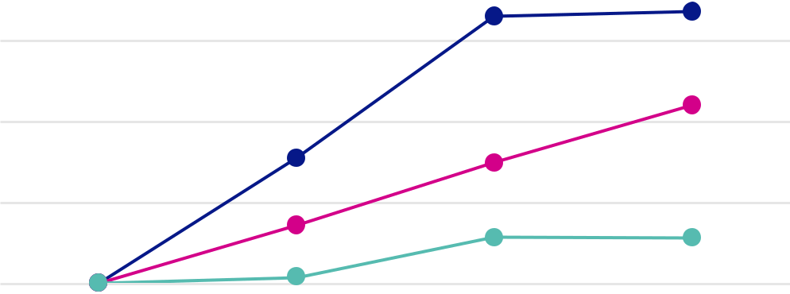

$250.00

$200.00

$150.00

$100.00

January 13, 2023 December 31, 2023 December 31, 2024 December 31, 2025

Skyward Specialty Insurance Group, Inc.
Nasdaq Composite Index

Nasdaq Insurance Index

 |  | January 13, |  | December 31, |  |  | December 31, |  |  | December 31,
 |  | 2023 |  |  | 2023 |  |  | 2024 |  |  | 2025
Skyward Specialty Insurance Group, Inc. | $ | 100.00 | $ |  | 177.38 | $ |  | 264.61 | $ |  | 267.59
Nasdaq Composite Index | $ | 100.00 | $ |  | 135.49 | $ |  | 174.30 | $ |  | 209.78
Nasdaq Insurance Index | $ | 100.00 | $ |  | 103.37 | $ |  | 128.30 | $ |  | 127.60

Item 6. [Reserved] - Not applicable.

42

Item 7. Management’s Discussion and Analysis of Financial Condition and Results of Operations Overview

We are a growing specialty insurance company delivering commercial P&C products and solutions on a non-admitted (or E&S) and admitted basis, predominantly in the United States. We focus our business on markets that are underserved, dislocated and/or for which standard insurance coverages are insufficient or inadequate to meet the needs of businesses, including our customers and prospective customers operating in these markets. Our customers typically require highly specialized, customized underwriting solutions and claims capabilities. As such, we develop and deliver tailored insurance products and services to address each of the niche markets we serve.

Our portfolio of insured risks is highly diversified — we insure customers operating in a wide variety of industries; we distribute through multiple channels; we write multiple lines of business, including general liability, excess liability, professional liability (which includes cyber and media liability insurance), commercial auto, group accident and health, property, agriculture, credit, surety and workers’ compensation; we insure both short and medium duration liabilities; and our business mix is principally primary insurance and balanced between E&S and admitted markets. A portion of our business is specialty reinsurance (principally agriculture and credit) which is similarly focused on attractive specialty classes where we believe it is more efficient to approach these classes through reinsurance given factors such as cost of entry, including the costs of geographic expansion. All of these factors enable us to respond to market opportunities and dislocations by deploying capital with attractive risk-adjusted returns. We believe this diversification, which includes businesses not typically aligned with traditional P&C pricing cycles, combined with our underwriting and claims expertise, will more consistently produce strong growth and profitability across all insurance pricing cycles.

We seek to lead in our chosen market niches and establish sustainable competitive positions in these markets. We refer to this strategy as “Rule Our Niche” and it forms the basis of our approach to building a strong defensible market position, creating a competitive moat, and winning our chosen markets. We believe that the principles underlying our strategy are key to achieving and sustaining best-in-class underwriting results through P&C insurance pricing cycles. We consistently strive for excellence in risk selection, pricing, and claims outcomes, and to amplify these critical functions with the use of advanced technology and analytics.

During the first quarter of 2025, we updated our underwriting divisions to align with how management currently oversees the business, allocates resources and evaluates operating performance. We added a ninth division, Agriculture and Credit (Re)insurance, which includes the Global Agriculture unit, previously reported with Global Property, and the Mortgage and Credit units, and focuses on specialty classes for which reinsurance provides a more attractive market entry. The Industry Solutions division is now the Construction & Energy Solutions division and the Inland Marine unit is now included in the Transactional E&S division. Programs is now Specialty Programs. Prior reporting periods have been conformed to reflect the new presentation.

On September 2, 2025, we entered into two share purchase agreements (the "Apollo Majority SPAs") with institutional and management shareholders, respectively, of Apollo Group Holdings Limited ("Apollo") (the "Majority Sellers"). Pursuant to the Apollo Majority SPAs and in accordance with the terms and subject to the conditions therein, we agreed to acquire all of the issued shares of Apollo held by the Majority Sellers, representing approximately 87% of the issued share capital of Apollo. In addition, closing of the transaction ("Closing") was conditioned upon our acquiring 100% of the issued share capital of Apollo (the “Acquisition”) at Closing pursuant to additional short-form share purchase agreements (the "Apollo Minority SPAs" and together with the Apollo Majority SPAs, the "Apollo SPAs") with the remaining minority shareholders of Apollo (the "Minority Sellers" and together with the Majority Sellers, the "Sellers"). The consideration for the entire issued share capital of Apollo under the Apollo SPAs was $555.0 million, which included (i) $371.0 million in cash (the “Cash Consideration”) and (ii) the issuance of 3,679,332 shares of the Company’s common stock. In connection with the Apollo SPAs, on December 30, 2025, we entered into a Term Loan Credit Agreement (the “Facility”) we the lenders from time to time parties thereto (each a “Lender” and collectively, the “Lenders”), Barclays Bank PLC, as Administrative Agent (the “Agent”), and the Agent, Truist Securities, Inc., Citizens Bank, N.A. and Texas Capital Bank as joint lead arrangers, joint book runners and co-syndication agents for the Tranche B Term Facility. The facility includes (a) an unsecured senior delayed draw term loan facility in the aggregate principal amount of $150.0 million (the “Tranche A Term Facility”) and (b) an additional unsecured senior delayed draw term loan facility in the aggregate principal of $150.0 million. The acquisition closed on January 1, 2026. The consideration for the transaction was satisfied by the issuance of common stock of the Company to certain sellers and the remainder in cash. As of December 31, 2025, we recognized $14.0 million in transaction expenses associated with the transaction.

43

Results of Operations

The following table summarizes our results for the years ended December 31, 2025 and 2024:

Years Ended December 31,

($ in thousands) |  | 2025 |  |  | 2024
Gross written premiums | $ | 2,166,236 | $ |  | 1,743,232
Ceded written premiums |  | (760,004) |  |  | (619,654)
Net written premiums | $ | 1,406,232 |  | $ | 1,123,578
Net earned premiums
Net earned premiums | $ | 1,304,505 |  | $ | 1,056,722
Commission and fee income |  | 6,855 |  |  | 6,703
Losses and LAE |  | 795,022 |  |  | 669,809
Underwriting, acquisition and insurance expenses |  | 377,359 |  |  | 311,757
Underwriting income⁽¹⁾ | $ | 138,979 |  | $ | 81,859
Net investment income | $ | 83,619 | $ |  | 80,600
Net investment gains | $ | 22,149 | $ |  | 6,342
Income before income taxes | $ | 216,424 | $ |  | 152,739
Net income | $ | 170,028 | $ |  | 118,828
Adjusted operating income⁽¹⁾ | $ | 167,372 | $ |  | 126,582
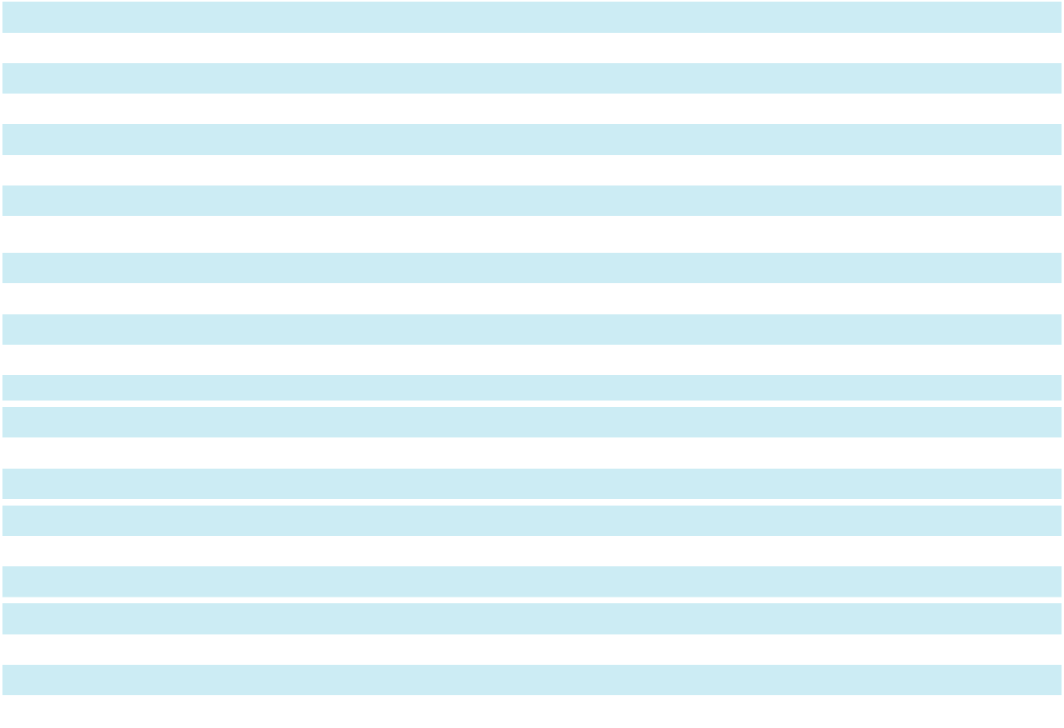
Loss and LAE ratio | 60.9 % | 63.4 %
Expense ratio | 28.4 % |  | 28.9 %
Combined ratio | 89.3 % |  | 92.3 %
Adjusted loss and LAE ratio⁽¹⁾ | _{NM}(2) | 62.3 %
Expense ratio | _{NM}(2) |  | 28.9 %
Adjusted combined ratio⁽¹⁾ | _{NM}(2) |  | 91.2 %
Return on equity | 18.9 % | 16.3 %
Return on tangible equity⁽¹⁾ | 20.9 % | 18.6 %
Adjusted return on equity⁽¹⁾ | 18.6 % | 17.4 %
Adjusted return on tangible equity⁽¹⁾ | 20.6 % | 19.8 %
- See “Reconciliation of Non-GAAP Financial Measures” in this Item 7

- Not meaningful

Reconciliation of Non-GAAP Financial Measures

Adjusted Operating Income

The following table provides a reconciliation of adjusted operating income to net income for the years ended

December 31, 2025 and 2024:

 |  | 2025 |  |  |  |  |  | 2024
($ in thousands) |  | Pre-tax |  |  | After-tax |  |  | Pre-tax |  |  | After-tax
Income as reported | $ | 216,424 |  | $ | 170,028 | $ |  | 152,739 | $ |  | 118,828
Less (add):
Net investment gains |  | 22,149 |  |  | 17,401 |  |  | 6,342 |  |  | 5,010
Net impact of LPT |  | — |  |  | — |  |  | (11,598) |  |  | (9,162)
Transaction costs |  | (14,019) |  |  | (11,014) |  |  | — |  |  | —
Other loss |  | (587) |  |  | (461) |  |  | (167) |  |  | (132)
Other expenses |  | (4,162) |  |  | (3,270) |  |  | (4,392) |  |  | (3,470)
Adjusted operating income | $ | 213,043 | $ |  | 167,372 | $ |  | 162,554 | $ |  | 126,582
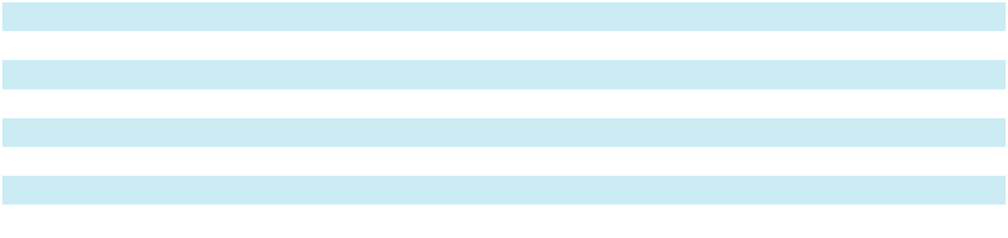

44

Underwriting Income

The following table provides a reconciliation of underwriting income to income before federal income tax expense for the years ended December 31, 2025 and 2024:

($ in thousands) |  | 2025 |  |  | 2024
Income before income taxes | $ | 216,424 | $ |  | 152,739
Add:
Interest expense |  | 7,919 |  |  | 9,496
Amortization expense |  | 1,636 |  |  | 2,007
Transaction costs |  | 14,019 |  |  | —
Other expenses |  | 4,162 |  |  | 4,392
Less (add):
Net investment income |  | 83,619 |  |  | 80,600
Net investment gains |  | 22,149 |  |  | 6,342
Other loss |  | (587) |  |  | (167)
Underwriting income | $ | 138,979 | $ |  | 81,859
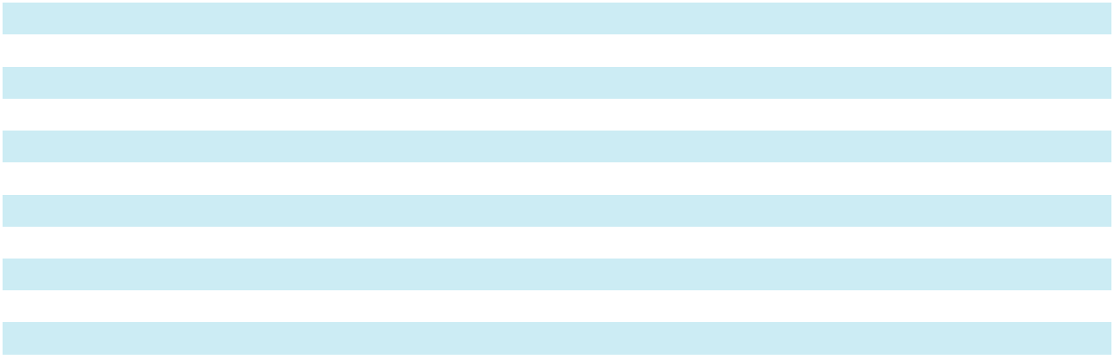

Adjusted Loss Ratio / Adjusted Combined Ratio

The following table provides a reconciliation of the adjusted loss and LAE ratio and adjusted combined ratio to the loss and LAE ratio and combined ratio for the year ended December 31, 2024:

($ in thousands) |  | 2024
Net earned premiums | $ | 1,056,722
Losses and LAE |  | 669,809
Pre-tax net impact of loss portfolio transfer |  | (11,598)
Adjusted losses and LAE | $ | 658,211
Loss ratio |  | 63.4 %
Less: Net impact of LPT |  | 1.1%
Adjusted loss ratio |  | 62.3 %
Combined ratio |  | 92.3 %
Less: Net impact of LPT |  | 1.1%
Adjusted combined ratio |  | 91.2 %
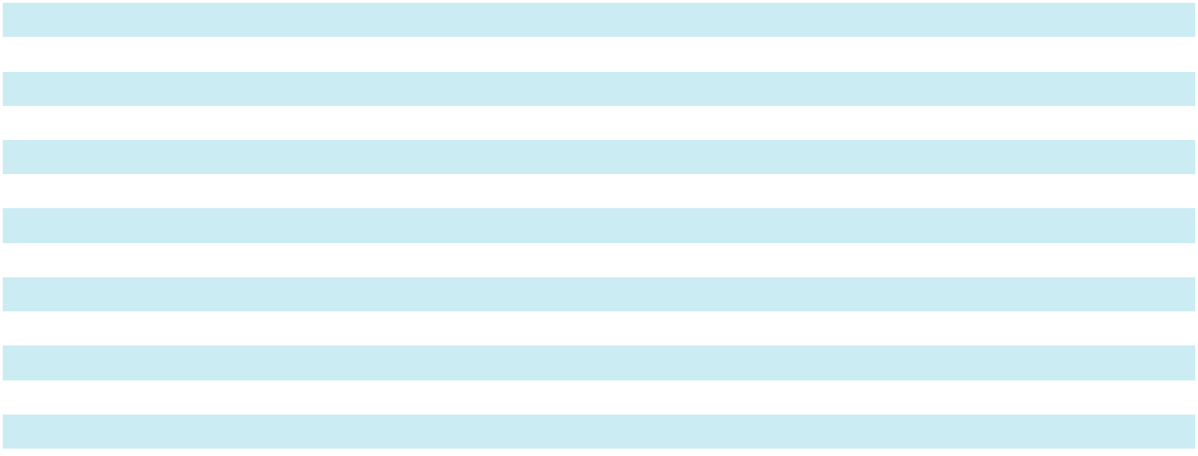

Tangible Stockholders’ Equity

The following table provides a reconciliation of tangible stockholders’ equity to stockholders’ equity for the years ended December 31, 2025 and 2024:

($ in thousands) |  | 2025 |  |  | 2024
Stockholders’ equity | $ | 1,009,565 | $ |  | 793,999
Less: Goodwill and intangible assets |  | 88,040 |  |  | 87,348
Tangible stockholders’ equity | $ | 921,525 | $ |  | 706,651

45

Adjusted Return on Equity

The following table provides a reconciliation of adjusted return on equity to return on equity for the years ended

December 31, 2025 and 2024:

($ in thousands) |  | 2025 |  |  | 2024
Numerator: adjusted operating income | $ | 167,372 |  | $ | 126,582
Denominator: average stockholders’ equity | $ | 901,782 | $ |  | 727,515
Adjusted return on equity |  | 18.6 % |  |  | 17.4 %

Return on Tangible Equity

Return on tangible equity for the years ended December 31, 2025 and 2024 reconciles to return on equity as follows:

($ in thousands) |  | 2025 |  |  | 2024
Numerator: net income | $ | 170,028 |  | $ | 118,828
Denominator: average tangible stockholders’ equity | $ | 814,088 | $ |  | 639,624
Return on tangible equity |  | 20.9 % |  |  | 18.6 %

Adjusted Return on Tangible Equity

Adjusted return on tangible equity for the years ended December 31, 2025 and 2024 reconciles to return on equity as follows:

($ in thousands) |  | 2025 |  |  | 2024
Numerator: adjusted operating income | $ | 167,372 |  | $ | 126,582
Denominator: average tangible stockholders’ equity | $ | 814,088 | $ |  | 639,624
Adjusted return on tangible equity |  | 20.6 % |  |  | 19.8 | %

Underwriting Results

Premiums

The following tables present gross written premiums by underwriting division for the years ended December 31, 2025 and 2024:

($ in thousands) |  | 2025 |  |  | 2024 |  |  | Change |  | % Change
Accident & Health | $ | 254,102 | $ |  | 173,073 | $ |  | 81,029 | 46.8%
Agriculture and Credit (Re)insurance |  | 346,212 |  |  | 118,070 |  |  | 228,142 | 193.2%
Captives |  | 275,694 |  |  | 241,902 |  |  | 33,792 | 14.0%
Construction & Energy Solutions |  | 274,318 |  |  | 296,582 |  |  | (22,264) | (7.5%)
Global Property |  | 178,128 |  |  | 201,796 |  |  | (23,668) | (11.7%)
Professional Lines |  | 149,231 |  |  | 159,785 |  |  | (10,554) | (6.6%)
Specialty Programs |  | 322,705 |  |  | 218,407 |  |  | 104,298 | 47.8%
Surety |  | 168,148 |  |  | 143,965 |  |  | 24,183 | 16.8%
Transactional E&S |  | 197,779 |  |  | 189,669 |  |  | 8,110 |  | 4.3%
Total gross written premiums⁽¹⁾ | $ | 2,166,317 | $ |  | 1,743,249 | $ |  | 423,068 | 24.3%
⁽¹⁾ Excludes exited business
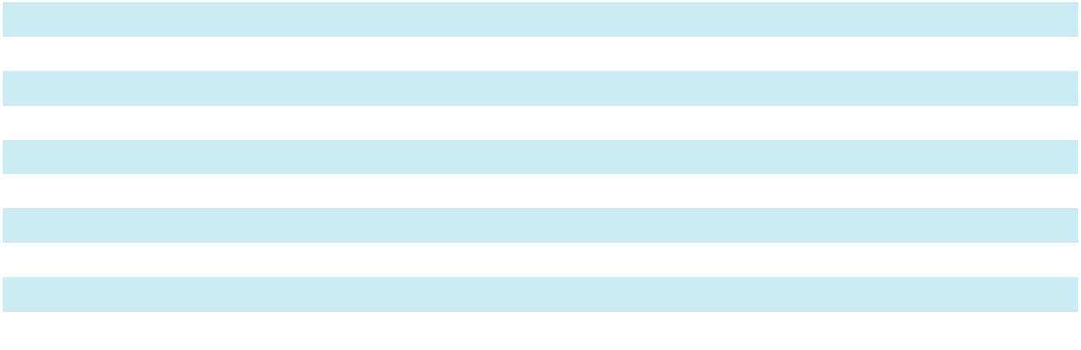

The year-over-year increase of $423.1 million in gross written premiums, when compared to 2024, was primarily driven by growth from the agriculture and credit (re)insurance division due to (i) new opportunities in dairy and livestock and crop, and (ii) growth in our credit portfolio which we started writing in the fourth quarter of 2024. Specialty programs, accident & health, surety and captives also contributed meaningfully to the growth in 2025. The growth in specialty programs was primarily due to the addition of two new programs in 2025. The growth in accident and health was primarily driven by the acquisition of more high deductible accident and health captives when compared to 2024. The increase in

46

surety was primarily due to market expansion in both commercial and contract bonds. The growth in the captives division was primarily due to rate increases and new business.

Partially offsetting the growth in gross written premiums were decreases in our global property, construction and energy solutions and professional lines divisions due to (i) continued downward pricing pressure in the global property market, although retention remained steady, and (ii) the exit of unprofitable lines in construction and energy solutions and professional lines during 2025.

Net written premiums were $1,406.2 million compared to $1,123.6 million in 2024, an increase of $282.7 million, or 25.2%. The increase in net written premiums was primarily driven by the same reasons that drove the increase in gross written premiums discussed above.

Net earned premiums for 2025 were $1,304.5 million compared to $1,056.7 million for 2024, an increase of $247.8 million, or 23.4%. The increase in net earned premiums was primarily driven by the same reasons that drove the increase in gross written premiums discussed above.

For additional information regarding our reinsurance programs, see the discussion included in “Item 1 Business - Reinsurance”.

Losses and LAE

The following tables set forth the components of the loss and LAE ratios and adjusted loss and LAE ratios for the years ended December 31, 2025 and 2024:

($ in thousands)

Losses and LAE:

Non-cat loss and LAE

Cat loss and LAE⁽¹⁾

Prior accident year development Total losses and LAE

- Current accident year

 | 2025 |  |  |  |  |  | 2024
 | Losses |  |  | % of |  |  | Losses |  |  | % of
 |  |  |  | Net Earned |  |  |  |  |  | Net Earned
 | and LAE |  |  | Premiums |  |  | and LAE |  |  | Premiums
$ | 786,949 |  |  | 60.3 % | $ |  | 640,257 |  |  | 60.6 %
 | 15,548 |  |  | 1.2 % |  |  | 17,954 |  |  | 1.7 %
 | (7,475) |  |  | (0.6)% |  |  | 11,598 |  |  | 1.1%
$ | 795,022 |  |  | 60.9 % | $ |  | 669,809 |  |  | 63.4 %


The 2025 loss ratio improved 2.5 points when compared to 2024, primarily due to favorable prior accident year development compared to adverse development due to the net impact of the LPT in 2024. The non-cat loss and LAE ratio for 2025 improved 0.3 points when compared to 2024, primarily driven by the shift in the mix of business. The 2025 cat loss and LAE ratio improved 0.5 points when compared to 2024, which was impacted by Hurricanes Helene and Beryl in the third quarter of 2024 and Hurricane Milton in the fourth quarter of 2024.

Losses and LAE Development

The following table sets forth the presentation of the development of the ultimate liability by accident year for the years ended December 31, 2025 and 2024:

($ in thousands) |  | Development
 |  | (Favorable) Adverse
Accident Year |  | 2025 |  |  | 2024
Prior | $ | 2,808 | $ |  | 24,929
2021 |  | 9,590 |  |  | 978
2022 |  | 2,300 |  |  | (1,479)
2023 |  | (16,515) |  |  | 1,300
2024 |  | (5,658) |  |  | —
Total | $ | (7,475) |  | $ | 25,728
Reserve development on losses subject to LPT
Reserve development on losses subject to LPT | $ | — |  | $ | 25,300
Reserve development on losses excluding losses subject to LPT | $ | (7,475) | $ |  | 428
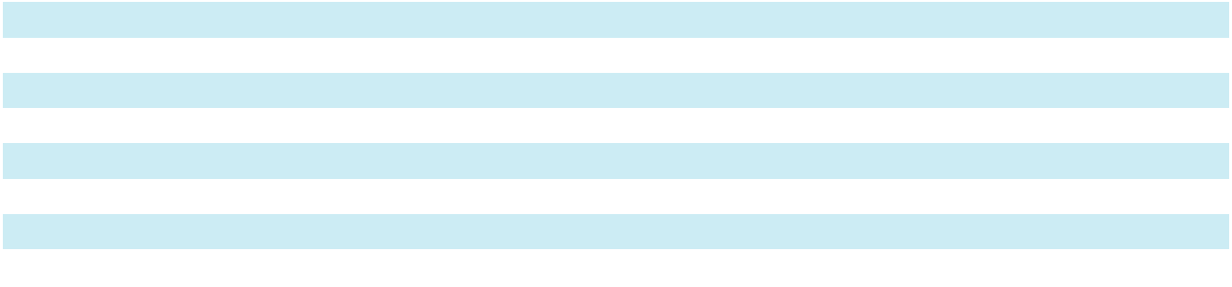

47

For the year ended December 31, 2025, we recognized favorable development related to prior years’ loss and loss expense reserves of $7.5 million due to favorable development of $24.6 million and $5.3 million in short-tail/monoline specialty lines and multi-line solutions, respectively, partially offset by $22.4 million of adverse development in exited lines. The adverse development is primarily attributable to commercial auto and excess over auto in divisions that we have non-renewed or significantly reduced our exposure over the past three years. This was offset by favorable development in surety and property.

For the year ended December 31, 2024, we recognized adverse development related to prior years’ loss and loss expense reserves of $25.7 million; $10.1 million and $15.2 million in multi-line solutions and exited lines, respectively, were related to losses previously subject to the LPT from accident years 2018 and prior.

Expense Ratio

The following tables set forth the components of the expense ratios for the years ended December 31, 2025 and 2024:

 |  | 2025 |  |  |  |  |  | 2024
 |  |  |  |  | % of |  |  |  |  |  | % of
 |  |  |  |  | Net Earned |  |  |  |  |  | Net Earned
($ in thousands) |  | Expenses |  |  | Premiums |  |  | Expenses |  |  | Premiums
Net policy acquisition expenses | $ | 195,422 |  |  | 15.0% | $ |  | 149,975 |  |  | 14.2%
Other operating and general expenses |  | 181,937 |  |  | 13.9% |  |  | 161,782 |  |  | 15.3%
Underwriting, acquisition and insurance |  | 377,359 |  |  | 28.9% |  |  | 311,757 |  |  | 29.5%
expenses |  | 377,359 |  |  | 28.9% |  |  | 311,757 |  |  | 29.5%
Less: commission and fee income |  | (6,855) |  |  | (0.5%) |  |  | (6,703) |  |  | (0.6%)
Total net expenses | $ | 370,504 |  |  | 28.4% | $ |  | 305,054 |  |  | 28.9%


The expense ratio for 2025 improved 0.5 points when compared to 2024, primarily due to earnings leverage, partially offset by higher acquisition costs due to the business mix shift.

Investment Results

The following table sets forth the components of net investment income and net investment gains (losses) for the years ended December 31, 2025 and 2024:

$ in thousands |  | 2025 |  |  | 2024
Short-term investments & cash and cash equivalents | $ | 15,877 | $ |  | 17,643
Fixed income |  | 77,888 |  |  | 57,631
Equities |  | 1,380 |  |  | 2,745
Alternative and strategic investments |  | (11,526) |  |  | 2,581
Net investment income | $ | 83,619 |  | $ | 80,600
Net unrealized (losses) gains on securities still held
Net unrealized (losses) gains on securities still held | $ | (1,555) |  | $ | 7,921
Net realized gains (losses) |  | 23,704 |  |  | (1,579)
Net investment gains | $ | 22,149 | $ |  | 6,342

Net investment income for the year ended 2025 increased $3.0 million when compared to 2024.

The increase in income from our fixed income portfolio for 2025, when compared to 2024, was due to (i) a larger asset base as we continued to increase our allocation to this part of our investment portfolio and (ii) a higher book yield of 5.4% at December 31, 2025 compared to 5.2% at December 31, 2024. The decrease in income from short-term investments & cash and cash equivalents for 2025 when compared to 2024 was due to an overall decrease in yields. The decrease in income from our alternative and strategic investments portfolio in 2025 when compared to 2024 due to a decline in the fair value of limited partnership investments. The decrease in income from equities was due to the sale of the equity portfolio in the third quarter of 2025.

48

Investments

Composition of Investment Portfolio

The following table sets forth the components of our investment portfolio at carrying value at December 31, 2025 and 2024:

 |  | 2025 |  |  |  |  |  | 2024
($ in thousands) | Carrying Value |  |  |  | % of Total |  | Carrying Value |  |  |  | % of Total
Cash and cash equivalents | $ | 168,544 |  |  | 6.8 % | $ |  | 121,603 |  |  | 6.1 %
Short-term investments |  | 264,299 |  |  | 10.7 % |  |  | 274,929 |  |  | 13.8 %
Fixed income |  | 1,866,205 |  |  | 75.6 % |  |  | 1,318,708 |  |  | 66.2 %
Equities |  | 1,174 |  |  | 0.1 % |  |  | 106,254 |  |  | 5.3 %
Alternative and strategic investments |  | 168,837 |  |  | 6.8 % |  |  | 170,929 |  |  | 8.6 | %
Total portfolio | $ | 2,469,059 |  |  | 100.0 % | $ |  | 1,992,423 |  |  | 100.0 | %


Fixed income

Our fixed income portfolio primarily consists of investment grade fixed income securities, which are predominantly highly-rated and liquid bonds, and commercial mortgage loans.

The following table sets forth the components of our fixed income securities at December 31, 2025 and 2024:

 |  | 2025 |  |  |  |  |  | 2024
 |  | Carrying |  |  |  |  |  | Carrying
($ in thousands) |  | Value |  |  | % of Total |  |  | Value |  |  | % of Total
U.S. government securities | $ | 44,468 |  |  | 2.4 % | $ |  | 26,486 |  |  | 2.0 %
Corporate securities and miscellaneous |  | 636,387 |  |  | 34.1 % |  |  | 425,628 |  |  | 32.3 | %
Municipal securities |  | 102,116 |  |  | 5.5 % |  |  | 84,716 |  |  | 6.4 | %
Residential mortgage-backed securities |  | 486,587 |  |  | 26.1 % |  |  | 393,833 |  |  | 29.9 | %
Commercial mortgage-backed securities |  | 73,050 |  |  | 3.9 % |  |  | 69,364 |  |  | 5.2 %
Other asset-backed securities |  | 513,695 |  |  | 27.5 % |  |  | 292,191 |  |  | 22.2 | %
Total fixed income portfolio, available-for-sale |  | 1,856,303 |  |  | 99.5 % |  |  | 1,292,218 |  |  | 98.0 | %
Commercial mortgage loans | $ | 9,902 |  |  | 0.5 % |  | $ | 26,490 |  |  | 2.0 %
Total fixed income portfolio | $ | 1,866,205 |  |  | 100.0 % | $ |  | 1,318,708 |  |  | 100.0 | %
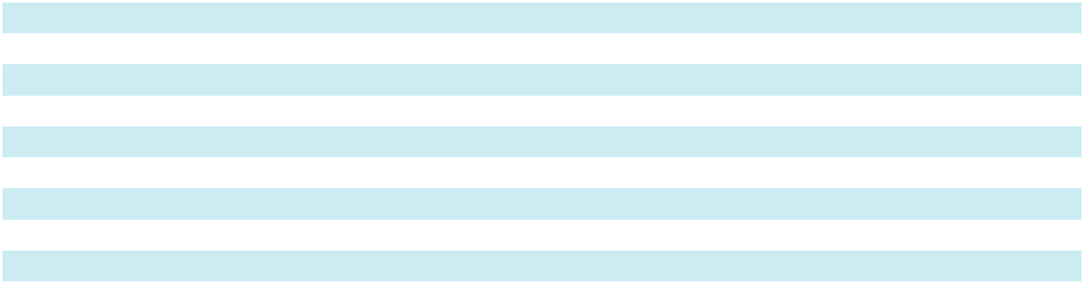

The weighted average credit rating of our available-for-sale fixed income portfolio was “A+” at December 31, 2025 and “AA-” at December 31, 2024. The following table sets forth the credit quality of our available-for-sale fixed income portfolio at December 31, 2025 and 2024:

 |  | 2025 |  |  |  |  |  | 2024
($ in thousands) |  | Fair Value |  |  | % of Total |  |  | Fair Value |  |  | % of Total
AAA | $ | 286,563 |  |  | 15.4 % | $ |  | 483,099 |  |  | 37.3 %
AA |  | 548,030 |  |  | 29.6 % |  |  | 141,177 |  |  | 10.9 %
A |  | 620,813 |  |  | 33.5 % |  |  | 429,703 |  |  | 33.3 %
BBB |  | 379,586 |  |  | 20.4 % |  |  | 216,602 |  |  | 16.8 %
BB and Lower |  | 21,311 |  |  | 1.1 % |  |  | 21,637 |  |  | 1.7 %
Total fixed income portfolio, available-for-sale | $ | 1,856,303 |  |  | 100.0 % | $ |  | 1,292,218 |  |  | 100.0 %


Our commercial mortgage loans are primarily senior loans on real estate across the U.S.

The average duration of our fixed income portfolio was approximately 3.60 years and 4.34 years, respectively, as of December 31, 2025 and 2024.

49

Equities

The equities portfolio primarily consisted of domestic preferred stocks, common equities, exchange traded funds, limited partnerships, limited liability corporations and other types of equity interests, 100.0% of which were publicly traded. During the third quarter of 2025, we sold almost all of our equities portfolio, retaining only our preferred stocks.

The following table sets forth the components of our equities portfolio by security type at December 31, 2025 and 2024:

 |  | 2025 |  |  |  |  |  | 2024
 |  | Fair |  |  | % of Total |  |  | Fair |  |  | % of Total
($ in thousands) |  | Value |  |  | Fair Value |  |  | Value |  |  | Fair Value
Domestic common equities | $ | — |  |  | — % |  | $ | 70,665 |  |  | 66.5 %
International common equities |  | — |  |  | — % |  |  | 34,425 |  |  | 32.4 %
Preferred stock |  | 1,174 |  |  | 100.0 % |  |  | 1,164 |  |  | 1.1 %
Equities | $ | 1,174 |  |  | 100.0 % |  | $ | 106,254 |  |  | 100.0 %


Alternative and strategic investments

Alternative investments consists of promissory notes, limited partnerships, joint ventures and equity interests. The underlying investments are primarily floating rate senior secured loans, comprised of short duration, collateralized, asset-oriented credit investments. The limited partnerships and joint ventures are subject to future increases or decreases in asset value as asset values are monetized and the income is distributed. Strategic investments consists of equity interests in private entities within the insurance industry.

Market Risk

Market risk is the risk of economic losses due to adverse changes in the estimated fair value of a financial instrument as the result of changes in interest rates, equity prices, foreign currency exchange rates and commodity prices. The primary components of market risk affecting us are credit risk and interest rate risk. We do not have significant exposure to foreign currency exchange rate risk or commodity risk.

Credit risk

Credit risk is the potential loss resulting from adverse changes in an issuer’s ability to repay its debt obligations. We have exposure to credit risk as a holder of debt instruments in our core fixed income and opportunistic fixed income portfolios. Our risk management strategy and investment policy is to invest primarily in debt instruments of high credit quality issuers and to limit the amount of credit exposure with respect to particular ratings categories and any one issuer. At December 31, 2025, our fixed income portfolio had an average rating of “A+,” with approximately 78.5% of securities in that portfolio rated “A” or better by at least one nationally recognized rating organization. Our policy is to invest in investment grade fixed income securities which are high quality and liquid, providing a stable income stream, supplemented by opportunistic fixed income and equity securities, with the objective of further enhancing the portfolio’s diversification and risk-adjusted returns. At December 31, 2025, approximately 1.1% of our fixed income portfolio was unrated or rated below investment-grade. Through our investment managers, we monitor the financial condition of all of the issuers of securities in our portfolio.

In addition, we are subject to credit risk with respect to our third-party reinsurers. Although our third-party reinsurers are obligated to reimburse us to the extent we cede risk to them, we are ultimately liable to our policyholders on all risks we have ceded. As a result, reinsurance contracts do not limit our ultimate obligations to pay claims covered under the insurance policies we issue, and we might not collect amounts recoverable from our reinsurers. We address this credit risk by seeking to purchase reinsurance from reinsurers that are rated at least “A-” (Excellent) or better by A.M. Best. We also perform, along with our reinsurance broker, periodic credit reviews of our reinsurers. At December 31, 2025, 98% of our reinsurance recoverables were either derived from reinsurers rated “A-” (Excellent) by A.M. Best, or better, or were collateralized through funds held, trusts and letters of credit by the reinsurer. If one of our reinsurers suffers a credit downgrade, we may consider various options to lessen the risk of asset impairment, including commutation, novation and letters of credit.

Interest rate risk

Interest rate risk is the risk that we will incur economic losses due to adverse changes in interest rates. The primary market risk to our investment portfolio is interest rate risk associated with investments in fixed income securities. Fluctuations in interest rates have a direct effect on the market valuation of these securities. When market interest rates rise,

50

the fair value of our securities decreases. Conversely, as interest rates fall, the fair value of our securities increases. We manage this interest rate risk by investing in securities with varied maturity dates and by managing the duration of our investment portfolio in directional relation to the duration of our reserves. Expressed in years, duration is the weighted average payment period of cash flows, where the weighting is based on the present value of the cash flows. We set duration targets for our core fixed income investment portfolio after consideration of the estimated duration of our liabilities and other factors. Our fixed maturity securities had a weighted average effective duration of 3.6 years as of December 31, 2025.

We had fixed income securities that were subject to interest rate risk with a fair value of $1,856.3 million at December 31, 2025. Our opportunistic fixed income securities are excluded from our interest rate sensitivity analysis as they are primarily floating rate and treated as held to maturity securities.

The following table sets forth what changes might occur in the value of our core fixed income portfolio given hypothetical changes in interest rates as of December 31, 2025:

 |  |  |  |  |  |  | Estimated %
 |  |  |  |  | Estimated |  | Increase
 |  | Estimated |  |  | Change |  | (Decrease)
($ in thousands) |  | Fair Value |  | in Fair Value |  |  | in Fair Value
300 basis point increase | $ | 1,654,474 |  | $ | (201,829) |  | (10.9)%
200 basis point increase | $ | 1,721,816 | $ |  | (134,487) | (7.2)%
100 basis point increase | $ | 1,789,092 | $ |  | (67,211) | (3.6)%
No change | $ | 1,856,303 | $ |  | — | 0.0 %
100 basis point decrease | $ | 1,923,448 | $ |  | 67,145 | 3.6 %
200 basis point decrease | $ | 1,990,528 | $ |  | 134,225 | 7.2 %
300 basis point decrease | $ | 2,057,542 | $ |  | 201,239 | 10.8 %


Changes in interest rates will have an immediate effect on comprehensive income and stockholders’ equity but will not ordinarily have an immediate effect on net income. Actual results may differ from the hypothetical change in market rates assumed in the table above. This sensitivity analysis does not reflect the results of any action that we may take to mitigate such hypothetical losses in fair value.

Equity price risk

Equity price risk represents the potential economic losses due to adverse changes in equity security prices. At December 31, 2025, approximately 0.1% of the fair value of our investment portfolio (excluding cash and cash equivalents and short-term investments) was invested in equity securities. During the third quarter of 2025, we sold almost all of our equities portfolio, retaining only our preferred stocks.

Other Items

Income Taxes

Income tax expense for the year ended December 31, 2025 was $46.4 million, compared to $33.9 million, for the year ended December 31, 2024. Our effective tax rate for the year ended December 31, 2025 was 21.4%, compared to 22.2%, for the year ended December 31, 2024.

See Note 13, “Income Taxes” to our consolidated financial statements included in Item 8 of this Form 10-K for a reconciliation between our actual federal income tax expense and the amount computed at the indicated statutory rate for the years ended December 31, 2025 and 2024.

Liquidity and Capital Resources

Sources and Uses of Funds

We are organized as a holding company with our operations primarily conducted by our wholly-owned insurance subsidiaries, GMIC, HSIC, and IIC, which are domiciled in Texas, and OSIC, which is domiciled in Oklahoma. Accordingly, the holding company may receive cash through (1) corporate service fees from our operating subsidiaries,

- payments pursuant to our consolidated tax allocation agreement, (3) dividends from our subsidiaries, subject to certain limitations discussed below regarding dividends from our insurance subsidiaries, (4) loans from banks, (5) draws on a revolving loan agreement, and (6) issuance of equity and debt securities. We also may use the proceeds from these sources

51

to contribute funds to insurance subsidiaries in order to support premium growth, pay dividends and taxes and for other business purposes.

Skyward Service Company receives corporate service fees from the operating subsidiaries to reimburse it for most of the operating expenses that it incurs. Reimbursement of expenses through corporate service fees is based on the actual costs that we expect to incur with no mark-up above our expected costs.

We file a consolidated U.S. federal income tax return with our subsidiaries, and under our corporate tax allocation agreement, each participant is charged or refunded taxes according to the amount that the participant would have paid or received had it filed on a separate return basis with the Internal Revenue Service (the “IRS”).

Applicable state insurance laws restrict the ability of the insurance subsidiaries to declare stockholder dividends without prior regulatory approval. Applicable state insurance regulators require insurance companies to maintain specified levels of statutory capital and surplus. Dividend payments are further limited to that part of available policyholder surplus which is derived from net profits on an insurer’s business.

Insurance regulators have broad powers to prevent reduction of statutory surplus to inadequate levels, and there is no assurance that dividends of the maximum amounts calculated under any applicable formula would be permitted. State insurance regulatory authorities that have jurisdiction over the payment of dividends by our insurance subsidiaries may in the future adopt statutory provisions more restrictive than those currently in effect. Our insurance subsidiaries did not pay dividends to us for the years ended December 31, 2025 and 2024. See Note 23, “Statutory Accounting Principles and Regulatory Matters” to our consolidated financial statements included in Item 8 of this Form 10-K for additional information regarding our insurance companies.

At December 31, 2025, our holding company had $3.5 million in cash and investments compared to $2.9 million at December 31, 2024.

We believe that we have sufficient liquidity available to meet our operating cash needs and obligations and committed capital expenditures for the next 12 months.

Cash Flows

Our most significant source of cash is from premiums received from our insureds, which, for most policies, we receive at the beginning of the coverage period, net of the related commission amount for the policies. Our most significant cash outflow is for claims that arise when a policyholder incurs an insured loss. Because the payment of claims occurs after the receipt of the premium, often years later, we invest the cash in various investment securities that generally earn interest and dividends. We also use cash to pay for operating expenses such as salaries, rent and taxes and capital expenditures such as technology systems. We use reinsurance to manage the risk that we take on our policies. We cede, or pay out, part of the premiums we receive to our reinsurers and collect cash back when losses subject to our reinsurance coverage are paid.

The timing of our cash flows from operating activities can vary amongst periods due to the timing by which payments are made or received. Some of our payments and receipts, including loss settlements and subsequent reinsurance receipts, can be significant, and as a result their timing can influence cash flows from operating activities in any given period. Management believes that cash receipts from premiums and proceeds from investment income are sufficient to cover cash outflows in the foreseeable future.

The following table sets forth our cash flows for the years ended December 31, 2025 and 2024:

($ in thousands) |  | 2025 |  |  | 2024
Cash and cash equivalents provided by (used in):
Operating activities | $ | 408,076 | $ |  | 305,115
Investing activities |  | (366,898) |  |  | (243,694)
Financing activities |  | 411 |  |  | (4,232)
Change in cash and cash equivalents and restricted cash | $ | 41,589 | $ |  | 57,189


The increase in cash provided by operating activities in 2025 when compared to 2024 was primarily due to an increase in cash inflows from our insurance operations. Cash from operations can vary from period to period due to the timing of premium receipts, claim payments and reinsurance activity. Cash flows from operations in each of the past two years were used primarily to fund investing activities.

Net cash used in investing activities in 2025 was primarily driven by purchases of fixed maturity securities, partially offset by sales and maturities of investment securities. Net cash used in investing activities in 2024 was driven by

52

purchases of fixed maturity securities, partially offset by sales and maturities of investment securities and sales of short-term investments.

Credit Agreements

FHLB Loan

On August 30, 2024, we entered into a loan (the “FHLB Loan”) with the Federal Home Loan Bank of Dallas (the “FHLB”) pursuant to its Advances and Security Agreement. The FHLB Loan is a 4.5-year term loan in the principal amount of $57.0 million. The FHLB Loan provides for interest-only payments during its term, with principal due in full at maturity. The interest rate is fixed over the term of the loan at 4.00%. The FHLB Loan is fully secured by a pledge of specific investment securities of HSIC. We used the proceeds to fund redemptions of the draws on the 2023 Revolving Credit Facility (see “Revolving Credit Facility” below for additional information regarding the redemption).

Term Loan Facility

During the fourth quarter of 2025, we entered into a Term Loan Credit Agreement (the “Term Loan Facility”) with a syndicate of participating banks The Term Loan Facility includes (a) an unsecured senior delayed draw term loan facility (“DDTL”) in the aggregate principal amount of $150.0 million (the “Tranche A DDTL”) and (b) an additional unsecured senior DDTL in the aggregate principal amount of $150.0 million (the “Tranche B DDTL”) and together with the Tranche A DDTL, the “Term Loan Facility”).

We used the Term Loan Facility to fund a portion of the consideration of the acquisition of Apollo Group Holdings Limited (“Apollo”) and related transaction fees and expenses. Amounts drawn under the Term Loan Facility will bear interest at either term SOFR plus a margin, which will range from 150 basis points to 190 basis points, or the base rate plus a margin, which will range from 50 basis points to 90 basis points, each depending on our debt to capitalization ratio. SOFR will be calculated using a SOFR floor of 0.00% and a credit spread adjustment of 0.10%. The base rate will be the highest of (i) the Agent’s then-current prime lending rate, (ii) the Federal Funds Rate plus 0.50%, (iii) SOFR plus 1.00% and (iv) zero percent (0%). In addition, we will also pay a fee ranging from 0.20% to 0.35% on average daily undrawn amounts under the Facility, depending on our debt to capitalization ratio. The Tranche A DDTL matures on January 1, 2028 and the Tranche B DDTL matures on July 2, 2029. On December 30, 2025, we drew $150 million of the Tranche A DDTL and $150 million of the Tranche B DDTL for the acquisition of Apollo on January 1, 2026.

The Term Loan Facility includes customary covenants, including certain limitations on the incurrence by us of additional indebtedness exceeding $10.0 million and on our ability to make distributions to our stockholders, or redeem, repurchase or retire shares of stock, upon the occurrence of certain events and certain financial covenants, including financial covenants relating to our minimum consolidated net worth, maximum total debt to capitalization, minimum A.M. Best rating and minimum liquidity, as well as customary events of default. As of December 31, 2025, we were in compliance with all covenants.

The Term Loan Facility is unsecured. In connection with the Credit Agreement, during the fourth quarter of 2025, we and the subsidiary guarantors party thereto, entered into a guaranty agreement, pursuant to which our obligations under the Term Loan Facility are guaranteed by us and our existing wholly-owned subsidiaries and subsequently acquired or organized subsidiaries, excluding insurance company subsidiaries and subject to certain other exceptions.

Revolving Credit Facilities

During the fourth quarter of 2025, we entered into a Credit Agreement (the “Revolving Credit Facility”) with a syndicate of participating banks. The Revolving Credit Facility is unsecured and provided us with up to an initial maximum principal amount of $150.0 million which was increased to $250.0 million on the closing date of our acquisition of Apollo. Also, during the fourth quarter of 2025, we amended the Revolving Credit Facility to permit the funding of certain revolving loans in connection with the acquisition of Apollo, among other things.

We initially drew $43.0 million, which was used to redeem our prior revolving credit facility (described below). On December 30, 2025, we drew an additional $71.5 million which was used for the consideration paid for the acquisition. The proceeds from the draws on the Term Loan Facility and the draw of the Revolving Credit Facility are presented net with the liabilities on the Consolidated Balance Sheets for the year ended December 31, 2025. The proceeds were used for the acquisition of Apollo on January 1, 2026.

Interest on the Revolving Credit Facility is payable quarterly. Amounts drawn under the Facility bear interest at either term SOFR plus a margin, which range from 150 and 190 basis points, or the base rate plus a margin, which range from 50 basis points to 90 basis points, each depending on our debt to capitalization ratio. SOFR will be calculated using a SOFR floor of 0.00% and a credit spread adjustment of 0.10%. The base rate will be the highest of (i) the Agent’s then current prime lending rate, (ii) the Federal Funds Rate plus 0.50%, (iii) SOFR plus 1.00% and (iv) zero percent (0%). In addition,

53

we will also pay a fee ranging from 0.20% to 0.35% on average daily undrawn amounts under the Facility, depending on our debt to capitalization ratio. The availability period under the Facility will terminate on November 12, 2030.

We are subject to covenants on the Revolving Credit Facility based on minimum net worth, maximum debt to capital ratio, minimum A.M. Best Rating and minimum liquidity, as well as customary events of default. As of December 31, 2025, we were in compliance with all covenants.

During the first quarter of 2023, we entered into an agreement to obtain a unsecured revolving credit facility (the “2023 Revolving Credit Facility”) with a syndicate of participating banks. The 2023 Revolving Credit Facility provided us with up to a $150.0 million revolving credit facility and a letter of credit sub-facility of up to $30.0 million. On November 13, 2025, we redeemed the 2023 Revolving Credit Facility, paid $0.3 million of accrued interest and recognized $0.6 million of expense for the remaining unamortized deferred financing costs.

Debentures

In May 2019, we entered into an agreement to issue unsecured subordinated notes (the “Notes”) with an aggregate principal amount of $20.0 million. Interest on the Notes is fixed at 7.25% for the first 8 years and fixed at 8.25% thereafter. Early retirement of the debt ahead of the 8-year commitment requires all interest payments to be paid in full as well as the return of outstanding principal. Principal is due at maturity on May 24, 2039 and interest is payable quarterly. The Notes have junior priority to all previously issued debt. We report debt related to the Notes in our December 31, 2025 and 2024 Consolidated Balance Sheets, net of debt issuance costs of approximately $0.4 million and $0.5 million, respectively. These deferred financing costs are presented as a direct deduction from the carrying amount of the subordinated debt.

Share Repurchase Program

In October 2024, the Board of Directors approved a share repurchase program authorizing the repurchase of up to $50.0 million of our common stock. The shares may be repurchased from time to time in open market purchases, privately-negotiated transactions, block purchases, accelerated share repurchase agreements or a combination of methods, including through Rule 10b5-1 trading plans. The timing, manner, price and amount of any repurchases under the share repurchase program will be determined by us in our discretion. The share repurchase program does not require us to repurchase any specific number of shares, and may be modified, suspended or terminated at any time. As of December 31, 2025, no shares have been repurchased under this plan.

Contractual Obligations and Commitments

The following table sets forth our contractual obligations and commercial commitments by due date as of

December 31, 2025:

 |  | Payments due by period
 |  |  |  |  | Less Than |  |  | One Year
($ in thousands) |  | Total |  |  | One Year |  |  | or More
Reserves for losses and LAE | $ | 2,318,894 |  | $ | 524,329 |  | $ | 1,794,565
Long-term debt |  | 548,500 |  |  | — |  |  | 548,500
Interest on debt obligations |  | 107,070 |  |  | 26,828 |  |  | 80,242
Total | $ | 2,974,464 |  | $ | 551,157 |  | $ | 2,423,307

Reserves for losses and LAE represent our best estimate of the ultimate cost of settling reported and unreported claims and related expenses. Estimating reserves for losses and LAE is based on various complex and subjective judgments. Actual losses and settlement expenses paid may deviate, perhaps substantially, from the reserve estimates reflected in our financial statements. Similarly, the timing for payment of our estimated losses is not fixed and is not determinable on an individual or aggregate basis. The assumptions used in estimating the payments due by period are based on our own, industry and peer group claims payment experience. Due to the uncertainty inherent in the process of estimating the timing of such payments, there is a risk that the amounts paid in any period will be significantly different than the amounts disclosed above. Amounts disclosed above are gross of anticipated amounts recoverable from reinsurers. Reinsurance balances recoverable on reserves for losses and LAE are reported separately as assets, instead of being netted with the related liabilities, since reinsurance does not discharge us of our liability to policyholders. Reinsurance balances recoverable on reserves for paid and unpaid losses and LAE totaled $1,119.9 million and $857.9 million at December 31, 2025 and December 31, 2024, respectively.

Critical Accounting Policies

We identified the accounting estimates below as critical to the understanding of our financial position and results of operations. Critical accounting estimates are defined as those estimates that are both important to the portrayal of our

54

financial condition and results of operations and require us to exercise significant judgment. We use significant judgment concerning future results and developments in applying these critical accounting estimates and in preparing our consolidated financial statements. These judgments and estimates affect our reported amounts of assets, liabilities, revenues and expenses and the disclosure of our material contingent assets and liabilities. Actual results may differ materially from the estimates and assumptions used in preparing the consolidated financial statements. We evaluate our estimates regularly using information that we believe to be relevant. For a detailed discussion of our accounting policies, see Note 1, “Summary of Significant Accounting Policies” to our consolidated financial statements included in Item 8 of this Form 10-K.

Reserves for unpaid losses and LAE

The reserves for unpaid losses and LAE is the largest and most complex estimate in our Consolidated Balance Sheets. The reserves for unpaid losses and LAE represent our estimated ultimate cost of all unreported and reported but unpaid insured claims and the cost to adjust these losses that have occurred as of or before the balance sheet date. We do not discount our reserves for losses and LAE to reflect estimated present value. We estimate the reserves using individual case-basis valuations of reported claims and statistical analyses and various actuarial procedures. Those estimates are based on our historical information, industry and peer group information and our estimates of future trends in variable factors such as loss severity, loss frequency and other factors such as inflation. We regularly review our estimates and adjust them as necessary as experience develops or as new information becomes known to us. Additionally, during the loss settlement period, it often becomes necessary to refine and adjust the estimates of liability on a claim either upward or downward. Even after such adjustments, the ultimate liability may exceed or be less than the revised estimates. Accordingly, the ultimate settlement of losses and the related LAE may vary significantly from the estimate included in our financial statements.

We categorize our reserves for unpaid losses and LAE into two types: case reserves and IBNR.

The following table sets forth our gross and net reserves for unpaid losses and LAE at December 31, 2025 and 2024:

 |  |  | 2025 |  |  |  |  |  |  |  |  |  | 2024
($ in thousands) |  | Gross |  | % of Total |  |  | Net |  | % of Total |  |  | Gross |  | % of Total |  |  | Net |  | % of Total
Case reserves | $ | 625,710 |  | 27.0 % |  | $ | 362,291 |  | 25.9 % | $ |  | 567,192 | 31.8 % |  | $ |  | 342,612 | 30.8 %
IBNR | 1,693,184 |  |  | 73.0 % |  | 1,035,438 |  |  | 74.1 % |  | 1,215,191 |  |  | 68.2 % |  |  | 768,925 |  | 69.2 %
Total | $ | 2,318,894 |  | 100.0 % |  | $ | 1,397,729 |  | 100.0 % | $ |  | 1,782,383 | 100.0 % |  | $ |  | 1,111,537 | 100.0 %

Case reserves are established for individual claims that have been reported to us. We are notified of losses by our insureds or their agents or our brokers. Based on the information provided, we establish case reserves by estimating the ultimate losses from the claim, including defense costs associated with the ultimate settlement of the claim. Our claims department personnel use their knowledge of the specific claim along with advice from internal and external experts, including underwriters and legal counsel, to estimate the expected ultimate losses. In limited circumstances, we utilize the services of TPAs to assist in the adjustment of claims. Our internal claims managers oversee TPA activities and monitor their individual claim handling activities to our prescribed standards. The incurred but not reported (“IBNR”) reserve is derived by estimating the ultimate unpaid reserve liability and subtracting case reserves.

Management’s best estimate of the ultimate unpaid liability is set by our Reserve Committee, who consider the actuarial indications along with other factors such as underwriting, claims handling, economic, legal and environmental changes.

Our Reserve Committee includes our Chief Actuary, Chief Reserving Actuary, Chief Financial Officer and Chief Claims Officer. The Reserve Committee meets quarterly to review the actuarial reserving recommendations made by the Chief Actuary and uses their judgment to determine the best estimate to be recorded for the reserve for losses and LAE on our balance sheet. In establishing the quarterly actuarial recommendation for the reserves for losses and LAE, our actuary estimates an initial expected ultimate loss ratio for each of our underwriting divisions. Input from our underwriting and claims departments, including premium pricing assumptions and historical experience, is considered in setting our reserves.

Our reserves are driven by several important factors, including litigation and regulatory trends, legislative activity, climate change, social and economic patterns and claims inflation assumptions. Our reserve estimates reflect current inflation in legal claims’ settlements and assume we will not be subject to losses from significant new legal liability theories. Our reserve estimates assume that there will not be significant changes in the regulatory and legislative environment. The impact of potential changes in the regulatory or legislative environment is difficult to quantify in the absence of specific, significant new regulation or legislation. In the event of significant new regulation or legislation, we

55

will attempt to quantify its impact on our business, but no assurance can be given that our attempt to quantify such inputs will be accurate or successful.

The actuarial review considers multiple actuarial methods to estimate the reserve for losses and LAE. These methods include paid and incurred loss development methods, paid and incurred Bornhuetter-Ferguson methods, paid and incurred loss ratio cape cod methods and frequency and severity methods. In circumstances where one actuarial method is considered more credible than the others, that method is used to set the point estimate. For example, the paid loss and incurred loss development methods rely on historical paid and incurred loss data. For new lines of business, where there is insufficient history of paid and incurred claims data, or in circumstances where there have been significant changes in claim practices, the paid and incurred loss development methods would be less credible than other actuarial methods. The actuarial point estimate may also be based on a judgmental weighting of estimates produced from each of the methods considered. These methods utilize, to varying degrees, the initial expected loss ratio, detailed statistical analysis of past claims reporting and payment patterns, claims frequency and severity, paid loss experience, industry loss experience, and changes in market conditions, policy forms, exclusions, and exposures.

Although we believe that our reserve estimates are reasonable, it is possible that our actual loss experience may not conform to our assumptions. Specifically, our actual ultimate loss ratio could differ from our initial expected loss ratio or our actual reporting and payment patterns could differ from our expected reporting and payment patterns, which are based on our own data and industry data. Accordingly, the ultimate settlement of losses and the related LAE may vary significantly from the estimates included in our financial statements. We regularly review our estimates and adjust them as necessary as experience develops or as new information becomes known to us. Such adjustments are included in the results of current operations.

The amount by which estimated losses differ from those originally reported for a period is known as “development.” Development is unfavorable when the losses ultimately settle for more than the amount reserved or subsequent estimates indicate a basis for reserve increases on unresolved claims. Development is favorable when losses ultimately settle for less than the amount reserved or subsequent estimates indicate a basis for reducing loss reserves on unresolved claims. We reflect favorable or unfavorable development of loss reserves in the results of operations in the period the estimates are changed.

A 5% change in net IBNR would result in a $51.8 million change in our reserves for losses and LAE and a $40.9 million change in net income and stockholders’ equity.

Recent Accounting Pronouncements

In December 2023, the FASB issued ASU 2023-09, Improvements to Income Tax Disclosures (Topic 740). ASU 2023-09 requires public companies, on an annual basis, provide enhanced rate reconciliation disclosures, including disclosures of specific categories and additional information that meet a quantitative threshold. This update also requires public companies to, among other things, disaggregate income taxes paid by federal, state and foreign taxes. The guidance became effective for fiscal years beginning after December 15, 2024. This update is applied prospectively. We have added additional disclosures as required by ASU 2023-09. There was no impact to the consolidated financial statements.

In November 2024, the FASB issued ASU 2024-03, which requires disaggregated disclosure of income statement expenses for public business entities (“PBEs”). The ASU does not change the expense captions an entity presents on the face of the income statement; rather, it requires disaggregation of certain expense captions into specified categories in disclosures within the footnotes to the financial statements. ASU 2024-03 require a footnote disclosure about specific expenses by requiring PBEs to disaggregate, in a tabular presentation, each relevant expense caption on the face of the income statement that includes any of the following natural expenses: (1) purchases of inventory, (2) employee compensation, (3) depreciation, (4) intangible asset amortization, and (5) depreciation, depletion, and amortization recognized as part of oil- and gas-producing activities or other types of depletion expenses. The tabular disclosure would also include certain other expenses, when applicable. In January 2025, the FASB issued ASU 2025-01 to clarify the effective date of ASU 2024-03 as the first annual reporting period beginning after December 15, 2026, and interim reporting periods within annual reporting periods beginning after December 15, 2027. We are evaluating the effect of the amendments on our consolidated financial statements.

Item 7A. Quantitative and Qualitative Disclosures About Market Risk

Qualitative and Quantitative Disclosures about Market Risk are included in Item 7 of this Form 10-K under “Investments—Market Risk.”

56

Item 8. Financial Statements

Report of Independent Registered Public Accounting Firm

To the Stockholders and the Board of Directors of Skyward Specialty Insurance Group, Inc.

Opinion on Internal Control Over Financial Reporting

We have audited Skyward Specialty Insurance Group, Inc. and subsidiaries’ internal control over financial reporting as of December 31, 2025, based on criteria established in Internal Control—Integrated Framework issued by the Committee of Sponsoring Organizations of the Treadway Commission (2013 framework) (the COSO criteria). In our opinion, Skyward Specialty Insurance Group, Inc. and subsidiaries (the Company) maintained, in all material respects, effective internal control over financial reporting as of December 31, 2025, based on the COSO criteria.

We also have audited, in accordance with the standards of the Public Company Accounting Oversight Board (United States) (PCAOB), the consolidated balance sheets of the Company as of December 31, 2025 and 2024, the related consolidated statements of operations and comprehensive income, stockholders’ equity and cash flows for each of the three years in the period ended December 31, 2025, and the related notes and financial statement schedules listed in the Index at Item 15(a) and our report dated March 2, 2026 expressed an unqualified opinion thereon.

Basis for Opinion

The Company’s management is responsible for maintaining effective internal control over financial reporting and for its assessment of the effectiveness of internal control over financial reporting included in the accompanying Management’s Report on Internal Control over Financial Reporting. Our responsibility is to express an opinion on the Company’s internal control over financial reporting based on our audit. We are a public accounting firm registered with the PCAOB and are required to be independent with respect to the Company in accordance with the U.S. federal securities laws and the applicable rules and regulations of the Securities and Exchange Commission and the PCAOB.

We conducted our audit in accordance with the standards of the PCAOB. Those standards require that we plan and perform the audit to obtain reasonable assurance about whether effective internal control over financial reporting was maintained in all material respects.

Our audit included obtaining an understanding of internal control over financial reporting, assessing the risk that a material weakness exists, testing and evaluating the design and operating effectiveness of internal control based on the assessed risk, and performing such other procedures as we considered necessary in the circumstances. We believe that our audit provides a reasonable basis for our opinion.

Definition and Limitations of Internal Control Over Financial Reporting

A company’s internal control over financial reporting is a process designed to provide reasonable assurance regarding the reliability of financial reporting and the preparation of financial statements for external purposes in accordance with generally accepted accounting principles. A company’s internal control over financial reporting includes those policies and procedures that (1) pertain to the maintenance of records that, in reasonable detail, accurately and fairly reflect the transactions and dispositions of the assets of the company; (2) provide reasonable assurance that transactions are recorded as necessary to permit preparation of financial statements in accordance with generally accepted accounting principles, and that receipts and expenditures of the company are being made only in accordance with authorizations of management and directors of the company; and (3) provide reasonable assurance regarding prevention or timely detection of unauthorized acquisition, use, or disposition of the company’s assets that could have a material effect on the financial statements.

Because of its inherent limitations, internal control over financial reporting may not prevent or detect misstatements. Also, projections of any evaluation of effectiveness to future periods are subject to the risk that controls may become inadequate because of changes in conditions, or that the degree of compliance with the policies or procedures may deteriorate.

/s/ Ernst & Young LLP

Houston, Texas

March 2, 2026

57

Report of Independent Registered Public Accounting Firm To the Stockholders and the Board of Directors of Skyward Specialty Insurance Group, Inc. Opinion on the Financial Statements

We have audited the accompanying consolidated balance sheets of Skyward Specialty Insurance Group, Inc. and subsidiaries (the Company) as of December 31, 2025 and 2024, the related consolidated statements of operations and comprehensive income, stockholders' equity and cash flows for each of the three years in the period ended December 31, 2025, and the related notes and financial statement schedules listed in the Index at Item 15(a) (collectively referred to as the “consolidated financial statements”). In our opinion, the consolidated financial statements present fairly, in all material respects, the financial position of the Company at December 31, 2025 and 2024, and the results of its operations and its cash flows for each of the three years in the period ended December 31, 2025, in conformity with U.S. generally accepted accounting principles.

We also have audited, in accordance with the standards of the Public Company Accounting Oversight Board (United States) (PCAOB), the Company's internal control over financial reporting as of December 31, 2025, based on criteria established in Internal Control—Integrated Framework issued by the Committee of Sponsoring Organizations of the Treadway Commission (2013 framework), and our report dated March 2, 2026 expressed an unqualified opinion thereon.

Basis for Opinion

These financial statements are the responsibility of the Company's management. Our responsibility is to express an opinion on the Company’s financial statements based on our audits. We are a public accounting firm registered with the PCAOB and are required to be independent with respect to the Company in accordance with the U.S. federal securities laws and the applicable rules and regulations of the Securities and Exchange Commission and the PCAOB.

We conducted our audits in accordance with the standards of the PCAOB. Those standards require that we plan and perform the audit to obtain reasonable assurance about whether the financial statements are free of material misstatement, whether due to error or fraud. Our audits included performing procedures to assess the risks of material misstatement of the financial statements, whether due to error or fraud, and performing procedures that respond to those risks. Such procedures included examining, on a test basis, evidence regarding the amounts and disclosures in the financial statements. Our audits also included evaluating the accounting principles used and significant estimates made by management, as well as evaluating the overall presentation of the financial statements. We believe that our audits provide a reasonable basis for our opinion.

Critical Audit Matter

The critical audit matter communicated below is a matter arising from the current period audit of the financial statements that was communicated or required to be communicated to the audit committee and that: (1) relates to accounts or disclosures that are material to the financial statements and (2) involved our especially challenging, subjective or complex judgments. The communication of the critical audit matter does not alter in any way our opinion on the consolidated financial statements, taken as a whole, and we are not, by communicating the critical audit matter below, providing a separate opinion on the critical audit matter or on the account or disclosure to which it relates.

Valuation of Reserves for Unpaid Losses and Loss Adjustment Expenses Description of the Matter

At December 31, 2025, the Company’s reserves for unpaid losses and loss adjustment expenses (LAE) was $2.3 billion, of which a significant portion represents incurred but not reported reserves (IBNR). As described in Note 1 of the consolidated financial statements, the reserves for unpaid losses and LAE represents the Company’s estimated ultimate cost of all unreported and reported but unpaid insured claims and the cost to adjust the losses that have been incurred as of the balance sheet date. The Company estimates the reserves for unpaid losses and LAE using individual case-basis valuations of reported claims and statistical analyses and various actuarial procedures. Those estimates are based on historical information, industry and peer group information, and estimates of trends in factors such as loss severity, loss frequency, and other factors such as inflation.

Auditing management’s estimate of reserves for unpaid losses and LAE, including IBNR, was complex and involved our actuarial specialists due to the significant estimation uncertainty associated with evaluating management’s methods and assumptions including loss development factors, expected loss ratios, and trends applied to the Company’s historical experience. These assumptions have a significant effect on the valuation of IBNR reserves.

58

How We Addressed the Matter in Our Audit

We obtained an understanding, evaluated the design and tested the operating effectiveness of internal controls over management’s process for estimating losses and loss adjustment expense reserves. This included, among others, the review and approval processes management has in place for the methods and assumptions used in estimating the reserves for losses and loss adjustment expenses.

With the assistance of actuarial specialists, our audit procedures to test the Company’s reserves for unpaid losses and LAE included, among others, an evaluation of the selection of the actuarial methods utilized by management, including comparison with the actuarial methods used in prior periods and those used in the industry. In addition, we evaluated the assumptions used in the actuarial methods, by comparing the significant assumptions, including loss development factors, expected loss ratios, and trends to the Company’s historical experience and current industry benchmarks and trends. We developed an independent range of reserve estimates and compared the range of reserve estimates to management’s best estimate for unpaid losses and LAE. We also performed a review of the development of prior year reserve estimates.

/s/ Ernst & Young LLP

We have served as the Company’s auditor since 2021.

Houston, Texas

March 2, 2026

59

SKYWARD SPECIALTY INSURANCE GROUP, INC. AND SUBSIDIARIES

CONSOLIDATED BALANCE SHEETS

 |  | December 31,
 |  | 2025 |  |  | 2024
($ in thousands, except share and per share amounts)
Assets
Investments:
Fixed maturity securities, available-for-sale, at fair value (net of allowance for credit
losses of $7,000 and $0, respectively) (amortized cost of $1,848,755 and | $ | 1,856,303 | $ |  | 1,292,218
$1,320,266, respectively)
Fixed maturity securities, held-to-maturity, at amortized cost (net of allowance for |  | 32,822 |  |  | 39,153
credit losses of $468 and $243, respectively) |  | 32,822 |  |  | 39,153
Equity securities, at fair value |  | 1,174 |  |  | 106,254
Mortgage loans, at fair value |  | 9,902 |  |  | 26,490
Equity method investments |  | 77,365 |  |  | 98,594
Other long-term investments |  | 58,650 |  |  | 33,182
Short-term investments, at fair value |  | 264,299 |  |  | 274,929
Total investments |  | 2,300,515 |  |  | 1,870,820
Cash and cash equivalents |  | 168,544 |  |  | 121,603
Restricted cash |  | 30,570 |  |  | 35,922
Premiums receivable, net |  | 544,217 |  |  | 321,641
Reinsurance recoverables, net |  | 1,119,880 |  |  | 857,876
Ceded unearned premium |  | 238,948 |  |  | 203,901
Deferred policy acquisition costs |  | 136,100 |  |  | 113,183
Deferred income taxes |  | 27,865 |  |  | 30,486
Goodwill and intangible assets, net |  | 88,040 |  |  | 87,348
Other assets |  | 137,173 |  |  | 86,698
Total assets | $ | 4,791,852 |  | $ | 3,729,478
Liabilities and stockholders’ equity
Liabilities: | $ | 2,318,894
Reserves for losses and loss adjustment expenses | $ | 2,318,894 | $ |  | 1,782,383
Unearned premiums |  | 774,035 |  |  | 637,185
Deferred ceding commission |  | 46,453 |  |  | 40,434
Reinsurance and premium payables |  | 279,888 |  |  | 177,070
Funds held for others |  | 128,003 |  |  | 102,665
Accounts payable and accrued liabilities |  | 115,034 |  |  | 76,206
Notes payable |  | 100,411 |  |  | 100,000
Subordinated debt, net of debt issuance costs |  | 19,569 |  |  | 19,536
Total liabilities |  | 3,782,287 |  |  | 2,935,479
Stockholders’ equity
Common stock, $0.01 par value, 500,000,000 shares authorized, 40,511,222 and |  | 405 |  |  | 401
40,127,908 shares issued and outstanding, respectively |  | 405 |  |  | 401
Additional paid-in capital |  | 730,555 |  |  | 718,598
Accumulated other comprehensive income (loss) |  | 11,457 |  |  | (22,120)
Retained earnings |  | 267,148 |  |  | 97,120
Total stockholders’ equity |  | 1,009,565 |  |  | 793,999
Total liabilities and stockholders’ equity | $ | 4,791,852 |  | $ | 3,729,478


The accompanying notes are an integral part of the consolidated financial statements.

60

SKYWARD SPECIALTY INSURANCE GROUP, INC. AND SUBSIDIARIES

CONSOLIDATED STATEMENTS OF OPERATIONS

AND COMPREHENSIVE INCOME

Years Ended December 31,

($ in thousands, except share and per share amounts) |  | 2025 |  |  | 2024 |  |  | 2023
Revenues: | $ | 1,304,505
Net earned premiums | $ | 1,304,505 | $ |  | 1,056,722 | $ |  | 829,143
Commission and fee income |  | 6,855 |  |  | 6,703 |  |  | 6,064
Net investment income |  | 83,619 |  |  | 80,600 |  |  | 40,340
Net investment gains |  | 22,149 |  |  | 6,342 |  |  | 11,054
Other loss |  | (587) |  |  | (167) |  |  | (632)
Total revenues |  | 1,416,541 |  |  | 1,150,200 |  |  | 885,969
Expenses: |  | 795,022
Losses and loss adjustment expenses |  | 795,022 |  |  | 669,809 |  |  | 515,237
Underwriting, acquisition and insurance expenses |  | 377,359 |  |  | 311,757 |  |  | 243,444
Transaction costs |  | 14,019 |  |  | — |  |  | —
Interest expense |  | 7,919 |  |  | 9,496 |  |  | 10,024
Amortization expense |  | 1,636 |  |  | 2,007 |  |  | 1,798
Other expenses |  | 4,162 |  |  | 4,392 |  |  | 5,364
Total expenses |  | 1,200,117 |  |  | 997,461 |  |  | 775,867
Income before income taxes |  | 216,424 |  |  | 152,739 |  |  | 110,102
Income tax expense |  | 46,396 |  |  | 33,911 |  |  | 24,118
Net income | $ | 170,028 | $ |  | 118,828 | $ |  | 85,984
Net income attributable to participating securities |  | — |  |  | — |  |  | 1,677
Net income attributable to common stockholders | $ | 170,028 | $ |  | 118,828 | $ |  | 84,307
Comprehensive income
Comprehensive income | $ | 170,028
Net income | $ | 170,028 | $ |  | 118,828 | $ |  | 85,984
Other comprehensive income:
Unrealized gains and losses on investments:
Net change in unrealized gains on investments, net of tax |  | 33,092 |  |  | 9,792 |  |  | 25,516
Reclassification adjustment for gains (losses) on securities no |  | 485
longer held, net of tax |  | 485 |  |  | (8,959) |  |  | (4,984)
Total other comprehensive income |  | 33,577 |  |  | 833 |  |  | 20,532
Comprehensive income | $ | 203,605 | $ |  | 119,661 | $ |  | 106,516
Per share data:
Per share data: | $ | 4.21
Basic earnings per share | $ | 4.21 |  | $ | 2.97 |  | $ | 2.34
Diluted earnings per share
Diluted earnings per share | $ | 4.07 |  | $ | 2.87 |  | $ | 2.24
Weighted-average common shares outstanding
Weighted-average common shares outstanding |  | 40,407,310
Basic |  | 40,407,310 |  |  | 40,056,475 |  |  | 36,031,907
Diluted
Diluted |  | 41,808,046 |  |  | 41,377,460 |  |  | 38,317,534


The accompanying notes are an integral part of the consolidated financial statements.

61

SKYWARD SPECIALTY INSURANCE GROUP, INC. AND SUBSIDIARIES

CONSOLIDATED STATEMENTS OF STOCKHOLDERS’ EQUITY

 |  | Years Ended December 31,
($ in thousands, except share amounts) |  | 2025 |  |  | 2024 |  |  | 2023
Preferred shares: |  | —
Balance at beginning of year |  | — |  |  | — |  |  | 1,969,660
Preferred stock conversion to common shares |  | — |  |  | — |  |  | (1,969,660)
Balance at December 31 |  | — |  |  | — |  |  | —
Common shares:
Common shares: |  | 40,127,908
Balance at beginning of year |  | 40,127,908 |  |  | 39,863,756 |  |  | 16,599,666
Issuance of shares |  | 383,314 |  |  | 264,152 |  |  | 6,958,977
Preferred stock conversion to common shares |  | — |  |  | — |  |  | 16,305,113
Balance at December 31 |  | 40,511,222 |  |  | 40,127,908 |  |  | 39,863,756
Preferred stock:
Preferred stock: | $ | —
Balance at beginning of year | $ | — | $ |  | — | $ |  | 20
Preferred stock conversion to common shares |  | — |  |  | — |  |  | (20)
Balance at December 31 | $ | — | $ |  | — | $ |  | —
Common stock:
Common stock: | $ | 401
Balance at beginning of year | $ | 401 | $ |  | 399 | $ |  | 168
Issuance of common stock |  | 4 |  |  | 2 |  |  | 22
Preferred stock conversion to common shares |  | — |  |  | — |  |  | 161
Proceeds from equity offerings, net |  | — |  |  | — |  |  | 48
Balance at December 31 | $ | 405 | $ |  | 401 | $ |  | 399
Treasury stock:
Treasury stock: | $ | —
Balance at beginning of year | $ | — | $ |  | — | $ |  | (2)
Preferred stock conversion to common shares |  | — |  |  | — |  |  | 2
Balance at December 31 | $ | — | $ |  | — | $ |  | —
Additional paid-in capital:
Additional paid-in capital: | $ | 718,598
Balance at beginning of year | $ | 718,598 | $ |  | 710,855 | $ |  | 577,289
Issuance of common stock |  | 11,957 |  |  | 7,743 |  |  | 9,213
Preferred stock conversion to common shares |  | — |  |  | — |  |  | (143)
Proceeds from equity offerings, net |  | — |  |  | — |  |  | 124,496
Balance at December 31 | $ | 730,555 | $ |  | 718,598 | $ |  | 710,855
Stock notes receivable:
Stock notes receivable: | $ | —
Balance at beginning of year | $ | — | $ |  | (5,562) | $ |  | (6,911)
Employee equity transactions |  | — |  |  | 5,562 |  |  | 1,349
Balance at December 31 | $ | — | $ |  | — | $ |  | (5,562)
Accumulated other comprehensive income (loss):
Accumulated other comprehensive income (loss): | $ | (22,120)
Balance at beginning of year | $ | (22,120) | $ |  | (22,953) | $ |  | (43,485)
Other comprehensive income, net of tax |  | 33,577 |  |  | 833 |  |  | 20,532
Balance at December 31 | $ | 11,457 | $ |  | (22,120) | $ |  | (22,953)
Retained earnings (accumulated deficit):
Retained earnings (accumulated deficit): | $ | 97,120
Balance at beginning of year | $ | 97,120 | $ |  | (21,708) | $ |  | (105,417)
Cumulative effect on adoption of ASU No. 2016-13 |  | — |  |  | — |  |  | (2,275)
Net income |  | 170,028 |  |  | 118,828 |  |  | 85,984
Balance at December 31 | $ | 267,148 | $ |  | 97,120 | $ |  | (21,708)
Total stockholders’ equity | $ | 1,009,565 |  | $ | 793,999 |  | $ | 661,031


The accompanying notes are an integral part of the consolidated financial statements.

62

SKYWARD SPECIALTY INSURANCE GROUP, INC. AND SUBSIDIARIES

CONSOLIDATED STATEMENTS OF CASH FLOWS

Years Ended December 31,

($ in thousands) |  | 2025 |  |  | 2024 |  |  | 2023
Cash flows from operating activities: | $ | 170,028 | $ |  | 118,828 | $ |  | 85,984
Net income
Adjustments to reconcile net income to net cash provided by (used in) operating activities: |  | (22,149)
Net investment (gains) losses |  | (22,149) |  |  | (6,342) |  |  | (11,054)
Depreciation and amortization expense |  | 3,535 |  |  | 3,358 |  |  | 3,891
Stock-based compensation expense |  | 11,960 |  |  | 9,395 |  |  | 8,525
Undistributed earnings (loss) from long-term investments |  | 10,122 |  |  | (6,252) |  |  | 6,730
Net change in fair value of derivatives |  | (34,857) |  |  | — |  |  | —
Deferred income tax, net |  | (6,397) |  |  | (8,708) |  |  | 9,383
Changes in operating assets and liabilities: |  | (222,576)
Premiums receivable, net |  | (222,576) |  |  | (142,406) |  |  | (40,020)
Reinsurance recoverables, net |  | (262,004) |  |  | (261,542) |  |  | (17,270)
Ceded unearned premium |  | (35,047) |  |  | (17,780) |  |  | (28,476)
Deferred policy acquisition costs |  | (22,917) |  |  | (21,228) |  |  | (23,017)
Federal income taxes |  | 1,797 |  |  | 4,500 |  |  | (1,892)
Losses and loss adjustment expenses |  | 536,511 |  |  | 467,882 |  |  | 172,744
Unearned premiums |  | 136,850 |  |  | 84,653 |  |  | 110,023
Deferred ceding commission |  | 6,019 |  |  | 3,377 |  |  | 7,208
Reinsurance and premium payables |  | 102,818 |  |  | 26,914 |  |  | 36,460
Funds held for others |  | 25,338 |  |  | 44,077 |  |  | 21,730
Accounts payable and accrued liabilities |  | 37,032 |  |  | 19,177 |  |  | 2,285
Other, net |  | (27,987) |  |  | (12,788) |  |  | (5,047)
Net cash provided by operating activities |  | 408,076 |  |  | 305,115 |  |  | 338,187
Cash flows from investing activities: |  | (910,039) |  |  | (617,606) |  |  | (459,672)
Purchase of fixed maturity securities, available-for-sale |  | (910,039) |  |  | (617,606) |  |  | (459,672)
Purchase of illiquid investments |  | — |  |  | (75) |  |  | (1,675)
Purchase of equity securities |  | (13,213) |  |  | (14,077) |  |  | (26,009)
Purchase of equity method investments and other long-term investments |  | (6,814) |  |  | (32,173) |  |  | —
Purchase of intangible assets and goodwill |  | (2,000) |  |  | — |  |  | (50)
Investment in direct and indirect loans |  | 19,674 |  |  | 27,480 |  |  | 2,984
Purchase of property and equipment |  | (5,454) |  |  | (4,224) |  |  | (3,108)
Proceeds from the sales of fixed maturity securities, available-for-sale |  | 198,195 |  |  | 217,468 |  |  | 26,626
Maturities, calls, transfers and paydowns of fixed maturity securities, available-for-sale |  | 183,951 |  |  | 122,694 |  |  | 48,957
Maturities, calls and paydowns of fixed maturity securities held-to-maturity |  | 4,357 |  |  | 6,015 |  |  | 11,444
Proceeds from the sales of equity securities |  | 126,738 |  |  | 37,534 |  |  | 40,201
Sales of and distributions from equity method and other long-term investments |  | 11,902 |  |  | 14,073 |  |  | 3,572
Change in short-term investments |  | 10,626 |  |  | (4,799) |  |  | (149,068)
Change in receivable/payable for securities |  | 11,928 |  |  | 34 |  |  | 76
Cash provided by deposit accounting |  | 3,251 |  |  | 3,962 |  |  | 11,913
Net cash used in investment activities |  | (366,898) |  |  | (243,694) |  |  | (493,809)
Cash flows from financing activities: |  | — |  |  | — |  |  | 1,350
Employee share purchases |  | — |  |  | — |  |  | 1,350
Repayment of stock notes receivable |  | — |  |  | 5,562 |  |  | —
Proceeds from long term borrowings |  | 43,411 |  |  | 107,000 |  |  | 50,000
Payments on long term borrowings and trust preferred |  | (43,000) |  |  | (116,794) |  |  | (50,000)
Proceeds from initial public offering |  | — |  |  | — |  |  | 129,597
Net cash provided by (used in) financing activities |  | 411 |  |  | (4,232) |  |  | 130,947
Net increase (decrease) in cash and cash equivalents and restricted cash |  | 41,589 |  |  | 57,189 |  |  | (24,675)
Cash and cash equivalents and restricted cash at beginning of period⁽¹⁾ |  | 157,525 |  |  | 100,336 |  |  | 125,011
Cash and cash equivalents and restricted cash at end of period⁽¹⁾ | $ | 199,114 |  | $ | 157,525 |  | $ | 100,336
Supplemental disclosure of cash flow information:
Supplemental disclosure of cash flow information: | $ | 6,149 | $ |  | 8,573 | $ |  | 10,667
Cash paid for interest
⁽¹⁾ The sum of cash and cash equivalents and restricted cash from the Consolidated Balance Sheets


The accompanying notes are an integral part of the consolidated financial statements.

63

SKYWARD SPECIALTY INSURANCE GROUP, INC. AND SUBSIDIARIES

NOTES TO CONSOLIDATED FINANCIAL STATEMENTS

- Summary of Significant Accounting Policies

A. Description of Business

Skyward Specialty Insurance Group, Inc. (the “Company”), an insurance holding company, is a Delaware corporation that was organized in 2006. It is a specialty insurance company operating in one segment delivering commercial property and casualty products insurance coverages through its underwriting divisions.

The Company has four wholly owned insurance company subsidiaries based in the United States:

- Great Midwest Insurance Company (“GMIC”) underwrites insurance on an admitted basis and is a certified surety bond company listed with the U.S. Department of the Treasury.

- Houston Specialty Insurance Company (“HSIC”), a subsidiary of GMIC, underwrites insurance on a non-admitted basis.

- Imperium Insurance Company (“IIC”), a subsidiary of HSIC, underwrites insurance on an admitted basis.

- Oklahoma Specialty Insurance Company (“OSIC”), a subsidiary of IIC, underwrites insurance on a non-admitted basis.

The Company has a wholly owned captive reinsurance company subsidiary, Skyward Re, that is domiciled in the Cayman Islands and assumed net reserves for certain divisions, related to a retroactive reinsurance contract, from the Company’s insurance companies and retroceded the net reserves to a third-party reinsurer.

The Company has three non-risk bearing wholly owned subsidiaries, (i) Skyward Underwriters Agency, Inc. (“SUA”),a managing general insurance agent and reinsurance broker for property and casualty risks in specialty niche markets, (ii) Skyward Service Company an entity which provides various administrative services to the Company’s subsidiaries, and (iii) Skyward Specialty No. 1 Limited, a Lloyd’s corporate member authorized to invest in Lloyd’s syndicates.

On January 1, 2026, the Company completed the acquisition of Apollo Group Holdings Limited for aggregate consideration of approximately $555.0 million. See Note 24 for additional information.

B. Basis of Presentation

The Company’s consolidated financial statements have been prepared in accordance with generally accepted accounting principles in the United States of America (“GAAP”), which differ in some respects from those followed in reports to insurance regulatory authorities. The consolidated financial statements include the accounts of the holding company and its subsidiaries. All intercompany transactions and balances have been eliminated in consolidation.

The preparation of the consolidated financial statements in conformity with GAAP requires the Company to make estimates and assumptions that affect amounts reported in the consolidated financial statements and accompanying notes. The Company’s actual results could differ from those estimates.

C. Consolidation

Variable interest entity

The Company consolidates an entity in which it has a controlling financial interest by first considering if an entity meets the definition of a variable interest entity ("VIE") for which the Company is deemed to be the primary beneficiary, or if the Company has the power to control an entity through a majority of voting interest or through other arrangements. A VIE is an entity that either (i) lacks sufficient equity to finance its activities without additional subordinated financial support from other parties; (ii) whose equity holders lack the characteristics of a controlling financial interest; and/or (iii) is established with non-substantive voting rights. The Company’s assessment may involve subjectivity in the determination of which activities most significantly affect the VIE’s performance, and estimates about current and future fair value of the assets held by the VIE and financial performance of the VIE. In performing the related party analysis, the Company considers both qualitative and quantitative factors, including, but not limited to: the characteristics and size of its investment relative to the related party; the Company’s and the related party's ability to control or significantly influence key decisions of the VIE including consideration of involvement by de facto agents; the obligation or likelihood for the Company or the related party to fund operating losses of the VIE; and the similarity and significance of the VIE’s business

64

SKYWARD SPECIALTY INSURANCE GROUP, INC. AND SUBSIDIARIES

NOTES TO CONSOLIDATED FINANCIAL STATEMENTS

- Summary of Significant Accounting Policies (continued)

activities to those of the Company and the related party. The determination of whether an entity is a VIE, and whether the Company is the primary beneficiary, may involve significant judgment, and depends upon facts and circumstances specific to an entity at the time of the assessment.

At each reporting period, the Company reassesses whether changes in facts and circumstances cause a change in the status of an entity as a VIE, and/or a change in the Company's consolidation assessment. Changes in consolidation status are applied prospectively. An entity may be consolidated as a result of this reassessment, in which case, the assets, liabilities and noncontrolling interest in the entity are recorded at fair value upon initial consolidation. Any existing equity interest held by the Company in the entity prior to the Company obtaining control will be remeasured at fair value, which may result in a gain or loss recognized upon initial consolidation. The Company may also deconsolidate a subsidiary as a result of this reassessment, which may result in a gain or loss recognized upon deconsolidation depending on the carrying values of deconsolidated assets and liabilities compared to the fair value of any interests retained.

After performing the above assessments, the Company has determined one entity meets the definition of a VIE for which the Company is the primary beneficiary. See Note 7 for further details and required disclosures.

D. Cash and Cash Equivalents

Cash and cash equivalents include cash on hand and fixed maturity securities with original maturities of three months or less. The carrying value of the Company’s cash and cash equivalents approximates fair value.

E. Restricted Cash

Cash with a legal restriction on withdrawal or use by the consolidated group is recorded as restricted cash. The carrying value of the Company’s restricted cash approximates fair value.

SUA collects premiums from clients, and after deducting commissions and any applicable fees, remits these premiums to the Company’s insurance companies, or to third-party insurance companies. SUA holds unremitted insurance premiums in a fiduciary capacity to third-party insurance companies, as restricted cash.

The Company is required by state regulations to maintain assets on deposit with certain states and hold cash as collateral for certain reinsurance balances. Cash held in a depository account for others, or restricted by a state, is recorded as restricted cash.

F. Investments

Available for Sale

Investments in fixed maturities that are classified as available-for-sale are carried at fair value. For available-for-sale fixed maturities in an unrealized loss position, the Company first determines whether there is an intent to sell the security or if it is more likely than not that the Company will be required to sell the security before maturity or recovery of its cost basis. If either of these criteria are met, the amortized cost of the security is written down to fair value with the losses recognized in net investment gains on the Consolidated Statements of Operations. If neither of the these criteria are met, the Company determines whether unrealized losses are due to credit-related factors. If the unrealized losses are due to credit-related factors, an allowance for credit losses is determined using a present value of cash flows compared to the amortized cost of the security. Prior to 2025, changes in the allowance for credit losses were recognized in net investment income on the Consolidated Statements of Operations. As of 2025, changes in the allowance for credit losses are recognized in net investment gains. Prior periods have been updated to conform to the current period presentation. Credit losses that are limited by the fair value of the security are recognized in stockholders’ equity, net of taxes, as a component of accumulated other comprehensive income (loss). Unrealized losses that are not credit-related continue to be recognized in stockholders’ equity, net of taxes, as a component of accumulated other comprehensive income (loss).

Held to maturity

Investments in fixed maturity securities that are held-to-maturity are carried at amortized cost net of an allowance for credit losses. The allowance for credit losses represents the current estimate of expected credit losses. The Company develops a historical loss rate from Moody’s multi-year cumulative loss rates for asset-backed securities. The historical loss rate is adjusted for current conditions and reasonable and supportable forecasts. Prior to 2025, changes in the allowance for credit losses were recognized in net investment income on the Consolidated Statements of Operations. As of 2025, changes in the allowance for credit losses are recognized in net investment gains. Prior periods have been updated to conform to the current period presentation.

65

SKYWARD SPECIALTY INSURANCE GROUP, INC. AND SUBSIDIARIES

NOTES TO CONSOLIDATED FINANCIAL STATEMENTS

- Summary of Significant Accounting Policies (continued)

Equity securities with a readily determinable fair value

Equity securities consists of common stock or preferred stock. Mutual funds, including those that invest mostly in debt securities, are classified as equity securities. Investments in equity securities with a readily determinable fair value are carried on the balance sheet at fair value using quoted market prices. Changes in the carrying value of equity securities are included in net investment gains (losses) within the Consolidated Statements of Operations.

Mortgage loans

Investments in mortgage loans are classified as held for investment and carried on the balance sheet at cost adjusted for unamortized premiums, discounts and loan fees. When an amount is determined to be uncollectible, the Company writes off the uncollectible amount in the period it was determined to be uncollectible. Interest on the loans is recognized as interest receivable which the Company includes in other assets on the Consolidated Balance Sheets.

The Company elected the fair value option in accounting for mortgage loans effective January 1, 2023 as targeted transition relief from the adoption of ASU 2016-13. Under the fair value option, mortgage loans are measured at fair value, and changes in unrealized gains and losses on mortgage loans are reported in net investment gains (losses) on the Consolidated Statements of operations. Interest income and amortization continue to be recognized in net investment income on the Consolidated Statements of Operations.

Equity method investments

Equity method investments include investments in equity and equity securities of non-public entities and indirect investments in loans and loan collateral.

The Company has equity investments in certain limited partnerships and corporations where it has significant influence but not control. The analysis of entities that are variable interest entities indicated the Company is not the primary beneficiary, and would not have to consolidate these entities. Equity method is used to account for these investments in unconsolidated subsidiaries. Under the equity method, initial investment is recorded at cost and is subsequently adjusted based on its proportionate share of distributions and net income or loss of the equity method investee. The difference between the cost of an investment and its proportionate share of the underlying equity in net assets recorded on the investee’s books is a component of investment income. The Company amortizes the difference as an adjustment to its pro-rata share of equity method income over the useful life which is based on the underlying asset.

The Company does not have significant influence in its investments in equity securities of non-public entities. When these securities do not have a readily determinable fair value, the Company carries these investments at cost, minus impairment, if any, and changes resulting from observable price changes in orderly transactions for identical or similar investments of the same issuer.

Investments in indirect collateralized loans and loan collateral are held through and accounted for as an ownership interest in an unconsolidated subsidiary. The Company’s ownership interests in unconsolidated subsidiaries consists of investments in entities such as partnerships, joint ventures, and special purpose investment vehicles. The Company has significant influence, but not control of these unconsolidated subsidiaries and uses the equity method to account for these investments.

Other long-term investments

Other long-term investments consist of an investment in a limited partnership held at net asset value (“NAV”) and other long-term investment securities.

Short-Term Investments

Short-term investments consist primarily of money market funds and are carried at cost which approximates fair value.

Net Investment Income and Net Investment Gains and Losses

Net investment income consists of interest, dividends and equity in earnings (losses) of unconsolidated subsidiaries net of investment expenses such as investment management expenses. Interest income is recognized on the accrual basis, and dividends as earned at the ex-dividend date. Interest income on mortgage-backed and other asset-backed securities is recognized using the effective-yield method based on estimated principal repayments. Included in interest income is the amortization of premium and accretion of discounts on debt securities.

66

SKYWARD SPECIALTY INSURANCE GROUP, INC. AND SUBSIDIARIES

NOTES TO CONSOLIDATED FINANCIAL STATEMENTS

- Summary of Significant Accounting Policies (continued)

Net investment gains and losses are recognized in net income based upon the specific identification method. G. Derivatives
The Company uses commodity derivatives to assume risk and manage its exposures in the insurance industry. Commodity derivatives expose the Company to potentially unfavorable price changes to the underlying commodities. The Company accounts for its derivatives in accordance with FASB ASC Topic 815, Derivatives and Hedging, which requires all derivatives to be recorded at fair value on the Company’s balance sheet as either assets or liabilities, depending on their rights or obligations, with changes in fair value reflected in current earnings. The Company meets the criteria in the guidance to net the assets and liabilities, which the Company includes in “other assets” on the Consolidated Balance Sheets. While the Company considers these exchange-traded futures and forward purchase and sale contracts to be effective economic hedges, the Company has not elected hedge accounting treatment. The fair value of the Company’s derivatives is estimated by reference to quoted prices or broker quotes, where available, or in the absence of quoted prices or broker quotes, the use of industry or internal valuation models. See Note 8 for further details and required disclosures.

H. Reinsurance

Reinsurance Accounting

In the normal course of business, the Company purchases prospective reinsurance for certain lines of business on a proportional, excess of loss and facultative basis. Proportional reinsurance requires the Company to share the losses and expenses with the reinsurer in exchange for a share of the premiums. Excess of loss reinsurance shares losses, either a proportion of or in its entirety, above a certain dollar threshold, in exchange for a negotiated cost. Facultative reinsurance covers specific risks and/or policies on either a proportional or excess of loss basis.

Ceded unearned premium and reinsurance balances recoverable—on paid and unpaid losses and settlement expenses— are reported separately as assets, instead of netting them with the related liabilities, since reinsurance does not relieve the Company of its legal liability to its policyholders. Reinsurance on unpaid losses and settlement expenses represent estimates of the portion of the liabilities recoverable from reinsurers. On the Consolidated Statements of Operations, net earned premiums, losses and loss adjustment expenses, net and underwriting, acquisition and insurance expenses are presented net of reinsurance ceded.

The Company has purchased retroactive reinsurance on certain lines of business in the form of loss portfolio transfers (“LPT”) and adverse development covers in prior years. These contracts provide indemnification of losses related to past loss events where the reinsurer shares losses, either a proportion of or in its entirety, depending on certain dollar thresholds. Income generated from retroactive reinsurance contracts is deferred and amortized into net income over the settlement period and losses are charged to net income immediately. Subsequent changes in the measurement of the retroactive reinsurance contract are accounted for under a full retrospective method.

Deposit Accounting

Certain ceded reinsurance contracts, which management determines do not transfer significant insurance risk, are accounted for using the deposit method of accounting. The evaluation of the transfer of significant insurance risk involves an assessment of both timing risk and underwriting risk. Management may determine that a reinsurance contract does not transfer significant insurance risk if either underwriting risk or timing risk or both are not deemed to have been transferred. For those contracts that transfer only significant timing risk and do not transfer sufficient underwriting risk, a deposit asset is recorded equal to the initial cash outflow under the contract, which will then be offset by cash inflows received from the reinsurers. To the extent cash outflows are expected to differ from expected cash inflows, an accretion rate is established at inception of the contract based on actuarial estimates whereby the deposit accounting asset is increased/decreased to the estimated amount receivable over the contract term. The accretion of the deposit is based on the expected rate of return implied from the estimated cash inflows and outflows under the contract.

Periodically, the Company reassesses the estimated ultimate receivable and the related expected rate of return on the deposit asset. The accretion of the deposit asset, including any changes in accretion resulting from changes in estimated cash flows, are reflected as part of investment income in the Company’s results of operations. Several reinsurance contracts require deposit accounting treatment due to not transferring sufficient underwriting risk. There were no reinsurance contracts that require deposit accounting treatment due to not transferring sufficient timing risk.

67

SKYWARD SPECIALTY INSURANCE GROUP, INC. AND SUBSIDIARIES

NOTES TO CONSOLIDATED FINANCIAL STATEMENTS

- Summary of Significant Accounting Policies (continued)

Reinsurance Recoverables

Reinsurance recoverables are carried net of an allowance for credit losses. The allowance for credit losses represents the current estimate of expected credit losses. The Company develops a historical loss rate using the A.M. Best impairment rate and rating transition study which provides historical loss data of similarly rated reinsurance companies based on the expected duration of the receivables. The historical loss rate is adjusted for current conditions, reasonable and supportable forecasts and consideration of current economic conditions. Changes in the allowance for credit losses are recognized in underwriting, acquisition and insurance expenses on the Consolidated Statements of Operations.

Reinsurance does not relieve the Company of its legal liability to its policyholders. The Company continuously monitors the financial condition of its reinsurers. As part of its monitoring efforts, the Company reviews the reinsurers’ annual financial statements. The Company also reviews insurance industry developments that may impact the financial condition of its reinsurers.

The Company analyzes the credit risk associated with its reinsurance recoverables by monitoring the financial strength rating of its reinsurers from A.M. Best. It also assesses the adequacy of collateral obtained, where applicable. Should its reinsurers fail to fulfill their obligations, the Company has access to collateral from various reinsurers. As of December 31, 2025 and 2024, reinsurance collateral from reinsurers was $344.1 million and $337.0 million, respectively.

Reinsurance recoverables present potential exposures to individual reinsurers. eMaxx Captives and Everest Reinsurance Co. represented 17.7% and 11.1%, respectively, of the Company’s reinsurance recoverable balances at December 31, 2025, and 16.8% and 18.0%, respectively, at December 31, 2024, and were the only reinsurers that represented 10% or more of the Company’s reinsurance recoverable balances. eMaxx Captives was not rated by A.M. Best at December 31, 2025 and 2024 and Everest Reinsurance Co’s financial strength rating from A.M. Best was A+ at December 31, 2025 and 2024.

- Concentration of Credit Risk

Other than reinsurance recoverables, financial instruments that potentially subject us to concentrations of credit risk are primarily cash and cash equivalents, restricted cash, investments and premiums receivable.

Cash equivalents and short-term investments include U.S. government securities and money market funds. Investments are diversified throughout many industries and geographic regions. The Company limits the amount of credit exposure with any one financial institution or issuer and believes no significant concentration of credit risk exists with respect to cash and investments. As of December 31, 2025 and 2024, outstanding premiums receivable are generally diversified due to the large number of entities comprising the Company’s customer base and their dispersion across many different lines of business and geographic regions. Failure by distribution sources to remit premiums could result in premium write-offs and a corresponding loss of income.

- Deferred Policy Acquisition Costs

Policy acquisition costs consist of commissions and premium taxes that vary with and are directly related to the successful production of new or renewal business. The Company defers policy acquisition costs and related ceding commissions and charges or credits them to earnings in proportion with the premium earned over the life of the policy.

A premium deficiency is recognized if the sum of expected losses, loss adjustment expenses, and unamortized acquisition costs exceed its related unearned premiums. The Company first recognizes a premium deficiency by charging any unamortized acquisition costs to expense to the extent required to eliminate the deficiency. If its premium deficiency is greater than unamortized acquisition costs, it accrues a liability for the excess deficiency. Anticipated investment income is considered in the determination of premium deficiencies. Management performed an analysis and determined no premium deficiency existed as of December 31, 2025 and 2024.

K. Goodwill and Intangible Assets

Goodwill and intangible assets are recorded as a result of a business combination. Goodwill represents the excess of the purchase price over the fair value of the assets acquired and liabilities assumed. The Company reviews its purchase price allocation up to one year subsequent to an acquisition and may make adjustments within the one-year period. The Company amortizes identifiable intangible assets with a finite useful life over the period that the intangible asset is expected to contribute directly or indirectly to its future cash flows; however, it does not amortize indefinite lived intangible assets.

68

SKYWARD SPECIALTY INSURANCE GROUP, INC. AND SUBSIDIARIES

NOTES TO CONSOLIDATED FINANCIAL STATEMENTS

- Summary of Significant Accounting Policies (continued)

The Company reviews goodwill and identifiable intangible assets for recoverability annually in the fourth quarter or on an interim basis should events or changes in circumstances indicate that a carrying amount may not be recoverable. Based upon this review, the Company did not have any goodwill impairment for the years ended December 31, 2025 and 2024.

L. Property and Equipment

Property and equipment, which is included in other assets on the Consolidated Balance Sheets, is recorded at cost less accumulated depreciation. Depreciation expense is recognized on a straight-line basis for financial statement purposes over periods ranging from three to seven years.

M. Reserves for Losses and Loss Adjustment Expenses

The reserves for unpaid losses and loss adjustment expenses (“LAE”) represents the Company’s estimated ultimate cost of all unreported and reported but unpaid insured claims and the cost to adjust the losses that have been incurred as of the balance sheet date. We estimate the reserves using individual case-basis valuations of reported claims and statistical analyses and various actuarial procedures. Those estimates are based on our historical information, industry and peer group information and our estimates of future trends in variable factors such as loss severity, loss frequency and other factors such as inflation. We regularly review our estimates and adjust them as necessary as experience develops or as new information becomes known to us. Additionally, during the loss settlement period, it often becomes necessary to refine and adjust the estimates of liability on a claim either upward or downward. Even after such adjustments, the ultimate liability may exceed or be less than the revised estimates. Accordingly, the ultimate settlement of losses and the related LAE may vary significantly from the estimate included in our financial statements. If actual liabilities do exceed recorded amounts, there will be an adverse effect. Furthermore, we may determine that recorded reserves are more than adequate to cover expected losses, which would lead to a reduction in our reserves.

N. Premiums

The Company earns and recognizes property and casualty and surety premiums on a pro-rata basis over the terms of the policies. The Company earns accident and health premiums as billed, based on census data. Gross premiums written are reduced by ceded premiums from proportional, facultative and excess of loss reinsurance costs for prospective reinsurance. Its premiums receivable includes deferred premiums, which represent installment payments the Company is due from insureds under the payment terms of their policies.

Premiums receivable are carried net of an allowance for credit losses. The allowance for credit losses represents the current estimate of expected credit losses. The Company develops a historical loss rate using historical write-offs and aging of receivables. This historical loss rate is adjusted for current conditions, reasonable and supportable forecasts and our ability to cancel coverage on a policy after premium is considered past due. Changes in the allowance for credit losses are recognized in underwriting, acquisition and insurance expenses on the Consolidated Statements of Operations.

Unearned premiums represent the portion of gross premiums written which is applicable to the unexpired terms of insurance policies or reinsurance contracts in force. Ceded unearned premiums represent the portion of ceded premiums written which is applicable to the unexpired terms of insurance policies or reinsurance contracts in force. These unearned premiums are calculated on a pro-rata basis over the terms of the policies for direct and ceded amounts.

O. Commission and Fee Income

SUA commission revenue

SUA commission revenue is generated from the placement of insurance policies on reinsurance programs through a reinsurance broker which represents the Company’s single performance obligation. Its transaction price is fixed at contract inception and based on a percentage of premiums placed. The Company recognizes 100% of the transaction price as the associated performance obligation is satisfied at the point in time a policy is placed as it has no constraints on revenue.

SUA fee income

SUA fee income is generated from the placement of insurance policies with a third-party insurance company. The Company’s single performance obligation consists of the placement of the policy. Its transaction price is variable at contract inception and based on a percentage of premium based on risk factors that vary every month such as employee census data and worker roles. The Company estimates its transaction price over the life of the policy using the expected value method and recognizes revenue at the point in time the policy is placed. When there are changes in the estimate of variable consideration, it recognizes those changes in the month they occur.

69

SKYWARD SPECIALTY INSURANCE GROUP, INC. AND SUBSIDIARIES

NOTES TO CONSOLIDATED FINANCIAL STATEMENTS

- Summary of Significant Accounting Policies (continued)

P. Income Taxes

Income tax expense is accrued for the tax effects of transactions reported on the consolidated financial statements, and this provision for income taxes consists of taxes currently due plus deferred taxes resulting from temporary differences between amounts reported for financial statement and income tax purposes. A valuation allowance is established for any deferred tax asset not expected to be realized.

Deferred tax assets and liabilities are measured using enacted tax rates expected to apply to taxable income in the years in which temporary differences are expected to be recovered or settled. The effect on deferred tax assets and liabilities from a change in tax rates is recognized in income in the period that includes the enactment date.

A liability for uncertain tax positions is recorded where it is more likely-than-not that the tax position will not be sustained upon examination by the appropriate tax authority. Changes in the liability for uncertain tax positions are reflected in income tax expense in the period when a new uncertain tax position arises, judgment changes about the likelihood of an uncertainty, the tax issue is settled, or the statute of limitation expires. Any potential net interest income or expense and penalties related to uncertain tax positions are recorded on the Consolidated Statements of Operations.

The Company files a consolidated federal income tax return in the United States and certain other state tax returns. Its admitted insurance subsidiaries pay premium taxes on gross written premiums in lieu of most state income or franchise taxes. Premium tax expense is recognized within underwriting, acquisition and insurance expense on the Consolidated Statements of Operations.

Q. Fair Value of Financial Instruments

Fair value is estimated for each class of financial instrument based on the framework established in the fair value accounting guidance. This guidance requires an entity to maximize the use of observable inputs and minimize the use of unobservable inputs when measuring fair value. Fair value hierarchy disclosures are based on the quality of inputs used to measure fair value. The hierarchy gives the highest priority to unadjusted quoted prices in active markets for identical assets or liabilities (Level 1 measurements) and the lowest priority to unobservable inputs (Level 3 measurements).

As a part of management’s process to determine fair value, the Company utilizes widely recognized, third-party pricing sources to determine the Company’s fair values of financial instruments. The Company has obtained an understanding of the third-party pricing sources’ valuation methodologies and inputs.

See Note 4 for further details regarding fair value disclosures.

R. Stock-Based Compensation

We expense the estimated fair value of employee stock options and similar awards. We measure compensation cost for awards of equity instruments to employees based on the grant-date fair value of those awards and recognize compensation expense over the service period that the awards are expected to vest. The tax effects related to share-based payments are made through net earnings. See note 18 for further discussion and related disclosures regarding stock-based compensation.

Employee Stock Purchase Plan

The Company’s employee stock purchase plan (“ESPP”), offers all employees the option to purchase common stock at a discount. The Company recognizes compensation cost on a straight-line basis over the offering period.

S. Earnings Per Share

Basic earnings per share is calculated using the two-class method. Undistributed earnings are allocated to participating securities based on the extent to which each class may share in earnings as if all the earnings for the period have been distributed. Basic earnings per share is calculated by dividing net income attributable to common stockholders by the weighted-average number of common shares outstanding for the period. Common shares, when contingencies, such as vesting requirements, exist and have not been satisfied, are excluded from basic earnings per share.

The Company’s preferred shares participate in dividends and distributions with common stock on an as-converted basis and represent a participating security. Instruments awarded to employees that provide the holder the right to purchase common stock at a fixed price were included as potential common shares, weighted for the portion of the period they were granted, if dilutive.

70

SKYWARD SPECIALTY INSURANCE GROUP, INC. AND SUBSIDIARIES

NOTES TO CONSOLIDATED FINANCIAL STATEMENTS

- Summary of Significant Accounting Policies (continued)

The Company’s common and preferred shares financed by stock notes are contingently issuable instruments where the holder must return, all or part of, the shares if the stock notes are not paid off. These instruments are excluded from basic and diluted earnings per share when the specified conditions are not met presuming the end of the period is the end of the contingency period. The impact of the contingently issuable instruments on diluted earnings per share was calculated using the treasury stock method and included in the reconciliation of the denominator of the basic and diluted earnings per share computations for the year ended December 31, 2024. All outstanding stock notes were settled during 2024, so there was no impact to the Company’s basic and diluted earnings per share computations for the year ended December 31, 2024.

Instruments that are convertible into common shares are included in diluted weighted-average common shares outstanding on an if-converted basis based on the legal conversion rate for the respective period, if dilutive. Share-based awards to employees with only service conditions are included as potential common shares, weighted for the portion of the period they are unvested, if dilutive. Share-based awards to employees with performance and service or market conditions are included as potential common shares presuming the end of the period is the end of the contingency period, if dilutive.

When inclusion of common share adjustments increases the earnings per share or reduces the loss per share, the effect on earnings is anti-dilutive, and the diluted net earnings or net loss per share is computed excluding these common share equivalents.

T. Recent Accounting Pronouncements

Recent Accounting Standards Adopted

In December 2023, the FASB issued ASU 2023-09, Improvements to Income Tax Disclosures (Topic 740). ASU 2023-09 requires public companies, on an annual basis, to provide enhanced rate reconciliation disclosures, including disclosures of specific categories and additional information that meets a quantitative threshold. This update also requires public companies to, among other things, disaggregate income taxes paid by federal, state and foreign taxes. The guidance became effective for fiscal years beginning after December 15, 2024. This update is applied prospectively. The Company has added additional disclosures as required by ASU 2023-09. There was no impact to the consolidated financial statements. See Note 13 for the additional disclosures required by this ASU.

Recent Accounting Standards Not Yet Adopted

In November 2024, the FASB issued ASU 2024-03, which requires disaggregated disclosure of income statement expenses for public business entities (“PBEs”). The ASU does not change the expense captions an entity presents on the face of the income statement; rather, it requires disaggregation of certain expense captions into specified categories in disclosures within the footnotes to the financial statements. ASU 2024-03 require a footnote disclosure about specific expenses by requiring PBEs to disaggregate, in a tabular presentation, each relevant expense caption on the face of the income statement that includes any of the following natural expenses: (1) purchases of inventory, (2) employee compensation, (3) depreciation, (4) intangible asset amortization, and (5) depreciation, depletion, and amortization recognized as part of oil- and gas-producing activities or other types of depletion expenses. The tabular disclosure will also include certain other expenses, when applicable. In January 2025, the FASB issued ASU 2025-01 to clarify the effective date of ASU 2024-03 as the first annual reporting period beginning after December 15, 2026, and interim reporting periods within annual reporting periods beginning after December 15, 2027. The Company is evaluating the effect of the amendments on its consolidated financial statements.

71

SKYWARD SPECIALTY INSURANCE GROUP, INC. AND SUBSIDIARIES

NOTES TO CONSOLIDATED FINANCIAL STATEMENTS

- Goodwill and Intangible Assets

The following tables set forth the carrying amount and changes in the balance of goodwill by reporting unit at

December 31, 2025 and 2024:

 |  | Accident |  |  |  |  | Construction
($ in thousands) |  | Accident |  |  | Surety |  |  | and Energy |  |  | Other |  |  | Total
($ in thousands) |  | and Health |  |  | Surety |  |  | Solutions |  |  | Other |  |  | Total
Goodwill
Gross balance at December 31, 2024 | $ | 91,577 | $ |  | 6,781 | $ |  | 10,204 | $ |  | 3,879 | $ |  | 112,441
Accumulated impairment at December 31, 2024 |  | (44,821) |  |  | — |  |  | — |  |  | (1,886) |  |  | (46,707)
Net balance at December 31, 2025 | $ | 46,756 | $ |  | 6,781 | $ |  | 10,204 | $ |  | 1,993 | $ |  | 65,734
 |  | Accident |  |  |  |  | Construction
($ in thousands) |  | Accident |  |  | Surety |  |  | and Energy |  |  | Other |  |  | Total
($ in thousands) |  | and Health |  |  | Surety |  |  | Solutions |  |  | Other |  |  | Total
Goodwill
Gross balance at December 31, 2023 | $ | 91,577 | $ |  | 6,781 | $ |  | 10,204 | $ |  | 3,879 | $ |  | 112,441
Accumulated impairment at December 31, 2023 |  | (44,821) |  |  | — |  |  | — |  |  | (1,886) |  |  | (46,707)
Net balance at December 31, 2024 | $ | 46,756 | $ |  | 6,781 | $ |  | 10,204 | $ |  | 1,993 | $ |  | 65,734



The following tables set forth the carrying amount and changes in the balance of other intangible assets at

December 31, 2025 and 2024:

($ in thousands) |  | Agent
($ in thousands) | Relationships |  |  | Non-competes |  |  |  | Trademarks |  |  | Licenses |  |  | Total
Other Intangible Assets
Gross balance at December 31, 2024 | $ | 24,491 | $ |  | 1,117 | $ |  | 999 | $ |  | 14,019 | $ |  | 40,626
Accumulated amortization at December 31, 2024 |  | (17,895) |  |  | (1,117) |  |  | — |  |  | — |  |  | (19,012)
Additions |  | 2,000 |  |  | — |  |  | — |  |  | — |  |  | 2,000
Amortization |  | (1,308) |  |  | — |  |  | — |  |  | — |  |  | (1,308)
Net balance at December 31, 2025 | $ | 7,288 | $ |  | — | $ |  | 999 | $ |  | 14,019 | $ |  | 22,306
($ in thousands) |  | Agent |  | Non-competes |  |  |  | Trademarks |  |  | Licenses |  |  | Total
($ in thousands) | Relationships |  |  |  |  |  |  | Trademarks |  |  | Licenses |  |  | Total
Other Intangible Assets
Gross balance at December 31, 2023 | $ | 24,491 | $ |  | 1,117 | $ |  | 999 | $ |  | 14,019 | $ |  | 40,626
Accumulated amortization at December 31, 2023 |  | (16,808) |  |  | (1,117) |  |  | — |  |  | — |  |  | (17,925)
Amortization |  | (1,087) |  |  | — |  |  | — |  |  | — |  |  | (1,087)
Net balance at December 31, 2024 | $ | 6,596 | $ |  | — | $ |  | 999 | $ |  | 14,019 | $ |  | 21,614



The Company’s indefinite lived intangible assets relate to insurance licenses and trademarks. Its finite lived intangible assets, which relate to policy renewals, agency relationships, within agent relationships, and non-compete/exclusivity agreements, within non-competes, have a weighted average useful life of approximately 12 years as of December 31, 2025.

72

SKYWARD SPECIALTY INSURANCE GROUP, INC. AND SUBSIDIARIES

NOTES TO CONSOLIDATED FINANCIAL STATEMENTS

- Goodwill and Intangible Assets (continued)

The Company recognized approximately $1.3 million, $1.1 million and $1.5 million in amortization expense for the years ended December 31, 2025, 2024 and 2023, respectively. The following table sets forth the estimated future net amortization expense of intangible assets:

($ in thousands)
Years Ending December 31, |  | Amount
2026 | $ | 1,053
2027 |  | 1,053
2028 |  | 1,053
2029 |  | 762
2030 |  | 553

- Investments

The following tables set forth the amortized cost and the fair value by investment category at December 31, 2025 and 2024:

 | Amortized |  |  |  | Gross |  |  | Gross |  | Allowance
 |  |  |  | Unrealized |  |  | Unrealized |  |  | for Credit
($ in thousands) |  | Cost |  |  | Gains |  |  | Losses |  |  | Losses |  | Fair Value
December 31, 2025
Fixed maturity securities, available-for-sale:
U.S. government securities | $ | 44,190 | $ |  | 292 | $ |  | (14) | $ |  | — | $ |  | 44,468
Corporate securities and miscellaneous |  | 632,244 |  |  | 14,223 |  |  | (3,080) |  |  | (7,000) |  |  | 636,387
Municipal securities |  | 102,691 |  |  | 1,725 |  |  | (2,300) |  |  | — |  |  | 102,116
Residential mortgage-backed securities |  | 487,145 |  |  | 8,928 |  |  | (9,486) |  |  | — |  |  | 486,587
Commercial mortgage-backed securities |  | 72,631 |  |  | 1,016 |  |  | (597) |  |  | — |  |  | 73,050
Other asset-backed securities |  | 509,854 |  |  | 5,194 |  |  | (1,353) |  |  | — |  |  | 513,695
Total fixed maturity securities, available-for- | $ 1,848,755 |  | $ |  | 31,378 | $ |  | (16,830) | $ |  | (7,000) | $ 1,856,303
sale
Fixed maturity securities, held-to-maturity:
Fixed maturity securities, held-to-maturity: | $ | 33,290 | $ |  | 829 | $ |  | (48) | $ |  | (468) | $ |  | 33,603
Other asset-backed securities
Total fixed maturity securities, held-to-maturity | $ | 33,290 |  | $ | 829 |  | $ | (48) |  | $ | (468) |  | $ | 33,603
 | Amortized |  |  |  | Gross |  |  | Gross |  | Allowance
 |  |  |  | Unrealized |  |  | Unrealized |  |  | for Credit
($ in thousands) |  | Cost |  |  | Gains |  |  | Loss |  |  | Losses |  | Fair Value
December 31, 2024
Fixed maturity securities, available-for-sale:
U.S. government securities | $ | 26,577 | $ |  | 35 | $ |  | (126) | $ |  | — | $ |  | 26,486
Corporate securities and miscellaneous |  | 433,298 |  |  | 5,618 |  |  | (13,288) |  |  | — |  |  | 425,628
Municipal securities |  | 89,966 |  |  | 116 |  |  | (5,366) |  |  | — |  |  | 84,716
Residential mortgage-backed securities |  | 408,585 |  |  | 1,875 |  |  | (16,627) |  |  | — |  |  | 393,833
Commercial mortgage-backed securities |  | 70,262 |  |  | 545 |  |  | (1,443) |  |  | — |  |  | 69,364
Other asset-backed securities |  | 291,578 |  |  | 2,447 |  |  | (1,834) |  |  | — |  |  | 292,191
Total fixed maturity securities, available-for- | $ 1,320,266 |  | $ |  | 10,636 | $ |  | (38,684) | $ |  | — | $ 1,292,218
sale
Fixed maturity securities, held-to-maturity:
Other asset-backed securities | $ | 39,396 |  | $ | — |  | $ | (436) |  | $ | (243) |  | $ | 38,717
Total fixed maturity securities, held-to-maturity | $ | 39,396 | $ |  | — | $ |  | (436) | $ |  | (243) | $ |  | 38,717
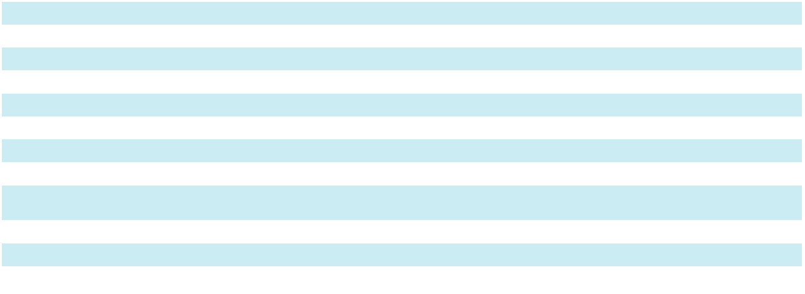
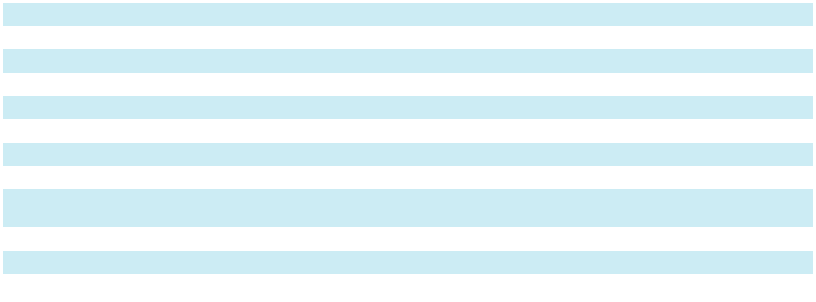

73

SKYWARD SPECIALTY INSURANCE GROUP, INC. AND SUBSIDIARIES

NOTES TO CONSOLIDATED FINANCIAL STATEMENTS

- Investments (continued)

The amortized cost and estimated fair value of fixed maturity securities, available for sale, at December 31, 2025 by contractual maturity are shown below.

 |  | Amortized |  |  | Fair Value
($ in thousands) |  | Cost |  |  | Fair Value
Due in less than one year | $ | 45,682 |  | $ | 45,478
Due after one year through five years |  | 449,790 |  |  | 449,145
Due after five years through ten years |  | 219,293 |  |  | 224,696
Due after ten years |  | 64,360 |  |  | 63,652
Mortgage-backed securities |  | 559,776 |  |  | 559,637
Other asset-backed securities |  | 509,854 |  |  | 513,695
Total | $ | 1,848,755 |  | $ | 1,856,303
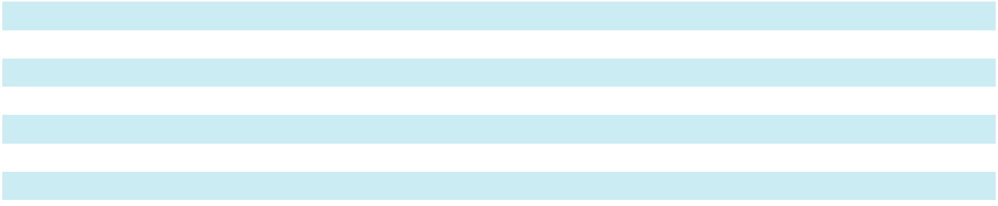

Expected maturities may differ from contractual maturities because borrowers have the right to call or prepay obligations with or without call or prepayment penalties. Also, changing interest rates, tax considerations or other factors may result in portfolio sales prior to maturity.

The Company’s fixed maturity securities, held-to-maturity, at December 31, 2025 consisted entirely of asset backed securities that were not due at a single maturity date.

At December 31, 2025, the Company had U.S. government agencies mortgage-backed fixed maturity securities, with a carrying value of approximately $68.5 million pledged as collateral for a loan (the “FHLB Loan”) from the Federal Home Loan Bank of Dallas (“FHLB”) pursuant to an Advances and Security Agreement between the Company and FHLB (the “Advances and Security Agreement”). In accordance with the terms of the FHLB Loan, the Company retains all rights regarding these pledged securities.

At December 31, 2025, the Company had assets with fair values of approximately $69.5 million pledged as collateral for performance obligations under reinsurance agreements. In accordance with the terms of the trust agreements, the Company retains all rights regarding these securities, of which $57.8 million are residential mortgage-backed securities, $9.5 million of cash and cash equivalents and other assets and $2.2 million of short-term investments.

74

SKYWARD SPECIALTY INSURANCE GROUP, INC. AND SUBSIDIARIES

NOTES TO CONSOLIDATED FINANCIAL STATEMENTS

- Investments (continued)

The following tables set forth the gross unrealized losses and the corresponding fair values of investments, aggregated by length of time that individual securities had been in a continuous unrealized loss position as of December 31, 2025 and 2024:

 |  | Less than 12 Months |  |  |  |  |  | 12 Months or More |  |  |  |  |  | Total
 |  |  |  |  | Gross |  |  |  |  |  | Gross |  |  |  |  |  | Gross
($ in thousands) |  | Fair Value |  |  | Unrealized |  |  | Fair Value |  |  | Unrealized |  |  | Fair Value |  |  | Unrealized
($ in thousands) |  | Fair Value |  |  | Losses |  |  | Fair Value |  |  | Losses |  |  | Fair Value |  |  | Losses
December 31, 2025
Fixed maturity securities, available-
for-sale:
U.S. government securities | $ | 349 | $ |  | (1) | $ |  | 1,565 | $ |  | (13) | $ |  | 1,914 | $ |  | (14)
Corporate securities and |  | 67,644 |  |  | (346) |  |  | 63,575 |  |  | (2,734) |  |  | 131,219 |  |  | (3,080)
miscellaneous |  | 67,644 |  |  | (346) |  |  | 63,575 |  |  | (2,734) |  |  | 131,219 |  |  | (3,080)
Municipal securities |  | 19,157 |  |  | (400) |  |  | 22,004 |  |  | (1,900) |  |  | 41,161 |  |  | (2,300)
Residential mortgage-backed |  | 56,147 |  |  | (262) |  |  | 74,075 |  |  | (9,224) |  |  | 130,222 |  |  | (9,486)
securities |  | 56,147 |  |  | (262) |  |  | 74,075 |  |  | (9,224) |  |  | 130,222 |  |  | (9,486)
Commercial mortgage-backed |  | 4,646 |  |  | (3) |  |  | 8,363 |  |  | (594) |  |  | 13,009 |  |  | (597)
securities |  | 4,646 |  |  | (3) |  |  | 8,363 |  |  | (594) |  |  | 13,009 |  |  | (597)
Other asset-backed securities |  | 85,098 |  |  | (424) |  |  | 16,081 |  |  | (929) |  |  | 101,179 |  |  | (1,353)
Total fixed maturity securities, |  | 233,041 |  |  | (1,436) |  |  | 185,663 |  |  | (15,394) |  |  | 418,704 |  |  | (16,830)
available-for-sale |  | 233,041 |  |  | (1,436) |  |  | 185,663 |  |  | (15,394) |  |  | 418,704 |  |  | (16,830)
Fixed maturity securities, held-to-
maturity:
Other asset-backed securities |  | 1,912 |  |  | (48) |  |  | — |  |  | — |  |  | 1,912 |  |  | (48)
Total fixed maturity securities, |  | 1,912 |  |  | (48) |  |  | — |  |  | — |  |  | 1,912 |  |  | (48)
held-to-maturity: |  | 1,912 |  |  | (48) |  |  | — |  |  | — |  |  | 1,912 |  |  | (48)
Total | $ | 234,953 |  | $ | (1,484) |  | $ | 185,663 |  | $ | (15,394) |  | $ | 420,616 |  | $ | (16,878)
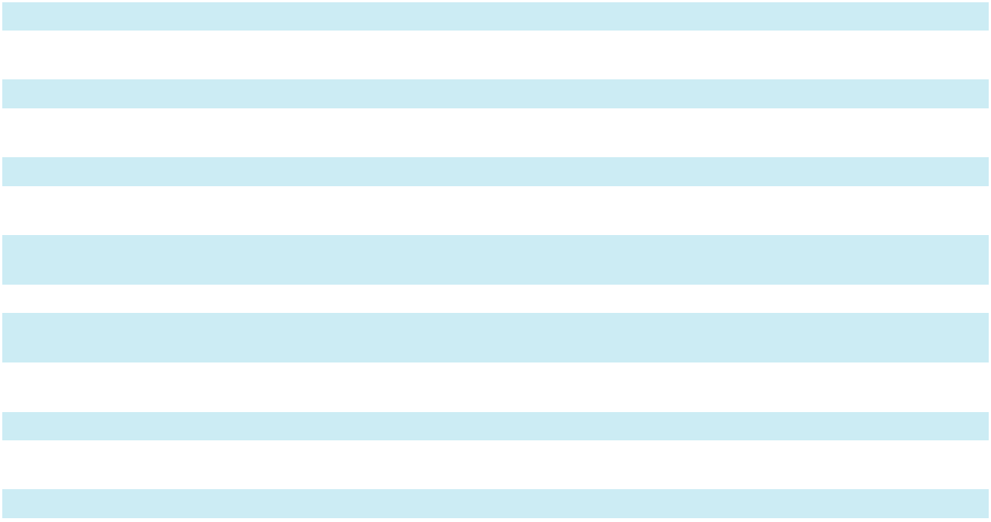

75

SKYWARD SPECIALTY INSURANCE GROUP, INC. AND SUBSIDIARIES

NOTES TO CONSOLIDATED FINANCIAL STATEMENTS

- Investments (continued)

 |  | Less than 12 Months |  |  |  |  |  | 12 Months or More |  |  |  |  |  | Total
 |  |  |  |  | Gross |  |  |  |  |  | Gross |  |  |  |  |  | Gross
($ in thousands) |  | Fair Value |  |  | Unrealized |  |  | Fair Value |  |  | Unrealized |  |  | Fair Value |  |  | Unrealized
($ in thousands) |  | Fair Value |  |  | Losses |  |  | Fair Value |  |  | Losses |  |  | Fair Value |  |  | Losses
December 31, 2024
Fixed maturity securities, available-
for-sale:
U.S. government securities | $ | 15,938 | $ |  | (34) | $ |  | 2,297 | $ |  | (92) | $ |  | 18,235 | $ |  | (126)
Corporate securities and |  | 136,888 |  |  | (2,060) |  |  | 81,232 |  |  | (11,228) |  |  | 218,120 |  |  | (13,288)
miscellaneous |  | 136,888 |  |  | (2,060) |  |  | 81,232 |  |  | (11,228) |  |  | 218,120 |  |  | (13,288)
Municipal securities |  | 41,930 |  |  | (1,046) |  |  | 27,687 |  |  | (4,320) |  |  | 69,617 |  |  | (5,366)
Residential mortgage-backed |  | 201,407 |  |  | (3,366) |  |  | 82,496 |  |  | (13,261) |  |  | 283,903 |  |  | (16,627)
securities |  | 201,407 |  |  | (3,366) |  |  | 82,496 |  |  | (13,261) |  |  | 283,903 |  |  | (16,627)
Commercial mortgage-backed |  | 9,411 |  |  | (126) |  |  | 13,178 |  |  | (1,317) |  |  | 22,589 |  |  | (1,443)
securities |  | 9,411 |  |  | (126) |  |  | 13,178 |  |  | (1,317) |  |  | 22,589 |  |  | (1,443)
Other asset-backed securities |  | 75,119 |  |  | (721) |  |  | 29,851 |  |  | (1,113) |  |  | 104,970 |  |  | (1,834)
Total fixed maturity securities, |  | 480,693 |  |  | (7,353) |  |  | 236,741 |  |  | (31,331) |  |  | 717,434 |  |  | (38,684)
available-for-sale |  | 480,693 |  |  | (7,353) |  |  | 236,741 |  |  | (31,331) |  |  | 717,434 |  |  | (38,684)
Fixed maturity securities, held-to-
maturity:
Other asset-backed securities |  | 2,144 |  |  | (2) |  |  | 36,573 |  |  | (434) |  |  | 38,717 |  |  | (436)
Total fixed maturity securities, |  | 2,144 |  |  | (2) |  |  | 36,573 |  |  | (434) |  |  | 38,717 |  |  | (436)
held-to-maturity: |  | 2,144 |  |  | (2) |  |  | 36,573 |  |  | (434) |  |  | 38,717 |  |  | (436)
Total | $ | 482,837 | $ |  | (7,355) | $ |  | 273,314 | $ |  | (31,765) | $ |  | 756,151 | $ |  | (39,120)

The Company regularly monitors its available-for-sale fixed maturity securities that have fair values less than cost or amortized cost for signs of impairment, an assessment that requires significant management judgment regarding the evidence known. Such judgments could change in the future as more information becomes known, which could negatively impact the amounts reported. Among the factors that management considers for fixed maturity securities are the financial condition of the issuer including receipt of scheduled principal and interest cash flows, and intent to sell, including if it is more likely than not that the Company will be required to sell the investments before recovery.

As of December 31, 2025, the Company had 450 lots of fixed maturity securities in an unrealized loss position. The Company does not have an intent to sell these securities and it is not more likely than not that the Company will be required to sell these securities before maturity or recovery of its cost basis. The Company reviewed its investments at December 31, 2025 and determined that for two available-for-sale securities in the “corporate securities and miscellaneous” category, credit impairments existed, based on new recovery analysis that showed deteriorating conditions raising credit concerns. Other than the securities discussed previously, the Company determined that no other credit impairment existed in the gross unrealized holding losses, due to the reasons discussed below:

- U.S. government securities and municipal securities: These securities were issued by the U.S. Treasury Department, Federal government-sponsored entities or by state and local governments. The decline in fair values was attributable to changes in interest rates and not credit quality. The Company does not intend to sell these securities and it is likely that it will not do so before their anticipated recovery. Therefore, the Company does not consider these impaired securities.

- Corporate securities and miscellaneous: Corporations in various industries issued these securities. The decline in fair values was attributable to changes in interest rates and not credit quality. The Company reviewed the issuers of these securities to identify any significant adverse change in financial condition, a change in the quality of credit enhancement (if any), a ratings decrease, or negative outlook assignment from a major credit rating agency, and any failure to make interest or principal payments. After these reviews, the Company determined that the decline in fair values was attributable to changes in interest rates and not credit quality. The Company does not intend to sell these securities and it is likely that it will not do so before their anticipated recovery. Therefore, the Company does not consider these impaired securities.

76

SKYWARD SPECIALTY INSURANCE GROUP, INC. AND SUBSIDIARIES

NOTES TO CONSOLIDATED FINANCIAL STATEMENTS

- Investments (continued)

  - Residential mortgage-backed securities, commercial mortgage-backed securities, and other asset-backed securities: The decline in fair values was attributable to changes in interest rates and not credit quality. The Company does not intend to sell these securities and it is likely that it will not do so before their anticipated recovery. Therefore, the Company does not consider these impaired securities.

The following table sets forth the changes in the allowance for credit losses on available-for-sale securities and held-to-maturity securities during the years ended December 31, 2025 and 2024:

 |  | Fixed Maturity Securities, |  |  | Fixed Maturity Securities,
($ in thousands) |  | Available-For-Sale |  |  | Held-to-Maturity
Balance at December 31, 2024 | $ | — | $ |  | 243
Current period provision for credit losses |  | 7,000 |  |  | 257
Recoveries of amounts previously written off |  | — |  |  | (32)
Balance at December 31, 2025 | $ | 7,000 | $ |  | 468
 |  |  |  |  | Fixed Maturity Securities,
 |  |  |  |  | Held-to-Maturity
Balance at December 31, 2023 |  |  | $ |  | 329
Current period provision for credit losses |  |  | $ |  | 18
Recoveries of amounts previously written off |  |  |  | $ | (104)
Balance at December 31, 2024 |  |  | $ |  | 243


The following table sets forth the components of net investment gains for the years ended December 31, 2025, 2024 and 2023:

($ in thousands) |  | 2025 |  |  | 2024 |  |  | 2023
Gross realized gains
Fixed maturity securities, available-for-sale | $ | 3,002 | $ |  | 2,662 | $ |  | 1,042
Equity securities |  | 34,262 |  |  | 8,062 |  |  | 6,035
Other |  | 685 |  |  | 213 |  |  | 2
Total |  | 37,949 |  |  | 10,937 |  |  | 7,079
Gross realized losses
Fixed maturity securities, available-for-sale |  | (10,832) |  |  | (8,161) |  |  | (1,879)
Equity securities |  | (3,000) |  |  | (4,132) |  |  | (5,256)
Other |  | (413) |  |  | (223) |  |  | (20)
Total |  | (14,245) |  |  | (12,516) |  |  | (7,155)
Net unrealized gains (losses) on investments
Equity securities |  | (22,908) |  |  | 7,500 |  |  | 11,516
Mortgage loans |  | (7) |  |  | 421 |  |  | (386)
Other |  | 21,360 |  |  | — |  |  | —
Net investment gains | $ | 22,149 | $ |  | 6,342 | $ |  | 11,054
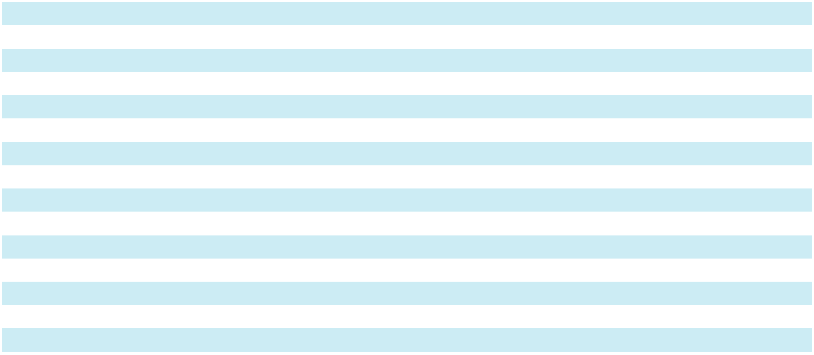

The following table sets forth the proceeds from sales of available-for-sale fixed maturity securities and equity securities for the years ended December 31, 2025, 2024 and 2023:

($ in thousands) |  | 2025 |  |  | 2024 |  |  | 2023
Fixed maturity securities, available-for-sale | $ | 198,195 | $ |  | 217,468 | $ |  | 26,626
Equity securities |  | 126,738 |  |  | 37,534 |  |  | 40,201

77

SKYWARD SPECIALTY INSURANCE GROUP, INC. AND SUBSIDIARIES

NOTES TO CONSOLIDATED FINANCIAL STATEMENTS

- Investments (continued)

The following table sets forth the components of net investment income for the years ended December 31, 2025, 2024 and 2023:

($ in thousands) |  | 2025 |  |  | 2024 |  |  | 2023
Income (loss):
Fixed maturity securities, available-for-sale | $ | 80,302 | $ |  | 57,574 | $ |  | 34,703
Fixed maturity securities, held-to-maturity |  | (804) |  |  | 4,091 |  |  | 4,181
Equity securities |  | 1,223 |  |  | 2,720 |  |  | 3,418
Equity method investments |  | (2,683) |  |  | 2,524 |  |  | (9,434)
Mortgage loans |  | 1,622 |  |  | 5,153 |  |  | 5,474
Indirect loans |  | (8,129) |  |  | (2,400) |  |  | (4,155)
Short-term investments and cash |  | 12,828 |  |  | 14,851 |  |  | 11,392
Other |  | 3,307 |  |  | 3,000 |  |  | 318
Total investment income |  | 87,666 |  |  | 87,513 |  |  | 45,897
Investment expenses |  | (4,047) |  |  | (6,913) |  |  | (5,557)
Net investment income | $ | 83,619 | $ |  | 80,600 | $ |  | 40,340
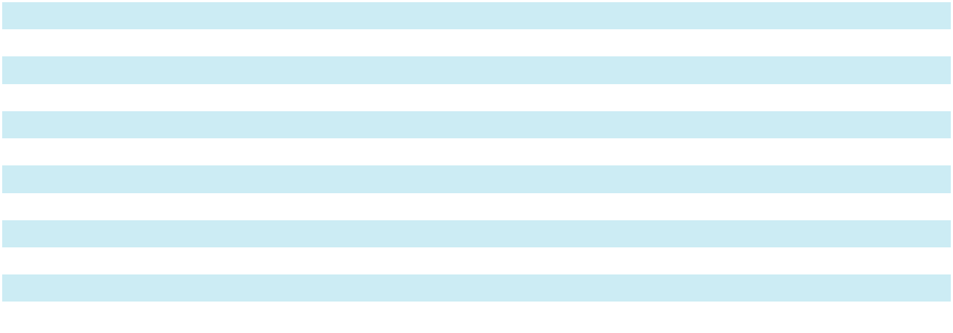

The following table sets forth the change in net unrealized gains on the Company’s investment portfolio, net of deferred income taxes, included in other comprehensive loss for the years ended December 31, 2025, 2024 and 2023:

($ in thousands) |  | 2025 |  |  | 2024 |  |  | 2023
Fixed maturity securities | $ | 42,594 | $ |  | 1,046 | $ |  | 25,952
Deferred income taxes |  | (9,017) |  |  | (213) |  |  | (5,420)
Total | $ | 33,577 | $ |  | 833 | $ |  | 20,532

Various state regulations require the Company to maintain cash, investment securities or letters of credit on deposit with the states in a depository account. At December 31, 2025 and 2024, cash and investment securities on deposit had carrying values of approximately $70.0 million and $66.8 million, respectively.

78

SKYWARD SPECIALTY INSURANCE GROUP, INC. AND SUBSIDIARIES

NOTES TO CONSOLIDATED FINANCIAL STATEMENTS

- Fair Value Measurements

The Company’s financial instruments include assets and liabilities carried at fair value, as well as assets and liabilities carried at cost or amortized cost but disclosed at fair value in its consolidated financial statements. In determining fair value, the market approach is generally applied, which uses prices and other relevant data based on market transactions involving identical or comparable assets and liabilities.

The Company uses data primarily provided by third-party investment managers or pricing vendors to determine the fair value of its investments. Periodic analyses are performed on prices received from third parties to determine whether the prices are reasonable estimates of fair value. The analyses include a review of month-to-month price fluctuations and, as needed, a comparison of pricing services’ valuations to other pricing services’ valuations for the identical security.

The Company classifies its financial instruments into the following three-level hierarchy:

Level 1 - Inputs are unadjusted, quoted prices for identical assets or liabilities in active markets at the measurement date.

Level 2 - Inputs are other than quoted prices included in Level 1 that are observable for the asset or liability through corroboration with market data at the measurement date.

Level 3 - Unobservable inputs that reflect management’s best estimate of what market participants would use in pricing the asset or liability at the measurement date.

The following methods and assumptions were used in estimating the fair value disclosures for financial instruments in the accompanying consolidated financial statements and in these notes:

U.S. government securities, mutual funds and common stock

The Company uses unadjusted quoted prices for identical instruments in an active exchange to measure fair value which represent Level 1 inputs.

Preferred stocks, municipal securities, corporate securities and miscellaneous

The Company uses a pricing model that utilizes market-based inputs such as trades in an illiquid market for a particular security or trades in active markets for securities with similar characteristics. The model considers other inputs such as benchmark yields, issuer spreads, security terms and conditions, and other market data. These represent Level 2 fair value inputs.

Commercial mortgage-backed securities, residential mortgage-backed securities and other asset-backed securities

The Company uses a pricing model that utilizes market-based inputs that may include dealer quotes, market spreads, and yield curves. It may evaluate individual tranches in a security by determining cash flows using the security’s terms and conditions, collateral performance, credit information benchmark yields and estimated prepayments. These represent Level 2 fair value inputs.

Fixed maturity securities, available for sale classified as Level 3

The Company has corporate securities and miscellaneous, other asset-backed securities that are managed by an independent asset manager and priced by an independent pricing provider. The provider estimates the value of the securities using the discount net present value of cash flows method using an unobservable discount rate. The discount rate spread represents the risk associated with future cash flows, including inflation, opportunity cost and the time value of money. This rate represents Level 3 fair value inputs.

79

SKYWARD SPECIALTY INSURANCE GROUP, INC. AND SUBSIDIARIES

NOTES TO CONSOLIDATED FINANCIAL STATEMENTS

- Fair Value Measurements (continued)

The following table sets forth the range of the discount rate as of December 31, 2025 and 2024:

 | 2025 |  | 2024
High | 11.10 % | 8.00 %
Low | 4.25 % | 5.70 %
Weighted average | 6.40 % | 6.60 %

Mortgage loans

Mortgage loans have variable interest rates and are collateralized by real property. The Company determines fair value of mortgage loans using the income approach utilizing inputs that are observable and unobservable (Level 3). The unobservable input consists of the spread applied to a prime rate used to discount cash flows. The spread represents the incremental cost of capital based on the borrower’s ability to make future payments and the value of the collateral relative to the loan balance and is subject to judgment and uncertainty.

The following table sets forth the range and weighted average, weighted by relative fair value, of the spread as of

December 31, 2025 and 2024:

 | 2025 |  |  | 2024
High |  | 8.34 % | 10.00 %
Low |  | 6.55 % | 7.00 %
Weighted average |  | 7.74 % | 7.93 %

Derivatives

Included in other assets are derivatives which consist of certain exchange traded options contracts entered into by the Company. The fair values of these options are measured using quoted prices in active markets on the relevant exchange, specifically utilizing either the volume-weighted average price of trades in similar contracts during a specified time window, or the last trade settlement price when no trades occur within that period. This method represents Level 1 inputs.

80

SKYWARD SPECIALTY INSURANCE GROUP, INC. AND SUBSIDIARIES

NOTES TO CONSOLIDATED FINANCIAL STATEMENTS

- Fair Value Measurements (continued)

The following tables set forth the Company’s investments and derivatives within the fair value hierarchy at

December 31, 2025 and 2024:

December 31, 2025
($ in thousands) |  | Level 1 |  |  | Level 2 |  |  | Level 3 |  |  | Total
Fixed maturity securities, available-for-sale:
U.S. government securities | $ | 44,468 | $ |  | — | $ |  | — | $ |  | 44,468
Corporate securities and miscellaneous |  | — |  |  | 503,274 |  |  | 133,113 |  |  | 636,387
Municipal securities |  | — |  |  | 102,116 |  |  | — |  |  | 102,116
Residential mortgage-backed securities |  | — |  |  | 486,587 |  |  | — |  |  | 486,587
Commercial mortgage-backed securities |  | — |  |  | 73,050 |  |  | — |  |  | 73,050
Other asset-backed securities |  | — |  |  | 495,891 |  |  | 17,804 |  |  | 513,695
Total fixed maturity securities, available-for-sale |  | 44,468 |  |  | 1,660,918 |  |  | 150,917 |  |  | 1,856,303
Fixed maturity securities, held-to-maturity: |  | — |  |  | — |  |  | 33,603 |  |  | 33,603
Other asset-backed securities |  | — |  |  | — |  |  | 33,603 |  |  | 33,603
Total fixed maturity securities, held-to-maturity |  | — |  |  | — |  |  | 33,603 |  |  | 33,603
Equity securities:
Preferred stocks |  | — |  |  | 1,174 |  |  | — |  |  | 1,174
Total equity securities |  | — |  |  | 1,174 |  |  | — |  |  | 1,174
Mortgage loans |  | — |  |  | — |  |  | 9,902 |  |  | 9,902
Short-term investments |  | 264,299 |  |  | — |  |  | — |  |  | 264,299
Derivatives |  | 34,857 |  |  | — |  |  | — |  |  | 34,857
Total | $ | 343,624 |  | $ | 1,662,092 |  | $ | 194,422 |  | $ | 2,200,138
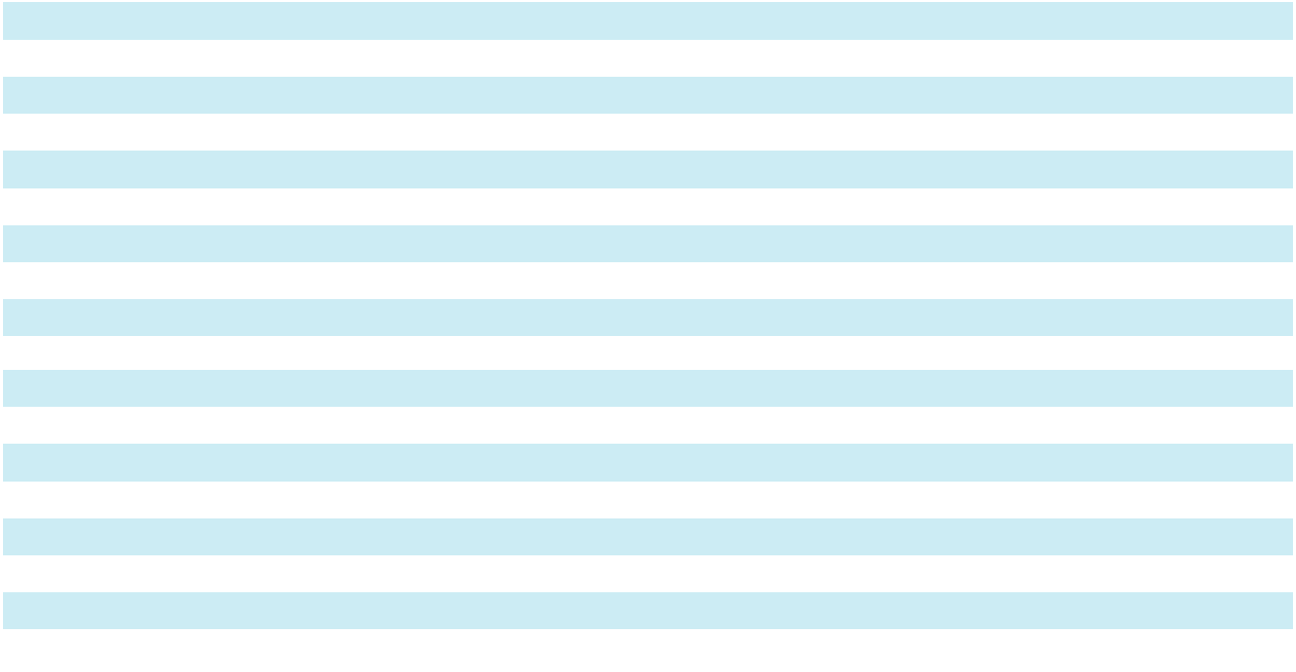

81

SKYWARD SPECIALTY INSURANCE GROUP, INC. AND SUBSIDIARIES

NOTES TO CONSOLIDATED FINANCIAL STATEMENTS

- Fair Value Measurements (continued)

December 31, 2024
($ in thousands) |  | Level 1 |  |  | Level 2 |  |  | Level 3 |  |  | Total
Fixed maturity securities, available-for-sale:
U.S. government securities | $ | 26,486 | $ |  | — | $ |  | — | $ |  | 26,486
Corporate securities and miscellaneous |  | — |  |  | 354,815 |  |  | 70,813 |  |  | 425,628
Municipal securities |  | — |  |  | 84,716 |  |  | — |  |  | 84,716
Residential mortgage-backed securities |  | — |  |  | 393,833 |  |  | — |  |  | 393,833
Commercial mortgage-backed securities |  | — |  |  | 69,364 |  |  | — |  |  | 69,364
Other asset-backed securities |  | — |  |  | 285,084 |  |  | 7,107 |  |  | 292,191
Total fixed maturity securities, available-for-sale |  | 26,486 |  |  | 1,187,812 |  |  | 77,920 |  |  | 1,292,218
Fixed maturity securities, held-to-maturity:
Other asset-backed securities |  | — |  |  | — |  |  | 38,717 |  |  | 38,717
Total fixed maturity securities, held-to-maturity: |  | — |  |  | — |  |  | 38,717 |  |  | 38,717
Equity securities:
Common stocks |  | 64,251 |  |  | — |  |  | — |  |  | 64,251
Preferred stocks |  | — |  |  | 1,164 |  |  | — |  |  | 1,164
Mutual funds |  | 40,839 |  |  | — |  |  | — |  |  | 40,839
Total equity securities |  | 105,090 |  |  | 1,164 |  |  | — |  |  | 106,254
Mortgage loans |  | — |  |  | — |  |  | 26,490 |  |  | 26,490
Short-term investments |  | 274,929 |  |  | — |  |  | — |  |  | 274,929
Total | $ | 406,505 | $ |  | 1,188,976 | $ |  | 143,127 | $ |  | 1,738,608
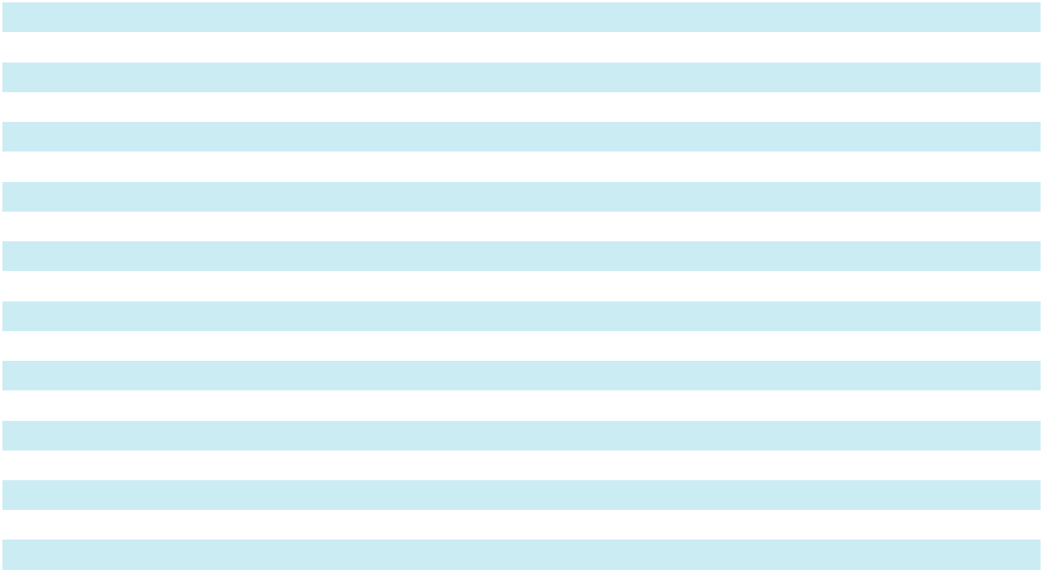

The following tables set forth the changes in the fair value of instruments carried at fair value with a Level 3 measurement during the years ended December 31, 2025 and 2024:

 | Fixed Maturity Securities, |  |  |  | Mortgage Loans
($ in thousands) |  | Available-For-Sale |  |  | Mortgage Loans
Balance at December 31, 2024 | $ | 77,920 | $ |  | 26,490
Total gains (losses) for the period recognized in net investment gains |  | (5,180) |  |  | (7)
(losses) |  | (5,180) |  |  | (7)
Issuances |  | — |  |  | 151
Settlements |  | — |  |  | (16,732)
Transfers into Level 3 |  | 6,143 |  |  | —
Purchases |  | 70,730 |  |  | —
Sales/Disposals |  | (1,493) |  |  | —
Total unrealized gains for the period recognized in accumulated |  | 2,797 |  |  | —
comprehensive income (loss) |  | 2,797 |  |  | —
Balance at December 31, 2025 |  | 150,917 |  |  | 9,902
Total losses for the period recognized in net investment gains
attributable to the change in unrealized gains or losses relating to |  | — |  |  | (201)
assets held as of period end |  | — |  |  | (201)
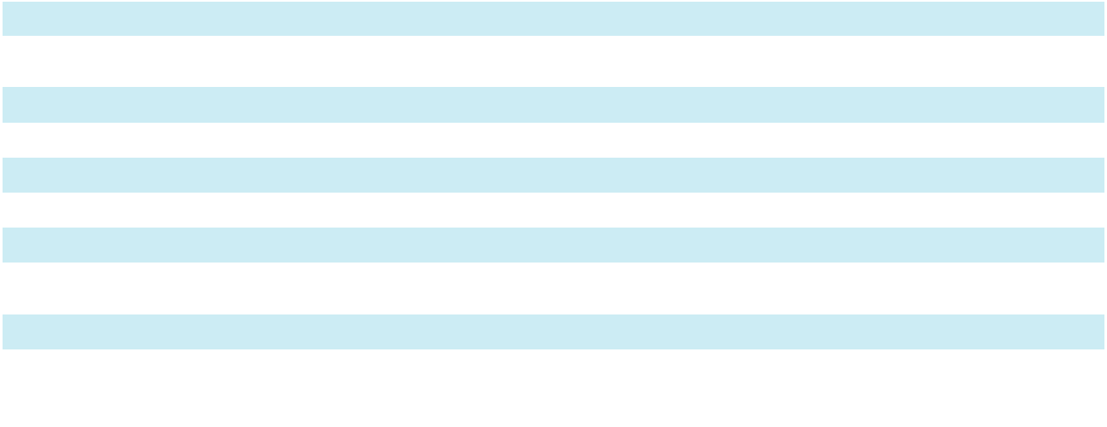

82

SKYWARD SPECIALTY INSURANCE GROUP, INC. AND SUBSIDIARIES

NOTES TO CONSOLIDATED FINANCIAL STATEMENTS

- Fair Value Measurements (continued)

 | Fixed Maturity Securities, |  |  |  | Mortgage Loans
($ in thousands) |  | Available-For-Sale |  |  | Mortgage Loans
Balance at December 31, 2023 | $ | — $ |  |  | 50,070
Total gains (losses) for the period recognized in net investment gains |  | (195) |  |  | 420
(losses) |  | (195) |  |  | 420
Issuances |  | — |  |  | 649
Settlements |  | — |  |  | (24,649)
Purchases |  | 77,979 |  |  | —
Sales/Disposals |  | (374) |  |  | —
Total unrealized gains for the period recognized in accumulated |  | 510 |  |  | —
comprehensive income (loss) |  | 510 |  |  | —
Balance at December 31, 2024 |  | 77,920 |  |  | 26,490
Total gains for the period recognized in net investment gains (losses)
attributable to the change in unrealized gains or losses relating to |  | — |  |  | 411
assets held as of period end |  |  |  |  | 411
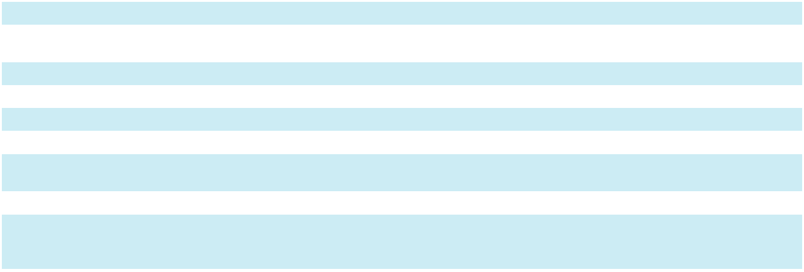

The Company measures certain assets, including investments in indirect loans and loan collateral, equity method investments and other invested assets, at fair value on a nonrecurring basis only when they are deemed to be impaired.

In addition to the preceding disclosures on assets and liabilities recorded at fair value in the Consolidated Balance Sheets, the Company is also required to disclose the fair values of certain other financial instruments for which it is practicable to estimate fair value. Estimated fair value amounts, defined as the quoted market price of a financial instrument, have been determined using available market information and other appropriate valuation methodologies. However, considerable judgments are required in developing the estimates of fair value where quoted market prices are not available. Accordingly, these estimates are not necessarily indicative of the amounts that could be realized in a current market exchange. The use of different market assumptions or estimating methodologies may have an effect on the estimated fair value amounts.

The following methods and assumptions were used in estimating the fair value disclosures of other financial instruments:

Fixed maturity securities, held-to-maturity: Fixed maturity securities, held-to-maturity consists of senior and junior notes with target rates of return. As of December 31, 2025, the Company determined the fair value of these instruments using the income approach utilizing inputs that are unobservable (Level 3).

Investment in RedBird Capital Partners: Included in other long-term investments is an investment in a limited partnership with RedBird Capital Partners, which invests in Bishop Street Underwriters, LLC (“Bishop Street”), a managing general agent (MGA). The investment had a fair value of $55.6 million and $28.2 million at December 31, 2025 and 2024, respectively, which was determined using the net asset value. The Company employs procedures to assess the reasonableness of the fair value of the investment including obtaining and reviewing the audited financial statements. The unfunded commitment related to the investment was $18.3 million and $24.4 million at December 31, 2025 and 2024, respectively. The Company may sell its interest in the investment with the appropriate prior written notice and approval by the general partner. In accordance with Accounting Standard Codification 820-10, this investment is measured at fair value using the net asset value per share practical expedient and has not been classified in the fair value hierarchy. Net earned premiums related to this agreement for the years ended December 31, 2025 and 2024 were $41.5 million and $2.5 million, respectively.

Notes payable: The carrying value approximates the estimated fair value for notes payable as the notes payable accrue interest at current market rates plus a spread. The Company determines fair value using the income approach utilizing inputs that are observable (Level 2).

Subordinated debt: Subordinated debt consists of the Unsecured Subordinated Notes, due May 24, 2039 and have a fixed interest rate. The Company determines the fair value of these instruments using the income approach utilizing inputs that are observable (Level 2).

83

SKYWARD SPECIALTY INSURANCE GROUP, INC. AND SUBSIDIARIES

NOTES TO CONSOLIDATED FINANCIAL STATEMENTS

- Fair Value Measurements (continued)

The following table sets forth the Company’s carrying and fair values of notes payable and subordinated debt as of

December 31, 2025 and 2024:

 |  | 2025 |  |  |  |  |  | 2024
 |  | Carrying |  |  | Fair |  |  | Carrying |  |  | Fair
($ in thousands) |  | Value |  |  | Value |  |  | Value |  |  | Value
Notes payable | $ | 57,000 | $ |  | 57,458
FHLB Loan |  |  |  |  |  | $ |  | 57,000 | $ |  | 56,200
Revolving Credit Facility |  | 114,500 |  |  | 114,500 |  |  | 43,000 |  |  | 43,000
Term Loan Facility |  | 300,000 |  |  | 300,000 |  |  | — |  |  | —
Notes payable | $ | 471,500 |  | $ | 471,958 | $ |  | 100,000 | $ |  | 99,200
Subordinated debt
Subordinated debt | $ | 19,569 |  | $ | 21,020
Unsecured subordinated notes |  |  |  |  |  |  | $ | 19,536 |  | $ | 20,541
Subordinated debt, net of debt issuance costs | $ | 19,569 |  | $ | 21,020 | $ |  | 19,536 | $ |  | 20,541
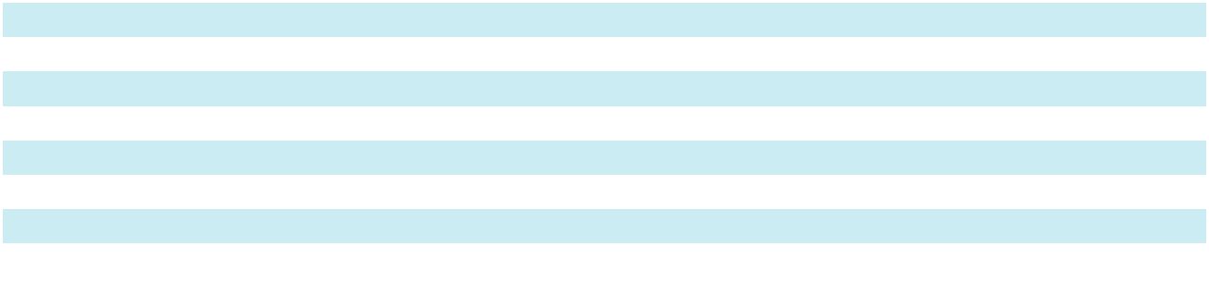

Other financial instruments qualify as insurance-related products and are specifically exempted from fair value disclosure requirements.

- Mortgage Loans

The Company has invested in Separately Managed Accounts (“SMA1” and “SMA2”). As of December 31, 2025 and 2024, the Company held direct investments in mortgage loans from various creditors through SMA1 and SMA2.

The Company’s mortgage loan portfolios are primarily senior loans on real estate across the U.S. The loans earn interest at a fixed spread above a prime rate and mature in approximately 2 to 4 years from loan origination. The principal amounts of the loans are approximately 64% of the property’s appraised value at the time the loans were made.

The following table sets forth the carrying value of the Company’s mortgage loans as of December 31, 2025 and 2024:

($ in thousands) |  | 2025 |  |  | 2024
Commercial | $ | 3,334 | $ |  | 8,474
Retail |  | — |  |  | 10,032
Hospitality |  | 6,568 |  |  | 7,984
 | $ | 9,902 | $ |  | 26,490


The following table sets forth the Company’s gross investment income for mortgage loans for the years ended

December 31, 2025, 2024 and 2023:

($ in thousands) |  | 2025 |  |  | 2024 |  |  | 2023
Commercial | $ | 432 | $ |  | 2,025 | $ |  | 2,340
Retail |  | 304 |  |  | 1,853 |  |  | 1,853
Hospitality |  | 886 |  |  | 1,277 |  |  | 1,034
Office |  | — |  |  | — |  |  | 203
Multi-family |  | — |  |  | — |  |  | 44
 | $ | 1,622 | $ |  | 5,155 | $ |  | 5,474
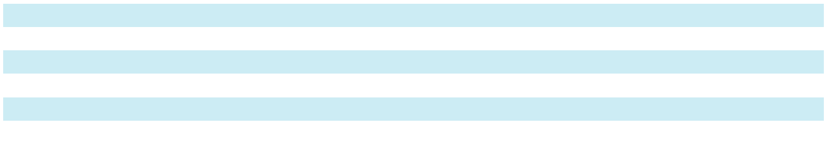

The uncollectible amounts on loans, on an individual loan basis, are determined based upon consultations and advice from the Company’s specialized investment manager and consideration of any adverse situations that could affect the borrower’s ability to repay, the estimated value of underlying collateral, and other relevant factors. The Company writes off the uncollectible amount in the period it was determined to be uncollectible. There was no write-off for uncollectible amounts during the years ended December 31, 2025 and 2024, respectively.

As of December 31, 2025 and 2024, no mortgage loans were in the process of foreclosure and there were no mortgage loans that were not producing income for the previous 12 months.

84

SKYWARD SPECIALTY INSURANCE GROUP, INC. AND SUBSIDIARIES

NOTES TO CONSOLIDATED FINANCIAL STATEMENTS

- Equity Method Investments and Other

The following table sets forth the carrying value and ownership percentage of the Company’s equity method investments as of December 31, 2025 and 2024:

($ in thousands) |  | 2025 |  |  |  |  |  | 2024
 | Carrying Value |  |  |  | Ownership % |  | Carrying Value |  |  |  | Ownership %
Arena Special Opportunities Fund, LP units | $ | 26,936 |  |  | 14.0 % | $ |  | 34,936 |  |  | 15.3 %
Arena SOP LP units |  | — |  |  | 11.2 % |  |  | 1,474 |  |  | 10.9 %
Brewer Lane Ventures Fund II LP units |  | 2,251 |  |  | 2.4 % |  |  | 1,040 |  |  | 2.4 %
Dowling Capital Partners LP units |  | 590 |  |  | 5.0 % |  |  | 666 |  |  | 5.0 %
Hudson Ventures Fund 2 LP units |  | 5,503 |  |  | 2.5 % |  |  | 4,967 |  |  | 2.5 %
JVM Funds LLC units |  | 14,911 |  |  | 10.1 % |  |  | 17,229 |  |  | 10.1 %
RISCOM |  | 3,307 |  |  | 20.0 % |  |  | 5,013 |  |  | 20.0 %
 | $ | 53,498 |  |  |  | $ |  | 65,325
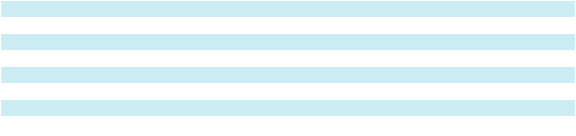

The following table sets forth the components of net investment income (loss) from equity method investments for the years ended December 31, 2025, 2024 and 2023:

($ in thousands) |  | 2025 |  |  | 2024 |  |  | 2023
Arena SOP LP units |  | (1,474) |  |  | (989) |  |  | (6,271)
Arena Special Opportunities Fund, LP units |  | (3,163) |  |  | 2,375 |  |  | (2,880)
Brewer Lane Ventures Fund II LP |  | 91 |  |  | (110) |  |  | (78)
Dowling Capital Partners LP units |  | 431 |  |  | 1,463 |  |  | 927
Hudson Ventures Fund II LP units |  | 480 |  |  | (153) |  |  | 170
JVM Funds LLC |  | (541) |  |  | (1,554) |  |  | (1,198)
RISCOM |  | 1,493 |  |  | 1,492 |  |  | 884
Universa Black Swan LP units |  | — |  |  | — |  |  | (988)
 | $ | (2,683) | $ |  | 2,524 | $ |  | (9,434)
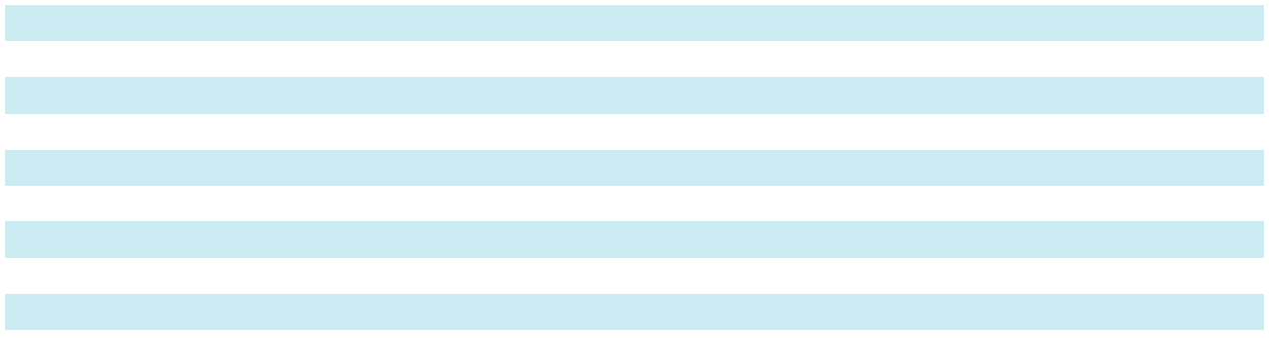

The following table sets forth the unfunded commitment of equity method investments as of December 31, 2025 and 2024:

($ in thousands) |  | 2025 |  |  | 2024
Brewer Lane Ventures Fund II LP units | $ | 3,237 | $ |  | 4,077
Dowling Capital Partners LP units |  | 386 |  |  | 386
Hudson Ventures Fund 2 LP units |  | 166 |  |  | 397
Red Bird Capital Partners LP units |  | 18,305 |  |  | 24,400
 | $ | 22,094 | $ |  | 29,260

The difference between the cost of an investment and its proportionate share of the underlying equity in net assets is allocated to the various assets and liabilities of the equity method investment. The Company amortizes the difference in net assets over the same useful life of a similar asset as the underlying equity method investment. For investment in RISCOM, a similar asset would be agent relationships. The Company amortizes this difference over a 15-year useful life.

85

SKYWARD SPECIALTY INSURANCE GROUP, INC. AND SUBSIDIARIES

NOTES TO CONSOLIDATED FINANCIAL STATEMENTS

- Equity Method Investments and Other (continued)

The following table sets forth the Company’s recorded investment in RISCOM compared to its share of underlying equity as of December 31, 2025 and 2024:

($ in thousands) |  | 2025 |  |  | 2024
Investment in RISCOM:
Underlying equity | $ | 2,292 | $ |  | 3,756
Difference |  | 1,015 |  |  | 1,258
Recorded investment balance | $ | 3,307 | $ |  | 5,013

The following table sets forth the Company’s recorded investment in JVM Funds LLC compared to its share of underlying equity as of December 31, 2025 and 2024:

($ in thousands) |  | 2025 |  |  | 2024
Investment in JVM Funds LLC:
Underlying equity | $ | 14,457 | $ |  | 16,624
Difference |  | 454 |  |  | 605
Recorded investment balance | $ | 14,911 | $ |  | 17,229

Investment in Indirect Loans and Loan Collateral

As of December 31, 2025 and 2024, the Company held indirect investments in collateralized loans and loan collateral through SMA1 and SMA2.

The carrying value of the SMA1 and SMA2 as of December 31, 2025 and 2024 were as follows:

($ in thousands) |  | 2025 |  |  | 2024
SMA1 | $ | 15,418 | $ |  | 20,296
SMA2 |  | 8,449 |  |  | 12,973
Investment in indirect loans and loan collateral | $ | 23,867 | $ |  | 33,269

- Variable Interest Entity

Pursuant to GAAP consolidation guidance, Skyward consolidates Separate Account HSIC-01 (“HSIC-01”), established by Mangrove Risk Solutions Bermuda Ltd. (“Mangrove”). HSIC-01 is a VIE for which the Company is the primary beneficiary. The purpose of the VIE is to hedge price volatility risks of certain insurance products by investing in dairy and livestock commodities. The Company directly manages the business; therefore, it considers itself the primary beneficiary. The Company does not provide performance guarantees and has no other financial obligation to provide funding to HSIC-01, other than its own capital commitments. The assets of consolidated variable interest entities may only be used to settle obligations of these entities. In addition, there is no recourse to the assets of HSIC-01 other than to satisfy associated liabilities.

The following table presents the assets of HSIC-01, included in the Consolidated Balance Sheets as of December 31, 2025. The assets presented below only include third-party net assets and exclude any intercompany balances, which were eliminated upon consolidation:

($ in thousands) |  | 2025
Assets | $ | 15,816
Cash and cash equivalents | $ | 15,816
Other assets |  | 34,856
Total assets | $ | 50,672


8. Derivatives

The Company uses derivatives as part of its financial risk management programs to mitigate price risk related to certain insurance contracts exposed to commodity price risk due to fluctuations in relevant market prices, including cattle

86

SKYWARD SPECIALTY INSURANCE GROUP, INC. AND SUBSIDIARIES

NOTES TO CONSOLIDATED FINANCIAL STATEMENTS

8. Derivatives (continued)

and milk. To mitigate revenue volatility and support financial stability, the Company employs a hedging strategy that utilizes derivatives, specifically put options and futures, as part of its risk management framework. The primary objective of holding these derivative instruments is to manage exposure to adverse price movements. The activity in these instruments generally reflects current market conditions and shifts in risk exposures throughout the year. The notional value of derivative contracts held and the degree of hedged exposure are actively managed and may vary depending on the prevailing pricing environment in cattle, hogs, and milk markets. The Company does not use derivatives for speculative or trading purposes. All derivative positions are intended to support the overall risk transfer objectives of the business. The Company has not elected hedge accounting for these derivatives.

The following table presents the notional amounts and fair value of derivative assets in the Consolidated Balance Sheets at December 31, 2025:

($ in thousands) |  | Derivative Assets
 | Notional Amount |  |  |  | Fair Value
Economic hedges | $ | 136,800 |  | $ | 34,857

The Company presents the net gain (loss) recognized on derivative instruments in economic hedging relationships in “losses and loss adjustment expenses” on the Consolidated Statements of Operations. For the years ended December 31, 2025, the Company recognized $7.9 million, respectively, of pre-tax net gains in losses and loss adjustment expenses.

- Allowance for Credit Losses

Premiums Receivable

The following tables set forth the changes in the allowance for expected credit losses on premiums receivable for the years ended December 31, 2025 and 2024:

 | Premiums Receivable, |  |  |  | Allowance for Estimated
($ in thousands) |  | Net |  |  | Uncollectible Premiums
Balance at December 31, 2024 | $ | 321,641 |  | $ | 2,432
Current period change for estimated uncollectible premiums |  |  |  |  | 2,351
Write-offs of uncollectible premiums receivable |  |  |  |  | (2,141)
Recoveries of amounts previously written off |  |  |  |  | 498
Balance at December 31, 2025 | $ | 544,217 |  | $ | 3,140
 | Premiums Receivable, |  |  |  | Allowance for Estimated
($ in thousands) |  | Net |  |  | Uncollectible Premiums
Balance at December 31, 2023 | $ | 179,235 | $ |  | 964
Current period change for estimated uncollectible premiums |  |  |  |  | 3,235
Write-offs of uncollectible premiums receivable |  |  |  |  | (1,895)
Recoveries of amounts previously written off |  |  |  |  | 128
Balance at December 31, 2024 | $ | 321,641 | $ |  | 2,432


87

SKYWARD SPECIALTY INSURANCE GROUP, INC. AND SUBSIDIARIES

NOTES TO CONSOLIDATED FINANCIAL STATEMENTS

- Allowance for Credit Losses (continued)

Reinsurance Recoverables

The Company analyzes the credit risk associated with its reinsurance recoverables by monitoring the financial strength rating of its reinsurers from A.M. Best, a widely recognized rating agency with an exclusive insurance industry focus. The Company assesses the financial strength rating annually and throughout the year as A.M. Best provides updates on ratings and outlooks. The Company assesses the adequacy of various forms of credit enhancements such as reinsurance payables, letters of credit and funds held. The following table sets forth the Company’s reinsurance recoverables net of credit enhancements by A.M. Best as of December 31, 2025:

 |  | 2025
A.M. Best Rating | Reinsurance Recoverables, |  |  | Percent of Total
A.M. Best Rating |  | Gross, Amortized Cost |  | Percent of Total
A- and above | $ | 652,178 |  | 98.2 %
B++ to B+ |  | 5,077 | 0.8
B to B - |  | 28 |  | —
Not rated |  | 6,919 | 1.0


The Company considers reinsurance balances to be past due when they are 90 days past due. The following tables set forth the changes in the allowance for estimated uncollectible reinsurance for the years ended December 31, 2025 and 2024:

 |  | Reinsurance |  |  | Allowance for Estimated
($ in thousands) |  | Recoverables, Net |  | Uncollectible Reinsurance
Balance at December 31, 2024 | $ | 857,876 |  | $ | 2,295
Balance at December 31, 2025 | $ | 1,119,880 |  | $ | 2,295
 |  | Reinsurance |  |  | Allowance for Estimated
($ in thousands) |  | Recoverables, Net |  | Uncollectible Reinsurance
Balance at December 31, 2023 | $ | 596,334 | $ |  | 2,295
Current period change for estimated uncollectible reinsurance |  |  |  |  | 13,585
Write-offs of uncollectible reinsurance recoverables |  |  |  |  | (13,585)
Balance at December 31, 2024 | $ | 857,876 | $ |  | 2,295

On January 31, 2025, the Company commuted the LPT with R&Q Re (Bermuda) Ltd. ("R&Q") related to accident years 2018 and prior. During the year ended December 31, 2024, the Company recognized the uncollectible reinsurance recoverable balance related to the LPT as a net increase of $13.6 million to the allowance for estimated uncollectible reinsurance, which was subsequently written-off.

- Property and Equipment

The following table presents the components of property and equipment as of December 31, 2025 and 2024, which are included within other assets on the Consolidated Balance Sheets:

(in thousands) |  | 2025 |  |  | 2024
Leasehold improvements | $ | 3,434 | $ |  | 3,056
Equipment |  | 4,750 |  |  | 4,506
Software |  | 39,263 |  |  | 33,972
 |  | 47,447 |  |  | 41,534
Accumulated depreciation |  | (32,307) |  |  | (29,355)
Total | $ | 15,140 | $ |  | 12,179


88

SKYWARD SPECIALTY INSURANCE GROUP, INC. AND SUBSIDIARIES

NOTES TO CONSOLIDATED FINANCIAL STATEMENTS

- Property and Equipment (continued)

Depreciation expense related to property and equipment was $3.3 million, $2.9 million, and $3.2 million for the years ended December 31, 2025, 2024 and 2023, respectively, which is presented in underwriting, acquisition and insurance expenses on the Consolidated Statements of Operations.

- Notes Payable & Subordinated Debt

FHLB Loan

On August 30, 2024, the Company entered into the FHLB Loan pursuant to the Advances and Security Agreement. The FHLB Loan is a 4.5-year term loan in the principal amount of $57.0 million. The FHLB Loan provides for interest-only payments during its term, with principal due in full at maturity. The interest rate is fixed over the term of the loan at 4.00%. The FHLB Loan is fully secured by a pledge of specific investment securities of HSIC. The Company used the proceeds to fund redemptions of the draws on the 2023 Revolving Credit Facility (see “Revolving Credit Facilities” below).

Term Loan Facility

During the fourth quarter of 2025, the Company entered into a Term Loan Credit Agreement (the “Term Loan Facility”) with a syndicate of participating banks. The Term Loan Facility includes (a) an unsecured senior delayed draw term loan facility (“DDTL”) in the aggregate principal amount of $150.0 million (the “Tranche A DDTL”) and (b) an additional unsecured senior DDTL in the aggregate principal amount of $150.0 million (the “Tranche B DDTL” and together with the Tranche A DDTL, the “Term Loan Facility”).

The Term Loan Facility was used by the Company to fund a portion of the consideration of the Company’s acquisition of Apollo Group Holdings Limited (“Apollo”) and related transaction fees and expenses. Amounts drawn under the Term Loan Facility bear interest at either term SOFR plus a margin, which ranges from 150 basis points to 190 basis points, or the base rate plus a margin, which ranges from 50 basis points to 90 basis points, each depending on the Company’s debt to capitalization ratio. SOFR is calculated using a SOFR floor of 0.00% and a credit spread adjustment of 0.10%. The base rate is the highest of (i) the Agent’s then-current prime lending rate, (ii) the Federal Funds Rate plus 0.50%, (iii) SOFR plus 1.00% and (iv) zero percent (0%). In addition, the Company pays a fee ranging from 0.20% to 0.35% on average daily undrawn amounts under the Facility, depending on the Company’s debt to capitalization ratio. The Tranche A DDTL matures on January 1, 2028 and the Tranche B DDTL matures on July 2, 2029. On December 30, 2025, the Company drew $150.0 million of the Tranche A DDTL and $150.0 million of the Tranche B DDTL for the acquisition of Apollo on January 1, 2026.

The Term Loan Facility includes customary covenants, including certain limitations on the incurrence by the Company of additional indebtedness exceeding $10.0 million and on the Company’s ability to make distributions to its stockholders, or redeem, repurchase or retire shares of stock, upon the occurrence of certain events and certain financial covenants, including financial covenants relating to our minimum consolidated net worth, maximum total debt to capitalization, minimum A.M. Best rating and minimum liquidity, as well as customary events of default. As of December 31, 2025, the Company was in compliance with all covenants.

The Term Loan Facility is unsecured. In connection with the Revolving Credit Facility (defined below), during the fourth quarter of 2025, the Company and the subsidiary guarantors party thereto, entered into a guaranty agreement, pursuant to which the Company’s obligations under the Term Loan Facility are guaranteed by the Company and its existing wholly-owned subsidiaries and subsequently acquired or organized subsidiaries, excluding insurance company subsidiaries and subject to certain other exceptions.

Revolving Credit Facilities

During the fourth quarter of 2025, the Company, entered into a Credit Agreement (the “Revolving Credit Facility”) with a syndicate of participating banks. The Revolving Credit Facility is unsecured and provided the Company with up to a initial maximum principal amount of $150.0 million which was increased to $250.0 million on the closing date of the Company’s acquisition of Apollo.

The Company initially drew $43.0 million, which was used to redeem the Company’s prior revolving credit facility (described below). On December 30, 2025, the company drew an additional $71.5 million which was used for the consideration paid for the acquisition of Apollo. The proceeds from the draws on the Term Loan Facility and the draw of the Revolving Credit Facility are presented net with the liabilities on the Consolidated Balance Sheets for the year ended December 31, 2025. The proceeds were used for the acquisition of Apollo on January 1, 2026.

89

SKYWARD SPECIALTY INSURANCE GROUP, INC. AND SUBSIDIARIES

NOTES TO CONSOLIDATED FINANCIAL STATEMENTS

- Notes Payable & Subordinated Debt (continued)

Interest on the Revolving Credit Facility is payable quarterly. Amounts drawn under the Facility bear interest at either term SOFR plus a margin, which will range from 150 and 190 basis points, or the base rate plus a margin, which ranges from 50 basis points to 90 basis points, each depending on the Company’s debt to capitalization ratio. SOFR is calculated using a SOFR floor of 0.00% and a credit spread adjustment of 0.10%. The base rate is the highest of (i) the Agent’s then current prime lending rate, (ii) the Federal Funds Rate plus 0.50%, (iii) SOFR plus 1.00% and (iv) zero percent (0%). In addition, the Company pays a fee ranging from 0.20% to 0.35% on average daily undrawn amounts under the Facility, depending on the Company’s debt to capitalization ratio. The availability period under the Facility will terminate on November 12, 2030.

The Company is subject to covenants on the Revolving Credit Facility based on minimum net worth, maximum debt to capital ratio, minimum A.M. Best Rating and minimum liquidity, as well as customary events of default. As of December 31, 2025, the Company was in compliance with all covenants.

During the first quarter of 2023, the Company entered into an agreement to obtain a unsecured revolving credit facility (the “2023 Revolving Credit Facility”) with a syndicate of participating banks. The 2023 Revolving Credit Facility provided the Company with up to a $150.0 million revolving credit facility and a letter of credit sub-facility of up to $30.0 million. On November 13, 2025, the Company redeemed the 2023 Revolving Credit Facility, paid $0.3 million of accrued interest and recognized $0.6 million of expense for the remaining unamortized deferred financing costs.

Debentures

In May 2019, the Company entered into an agreement to issue unsecured subordinated notes (the “Notes”) with an aggregate principal amount of $20.0 million. Interest on the Notes is fixed at 7.25% for the first 8 years and fixed at 8.25% thereafter. Early retirement of the debt ahead of 8 year commitment requires all interest payments to be paid in full as well as the return of outstanding principal. Principal is due at maturity on May 24, 2039 and interest is payable quarterly. The Notes have junior priority to all previously issued debt. The Company reports debt related to the Notes in its December 31, 2025 and 2024 Consolidated Balance Sheets, net of debt issuance costs of approximately $0.4 million and $0.5 million, respectively. These deferred financing costs are presented as a direct deduction from the carrying amount of the subordinated debt.

- Segment

The Company has one reportable segment through which it offers a broad array of commercial property and casualty products and solutions on a non-admitted (or E&S) and admitted basis, predominantly in the United States. The segment is made up of nine distinct underwriting divisions, or “continuing business,” and has dedicated underwriting leadership supported by high-quality technical staff with deep experience in their respective niches. The Company defines its segment on the basis of the way in which internally reported financial information is regularly reviewed by the Chief Operating Decision Maker (“CODM”) to analyze financial performance, make decisions and allocate resources. The Company’s CODM is the chief executive officer.

The accounting policies of the segment are the same as those described in Note 1 “Summary of Significant Accounting Policies” of this Form 10-K. The CODM assesses performance for the segment and decides how to allocate resources based on gross written premiums by net underwriting division, underwriting income, and income before income taxes that also is reported on the Consolidated Statements of Operations as consolidated income before income taxes. The measure of segment assets is reported on the Consolidated Balance Sheets as total consolidated assets.

Gross written premiums by underwriting division, net underwriting income, and consolidated net income are used to monitor budget versus actual results. The chief operating decision maker also uses net underwriting income, annualized return on equity and growth in book value per share in competitive analysis by benchmarking to the Company’s competitors. The competitive analysis along with the monitoring of budgeted versus actual results are used in assessing performance of the segment and in establishing management’s compensation.

90

SKYWARD SPECIALTY INSURANCE GROUP, INC. AND SUBSIDIARIES

NOTES TO CONSOLIDATED FINANCIAL STATEMENTS

12. Segment (continued)

The following table presents gross written premiums by underwriting division for the years ended December 31, 2025,

2024 and 2023:

($ in thousands) |  | 2025 |  |  | 2024 |  |  | 2023
Accident & Health | $ | 254,102 | $ |  | 173,073 | $ |  | 151,701
Agriculture and Credit (Re)insurance |  | 346,212 |  |  | 118,070 |  |  | 30,598
Captives |  | 275,694 |  |  | 241,902 |  |  | 167,624
Construction & Energy Solutions |  | 274,318 |  |  | 296,582 |  |  | 299,748
Global Property |  | 178,128 |  |  | 201,796 |  |  | 242,593
Professional Lines |  | 149,231 |  |  | 159,785 |  |  | 154,565
Specialty Programs |  | 322,705 |  |  | 218,407 |  |  | 178,726
Surety |  | 168,148 |  |  | 143,965 |  |  | 106,056
Transactional E&S |  | 197,779 |  |  | 189,669 |  |  | 128,236
Total continuing business |  | 2,166,317 |  |  | 1,743,249 | $ |  | 1,459,847
Exited business |  | (81) |  |  | (17) |  |  | (18)
Total gross written premiums | $ | 2,166,236 | $ |  | 1,743,232 | $ |  | 1,459,829
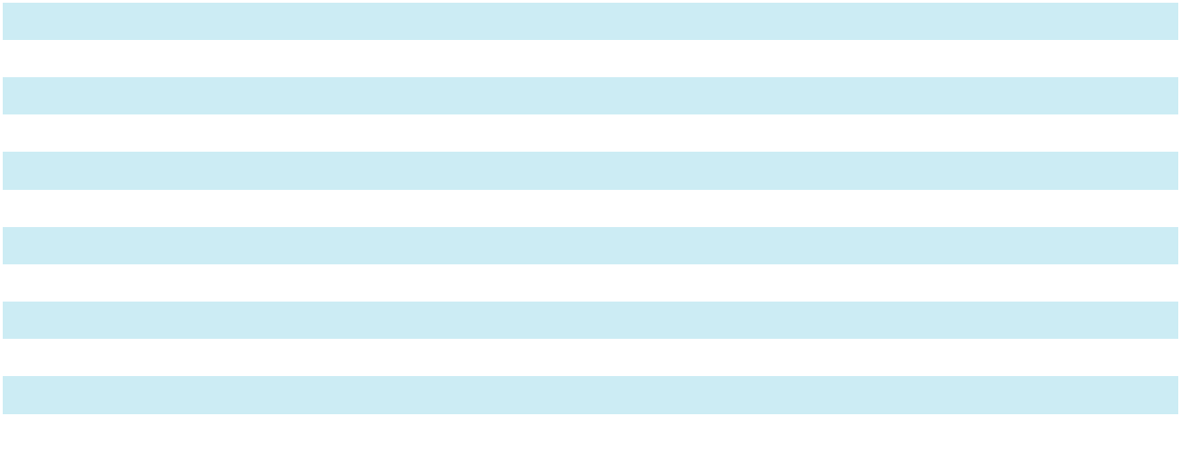

91

SKYWARD SPECIALTY INSURANCE GROUP, INC. AND SUBSIDIARIES

NOTES TO CONSOLIDATED FINANCIAL STATEMENTS

12. Segment (continued)

The following table presents information about reported segment net underwriting income, significant segment expenses and a reconciliation of net underwriting income to net income for the years ended December 31, 2025, 2024 and 2023:

 | ($ in thousands) |  |  |  | 2025 |  |  | 2024 |  |  | 2023
 | Underwriting income
 | Revenues:
 | Net earned premiums |  | $ |  | 1,304,505 | $ |  | 1,056,722 | $ |  | 829,143
 | Commission and fee income |  |  |  | 6,855 |  |  | 6,703 |  |  | 6,064
 | Total underwriting revenues |  |  |  | 1,311,360 |  |  | 1,063,425 |  |  | 835,207
 | Expenses: |  |  |  | 795,022
 | Losses and LAE |  |  |  | 795,022 |  |  | 669,809 |  |  | 515,237
 | Amortization of policy acquisition costs |  |  |  | 195,422 |  |  | 149,975 |  |  | 108,514
 | Other operating and general expenses |  |  |  | 181,937 |  |  | 161,782 |  |  | 134,930
 | Total underwriting expenses |  |  |  | 1,172,381 |  |  | 981,566 |  |  | 758,681
 | Net underwriting income |  |  | $ | 138,979 | $ |  | 81,859 | $ |  | 76,526
 | Reconciliation of net underwriting income to net income:
 | Net underwriting income
 |  |  |  | $ | 138,979 | $ |  | 81,859 | $ |  | 76,526
 | Add:
 |  |  |  |  | 83,619
 | Net investment income |  |  |  | 83,619 |  |  | 80,600 |  |  | 40,340
 | Net investment gains |  |  |  | 22,149 |  |  | 6,342 |  |  | 11,054
 | Other loss |  |  |  | (587) |  |  | (167) |  |  | (632)
 | Less:
 | Transaction costs |  |  |  | 14,019 |  |  | — |  |  | —
 | Interest expense |  |  |  | 7,919 |  |  | 9,496 |  |  | 10,024
 | Amortization expense |  |  |  | 1,636 |  |  | 2,007 |  |  | 1,798
 | Other expenses |  |  |  | 4,162 |  |  | 4,392 |  |  | 5,364
 | Income before income taxes |  |  |  | 216,424 |  |  | 152,739 |  |  | 110,102
 | Income tax expense |  |  |  | 46,396 |  |  | 33,911 |  |  | 24,118
 | Net income |  |  | $ | 170,028 | $ |  | 118,828 | $ |  | 85,984
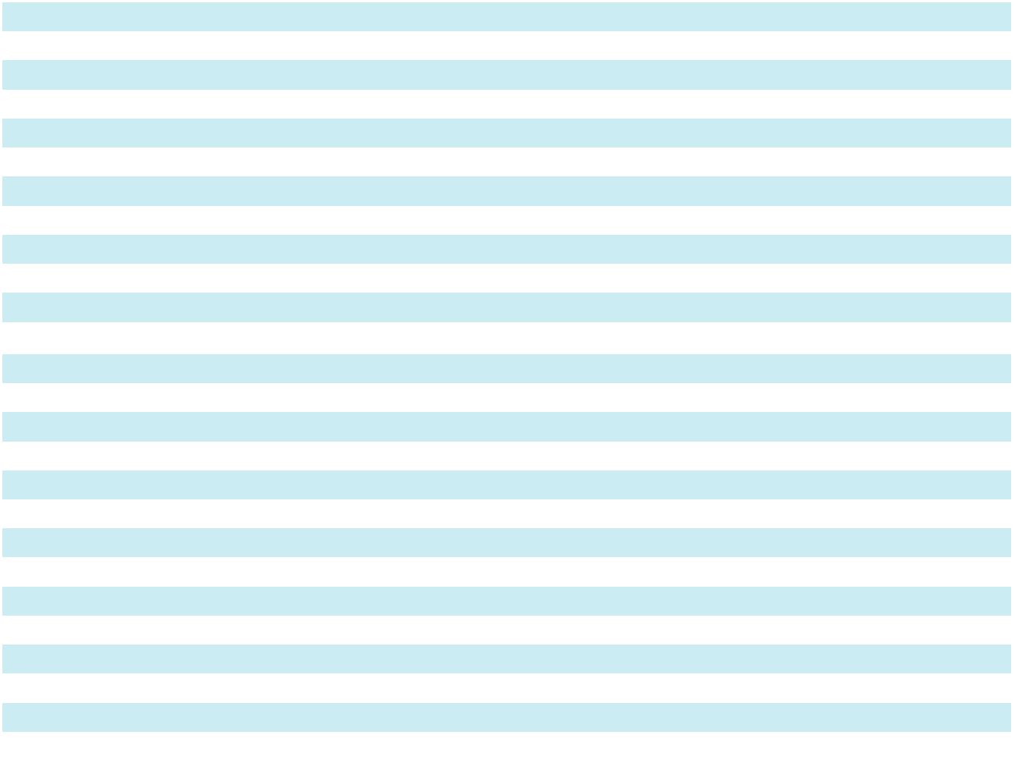

The following table presents return on equity and book value per share for the years ended December 31, 2025, 2024 and 2023:

 |  | 2025 |  |  | 2024 |  |  | 2023
Return on equity |  | 18.9 % |  |  | 16.3 % |  |  | 15.9 %
Book value per share | $ | 24.92 | $ |  | 19.79 | $ |  | 16.72

92

SKYWARD SPECIALTY INSURANCE GROUP, INC. AND SUBSIDIARIES

NOTES TO CONSOLIDATED FINANCIAL STATEMENTS

- Income Taxes

The following table sets forth the components of the Company’s income tax expense for the year ended December 31, 2025 after the adoption of ASU 2023-09:

($ in thousands) |  | 2025
Income from continuing operations before income tax expense
United States | $ | 208,763
Foreign |  | 7,661
Total |  | 216,424
Income tax expense (benefit) from continuing operations
Current tax expense
United States |  | 51,758
U.S. state and local |  | 1,107
Deferred tax benefit related to:
United States |  | (5,584)
U.S. state and local |  | (885)
Total income tax expense | $ | 46,396
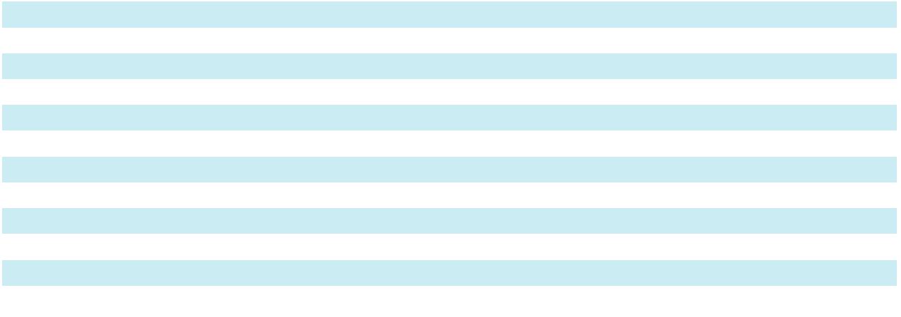

The following table sets forth the components of the Company's income tax expense for the years ended December 31, 2024 and 2023 prior to the adoption of ASU 2023-09:

($ in thousands) |  | 2024 |  |  | 2023
Current income tax expense | $ | 42,626 | $ |  | 14,736
Deferred tax (benefit) expense related to temporary differences |  | (8,715) |  |  | 9,382
Total income tax expense | $ | 33,911 | $ |  | 24,118

The following table reconciles the Company's annual effective tax rate to the U.S. Federal statutory tax rate for the year ended December 31, 2025 after the adoption of ASU 2023-09:

 |  | 2025
($ in thousands) |  | Amount |  |  | Percentage
U.S. federal statutory income tax rate | $ | 45,449 |  |  | 21.0 %
State income taxes, net of federal benefit⁽¹⁾ |  | (508) |  |  | (0.3)%
Foreign tax effects
Bermuda statutory rate differential |  | (1,609) |  |  | (0.7)%
Effects of other cross-border tax laws |  | 717 |  |  | 0.3 %
Change of Valuation Allowance |  | 68 |  |  | — %
Nondeductible and Nontaxable items
Nondeductible transaction costs |  | 1,689 |  |  | 0.8 %
Other nondeductible and nontaxable items |  | 590 |  |  | 0.3 %
Effective tax rate | $ | 46,396 |  |  | 21.4 %
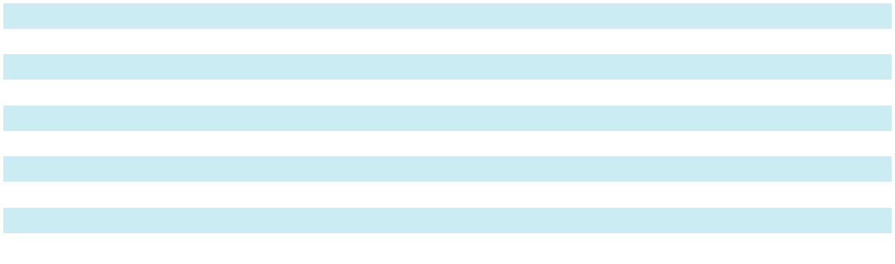
- The following state(s) and/or local jurisdictions make up more than 50% of the state income taxes: Florida

93

SKYWARD SPECIALTY INSURANCE GROUP, INC. AND SUBSIDIARIES

NOTES TO CONSOLIDATED FINANCIAL STATEMENTS

- Income Taxes (continued)

The following table presents the required disclosures prior to our adoption of ASU 2023-09 and reconciles the statutory U.S. federal income tax rate to the Company’s effective tax rate for continuing operations for the years ended December 31, 2024 and 2023:

 |  | 2024 |  |  |  |  | 2023
($ in thousands) |  | Amount |  | Percentage |  |  | Amount |  | Percentage
Income tax expense at federal statutory rate | $ | 32,075 | 21.0 % |  | $ |  | 23,121 | 21.0 %
Tax advantaged investments |  | (239) | (0.2) |  |  |  | (295) | (0.3)
Other |  | 2,075 |  | 1.4 |  |  | 1,292 |  | 1.2
Total income tax expense | $ | 33,911 | 22.2 % |  | $ |  | 24,118 | 21.9 %

The following table presents income taxes paid (net of refunds received) for the year ended December 31, 2025:

($ in thousands) |  | 2025
United States | $ | 49,830
U.S. state and local⁽¹⁾ |  | 1,164
Total income taxes paid | $ | 50,994

- No single state or jurisdiction accounts for greater than 5% of total taxes paid.

The Company paid $37.0 million and $15.8 million in federal income taxes during the years ended December 31, 2024 and 2023, respectively.

The following table sets forth the tax effects of temporary differences that give rise to significant portions of the deferred tax assets and deferred tax liabilities at December 31, 2025 and 2024:

($ in thousands) |  | 2025 |  |  | 2024
Deferred tax assets: | $ | 9,409
Net operating losses | $ | 9,409 | $ |  | 9,389
Losses and loss adjustment expenses |  | 21,401 |  |  | 16,967
Unearned premiums |  | 22,775 |  |  | 18,178
Unrealized losses on fixed maturity securities, available-for-sale |  | — |  |  | 5,893
Stock options/awards |  | 2,446 |  |  | 2,453
Other |  | 8,933 |  |  | 6,067
Total deferred tax assets before valuation allowance |  | 64,964 |  |  | 58,947
Valuation allowance |  | (654) |  |  | (586)
Total deferred tax assets |  | 64,310 |  |  | 58,361
Deferred tax liabilities: |  | 19,132
Deferred policy acquisition costs |  | 19,132 |  |  | 15,277
Other long-term investments |  | 2,888 |  |  | 2,625
Section 481(a) adjustment |  | 87 |  |  | 1,391
Unrealized gains on equity securities |  | 7 |  |  | 4,818
Unrealized gains on fixed maturity securities, available-for-sale |  | 3,101 |  |  | —
Unrealized gains on other investments |  | 5,465 |  |  | —
Depreciation |  | 2,152 |  |  | 1,426
Other |  | 3,613 |  |  | 2,338
Total deferred tax liabilities |  | 36,445 |  |  | 27,875
Net deferred tax asset | $ | 27,865 | $ |  | 30,486
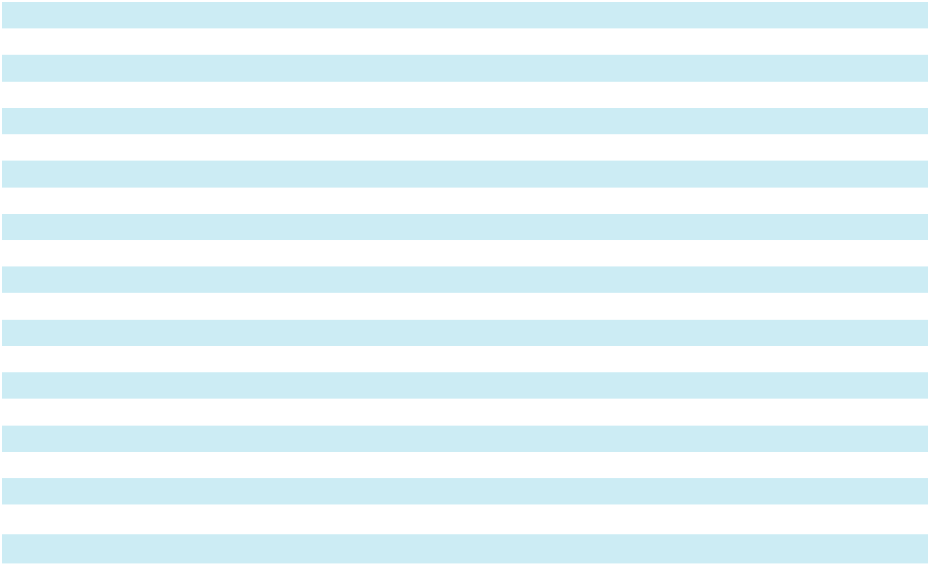

The Company has federal net operating loss carryforwards of approximately $40.3 million. These net operating losses are set to expire beginning in 2032. The Company is limited on the utilization of $40.3 million of the net operating losses

94

SKYWARD SPECIALTY INSURANCE GROUP, INC. AND SUBSIDIARIES

NOTES TO CONSOLIDATED FINANCIAL STATEMENTS

- Income Taxes (continued)

under Internal Revenue Code Section 382 which imposes limitations on a corporation’s ability to utilize tax attributes if the corporation experiences an “ownership change.” The Company experienced an ownership change during 2014. The 382 limitation is expected to result in an expiration of $2.8 million ($0.6 million tax effected) of net operating losses. In 2025, a valuation allowance has been established against this balance that is expected to expire without utilization. Out of the total $40.3 million federal NOL, $0.3 million ($0.1 million tax effected) is related to dual consolidated loss that Skyward is not expected to be able to utilize. The Company also has net operating losses in various state and local jurisdictions of $0.9 million which are set to expire between 5 and 20 years or carryforward indefinitely, depending on the jurisdiction. The Company expects to fully utilize these state and local net operating losses.

The following table presents the change in the Company's valuation allowance for the years ended December 31, 2025 and 2024:

($ in thousands) |  | 2025 |  |  | 2024
Balance at beginning of the period | $ | 586 | $ |  | 586
Increase related to net operating loss |  | 68 |  |  | —
Balance at the end of the period | $ | 654 | $ |  | 586

The Company’s federal income tax returns for tax years 2022-2024 are subject to examination by the Internal Revenue Service.

As of December 31, 2025, the Company had no provision for uncertain tax positions and no provision for penalties or interest. In addition, management does not believe there are any uncertain tax benefits that could be recognized within the next twelve months that would impact the Company’s effective tax rate.

Tax Legislative Update

On July 4, 2025, the One Big Beautiful Bill Act (“OBBB Act”), which includes a broad range of tax reform provisions, was signed into law in the United States. The OBBB Act did not have a material impact on the Company's annual effective tax rate in 2025 and no material impact is expected in 2026.

- Reserves for Losses and Loss Adjustment Expenses

The Company presents its loss development on a consolidated basis; however, it evaluates net ultimate loss and LAE under three sub-categories: multi-line solutions, short-tail/monoline specialty lines and exited lines. The Company determined that these disaggregated groupings have more homogeneous risk characteristics with similar development patterns and are generally subject to similar trends.

Short-tail/Monoline Specialty Lines

Short-tail/monoline specialty lines includes the Company’s global property & agriculture, accident & health, surety, and professional lines underwriting divisions. These are market niches for which the Company serves with monoline solutions which generally have shorter durations for losses to fully develop. Losses for these lines are generally reported within a short period of time from the date of loss, and in most instances, claims are settled and paid within a relatively short timeframe. Short tail/monoline specialty can be impacted by larger losses which can be more complex due to factors such as difficulty determining actual damages, legal and regulatory impediments potentially extending the period of time it takes to settle and pay claims.

Multi-line Solutions

Multi-line solutions includes the Company’s industry solutions, programs, captives and transactional E&S underwriting divisions. These are market niches for which the Company provides multiple products most frequently as an integrated solution. The multi-line solution subcategory is made up predominantly of occurrence liability including general liability, excess liability, and commercial auto. Multi-line solutions have a longer duration for losses to fully develop compared to short-tail/monoline specialty lines. Due to the unique claim characteristics of each product and the longer-tail nature of the multi-line solutions, this introduces more uncertainty as over time the claims can be impacted by changes in regulation, inflation and other unforeseen factors.

95

SKYWARD SPECIALTY INSURANCE GROUP, INC. AND SUBSIDIARIES

NOTES TO CONSOLIDATED FINANCIAL STATEMENTS

- Reserves for Losses and Loss Adjustment Expenses (continued)

Exited lines

Exited lines includes all underwriting units that the Company placed in run-off and are presented separately from on-going lines of business.

The following table sets forth the reconciliation of unpaid losses and loss adjustment expenses (“LAE”) as reported in the Consolidated Balance Sheets as of and for the years ended December 31, 2025 and 2024:

($ in thousands) |  | 2025 |  |  | 2024 |  |  | 2023
Reserves for losses and LAE, beginning of period | $ | 1,782,383 | $ |  | 1,314,501 | $ |  | 1,141,757
Less: reinsurance recoverable on unpaid claims, beginning of period |  | (670,846) |  |  | (455,484) |  |  | (435,986)
Reserves for losses and LAE, beginning of period, net of reinsurance |  | 1,111,537 |  |  | 859,017 |  |  | 705,771
Incurred, net of reinsurance, related to:
Current period |  | 810,375 |  |  | 657,783 |  |  | 505,894
Prior years |  | (7,471) |  |  | 25,728 |  |  | 10,770
Total incurred, net of reinsurance |  | 802,904 |  |  | 683,511 |  |  | 516,664
Paid, net of reinsurance, related to:
Current period |  | 144,799 |  |  | 136,731 |  |  | 109,937
Prior years |  | 371,913 |  |  | 294,260 |  |  | 253,481
Total paid |  | 516,712 |  |  | 430,991 |  |  | 363,418
Net reserves for losses and LAE, end of period |  | 1,397,729 |  |  | 1,111,537 |  |  | 859,017
Plus: reinsurance recoverable on unpaid claims, end of period |  | 921,165 |  |  | 670,846 |  |  | 455,484
Reserves for losses and LAE, end of period | $ | 2,318,894 | $ |  | 1,782,383 | $ |  | 1,314,501
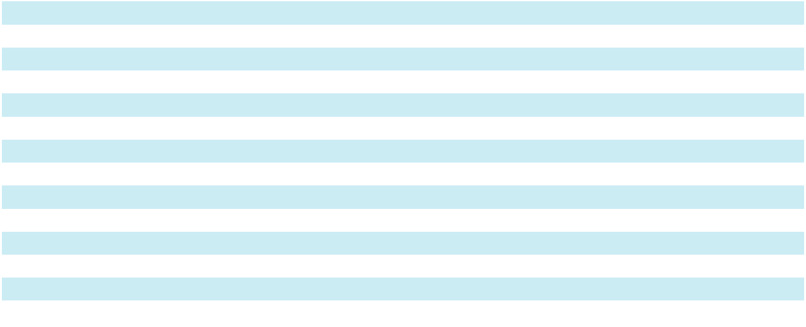

For the year ended December 31, 2025, the Company recognized favorable development related to prior years’ loss and loss expense reserves of $7.5 million driven by favorable development of $24.6 million and $5.3 million in short-tail/ monoline specialty lines and multi-line solutions, respectively, partially offset by $22.4 million of adverse development in exited lines. The adverse development is primarily attributable to commercial auto and excess over auto in divisions that have been non-renewed or have significantly reduced exposure over the past three years. This was offset by favorable development in surety and property.

For the year ended December 31, 2024, the Company recognized adverse development related to prior years’ loss and loss expense reserves of $25.7 million, primarily related to losses previously subject to the LPT from accident years 2018 and prior, with $10.1 million and $15.2 million in multi-line solutions and exited lines, respectively.

During the year ended December 31, 2023, the Company recognized adverse development related to prior years’ loss and loss expense reserves of $10.8 million. Adverse development of $11.7 million in multi-line solutions was driven by greater than expected severity in auto, general, and excess liability lines of business primarily from accident years 2020 to 2022. The adverse development was partially offset by favorable development in short-tail/monoline specialty lines. The favorable development was in the property line of business primarily from accident years 2021 and 2022.

Short Duration Contract Disclosures

Losses and LAE reserves represent the Company’s best estimate of the ultimate net cost of all reported and unreported losses that are unpaid as of the balance sheet dates. The Company’s estimated reserves for losses and LAE include the accumulation of estimates for claims reported and unpaid prior to the balance sheet dates, estimates (based on projections of relevant historical data) of increases in claims costs for claims already reported, of claims incurred but not reported, and estimates of expenses for investigating and adjusting all incurred and unpaid claims.

In determining the cumulative number of reported claims, the Company measures claim counts by incident. The claim counts include all claims reported, even if the Company does not establish a liability for the claim (i.e. reserve for loss and loss adjustment expenses).

96

SKYWARD SPECIALTY INSURANCE GROUP, INC. AND SUBSIDIARIES

NOTES TO CONSOLIDATED FINANCIAL STATEMENTS

- Reserves for Losses and Loss Adjustment Expenses (continued) Short-tail/Monoline Specialty Lines

($ in thousands except number of claims)
 | Incurred Losses and ALAE, Net of Reinsurance |  |  |  |  |  |  |  |  |  |  |  |  |  | As of December 31, 2025
 |  |  |  |  |  | Years Ended December 31, |  |  |  |  |  |  |  |  |  |  |  | Reported
Accident Year |  |  | 2021* |  |  | 2022* |  | 2023* |  | 2024* |  |  | 2025 |  |  | IBNR |  | Reported
 |  |  |  |  |  |  |  |  |  |  |  |  | 2025 |  |  | IBNR |  | Claims
2021 | $ 92,780 |  |  | $ |  | 93,429 | $ 92,143 |  | $ 92,134 |  |  | $ | 99,783 |  | $ | 1,774 |  | 1,656
2022 |  |  |  |  |  | 108,299 | 105,394 |  | 104,095 |  |  |  | 96,874 |  |  | 6,266 | 2,414
2023 |  |  |  |  |  |  | 190,565 |  | 191,865 |  |  |  | 161,222 |  |  | 28,997 | 5,015
2024 |  |  |  |  |  |  |  |  | 280,147 |  |  |  | 292,220 |  |  | 99,302 | 5,819
2025 |  |  |  |  |  |  |  |  |  |  |  |  | 422,528 |  |  | 275,190 | 5,495
Total |  |  |  |  |  |  |  |  |  |  |  | $ | 1,072,627
Cumulative net paid loss and ALAE from the table below |  |  |  |  |  |  |  |  |  |  |  |  | (528,255)
Net reserves for loss and ALAE before 2021 |  |  |  |  |  |  |  |  |  |  |  |  | 1,570
Total net reserves for loss and ALAE |  |  |  |  |  |  |  |  |  |  |  | $ | 545,942
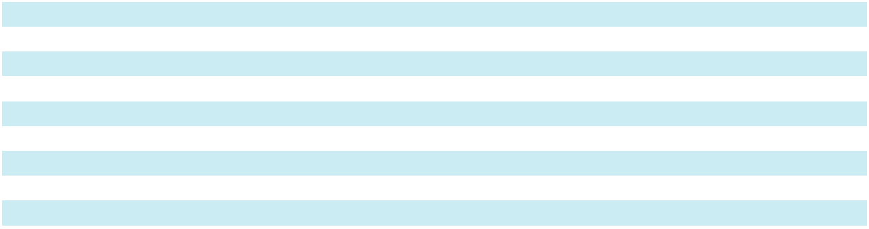

*Supplementary information and unaudited

($ in thousands)

Cumulative Paid Losses and ALAE, Net of Reinsurance ($ in thousands)

 |  |  |  |  |  |  |  |  |  |  |  |  |  |  |  |  |  |  |  | Years Ended December 31,
Accident Year |  |  |  |  |  |  |  |  |  |  |  |  |  | 2021* |  |  |  |  | 2022* |  |  |  |  |  | 2023* |  |  |  |  |  |  | 2024* |  |  |  |  |  | 2025
2021 |  |  |  |  |  |  |  |  |  |  | $ |  |  | 18,447 |  |  | $ |  | 56,803 |  |  |  | $ |  |  | 67,912 |  |  | $ |  |  | 78,439 |  |  |  |  | $ | 93,560
2022 |  |  |  |  |  |  |  |  |  |  |  |  |  |  |  |  |  |  | 27,773 |  |  |  |  |  |  | 64,594 |  |  |  |  |  | 77,150 |  |  |  |  |  | 85,696
2023 |  |  |  |  |  |  |  |  |  |  |  |  |  |  |  |  |  |  |  |  |  |  |  |  |  | 33,795 |  |  |  |  |  | 100,705 |  |  |  |  |  | 114,247
2024 |  |  |  |  |  |  |  |  |  |  |  |  |  |  |  |  |  |  |  |  |  |  |  |  |  |  |  |  |  |  |  | 53,691 |  |  |  |  |  | 154,896
2025 |  |  |  |  |  |  |  |  |  |  |  |  |  |  |  |  |  |  |  |  |  |  |  |  |  |  |  |  |  |  |  |  |  |  |  |  |  | 79,856
Total |  |  |  |  |  |  |  |  |  |  |  |  |  |  |  |  |  |  |  |  |  |  |  |  |  |  |  |  |  |  |  |  |  |  |  |  | $ | 528,255
*Supplementary information and unaudited
Multi-line Solutions
($ in thousands except number of claims)
 |  |  |  |  | Incurred Losses and ALAE, Net of Reinsurance ($ in thousands) |  |  |  |  |  |  |  |  |  |  |  |  |  |  |  |  |  |  |  |  |  |  |  |  |  |  |  |  | As of December 31, 2025
Accident |  |  |  |  |  |  |  |  |  |  |  |  |  | Years Ended December 31, |  |  |  |  |  |  |  |  |  |  |  |  |  |  |  |  |  |  |  |  |  |  |  |  | Reported
Accident |  | 2016* |  | 2017* |  |  | 2018* |  | 2019* |  |  |  |  | 2020* |  | 2021* |  |  |  | 2022* |  |  | 2023* |  |  |  | 2024* |  |  |  |  | 2025 |  | IBNR |  |  |  |  | Reported
Year |  |  |  |  |  |  |  |  |  |  |  |  |  | 2020* |  |  |  |  |  | 2022* |  |  |  |  |  |  | 2024* |  |  |  |  | 2025 |  |  |  |  |  |  | Claims
2016 | $ 63,223 |  | $ 62,843 |  | $ 62,843 |  |  | $ 62,643 |  |  | $ |  |  | 84,579 |  | $ 84,579 |  |  | $ 84,829 |  |  |  | $ 84,829 |  |  | $ 85,434 |  |  | $ |  |  | 85,098 |  | $ | 828 |  |  | 4,744
2017 |  |  | 65,332 |  | 65,332 |  |  | 64,260 |  |  |  |  |  | 78,166 |  | 78,166 |  |  | 78,766 |  |  |  | 78,766 |  |  | 80,493 |  |  |  |  |  | 79,819 |  |  | 837 |  |  | 5,592
2018 |  |  |  |  | 74,476 |  |  | 74,476 |  |  |  |  |  | 69,319 |  | 71,719 |  |  | 73,019 |  |  |  | 73,019 |  |  | 75,686 |  |  |  |  |  | 72,963 |  |  | 673 |  |  | 5,103
2019 |  |  |  |  |  |  |  | 107,432 |  |  |  |  |  | 109,226 |  | 112,378 |  |  | 115,530 |  |  |  | 116,230 |  |  | 116,206 |  |  |  |  |  | 110,564 |  |  | 1,384 |  |  | 6,113
2020 |  |  |  |  |  |  |  |  |  |  |  |  |  | 113,030 |  | 124,076 |  |  | 128,111 |  |  |  | 132,495 |  |  | 132,125 |  |  |  |  |  | 134,281 |  |  | 4,174 |  |  | 5,542
2021 |  |  |  |  |  |  |  |  |  |  |  |  |  |  |  | 156,067 |  |  | 158,891 |  |  |  | 160,331 |  |  | 160,546 |  |  |  |  |  | 157,006 |  |  | 7,932 |  |  | 6,727
2022 |  |  |  |  |  |  |  |  |  |  |  |  |  |  |  |  |  |  | 236,909 |  |  |  | 242,097 |  |  | 242,358 |  |  |  |  |  | 249,317 |  | 19,315 |  |  |  | 8,679
2023 |  |  |  |  |  |  |  |  |  |  |  |  |  |  |  |  |  |  |  |  |  |  | 306,511 |  |  | 306,511 |  |  |  |  |  | 320,637 |  | 96,700 |  |  |  | 8,468
2024 |  |  |  |  |  |  |  |  |  |  |  |  |  |  |  |  |  |  |  |  |  |  |  |  |  | 353,933 |  |  |  |  |  | 336,197 |  | 155,878 |  |  |  | 7,700
2025 |  |  |  |  |  |  |  |  |  |  |  |  |  |  |  |  |  |  |  |  |  |  |  |  |  |  |  |  |  |  |  | 356,590 |  | 257,468 |  |  |  | 6,139
Total |  |  |  |  |  |  |  |  |  |  |  |  |  |  |  |  |  |  |  |  |  |  |  |  |  |  |  |  | $1,902,472
Cumulative net paid loss and ALAE from the table below |  |  |  |  |  |  |  |  |  |  |  |  |  |  |  |  |  |  |  |  |  |  |  |  |  |  |  |  | (1,162,853)
Net reserves for loss and ALAE before 2016 |  |  |  |  |  |  |  |  |  |  |  |  |  |  |  |  |  |  |  |  |  |  |  |  |  |  |  |  |  |  |  | (189)
Total net reserves for loss and ALAE |  |  |  |  |  |  |  |  |  |  |  |  |  |  |  |  |  |  |  |  |  |  |  |  |  |  |  |  | $ 739,430
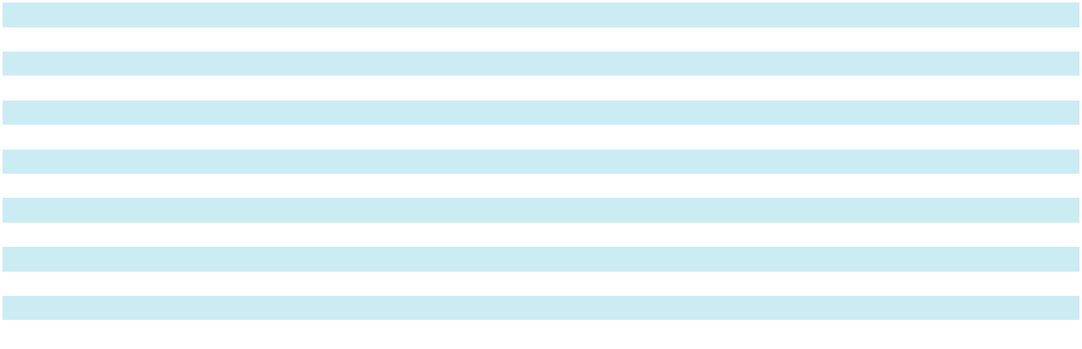

*Supplementary information and unaudited

97

SKYWARD SPECIALTY INSURANCE GROUP, INC. AND SUBSIDIARIES

NOTES TO CONSOLIDATED FINANCIAL STATEMENTS

- Reserves for Losses and Loss Adjustment Expenses (continued)

($ in thousands)

Cumulative Paid Losses and ALAE, Net of Reinsurance ($ in thousands)

 |  |  |  |  |  |  |  |  |  |  |  |  |  |  |  |  |  |  |  |  |  |  |  | Years Ended December 31,
Accident |  |  |  | 2016* |  |  |  |  | 2017* |  |  |  |  |  |  | 2018* |  |  |  | 2019* |  |  |  |  | 2020* |  |  |  |  | 2021* |  |  |  | 2022* |  |  |  |  |  | 2023* |  |  | 2024* |  |  |  |  |  | 2025
Year |  |  |  |  |  |  |  |  |  |  |  |  |  |  |  |  |  |  |  |  |  |  |  |  |  |  |  |  |  |  |  |  |  |  |  |  |  |  |  |  |  |  |  |  |  |  |  |  | 2025
2016 | $ 23,239 |  |  |  |  |  | $ 42,528 |  |  |  |  |  |  |  | $ 53,352 |  |  |  |  | $ 58,895 |  |  |  | $ 69,691 |  |  |  | $ 72,544 |  |  |  |  | $ 75,855 |  |  |  | $ 77,160 |  |  |  |  |  | $ 77,760 |  |  |  |  | $ | 77,825
2017 |  |  |  |  |  |  | 23,770 |  |  |  |  |  |  |  |  | 41,945 |  |  |  | 53,093 |  |  |  | 61,354 |  |  |  | 67,926 |  |  |  |  | 71,109 |  |  |  |  |  |  | 73,770 |  |  | 75,714 |  |  |  |  |  | 77,177
2018 |  |  |  |  |  |  |  |  |  |  |  |  |  |  |  | 26,201 |  |  |  | 42,568 |  |  |  | 47,226 |  |  |  | 58,655 |  |  |  |  | 65,635 |  |  |  |  |  |  | 69,893 |  |  | 70,128 |  |  |  |  |  | 72,429
2019 |  |  |  |  |  |  |  |  |  |  |  |  |  |  |  |  |  |  |  | 33,019 |  |  |  | 50,933 |  |  |  | 71,053 |  |  |  |  | 87,816 |  |  |  |  |  |  | 99,451 |  |  | 106,765 |  |  |  |  |  | 106,826
2020 |  |  |  |  |  |  |  |  |  |  |  |  |  |  |  |  |  |  |  |  |  |  |  | 29,499 |  |  |  | 60,680 |  |  |  |  | 82,236 |  |  |  | 105,283 |  |  |  |  |  | 121,097 |  |  |  |  |  | 126,965
2021 |  |  |  |  |  |  |  |  |  |  |  |  |  |  |  |  |  |  |  |  |  |  |  |  |  |  |  | 37,118 |  |  |  |  | 73,293 |  |  |  | 102,772 |  |  |  |  |  | 125,749 |  |  |  |  |  | 141,539
2022 |  |  |  |  |  |  |  |  |  |  |  |  |  |  |  |  |  |  |  |  |  |  |  |  |  |  |  |  |  |  |  |  | 50,148 |  |  |  | 114,794 |  |  |  |  |  | 165,854 |  |  |  |  |  | 205,410
2023 |  |  |  |  |  |  |  |  |  |  |  |  |  |  |  |  |  |  |  |  |  |  |  |  |  |  |  |  |  |  |  |  |  |  |  |  |  |  |  | 63,079 |  |  | 122,186 |  |  |  |  |  | 181,636
2024 |  |  |  |  |  |  |  |  |  |  |  |  |  |  |  |  |  |  |  |  |  |  |  |  |  |  |  |  |  |  |  |  |  |  |  |  |  |  |  |  |  |  | 58,281 |  |  |  |  |  | 123,488
2025 |  |  |  |  |  |  |  |  |  |  |  |  |  |  |  |  |  |  |  |  |  |  |  |  |  |  |  |  |  |  |  |  |  |  |  |  |  |  |  |  |  |  |  |  |  |  |  |  | 49,558
Total |  |  |  |  |  |  |  |  |  |  |  |  |  |  |  |  |  |  |  |  |  |  |  |  |  |  |  |  |  |  |  |  |  |  |  |  |  |  |  |  |  |  |  |  |  |  |  | $ | 1,162,853
*Supplementary information and unaudited
Exited Lines — all lines in runoff
($ in thousands except number of claims)
 |  |  |  |  |  | Incurred Losses and ALAE, Net of Reinsurance ($ in thousands) |  |  |  |  |  |  |  |  |  |  |  |  |  |  |  |  |  |  |  |  |  |  |  |  |  |  |  |  |  |  |  |  |  |  |  |  |  | As of December 31, 2025
 |  |  |  |  |  |  |  |  |  |  |  |  |  |  |  |  |  |  |  |  |  | Years Ended December 31,
Accident |  | 2016* |  |  |  | 2017* |  |  |  |  |  | 2018* |  |  |  |  |  | 2019* |  |  |  | 2020* |  | 2021* |  |  |  | 2022* |  |  |  | 2023* |  |  |  | 2024* |  |  |  |  | 2025 |  |  | IBNR |  |  |  |  | Reported
Year |  |  |  |  |  |  |  |  |  |  |  |  |  |  |  |  |  | 2019* |  |  |  | 2020* |  |  |  |  |  |  |  |  |  |  |  |  |  |  |  |  |  |  | 2025 |  |  | IBNR |  |  |  |  | Claims
2016 | $ 93,019 |  |  |  | $ |  | 92,996 |  |  |  |  | $ 91,372 |  |  |  | $ 93,577 |  |  |  | $ 97,301 |  |  |  | $ 98,301 |  |  | $ 100,651 |  |  |  | $ 100,651 |  |  |  | $ 102,801 |  |  |  |  | $ 104,246 |  |  | $ 1,851 |  |  |  |  |  | 4,911
2017 |  |  |  |  |  |  | 75,159 |  |  |  |  | 79,581 |  |  |  | 81,785 |  |  |  | 65,735 |  |  |  | 68,346 |  |  |  | 68,646 |  |  | 68,646 |  |  |  | 70,885 |  |  |  |  | 72,682 |  |  | 1,819 |  |  |  |  |  | 4,370
2018 |  |  |  |  |  |  |  |  |  |  |  | 74,357 |  |  |  | 68,990 |  |  |  | 76,506 |  |  |  | 79,006 |  |  |  | 84,165 |  |  | 84,165 |  |  |  | 92,082 |  |  |  |  | 91,897 |  |  | 4,093 |  |  |  |  |  | 4,941
2019 |  |  |  |  |  |  |  |  |  |  |  |  |  |  |  | 87,115 |  |  |  | 73,635 |  |  |  | 77,770 |  |  |  | 79,414 |  |  | 79,572 |  |  |  | 79,823 |  |  |  |  | 86,131 |  |  | 9,773 |  |  |  |  |  | 5,660
2020 |  |  |  |  |  |  |  |  |  |  |  |  |  |  |  |  |  |  |  | 132,248 |  |  |  | 136,469 |  |  |  | 137,835 |  |  | 137,907 |  |  |  | 137,671 |  |  |  |  | 138,320 |  |  | 10,644 |  |  |  |  |  | 4,867
2021 |  |  |  |  |  |  |  |  |  |  |  |  |  |  |  |  |  |  |  |  |  |  |  | 83,322 |  |  |  | 91,188 |  |  | 91,323 |  |  |  | 92,095 |  |  |  |  | 97,577 |  |  | 10,676 |  |  |  |  |  | 2,446
2022 |  |  |  |  |  |  |  |  |  |  |  |  |  |  |  |  |  |  |  |  |  |  |  |  |  |  |  | 12,717 |  |  | 12,240 |  |  |  | 11,800 |  |  |  |  | 14,362 |  |  | 2,025 |  |  |  |  |  | 246
2023 |  |  |  |  |  |  |  |  |  |  |  |  |  |  |  |  |  |  |  |  |  |  |  |  |  |  |  |  |  |  |  |  |  | — |  |  | — |  |  | 2 |  |  | 1 |  |  |  |  |  | 1
2024 |  |  |  |  |  |  |  |  |  |  |  |  |  |  |  |  |  |  |  |  |  |  |  |  |  |  |  |  |  |  |  |  |  |  |  |  | — |  |  | 5 |  |  | 5 |  |  |  |  |  | —
2025 |  |  |  |  |  |  |  |  |  |  |  |  |  |  |  |  |  |  |  |  |  |  |  |  |  |  |  |  |  |  |  |  |  |  |  |  |  |  |  |  | 11 |  | 11 |  |  |  |  |  | —
Total |  |  |  |  |  |  |  |  |  |  |  |  |  |  |  |  |  |  |  |  |  |  |  |  |  |  |  |  |  |  |  |  |  |  |  |  |  |  |  | $ 605,233
Cumulative net paid loss and ALAE from the table below |  |  |  |  |  |  |  |  |  |  |  |  |  |  |  |  |  |  |  |  |  |  |  |  |  |  |  |  |  |  |  |  |  |  |  |  |  |  |  | (538,304)
Net reserves for loss and ALAE before 2015 |  |  |  |  |  |  |  |  |  |  |  |  |  |  |  |  |  |  |  |  |  |  |  |  |  |  |  |  |  |  |  |  |  |  |  |  |  |  |  |  | 14,737
Total net reserves for loss and ALAE |  |  |  |  |  |  |  |  |  |  |  |  |  |  |  |  |  |  |  |  |  |  |  |  |  |  |  |  |  |  |  |  |  |  |  |  |  |  |  | $ 81,666
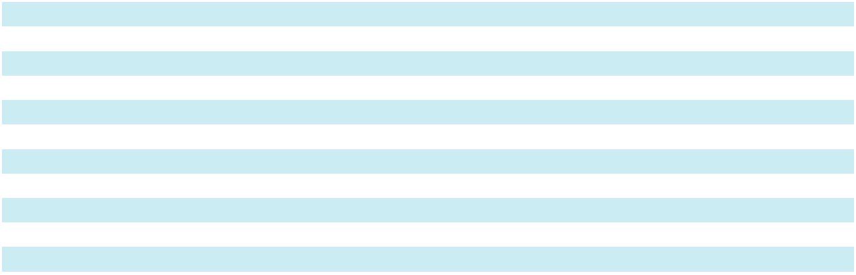
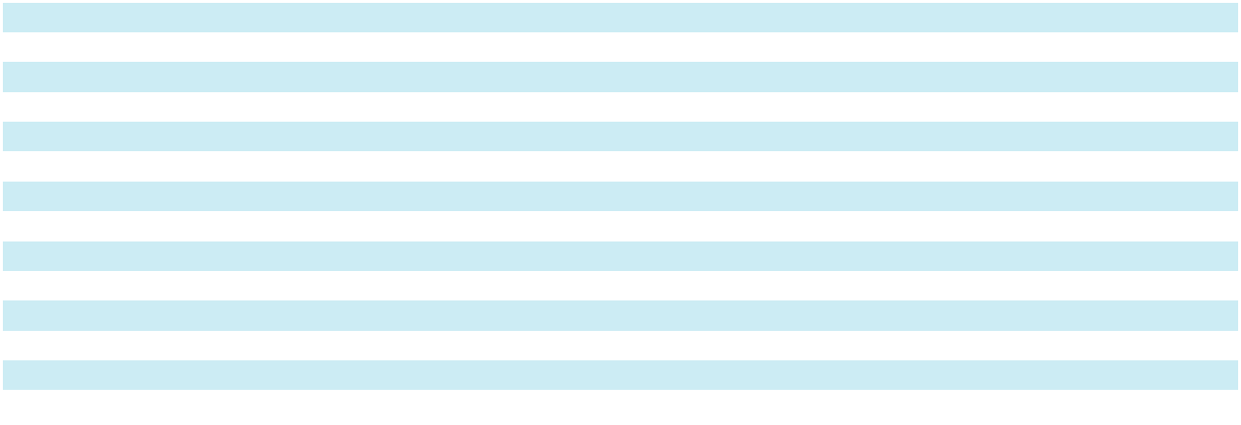

*Supplementary information and unaudited

98

SKYWARD SPECIALTY INSURANCE GROUP, INC. AND SUBSIDIARIES

NOTES TO CONSOLIDATED FINANCIAL STATEMENTS

- Reserves for Losses and Loss Adjustment Expenses (continued)

($ in thousands)

Cumulative Paid Losses and ALAE, Net of Reinsurance ($ in thousands)

 |  |  |  |  |  |  |  |  | Years Ended December 31,
Accident |  | 2016* |  | 2017* |  | 2018* |  | 2019* |  | 2020* |  | 2021* |  | 2022* |  | 2023* |  | 2024* |  |  | 2025
Year |  |  |  |  |  |  |  |  |  |  |  |  |  |  |  |  |  |  |  |  | 2025
2016 | $ 36,592 |  | $ 57,638 |  | $ 70,253 |  | $ 78,070 |  | $ 81,181 |  | $ 87,482 |  | $ 91,556 |  | $ 95,114 |  | $ 97,462 |  |  | $ | 98,831
2017 |  |  | 34,176 |  | 52,103 |  | 51,985 |  | 50,545 |  | 57,457 |  | 62,924 |  | 66,498 |  | 68,480 |  |  |  | 69,798
2018 |  |  |  |  | 25,553 |  | 60,149 |  | 39,870 |  | 54,339 |  | 67,001 |  | 74,604 |  | 79,860 |  |  |  | 82,244
2019 |  |  |  |  |  |  | 28,636 |  | 28,954 |  | 30,948 |  | 45,696 |  | 57,341 |  | 65,847 |  |  |  | 70,367
2020 |  |  |  |  |  |  |  |  | 102,725 |  | 98,202 |  | 102,132 |  | 114,543 |  | 120,831 |  |  |  | 124,139
2021 |  |  |  |  |  |  |  |  |  |  | 41,540 |  | 57,820 |  | 66,012 |  | 72,923 |  |  |  | 81,600
2022 |  |  |  |  |  |  |  |  |  |  |  |  | 2,155 |  | 4,077 |  | 9,211 |  |  |  | 11,325
2023 |  |  |  |  |  |  |  |  |  |  |  |  |  |  |  | — |  | — |  |  | —
2024 |  |  |  |  |  |  |  |  |  |  |  |  |  |  |  |  |  | — |  |  | —
2025 |  |  |  |  |  |  |  |  |  |  |  |  |  |  |  |  |  |  |  |  | —
Total |  |  |  |  |  |  |  |  |  |  |  |  |  |  |  |  |  |  | $ |  | 538,304
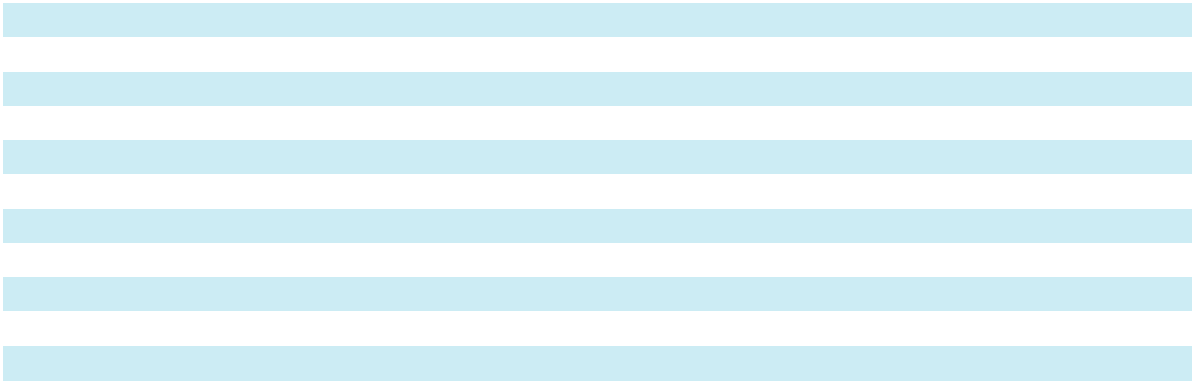

*Supplementary information and unaudited

The table below presents the reconciliation of the net incurred and paid loss development tables to the balance sheet reserves for losses and loss adjustment expenses at December 31, 2025 and 2024:

($ in thousands) |  | 2025 |  |  | 2024
Net reserves for losses and ALAE:
Short-tail/Monoline Specialty Lines | $ | 545,942 | $ |  | 367,226
Multi-line Solutions |  | 739,430 |  |  | 631,065
Exited Lines |  | 81,666 |  |  | 86,689
Reserves for losses and ALAE, net of reinsurance |  | 1,367,038 |  |  | 1,084,980
Reinsurance recoverable on unpaid claims:
Short-tail/Monoline Specialty Lines |  | 388,276 |  |  | 275,204
Multi-line Solutions |  | 514,393 |  |  | 380,344
Exited Lines |  | 18,496 |  |  | 15,298
Total reinsurance recoverable on unpaid claims |  | 921,165 |  |  | 670,846
Unallocated LAE |  | 30,691 |  |  | 26,557
Reserves for losses and LAE at end of year | $ | 2,318,894 | $ |  | 1,782,383
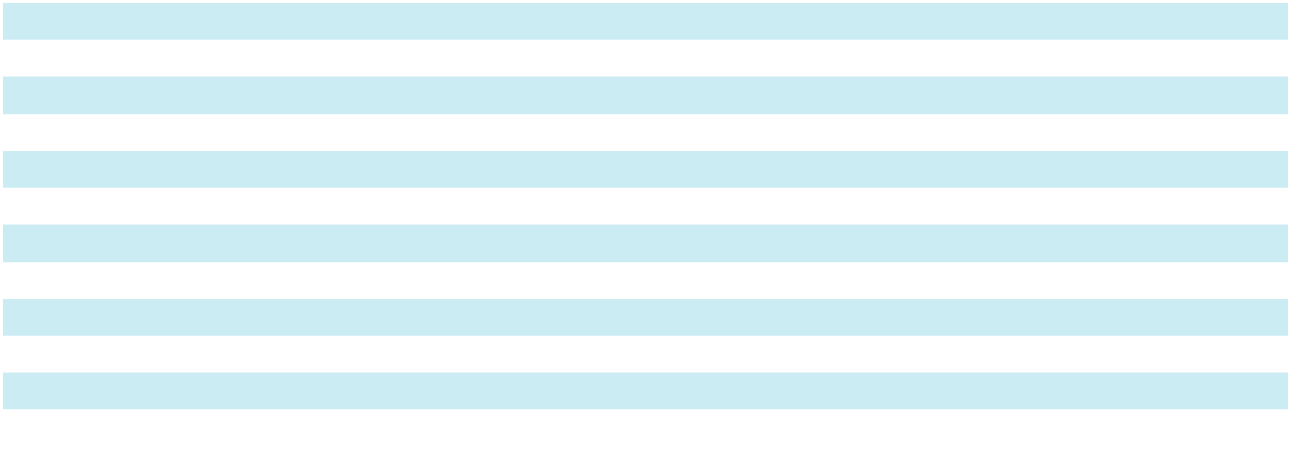

The following table sets forth the historical average annual payout of incurred losses and allocated loss adjustment expenses (claims duration) for short-duration contracts, based on the disaggregated information in the paid loss development tables, net of reinsurance:

Average Annual Percentage Payout of Incurred Claims by Age, Net of Reinsurance

 |  |  |  |  |  |  |  |  |  | Years
 |  | 1* |  | 2* |  | 3* |  | 4* |  | 5* |  |  | 6* |  | 7* |  | 8* |  | 9* |  | 10*
Short-Tail/Monoline |  | 21.1 % | 38.1 % |  | 10.8 % |  | 9.7 % 15.2 % |  |  |  |  |  | N/A |  | N/A |  | N/A |  | N/A |  | N/A
Specialty Lines |  |  |  |  |  |  |  |  |  |  |  |  | N/A |  | N/A |  | N/A |  | N/A |  | N/A
Multi-line Solutions |  | 23.9 % | 21.6 % |  | 15.6 % |  | 13.6 % 10.5 % |  |  |  |  |  | 4.8 % | 1.9 % |  | 2.4 % |  | 1.3 % |  | 0.1 %
Exited Lines |  | 27.5 % | 12.2 % |  | 4.9 % |  | 9.9 % |  | 8.9 % |  |  |  | 6.8 % | 4.9 % |  | 2.9 % |  | 2.0 % |  | 1.3 %


*Supplementary information and unaudited

99

SKYWARD SPECIALTY INSURANCE GROUP, INC. AND SUBSIDIARIES

NOTES TO CONSOLIDATED FINANCIAL STATEMENTS

- Commission and Fee Income

Skyward Underwriters Agency, Inc. (“SUA”), a subsidiary of the Company, is a managing general insurance agent and reinsurance broker for property and casualty and accident and health risks in specialty niche markets. Commission and fee income is primarily generated from SUA for the placement of insurance policies on either a third-party insurance or reinsurance company.

The following table sets forth the Company’s disaggregated revenues from contracts with customers for the years ended December 31, 2025, 2024 and 2023:

($ in thousands) |  | 2025 |  |  | 2024 |  |  | 2023
SUA commission revenue | $ | 8,323 | $ |  | 7,967 | $ |  | 7,222
SUA fee revenue |  | 2,333 |  |  | 2,443 |  |  | 2,732
Other commission and fee revenue (loss) |  | 1,725 |  |  | 266 |  |  | (135)
Total commission and fee revenue |  | 12,381 |  |  | 10,676 |  |  | 9,819
Commission and fee expenses |  | (5,526) |  | $ | (3,973) |  | $ | (3,755)
Net commission and fee income | $ | 6,855 | $ |  | 6,703 | $ |  | 6,064


The following table sets forth the Company’s opening and closing balances of contract assets from commission and fee income for the years ended December 31, 2025, 2024 and 2023:

($ in thousands) | Contract Assets
Balance at December 31, 2023 | $ | 976
Balance at December 31, 2024 |  | 1,416
Balance at December 31, 2025 |  | 953

- Underwriting, Acquisition and Insurance Expenses

The following table sets forth the components of underwriting, acquisition and insurance expenses for the years ended

December 31, 2025, 2024 and 2023:

($ in thousands) |  | 2025 |  |  | 2024 |  |  | 2023
Amortization of policy acquisition costs | $ | 195,422 | $ |  | 149,975 | $ |  | 108,514
Other operating and general expenses |  | 181,937 |  |  | 161,782 |  |  | 134,930
Total underwriting, acquisition and insurance expenses | $ | 377,359 | $ |  | 311,757 | $ |  | 243,444

- Reinsurance

Certain premiums and benefits are assumed from and ceded to other insurance companies under various reinsurance agreements. The reinsurance agreements provide the Company with increased capacity to write larger risks and maintain its exposure to loss within its capital resources. The Company remains obligated for amounts ceded in the event that the reinsurers do not meet their obligations.

The following tables set forth the effects of reinsurance on written and earned premiums and losses and loss adjustment expenses for the years ended December 31, 2025, 2024 and 2023:

 |  | 2025 |  |  |  |  |  | 2024 |  |  |  |  |  | 2023
($ in thousands) |  | Written |  |  | Earned |  |  | Written |  |  | Earned |  |  | Written |  |  | Earned
Direct premiums | $ | 1,684,411 |  | $ | 1,622,594 | $ |  | 1,458,637 | $ |  | 1,375,917 | $ |  | 1,241,180 | $ |  | 1,155,835
Assumed premiums |  | 481,825 |  |  | 406,792 |  |  | 284,595 |  |  | 282,662 |  |  | 218,649 |  |  | 193,971
Ceded premiums |  | (760,004) |  |  | (724,881) |  |  | (619,654) |  |  | (601,857) |  |  | (549,138) |  |  | (520,663)
Net premiums | $ | 1,406,232 |  | $ | 1,304,505 |  | $ | 1,123,578 |  | $ | 1,056,722 |  | $ | 910,691 |  | $ | 829,143
Ceded losses and LAE incurred
Ceded losses and LAE incurred |  |  |  | $ | 697,978 |  |  |  |  | $ | 534,295 |  |  |  |  | $ | 337,011

100

SKYWARD SPECIALTY INSURANCE GROUP, INC. AND SUBSIDIARIES

NOTES TO CONSOLIDATED FINANCIAL STATEMENTS

- Reinsurance (continued)

The following table sets forth the components of reinsurance recoverables and ceded unearned premium as of

December 31, 2025 and 2024:

($ in thousands) |  | 2025 |  |  | 2024
Ceded unpaid losses and LAE | $ | 921,165 | $ |  | 670,846
Ceded paid losses and LAE |  | 201,010 |  |  | 166,663
Loss portfolio transfer |  | — |  |  | 22,662
Allowance for credit losses |  | (2,295) |  |  | (2,295)
Reinsurance recoverables | $ | 1,119,880 |  | $ | 857,876
Ceded unearned premium
Ceded unearned premium | $ | 238,948 |  | $ | 203,901

The Company entered into agreements with several of its reinsurers, whereby the reinsurer established funded trust accounts with the Company as the sole beneficiary. These trust accounts provide the Company additional security to collect claim recoverables under reinsurance contracts and the Company does not carry these on the balance sheet because the Company will only have custody over these accounts upon the failure of the reinsurer to pay amounts due. At December 31, 2025, the market value of these accounts was approximately $233.5 million. The trust amount will be adjusted periodically, by mutual agreement, based on claim payments and loss reserve recoverables.

During the first quarter of 2020, the Company entered into an LPT retroactive reinsurance agreement (“LPT”) with R&Q. At December 31, 2024 the reinsurance recoverable from R&Q was $22.7 million. The LPT was commuted effective January 31, 2025 and the Company received the reinsurance recoverable balance in full.

Certain ceded reinsurance contracts that transfer only significant timing risk and do not transfer sufficient underwriting risk are accounted for using the deposit method of accounting. The Company’s deposit asset at December 31, 2025 and December 31, 2024 was $22.7 million and $25.9 million, respectively, and was included in other assets on the Consolidated Balance Sheets.

- Stock Based Compensation

On September 23, 2022, the Board of Directors approved the Company’s 2022 Long-Term Incentive Plan (the “2022 Plan”), which became effective on January 12, 2023 and replaced the Company’s prior Long Term Incentive Plan (the “2020 Plan”). The 2022 Plan provides for the granting of restricted stock, restricted stock units, performance stock units, stock options as well as cash-based performance awards, to select employees and non-employee directors of the Company. The 2022 Plan stated that 3,200,656 shares of common stock were available for issuance.

In November 2024, the Compensation Committee approved a program that permits the independent directors to elect to defer settlement of their annual restricted stock units (“RSU”) awards to the fifth anniversary of the grant date, the tenth anniversary of the grant date, or the date of separation of service from the Company. This program became available for the Directors who elected in 2024 to defer settlement of their 2025 RSU awards which vest in 2026.

101

SKYWARD SPECIALTY INSURANCE GROUP, INC. AND SUBSIDIARIES

NOTES TO CONSOLIDATED FINANCIAL STATEMENTS

- Stock Based Compensation (continued)

The following table sets forth the Company’s equity awards, target payout ranges and authorized target restricted stock and stock units for the years ended December 31, 2025, 2024 and 2023:

 | Award Payout |  | Requisite |  | Target
 | Award Payout |  | Requisite |  | Stock and Stock
 | Range |  | Service Period |  | Units
Year ended December 31, 2025 | 0%–150% |  | 3 years | 22,495
Market condition awards | 0%–150% |  | 3 years
Performance condition awards | 0%–150% |  | 3 years | 59,769
Service condition awards | N/A |  | 1–4 years | 144,921
 |  |  |  |  | 227,185
Year ended December 31, 2024
Market condition awards | 0%–150% |  | 3 years | 32,058
Performance condition awards | 0%–150% |  | 3 years | 76,881
Service condition awards | N/A |  | 1–4 years |  | 124,025
 |  |  |  | 232,964
Year ended December 31, 2023
Market condition awards | 0%–150% |  | 3 years | 37,622
Performance condition awards | 0%–150% |  | 3 years | 95,456
Service condition awards | N/A |  | 1–4 years | 968,778
Stock options | N/A |  | 3–4 years |  | 759,990
 |  |  |  | 1,861,846
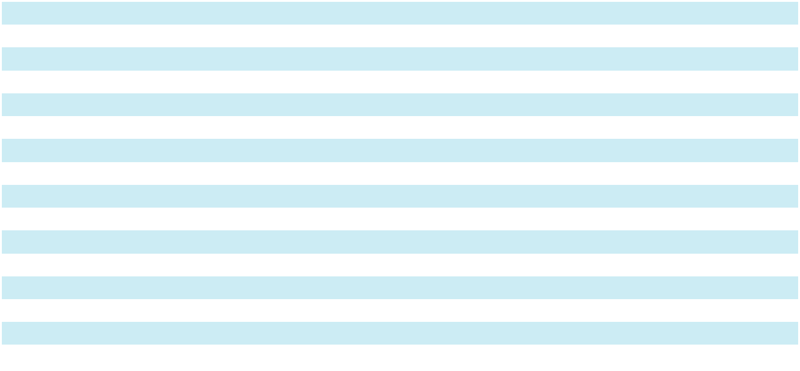

Stock options

The grant date fair value of the options under the 2022 Plan was determined using the Black-Scholes model where the term was the contractual term of 10 years less the weighted average service period. The volatility was determined based on the historical volatility of comparable publicly traded insurance companies. The stock options granted to employees during the year ended December 31, 2023 were valued at approximately $4.4 million based on the grant date fair value.

The following tables sets forth option activity for the years ended December 31, 2025 and 2024:

 |  | Weighted-
 |  | Average | Stock
 | Exercise Price |  | Stock
Outstanding at January 1, 2025 |  |  | 759,990
Forfeited | $ | 15.00 | (219)
Outstanding at December 31, 2025 |  |  | 759,771
 |  | Weighted-
 |  | Average | Stock
 | Exercise Price |  | Stock
Outstanding at January 1, 2024 |  |  | 759,990
Outstanding at December 31, 2024 |  |  | 759,990

The intrinsic value of each option is determined based on the difference between the fair value of the underlying share and the exercise price of the underlying option. The aggregate intrinsic value of options outstanding at December 31, 2025 and 2024 was $27.4 million and $27.0 million, respectively. The weighted-average remaining contractual life of the options outstanding at December 31, 2025 was 7.0 years.

102

SKYWARD SPECIALTY INSURANCE GROUP, INC. AND SUBSIDIARIES

NOTES TO CONSOLIDATED FINANCIAL STATEMENTS

- Stock Based Compensation (continued)

Restricted stock awards and restricted stock units

The fair value of restricted stock and restricted stock units under the 2022 Plan for awards granted at the time of the Company’s IPO were granted at the IPO price of $15.00 per share. The fair value of subsequent grants were equal to the closing stock price on the date the restricted stock units were granted. The expense for these equity-based incentives is based on their fair value at the date of grant and amortized over their vesting period.

The restricted stock and restricted stock units granted to employees and the Board of Directors during the years ended December 31, 2025, 2024 and 2023 were valued at approximately $12.2 million, $8.5 million and $17.7 million respectively, based on the grant date fair value.

The following table sets forth the Company’s restricted stock and restricted stock units activity for the years ended

December 31, 2025, 2024 and 2023:

 | Weighted-Average |  |  | Stock and Stock
 |  | Grant-Date |  | Stock and Stock
 |  | Fair Value |  | Units
Non-vested at January 1, 2025 | $ | 19.06 |  | 1,325,483
Granted⁽¹⁾ |  | 47.77 | 254,978
Vested |  | 15.33 | (391,746)
Forfeited⁽²⁾ |  | 25.74 | (53,247)
Non-vested at December 31, 2025 | $ | 27.06 |  | 1,135,468
Non-vested at January 1, 2024 | $ | 15.13 | 1,445,449
Granted⁽¹⁾ |  | 31.72 | 268,631
Vested |  | 13.16 | (285,957)
Forfeited⁽²⁾ |  | 18.27 |  | (102,640)
Non-vested at December 31, 2024 | $ | 19.06 |  | 1,325,483
Non-vested at January 1, 2023 | $ | 12.55 | 419,896
Granted⁽¹⁾ |  | 16.07 | 1,101,856
Vested |  | 13.39 | (40,645)
Forfeited⁽²⁾ |  | 15.29 |  | (35,658)
Non-vested at December 31, 2023 | $ | 15.13 | 1,445,449
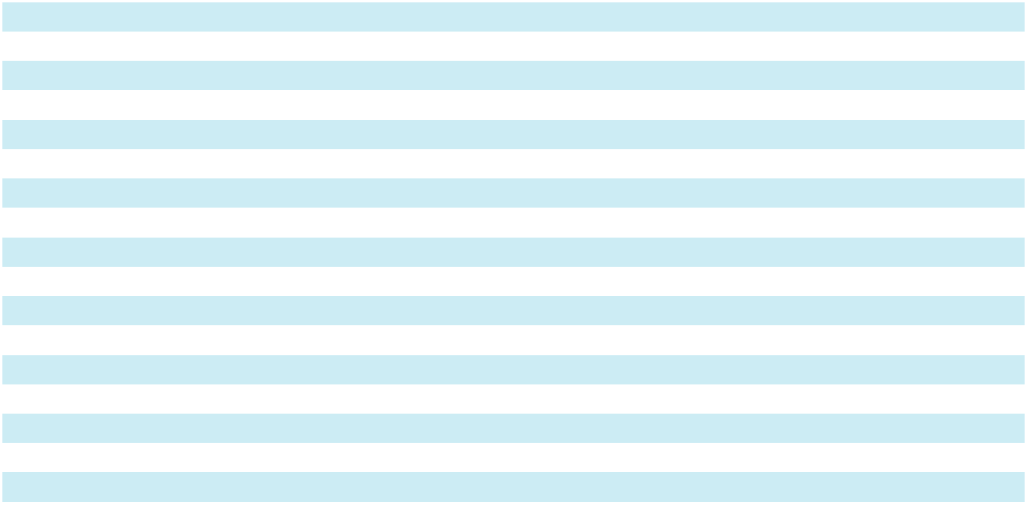

- Increases above the 100% target level are reflected as granted in the period after which performance-based stock unit goals are achieved.

- Decreases below the 100% target level are reflected as forfeited.

Members of the Board of Directors were granted 12,579, 19,453 and 23,482 shares of restricted stock and restricted stock units during the years ended December 31, 2025, 2024 and 2023, respectively, with a service period of one year. The total fair value of shares vested for employees and members of the Board of Directors at December 31, 2025, 2024 and 2023 was $6.0 million, $3.8 million and $0.5 million, respectively.

As of December 31, 2025 the total unrecognized compensation cost related to non-vested, stock-based compensation awards was $17.4 million and the weighted average period over which that cost is expected to be recognized is 1.6 years. For the years ended December 31, 2025, 2024 and 2023 the Company recognized $12.0 million, $9.4 million and $8.5 million, respectively, of stock-based compensation expense.

Employee Stock Purchase Plan

On September 23, 2022, the Board of Directors approved the Company’s 2022 Employee Stock Purchase Plan (the “ESPP”), which became effective on May 15, 2023, and is administered by the Compensation Committee. Under the ESPP, all employees of the Company may choose, at two different specified time intervals each year, to have a percentage of their annual base earnings withheld to purchase the Company’s common stock. The purchase price of the common stock is 85% of the lower of its beginning-of-interval or end-of-interval market price. The Company has reserved 376,548 common shares under this plan.

103

SKYWARD SPECIALTY INSURANCE GROUP, INC. AND SUBSIDIARIES

NOTES TO CONSOLIDATED FINANCIAL STATEMENTS

- Stock Based Compensation (continued)

The grant date fair value of options under the ESPP was determined using the Black-Scholes model where the term was the length of time between the grant date and the date the options are exercisable of 6 months. The volatility was determined based on the historical volatility of comparable publicly traded insurance companies.

As of December 31, 2025, a total of 141,845 shares had been purchased under this plan. The Company recognized $0.7 million and $0.5 million of expense during the years ended December 31, 2025 and 2024, respectively. As of December 31, 2025, the fair value of unrecognized expense was $0.3 million.

- Earnings Per Share

The following table sets forth the computation of basic and diluted net earnings per share for the years ended

December 31, 2025, 2024 and 2023:

($ in thousands, except for share and per share amounts) |  | 2025 |  |  | 2024 |  |  | 2023
Numerator
Net income | $ | 170,028 | $ |  | 118,828 | $ |  | 85,984
Less: Undistributed income allocated to participating securities
 |  | — |  |  | — |  |  | (1,677)
Net income attributable to common stockholders (numerator for |  | 170,028
basic earnings per share) |  | 170,028 |  |  | 118,828 |  |  | 84,307
Add back: Undistributed income allocated to participating |  | —
securities |  | — |  |  | — |  |  | 1,677
Net income (numerator for diluted earnings per share under the | $ | 170,028
two-class method) | $ | 170,028 | $ |  | 118,828 | $ |  | 85,984
Denominator
Denominator |  | 40,407,310
Basic weighted-average common shares |  | 40,407,310 |  |  | 40,056,475 |  |  | 36,031,907
Dilutive effect of preferred shares |  | — |  |  | — |  |  | 716,708
Dilutive effect of stock notes |  | — |  |  | — |  |  | 696,110
Dilutive effect of stock units |  | 897,426 |  |  | 917,510 |  |  | 736,837
Dilutive effect of options |  | 503,310 |  |  | 403,475 |  |  | 135,972
Diluted weighted-average common share equivalents |  | 41,808,046 |  |  | 41,377,460 |  |  | 38,317,534
Basic earnings per share
Basic earnings per share | $ | 4.21 |  | $ | 2.97 |  | $ | 2.34
Diluted earnings per share | $ | 4.07 | $ |  | 2.87 | $ |  | 2.24
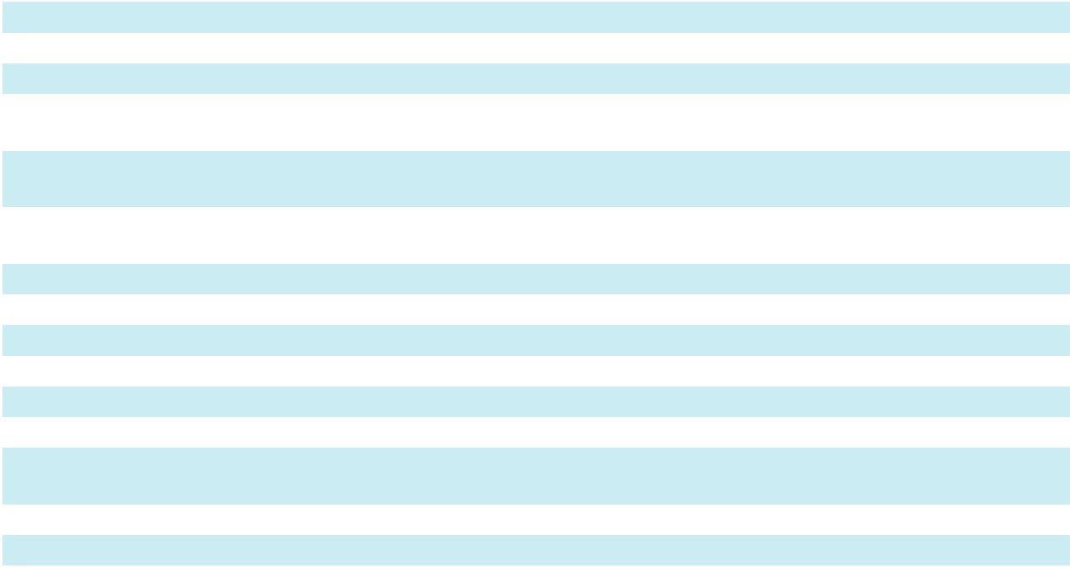

The following table presents anti-dilutive instruments that were excluded from the calculation of diluted weighted-average common share equivalents during the years ended December 31, 2025, 2024 and 2023:

 | 2025 |  | 2024 |  | 2023
Stock units | 104,531 | 20,346 |  | 3,931
Options | 242 | 859 |  | 914

The following table presents common share equivalents of contingently issuable instruments that were excluded from basic earnings per share in the years ended December 31, 2025, 2024 and 2023:

 | 2025 |  |  | 2024 |  |  | 2023
Common shares |  | — |  |  | — |  | 920,864
Total |  | — |  |  | — | 920,864

104

SKYWARD SPECIALTY INSURANCE GROUP, INC. AND SUBSIDIARIES

NOTES TO CONSOLIDATED FINANCIAL STATEMENTS

- Employee Benefit Plan

The Company sponsors the 401(k) Plan (the “Plan”). The Plan, available to substantially all its employees, is subject to provisions of the Employee Retirement Income Security Act of 1974. The Company matches employee contributions on a discretionary basis. During the years ended December 31, 2025, 2024 and 2023, the Company contributed $3.9 million, $3.2 million, and $2.9 million in matching contributions to the Plan, respectively.

- Related Party Transactions

RISCOM

RISCOM provides the Company with wholesale brokerage services. RISCOM and the Company also have a managing general agency agreement. The Company holds a 20% ownership interest in RISCOM.

Net earned premiums and gross commission expense related to these agreements for the years ended December 31, 2025, 2024 and 2023 were as follows:

($ in thousands) |  | 2025 |  |  | 2024 |  |  | 2023
Net earned premium | $ | 120,067 | $ |  | 108,130 | $ |  | 99,736
Commissions |  | 28,728 |  |  | 25,372 |  |  | 24,177

Premiums receivable as of December 31, 2025 and December 31, 2024 were $13.9 million and $12.6 million, respectively.

Other

Advisory and professional services fees and expense reimbursements paid to various affiliated stockholders and directors for the years ended December 31, 2025 and 2024 were $0.6 million and for the year ended December 31, 2023 were $3.6 million.

See Notes 5, 6 and 11 for investments involving affiliated companies and additional related party transactions.

- Commitments and Contingencies Litigation

The Company is named as a party in various legal actions arising from claims made under insurance policies and contracts. Those actions are considered by the Company in estimating the losses and loss adjustment expense reserves. Also, from time to time, the Company is a defendant in various legal actions that relate to bad faith claims, disputes with third parties or that involve alleged errors and omissions. The Company records accruals for these items to the extent the losses are probable and reasonably estimable. Although the ultimate outcome of these matters cannot be determined at this time, based on present information, the availability of insurance coverage and advice received from outside legal counsel, the Company believes the resolution of any such matters will not, individually or in the aggregate, have a material adverse effect on the Company’s consolidated financial position, results of operations or cash flows.

Indemnification

In conjunction with the sale of business assets and subsidiaries, the Company has provided indemnifications to certain buyers. Certain indemnifications cover typical representations and warranties related to the responsibilities to perform under the sales contracts. The amount of potential exposure covered by the indemnifications is difficult to determine because the indemnifications cover a variety of matters, operations and scenarios. Certain of these indemnifications have no time limit. At this time, the Company does not have reason to believe any such significant claims exist.

- Statutory Accounting Principles and Regulatory Matters

The Company’s statutory net income was $159.1 million, $108.2 million and $73.1 million for the years ended December 31, 2025, 2024 and 2023, respectively. The Company’s statutory capital and surplus was $872.0 million and $710.6 million as of December 31, 2025 and 2024, respectively.

105

SKYWARD SPECIALTY INSURANCE GROUP, INC. AND SUBSIDIARIES

NOTES TO CONSOLIDATED FINANCIAL STATEMENTS

- Statutory Accounting Principles and Regulatory Matters (continued)

Effective December 31, 2024, the Company restacked its insurance company subsidiaries and GMIC became the lead insurance company which resulted in the following changes:

- HSIC became a wholly owned subsidiary of GMIC;

- IIC became a wholly owned subsidiary of HSIC; and,

- OSIC became a wholly owned subsidiary of IIC.

Dividend payments to the Company from GMIC are restricted by Texas state law as to the amount that may be paid without the approval of regulatory authorities. The maximum amount of dividends which can be paid by GMIC without prior approval is subject to restrictions relating to policyholder surplus, net income, and dividends declared or distributed during the preceding 12 months. As of December 31, 2025, GMIC, as a company domiciled in Texas and subject to state insurance regulations, is restricted to paid dividends of the greater of ten percent of prior year ending capital and surplus or prior year net income. GMIC did not declare or pay any dividend during the year ended December 31, 2025 and HSIC did not declare or pay any dividends during the year ended December 31, 2024.

Property and casualty insurance companies are subject to certain Risk Based Capital (“RBC”) requirements as specified by the National Association of Insurance Commissioners (“NAIC”). Under those requirements, the amount of capital and surplus maintained by a property and casualty insurance company is to be determined based on the various risk factors related to it. As of December 31, 2025 and 2024 GMIC’s statutory capital and surplus substantially exceeded the regulatory requirements.

- Subsequent Events

On September 2, 2025, the Company entered into two share purchase agreements (the "Apollo Majority SPAs") with institutional and management shareholders, respectively, of Apollo Group Holdings Limited ("Apollo") (the "Majority Sellers"). Pursuant to the Apollo Majority SPAs, in accordance with the terms and subject to the conditions therein, the Company agreed to acquire all of the issued shares of Apollo held by the Majority Sellers, representing approximately 87% of the issued share capital of Apollo. In addition, closing of the transaction ("Closing") was conditioned upon the Company acquiring 100% of the issued share capital of Apollo (the “Acquisition”) at Closing pursuant to additional short-form share purchase agreements with the remaining minority shareholders of Apollo. On January 1, 2026, the Company completed the acquisition for aggregate consideration of approximately $555.0 million, payable in a combination of cash and newly issued shares of the Company’s common stock.

The acquisition closed shortly before the issuance of these consolidated financial statements, therefore, the initial accounting under ASC 805 is not yet complete. The Company is obtaining and evaluating the information necessary to determine the identifiable assets acquired, liabilities assumed, and any resulting goodwill or intangible assets. The required purchase accounting disclosures will be provided in future filings once available.

The Company evaluated subsequent events from December 31, 2025, through the date these consolidated financial statements were issued and did not identify any additional subsequent events requiring disclosure.

106

Item 9. Changes in and Disagreements With Accountants on Accounting and Financial Disclosures

None.

Item 9A. Controls and Procedures

Evaluation of Disclosure Controls and Procedures

Our management, with the participation of our principal executive officer and our principal financial officer, evaluated, as of the end of the period covered by this Annual Report on Form 10-K, the effectiveness of our disclosure controls and procedures (as defined in Rules 13a-15(e) and 15d-15(e) under the Securities Exchange Act of 1934, as amended, or the Exchange Act). Based on that evaluation, our principal executive officer and principal financial officer have concluded that as of December 31, 2025, our disclosure controls and procedures were effective at the reasonable assurance level. Management recognizes that any controls and procedures, no matter how well designed and operated, can provide only reasonable assurance of achieving their objectives and our management necessarily applies its judgment in evaluating the cost-benefit relationship of possible controls and procedures.

Management’s Report on Internal Control over Financial Reporting

Our management is responsible for establishing and maintaining adequate internal control over financial reporting as defined in Rules 13a-15(f) and 15d-15(f) under the Securities Exchange Act of 1934, as amended. Our internal control over financial reporting is designed to provide reasonable assurance regarding the reliability of financial reporting and the preparation of financial statements for external purposes in accordance with generally accepted accounting principles in the United States of America. Our internal control over financial reporting includes those policies and procedures that:

- Pertain to the maintenance of records that, in reasonable detail, accurately and fairly reflect the transactions and dispositions of our assets;

- Provide reasonable assurance that transactions are recorded as necessary to permit preparation of financial statements in accordance with generally accepted accounting principles, and that our receipts and expenditures are being made only in accordance with authorizations of our management and directors; and

- Provide reasonable assurance regarding prevention or timely detection of unauthorized acquisition, use or disposition of our assets that could have a material effect on the financial statements.

Remediation of Material Weakness in Internal Control Over Financial Reporting

As previously disclosed in the Annual Report on Form 10-K for the fiscal year ended December 31, 2024, management concluded that its internal control over financial reporting was not effective because management identified material weaknesses in internal control over financial reporting. Our management concluded that a material weakness existed as of December 31, 2024 related to the ineffective implementation of information technology general controls (“ITGCs”) in the area of user access for systems that support our financial reporting processes. Further, our related process-level IT dependent manual and automated controls that rely upon the affected ITGCs, or information coming from IT systems with affected ITGCs, were also deemed ineffective.

During the year ended December 31, 2025, management took the following actions to remediate the aforementioned internal control deficiencies:

- enhanced our IT compliance oversight function and expanded our team to include team members with experience designing and implementing ITGC;

- developed a training program addressing ITGCs and policies, including educating control owners about the principles and requirements of each control;

- implemented procedures to develop and maintain documentation of underlying ITGCs to promote knowledge transfer upon IT personnel and function changes;

- implemented an IT management review and testing procedures to monitor ITGCs; and

- provided quarterly reporting on the remediation measures to the Audit Committee of our board of directors.

We believe the measures described above have remediated the material weakness previously identified and we have concluded our internal control over financial reporting was effective at a reasonable assurance level as of December 31, 2025.

Under the supervision and with the participation of our senior management, including our Chief Executive Officer and Chief Financial Officer, we assessed the effectiveness of our internal control over financial reporting as of December 31, 2025. In making this assessment, we used the criteria set forth by the Committee of Sponsoring Organizations of the

107

Treadway Commission in the Internal Control — Integrated Framework (2013 Framework). Based on this assessment, management has concluded our internal control over financial reporting was effective as of December 31, 2025.

The effectiveness of our internal control over financial reporting as of December 31, 2025 has been audited by Ernst & Young, LLP, the Company’s independent registered public accounting firm, as stated in their report included herein titled “Report of Independent Registered Public Accounting Firm-Opinion on Internal Control over Financial Reporting.”

Changes in Internal Control over Financial Reporting

Except in connection with the remediation of the material weakness identified in 2024 as discussed above, there has been no change in our internal control over financial reporting identified in connection with the evaluation required by Rule 13a-15(d) and 15d-15(d) of the Exchange Act that occurred during the year ended December 31, 2025 that have materially affected, or are reasonably likely to materially affect, our internal control over financial reporting.

Limitations on Effectiveness of Controls and Procedures

In designing and evaluating the disclosure controls and procedures, management recognizes that any controls and procedures, no matter how well designed and operated, can provide only reasonable assurance of achieving the desired control objectives. In addition, the design of disclosure controls and procedures must reflect the fact that there are resource constraints and that management is required to apply judgment in evaluating the benefits of possible controls and procedures relative to their costs.

Item 9B. Other Information

During the quarter ended December 31, 2025, none of our directors or officers (as defined in Rule 16a-1(f) of the Securities Exchange Act of 1934) adopted, terminated or modified a Rule 10b5-1 trading arrangement or non-Rule 10b5-1 trading arrangement (as such terms are defined in Item 408 of Regulation S-K).

Item 9C. Disclosure Regarding Foreign Jurisdictions that Prevent Inspections - Not applicable.

PART III

Item 10. Directors, Executive Officers and Corporate Governance

The information required by this Item 10 of Form 10-K will be included in our 2026 Proxy Statement and is incorporated herein by reference.

Item 11. Executive Compensation

The information required by this Item 11 of Form 10-K will be included in our 2026 Proxy Statement and is incorporated herein by reference.

Item 12. Security Ownership of Certain Beneficial Owner and Management and Related Stockholder Matters

The information required by this Item 12 of Form 10-K will be included in our 2026 Proxy Statement and is incorporated herein by reference.

Item 13. Certain Relationships and Related Transactions, and Director Independence

The information required by this Item 13 of Form 10-K will be included in our 2026 Proxy Statement and is incorporated herein by reference.

Item 14. Principal Accounting Fees and Services

Our independent registered public accounting firm is Ernst & Young LLP, Houston, Texas. Auditor Firm ID: 42

The information required by this Item 14 of Form 10-K will be included in our 2026 Proxy Statement and is incorporated herein by reference.

108

PART IV

Item 15. Exhibits, Financial Statement Schedules.

(a)(1) LISTING OF FINANCIAL STATEMENTS

The following consolidated financials statements of the Company are filed as part of this Form 10-K and are included in

Item 8:

Report of Independent Registered Public Accounting Firm Consolidated Balance Sheets as of December 31, 2025 and 2024
Consolidated Statements of Operations and Comprehensive Income (loss) for the three years in the periods ended December 31, 2025, 2024 and 2023

Consolidated Statements of Stockholders’ Equity for the three years in the period ended December 31, 2025, 2024 and 2023

Consolidated Statements of Cash Flows for the three years in the period ended December 31, 2025, 2024 and 2023 (a)(2)

Schedule
Number |  | Schedule Description |  | Page
I. |  | Summary of Investments — Other Than in Related Parties at December 31, 2025 | 113
- Financial Information of Registrant (Parent Company) for the years ended December 31, 2025,

 | 2024 and 2023 | 114
IV. | Supplementary Reinsurance Information for the years ended December 31, 2025, 2024, and | 118
 | 2023 | 118
V. | Valuation and Qualifying Accounts for the years ended December 31, 2025, 2024, and 2023 | 119
VI. | Supplementary Information Concerning Property — Casualty Insurance Operations for the years | 120
 | ended December 31, 2025, 2024, and 2023 | 120

(a)(3) LISTING OF EXHIBITS

Exhibit
Number |  | Exhibit Description
3.1 |  | Amended and Restated Certificate of Incorporation (incorporated by reference to Exhibit 3.1 to the
 |  | Company's Current Report on Form 8-K filed with the Commission on January 18, 2023).
3.2 |  | Amended and Restated Bylaws (incorporated by reference to Exhibit 3.2 to the Company's Current Report
 |  | on Form 8-K filed with the Commission on January 18, 2023).
4.1 |  | Amended and Restated Stockholders’ Agreement, dated March 12, 2014, by and among the Company and
 |  | the stockholders listed therein (incorporated by reference to Exhibit 4.1 to the Company's Registration
 |  | Statement on Form S-1, filed with the SEC on November 14, 2022).
4.2 |  | Description of Capital Stock (incorporated by reference to Exhibit 4.2 to the Company’s Annual Report on
 |  | Form 10-K, filed with the SEC on March 28, 2023).
10.1+ |  | Share Purchase and Award Agreement and form of agreements thereunder in use before 2016 (incorporated
 |  | by reference to Exhibit 10.1 to the Company's Registration Statement on Form S-1, filed with the SEC on
 |  | November 14, 2022).
10.2+ |  | 2016 Equity Incentive Program and form of award agreements thereunder (incorporated by reference to
 |  | Exhibit 10.2 to the Company's Registration Statement on Form S-1, filed with the SEC on November 14,
 | 2022).
10.3+ |  | 2020 Long Term Incentive Plan and form of award agreements thereunder (incorporated by reference to
 |  | Exhibit 10.3 to the Company's Registration Statement on Form S-1, filed with the SEC on November 14,
 | 2022).
10.4+ |  | Skyward Specialty Insurance Group, Inc. 2022 Long-Term Incentive Plan (incorporated by reference to
 |  | Exhibit 10.4 to the Company's Registration Statement on Form S-1, filed with the SEC on November 14,
 | 2022).
10.5+ |  | Skyward Specialty Insurance Group, Inc. 2022 Employee Stock Purchase Plan (incorporated by reference
 |  | to Exhibit 10.5 to the Company's Registration Statement on Form S-1, filed with the SEC on November 14,
 | 2022).
10.6+ |  | Form of Restricted Stock Units Agreement and form of notice under the Company's 2022 Long-Term
 |  | Incentive Plan (incorporated by reference to Exhibit 99.6 to the Company's Registration Statement on Form
 |  | S-8, filed with the SEC on January 12, 2023).

109

Exhibit
Number |  | Exhibit Description
10.7+ |  | Form of Restricted Stock Agreement under the Company’s 2022 Long-Term Incentive Plan (incorporated
 |  | by reference to Exhibit 99.7 to the Company's Registration Statement on Form S-8, filed with the SEC on
 |  | January 12, 2023).
10.8+ |  | Form of Nonstatutory Stock Option Agreement and form of notice under the Company's 2022 Long-Term
 |  | Incentive Plan (incorporated by reference to Exhibit 99.8 to the Company's Registration Statement on Form
 |  | S-8, filed with the SEC on January 12, 2023).
10.9+ |  | Form of Incentive Stock Option Agreement and form of notice under the Company's 2022 Long-Term
 |  | Incentive Plan (incorporated by reference to Exhibit 99.9 to the Company's Registration Statement on Form
 |  | S-8, filed with the SEC on January 12, 2023).
10.10+ |  | Form of Performance-Based Restricted Stock Units Agreement under the Company’s 2022 Long-Term
 |  | Incentive Plan (incorporated by reference to Exhibit 10.10 to the Company’s Annual Report on Form 10-K,
 |  | filed with the SEC on March 28, 2023).
10.11+ |  | Performance-Based Restricted Stock Units Agreement under the Company’s 2022 Long-Term Incentive
 |  | Plan (incorporated by reference to Exhibit 10.11 to the Company’s Annual Report on Form 10-K, filed with
 |  | the SEC on March 28, 2023).
10.12+ |  | Performance Unit Agreement under the Company’s 2022 Long-Term Incentive Plan (incorporated by
 |  | reference to Exhibit 10.12 to the Company’s Annual Report on Form 10-K, filed with the SEC on March
 | 28, 2023).
10.13+ |  | Amended Form of Performance Share (GBVPS) Agreement under the Company’s 2022 Long-Term
 |  | Incentive Plan (incorporated by reference to Exhibit 10.13 to the Company’s Annual Report on Form 10-K,
 |  | filed with the SEC on April 1, 2024).
10.14+ |  | Amended Form of Performance Share (Executives) Agreement under the Company’s 2022 Long-Term
 |  | Incentive Plan (incorporated by reference to Exhibit 10.14 to the Company’s Annual Report on Form 10-K,
 |  | filed with the SEC on April 1, 2024).
10.15+ |  | Amended Form of Performance Share (Others) Agreement under the Company’s 2022 Long-Term
 |  | Incentive Plan (incorporated by reference to Exhibit 10.15 to the Company’s Annual Report on Form 10-K,
 |  | filed with the SEC on April 1, 2024).
10.16+ |  | Amended Form of Performance Cash Units Agreement under the Company’s Long-Term Incentive Plan.
 |  | (incorporated by reference to Exhibit 10.16 to the Company’s Annual Report on Form 10-K, filed with the
 |  | SEC on April 1, 2024).
10.17+ |  | Amended Form of the Restricted Stock Unit (Executives) Agreement under the Company’s 2022 Long-
 |  | Term Incentive Plan (incorporated by reference to Exhibit 10.17 to the Company’s Annual Report on Form
 |  | 10-K, filed with the SEC on April 1, 2024).
10.18+ |  | Amended Form of Restricted Stock Unit (Others) Agreement under the Company’s 2022 Long-Term
 |  | Incentive Plan (incorporated by reference to Exhibit 10.18 to the Company’s Annual Report on Form 10-K,
 |  | filed with the SEC on April 1, 2024).
10.19+ |  | Amended Form of Long-Term Performance Cash Plan and Award Letter under the Company’s 2022 Long-
 |  | Term Incentive Plan (incorporated by reference to Exhibit 10.19 to the Company’s Annual Report on Form
 |  | 10-K, filed with the SEC on April 1, 2024).
10.20+ |  | Form of Indemnification Agreement (incorporated by reference to Exhibit 10.6 to the Company's
 |  | Registration Statement on Form S-1, filed with the SEC on November 14, 2022).
10.21+ |  | Employment Agreement, dated May 22, 2020, by and between the Registrant and Andrew Robinson, with
 |  | Amendment No. 1 dated January 1, 2022 (incorporated by reference to Exhibit 10.7 to the Company's
 |  | Registration Statement on Form S-1, filed with the SEC on November 14, 2022).
10.22+ |  | Form of Non-Employee Director Deferred Restricted Stock Unit Agreement and Form of Notice Under the
 |  | Company’s 2022 Long-Term Incentive Plan (incorporated by reference to Exhibit 10.22 to the Company’s
 |  | Annual Report on Form 10-K, filed with the SEC on March 3, 2025).
10.23 |  | Commutation and Release Agreement by and among R&Q Re (Bermuda) Ltd., Skyward Re, Houston
 |  | Specialty Insurance Company, Imperium Insurance Company, and Great Midwest Insurance Company,
 |  | dated January 31, 2025 (incorporated by reference to Exhibit 10.1 to the Company's Current Report on
 |  | Form 8-K filed with the Commission on February 5, 2025).
10.24 |  | Credit Agreement, dated March 29, 2023, by and among Skyward Specialty Insurance Group, Inc., the
 |  | lenders from time to time party thereto and Truist Bank, as administrative agent (incorporated by reference
 |  | to Exhibit 10.1 to the Company's Current Report on Form 8-K filed with the Commission on April 3,
 | 2023).
10.25 |  | First Amendment dated as of February 26, 2024, to that certain Credit Agreement, dated March 29, 2023,
 |  | by and among Skyward Specialty Inc., the lenders from time to time party thereto and Truist Bank, as
 |  | administrative agent (incorporated by reference to Exhibit 10.28 to the Company’s Annual Report on Form
 |  | 10-K, filed with the SEC on April 1, 2024).

110

Exhibit
Number |  | Exhibit Description
10.26 |  | Guaranty Agreement, dated March 29, 2023, by and among Skyward Service Company, Skyward
 |  | Underwriters Agency, Inc., the loan parties identified on the signature pages thereto and Truist Bank.
 |  | (incorporated by reference to Exhibit 10.2 to the Company's Current Report on Form 8-K filed with the
 |  | Commission on April 3, 2023).
10.27 |  | Advances and Security Agreement, dated August 1, 2024, by and between Houston Specialty Insurance
 |  | Company, a wholly owned insurance company subsidiary of the Company and the Federal Home Loan
 |  | Bank of Dallas (incorporated by reference to Exhibit 10.1 to the Company’s Current Report on Form 8-K
 |  | filed with the Commission on September 6, 2024).
10.28+ |  | Form of Severance Agreement between the Company and executive officers (other than the CEO)
 |  | (incorporated by reference to Exhibit 10.30 to the Company’s Annual Report on Form 10-K, filed with the
 |  | SEC on March 3, 2025).
10.29+ |  | Amendment No. 2 to Employment Agreement between the Registrant and Andrew Robinson dated March
 |  | 1, 2025 (incorporated by reference to Exhibit 10.31 to the Company’s Annual Report on Form 10-K, filed
 |  | with the SEC on March 3, 2025).
10.30+ |  | Amended Form of Restricted Stock Unit (Executives) Agreement under the Company’s 2022 Long-Term
 |  | Incentive Plan (incorporated by reference to Exhibit 99.21 to the Company’s Registration Statement on
 |  | Form S-8, filed with the SEC on March 5, 2025).
10.31+ |  | Amended Form of the Restricted Stock Unit (Others) Agreement under the Company’s 2022 Long-Term
 |  | Incentive Plan (incorporated by reference to Exhibit 99.22 to the Company’s Registration Statement on
 |  | Form S-8, filed with the SEC on March 5, 2025).
10.32+ |  | Amended Form of Performance Share (Executives) Agreement under the Company’s 2022 Long-Term
 |  | Incentive Plan (incorporated by reference to Exhibit 99.23 to the Company’s Registration Statement on
 |  | Form S-8, filed with the SEC on March 5, 2025).
10.33+ |  | Amended Form of Performance Share (Others) Agreement under the Company’s 2022 Long-Term
 |  | Incentive Plan (incorporated by reference to Exhibit 99.24 to the Company’s Registration Statement on
 |  | Form S-8, filed with the SEC on March 5, 2025).
10.34+ |  | Amended Form of Performance Share (GBVPS) (Executives) Agreement under the Company’s 2022 Long-
 |  | Term Incentive Plan (incorporated by reference to Exhibit 99.25 to the Company’s Registration Statement
 |  | on Form S-8, filed with the SEC on March 5, 2025).
10.35+ |  | Amended Form of Performance Share (GBVPS) (Others) Agreement under the Company’s 2022 Long-
 |  | Term Incentive Plan (incorporated by reference to Exhibit 99.26 to the Company’s Registration Statement
 |  | on Form S-8, filed with the SEC on March 5, 2025).
10.36+ |  | Amended Form of Long-Term Performance Cash Plan and Award Letter under the Company’s 2022 Long-
 |  | Term Incentive Plan (incorporated by reference to Exhibit 99.27 to the Company’s Registration Statement
 |  | on Form S-8, filed with the SEC on March 5, 2025).
10.37 |  | Share Purchase Agreement, dated September 2, 2025, by and between Skyward Specialty Insurance Group,
 |  | Inc. and Apollo institutional shareholders, of Apollo Group Holdings Limited (incorporated by reference to
 |  | Exhibit 2.1 to the Company’s Current Report on Form 8-K filed with the Commission on September 8,
 | 2025).
10.38 |  | Share Purchase Agreement, dated September 2, 2025, by and between Skyward Specialty Insurance Group,
 |  | Inc. and Apollo management shareholders, of Apollo Group Holdings Limited (incorporated by reference
 |  | to Exhibit 2.2 to the Company’s Current Report on Form 8-K filed with the Commission on September 8,
 | 2025).
10.39 |  | Credit Agreement, dated November 13, 2025, by and between Skyward Specialty Insurance Group, Inc.
 |  | and Barclays Bank PLC, as Administrative Agent, Truist Securities, Inc., Citizens Bank, N.A. and Texas
 |  | Capital Bank (incorporated by reference to Exhibit 10.1 to the Company's Current Report on Form 8-K
 |  | filed with the Commission on November 18, 2025).
10.40 |  | Guaranty Agreement, dated November 13, 2025, by and among Skyward Specialty Insurance Group, Inc.,
 |  | Skyward Service Company, Skyward Underwriters Agency, Inc., the loan parties identified on the
 |  | signature pages thereto and Barclays Bank PLC. Barclays Bank PLC (incorporated by reference to Exhibit
 |  | 10.2 to the Company's Current Report on Form 8-K filed with the Commission on November 18, 2025).
10.41 |  | Term Loan Credit Agreement, dated December 30, 2025, by and among Skyward Specialty Insurance
 |  | Group, Inc., and Barclays Bank PLC, as Administrative Agent, Truist Securities, Inc., Citizens Bank, N.A.
 |  | and Texas Capital Bank (incorporated by reference to Exhibit 10.1 to the Company's Current Report on
 |  | Form 8-K filed with the Commission on January 6, 2026).
10.42 |  | Guaranty Agreement, dated December 30, 2025, by and among Skyward Specialty Insurance Group, Inc.,
 |  | Skyward Service Company, Skyward Underwriters Agency, Inc., the loan parties identified on the
 |  | signature pages and Barclays Bank PLC (incorporated by reference to Exhibit 10.2 to the Company's
 |  | Current Report on Form 8-K filed with the Commission on January 6, 2026).

111

Exhibit
Number |  | Exhibit Description
10.43 |  | First Amendment, dated December 30, 2025, by and among Skyward Specialty Insurance Group, Inc.,
 |  | Skyward Service Company, Skyward Underwriters Agency, Inc., the loan parties identified on the
 |  | signature pages and Barclays Bank PLC (incorporated by reference to Exhibit 10.3 to the Company's
 |  | Current Report on Form 8-K filed with the Commission on January 6, 2026).

- Skyward Specialty Insurance Securities Trading Policy (incorporated by reference to Exhibit 19 to the Company’s Annual Report on Form 10-K, filed with the SEC on March 3, 2025).

19.1* Skyward Specialty Insurance Securities Trading Policy amended November 5, 2025.

21.1* List of Subsidiaries of the Company

23.1* Consent of Ernst & Young LLP, Independent Registered Public Accounting Firm.

31.1* Certification of Principal Executive Officer pursuant to Rule 13a-14(a) or Rule 15d-14(a) of the Securities
Exchange Act of 1934, as adopted pursuant to Section 302 of the Sarbanes-Oxley Act of 2002.

31.2* Certification of Principal Financial and Accounting Officer pursuant to Rule 13a 14(a) or Rule 15d 14(a) of the Securities Exchange Act of 1934, as adopted pursuant to Section 302 of the Sarbanes-Oxley Act of 2002.

32.1* Certification of Principal Executive Officer pursuant to 18 U.S.C. Section 1350, as adopted pursuant to Section 906 of the Sarbanes-Oxley Act of 2002.

- Policy for Recovery of Erroneously Awarded Incentive Compensation (“Clawback Policy”) (incorporated by reference to Exhibit 97 to the Company’s Annual Report on Form 10-K, filed with the SEC on April 1, 2024).
101.INS | Inline XBRL Instance Document – the instance document does not appear in the Interactive Data File
 | because XBRL tags are embedded within the Inline XBRL document.
101.SCH | Inline XBRL Taxonomy Extension Schema With Embedded Linkbase Documents

  - Cover Page Interactive Date File (embedded within the Inline XBRL document)

____________________

*Filed herewith.

- Management contract or compensatory plan or arrangement.

112

SKYWARD SPECIALTY INSURANCE GROUP, INC. AND SUBSIDIARIES

SCHEDULE I — SUMMARY OF INVESTMENTS — OTHER THAN IN RELATED PARTIES

 |  |  |  | Fair Value (if |  |  |  | Amount on
($ in thousands) |  | Cost |  |  | applicable) |  | Balance Sheet
December 31, 2025
Fixed maturity securities, available for sale:
U.S. government securities | $ | 44,190 | $ |  | 44,468 | $ |  | 44,468
Corporate securities and miscellaneous |  | 632,244 |  |  | 636,387 |  |  | 636,387
Municipal securities |  | 102,691 |  |  | 102,116 |  |  | 102,116
Residential mortgage-backed securities |  | 487,145 |  |  | 486,587 |  |  | 486,587
Commercial mortgage-backed securities |  | 72,631 |  |  | 73,050 |  |  | 73,050
Other asset-backed securities |  | 509,854 |  |  | 513,695 |  |  | 513,695
Total fixed maturity securities, available for sale |  | 1,848,755 |  |  | 1,856,303 |  |  | 1,856,303
Fixed maturity securities, held to maturity:
Other asset-backed securities |  | 33,290 |  |  | 33,603 |  |  | 32,822
Total fixed maturity securities, held to maturity |  | 33,290 |  |  | 33,603 |  |  | 32,822
Equity securities:
Preferred stocks |  | 1,138 |  |  | 1,174 |  |  | 1,174
Total equity securities |  | 1,138 |  |  | 1,174 |  |  | 1,174
Mortgage loans |  | 10,093 |  |  | 9,902 |  |  | 9,902
Other long-term investments |  | 37,290 |  |  | 58,650 |  |  | 58,650
Short-term investments |  | 264,299 |  |  | 264,299 |  |  | 264,299
Total | $ | 2,194,865 |  | $ | 2,223,931 |  | $ | 2,223,150
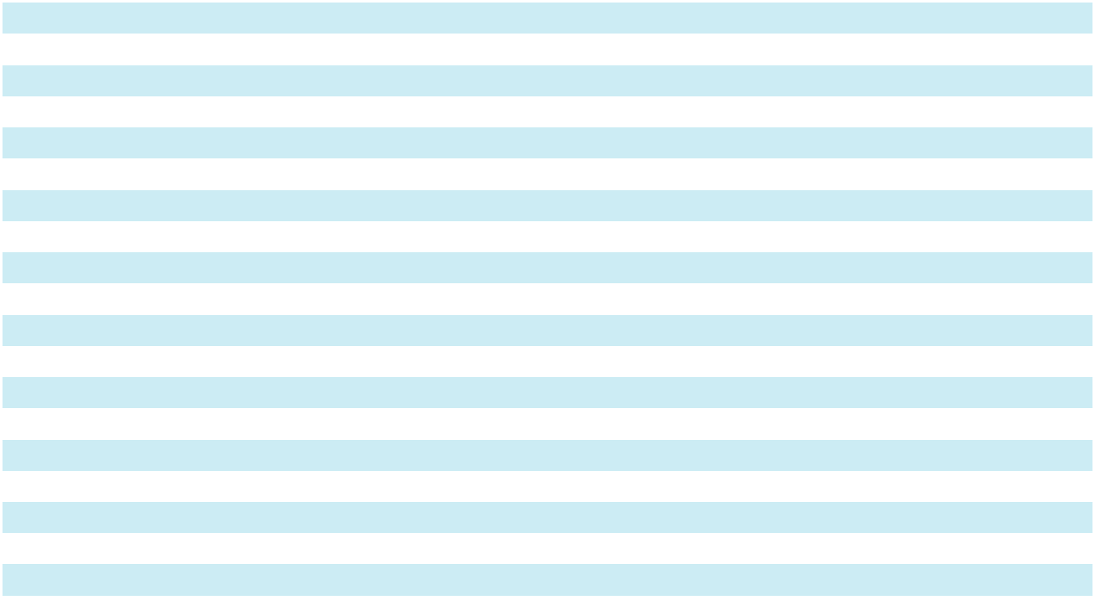

113

SKYWARD SPECIALTY INSURANCE GROUP, INC. AND SUBSIDIARIES SCHEDULE II — FINANCIAL INFORMATION OF REGISTRANT BALANCE SHEETS (PARENT COMPANY)

December 31,

($ in thousands) |  | 2025 |  |  | 2024
Assets
Investments:
Investment in subsidiaries | $ | 1,076,288 | $ |  | 853,670
Short-term investments, at fair value |  | 14,513 |  |  | 14,000
Total investments |  | 1,090,801 |  |  | 867,670
Cash and cash equivalents |  | 3,500 |  |  | 2,943
Deferred income taxes |  | 27,865 |  |  | 30,486
Goodwill and intangible assets, net |  | 14,349 |  |  | 12,641
Other assets |  | 10,709 |  |  | 2,905
Total assets | $ | 1,147,224 | $ |  | 916,645
Liabilities and Stockholders’ Equity
Liabilities:
Accounts payable and accrued liabilities | $ | 17,680 | $ |  | 3,110
Notes payable |  | 100,410 |  |  | 100,000
Subordinated debt, net of debt issuance costs |  | 19,569 |  |  | 19,536
Total liabilities |  | 137,659 |  |  | 122,646
Stockholders’ Equity:
Stockholders’ equity |  | 1,009,565 |  |  | 793,999
Total liabilities and stockholders’ equity | $ | 1,147,224 | $ |  | 916,645

114

SKYWARD SPECIALTY INSURANCE GROUP, INC. AND SUBSIDIARIES SCHEDULE II — STATEMENTS OF OPERATIONS (PARENT COMPANY)

Years Ended December 31,

($ in thousands) |  | 2025 |  |  | 2024 |  |  | 2023
Revenues:
Net investment income | $ | 3,371 | $ |  | 3,212 | $ |  | 3,822
Net investment gains (losses) |  | — |  |  | 963 |  |  | (963)
Other loss |  | — |  |  | (2) |  |  | (27)
Total revenues |  | 3,371 |  |  | 4,173 |  |  | 2,832
Expenses
Operating expenses |  | 7,899 |  |  | 10,632 |  |  | —
Interest expense |  | 6,762 |  |  | 8,140 |  |  | 9,815
Amortization expense |  | 620 |  |  | 920 |  |  | 313
Other expenses |  | 17,962 |  |  | 9,646 |  |  | 451
Total expenses |  | 33,243 |  |  | 29,338 |  |  | 10,579
Loss before income tax expense |  | (29,872) |  |  | (25,165) |  |  | (7,747)
Income tax expense |  | 45,860 |  |  | 33,578 |  |  | 6,808
Loss before equity in earnings of subsidiaries |  | (75,732) |  |  | (58,743) |  |  | (14,555)
Equity in undistributed earnings of subsidiaries |  | 245,760 |  |  | 177,571 |  |  | 100,539
Net income | $ | 170,028 | $ |  | 118,828 | $ |  | 85,984

See accompanying notes to financial statements.

115

SKYWARD SPECIALTY INSURANCE GROUP, INC. AND SUBSIDIARIES

SCHEDULE II — STATEMENTS OF CASH FLOWS (PARENT COMPANY)

Years Ended December 31,

($ in thousands) |  | 2025 |  |  | 2024 |  |  | 2023
Cash flows from operating activities:
Net income | $ | 170,028 | $ |  | 118,828 | $ |  | 85,984
Adjustments to reconcile net income to net cash used in operating |  | (175,769)
activities |  | (175,769) |  |  | (121,563) |  |  | (95,947)
Net cash used in operating activities |  | (5,741) |  |  | (2,735) |  |  | (9,963)
Cash flows from investing activities:
Purchase of intangible assets and goodwill |  | (2,000) |  |  | — |  |  | —
Capital contributions to subsidiaries |  | (100) |  |  | — |  |  | (122,800)
Distributions from investment in subsidiaries |  | 8,500 |  |  | 8,500 |  |  | 6,500
Change in short-term investments |  | (513) |  |  | (3,407) |  |  | (10,569)
Net cash provided by (used in) investing activities |  | 5,887 |  |  | 5,093 |  |  | (126,869)
Cash flows from financing activities:
Repayment of stock notes receivable |  | — |  |  | 5,561 |  |  | 1,350
Proceeds from long term borrowings |  | 43,411 |  |  | 107,000 |  |  | 50,000
Payments on long term borrowings and trust preferred |  | (43,000) |  |  | (115,000) |  |  | (50,000)
Proceeds from equity offerings |  | — |  |  | — |  |  | 128,887
Proceeds from employee stock purchase plan |  | — |  |  | — |  |  | 710
Net cash provided by (used in) financing activities |  | 411 |  |  | (2,439) |  |  | 130,947
Net increase (decrease) in cash and cash equivalents and restricted |  | 557 |  |  | (81) |  |  | (5,885)
cash |  | 557 |  |  | (81) |  |  | (5,885)
Cash and cash equivalents and restricted cash at beginning of year |  | 2,943 |  |  | 3,024 |  |  | 8,909
Cash and cash equivalents and restricted cash at end of year | $ | 3,500 | $ |  | 2,943 | $ |  | 3,024
Supplemental disclosure of cash flow information:
Supplemental disclosure of cash flow information: | $ | 6,149
Cash paid for interest | $ | 6,149 | $ |  | 8,573 | $ |  | 10,667
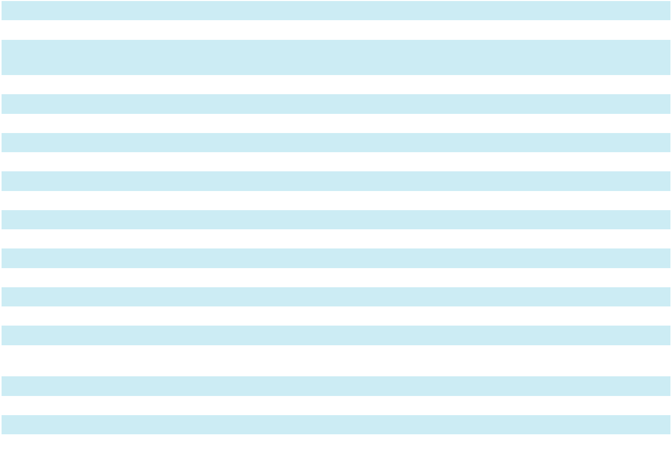

See accompanying notes to financial statements.

116

SKYWARD SPECIALTY INSURANCE GROUP, INC. AND SUBSIDIARIES

SCHEDULE II — FINANCIAL INFORMATION OF REGISTRANT

CONTINUED

Notes to Financial Statements

On September 30, 2024, Skyward Specialty entered into an Intercompany Loan Promissory Note (“the Promissory Note”) with Houston Specialty Insurance Company (“HSIC”). Under the terms of the Promissory Note, Skyward Specialty borrowed $57.0 million from HSIC. Under the terms of the Promissory Note, interest is payable monthly at a fixed annual interest rate of 4.00%, with the principal due at the maturity date. There are no prepayment penalties and no collateral was given as security for the payment of the Promissory Note.

During the year ended December 31, 2024, Skyward Specialty provided funds for a new subsidiary, Skyward Specialty No. 1 Limited Company, a UK company authorized as a Lloyd’s corporate member to invest in Lloyd’s syndicates.

Financial Instruments Disclosed, But Not Carried, At Fair Value Notes Payable

Included in notes payable is the Promissory Note described above between Skyward Specialty and HSIC. Skyward Specialty determined its fair value using the income approach utilizing inputs that are observable. The Promissory Note has been placed in Level 2 of the fair value hierarchy.

The following table sets forth the Company’s carrying and fair values of the Promissory Note as of December 31, 2025 and 2024:

 |  | 2025 |  |  |  |  |  | 2024
 |  | Carrying |  |  | Fair |  |  | Carrying |  |  | Fair
($ in thousands) |  | Value |  |  | Value |  |  | Value |  |  | Value
Notes payable | $ | 57,000 | $ |  | 57,401
Promissory Note |  |  |  |  |  | $ |  | 57,000 | $ |  | 56,300

Other financial instruments qualify as insurance-related products and are specifically exempted from fair value disclosure requirements.

117

SKYWARD SPECIALTY INSURANCE GROUP, INC. AND SUBSIDIARIES

SCHEDULE IV — REINSURANCE

 |  |  |  | Years Ended December 31,
 | 2025 |  |  |  | 2024 |  |  |  | 2023
 | Accident & |  | Property & |  | Accident & |  | Property & |  | Accident & |  | Property &
($ in thousands) | Health |  | Casualty |  | Health |  | Casualty |  | Health |  | Casualty
Gross amount | $ 254,102 |  | $1,430,309 | $ 173,073 |  | $1,285,564 |  |  | $ 151,702 | $1,089,478
Ceded to other companies | (143,811) | (616,193) |  | (86,503) |  | (533,151) |  |  | (79,091) | (470,047)
Assumed from other companies | — |  | 481,825 |  | — |  | 284,595 |  | — |  | 218,649
Net amount | $ 110,291 |  | $1,295,941 | $ 86,570 |  | $1,037,008 |  |  | $ 72,611 | $ 838,080
Percentage of amount assumed to
Percentage of amount assumed to | — % | 37.2 % |  |  | — % | 27.4 % |  |  | — % | 26.1 %
net | — % |  |  |  | — % |  |  |  | — %


118

SKYWARD SPECIALTY INSURANCE GROUP, INC. AND SUBSIDIARIES

SCHEDULE V — VALUATION AND QUALIFYING ACCOUNTS

 |  | Valuation |  | Allowance for |  |  | Allowance for
 |  | Allowance |  | Uncollectible |  |  | Uncollectible
 | For Deferred |  |  |  | Reinsurance |  |  | Premiums
($ in thousands) |  | Tax Assets |  |  | Recoverable |  |  | Receivable
Balance at January 1, 2023 |  | 586 |  |  | — |  |  | 629
Cumulative effect of adoption of ASU 2016-13 at January 1, 2023 |  | — |  |  | 2,295 |  |  | —
Charged to costs and expenses |  | — |  |  | — |  |  | 748
Amounts written off |  | — |  |  | — |  |  | (513)
Recoveries of amounts previously written off |  | — |  |  | — |  |  | 100
Balance at December 31, 2023 |  | 586 |  |  | 2,295 |  |  | 964
Charged to costs and expenses |  | — |  |  | 13,585 |  |  | 3,235
Amounts written off |  | — |  |  | (13,585) |  |  | (1,895)
Recoveries of amounts previously written off |  | — |  |  | — |  |  | 128
Balance at December 31, 2024 |  | 586 |  |  | 2,295 |  |  | 2,432
Charged to costs and expenses |  | 68 |  |  | — |  |  | 2,351
Amounts written off |  | — |  |  | — |  |  | (2,141)
Recoveries of amounts previously written off |  | — |  |  | — |  |  | 498
Balance at December 31, 2025 | $ | 654 |  | $ | 2,295 |  | $ | 3,140
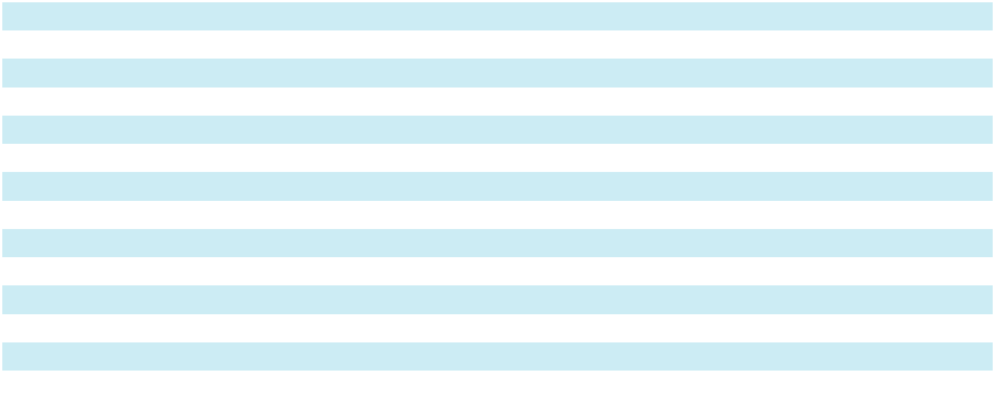

119

SKYWARD SPECIALTY INSURANCE GROUP, INC. AND SUBSIDIARIES

SCHEDULE VI — SUPPLEMENTAL INFORMATION CONCERNING PROPERTY-CASUALTY

INSURANCE OPERATIONS

As of and Years Ended December 31,

($ in thousands) |  | 2025 |  |  | 2024 |  |  | 2023
Deferred policy acquisition costs | $ | 136,100 | $ |  | 113,183 | $ |  | 91,955
Reserve for losses and loss adjustment expenses |  | 2,318,894 |  |  | 1,782,383 |  |  | 1,314,501
Unearned premiums |  | 774,035 |  |  | 637,185 |  |  | 552,532
Net earned premium⁽¹⁾ |  | 1,304,505 |  |  | 1,056,722 |  |  | 829,143
Net investment income |  | 83,619 |  |  | 80,686 |  |  | 40,322
Losses and loss adjustment expenses (current year)⁽¹⁾ |  | 810,375 |  |  | 657,783 |  |  | 516,664
Losses and loss adjustment expenses (prior years)⁽¹⁾⁽²⁾ |  | (7,471) |  |  | 25,728 |  |  | —
Amortization of policy acquisition costs⁽¹⁾ |  | 195,422 |  |  | 149,975 |  |  | 108,514
Paid claims and claim adjustment expenses⁽¹⁾ |  | 516,712 |  |  | 430,991 |  |  | 363,418
Net premiums written⁽¹⁾ |  | 1,406,232 |  |  | 1,123,578 |  |  | 910,691
Ceded unearned premium |  | 238,948 |  |  | 203,901 |  |  | 186,121
Deferred ceding commission |  | 46,453 |  |  | 40,434 |  |  | 37,057
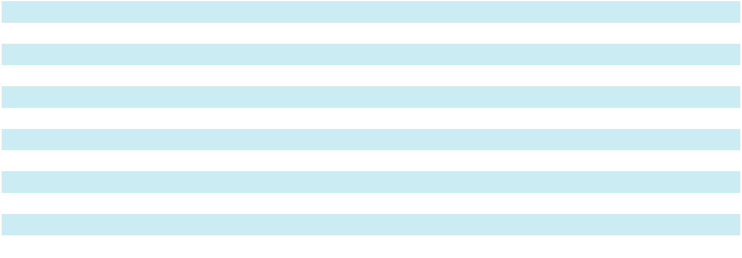

- Amount is presented net of reinsurance

- Amount does not include gain on retroactive reinsurance which is included in losses and loss adjustment expenses presented on the Consolidated Statements of Operations

120

SIGNATURES

Pursuant to the requirements of Section 13 or 15(d) of the Securities Exchange Act of 1934, the registrant has duly caused this report to be signed on its behalf by the undersigned, thereunto duly authorized.

Skyward Specialty Insurance Group, Inc.

Dated: March 2, 2026 /s/ Andrew Robinson

Andrew Robinson

Chairman and Chief Executive Officer

Pursuant to the requirements of the Securities Exchange Act of 1934, this report has been signed by the following persons on behalf of the Registrant and in the capacities and on the dates indicated.

Signature |  | Title |  | Date
/s/ Andrew Robinson |  | Chairman and Chief Executive Officer |  | March 2, 2026
Andrew Robinson |  | (Principal Executive Officer)
/s/ Mark Haushill |  | Chief Financial Officer |  | March 2, 2026
Mark Haushill |  | (Principal Financial and Accounting Officer)
/s/ Gena Ashe |  | Director |  | March 2, 2026
Gena Ashe
/s/ Robert Creager |  | Director |  | March 2, 2026
Robert Creager
/s/ Marcia Dall |  | Director |  | March 2, 2026
Marcia Dall
/s/ James Hays |  | Director |  | March 2, 2026
James Hays
/s/ Anthony J. Kuczinski |  | Director |  | March 2, 2026
Anthony J. Kuczinski
/s/ Michael Morrissey |  | Director |  | March 2, 2026
Michael Morrissey
/s/ Christopher L. Peirce |  | Director |  | March 2, 2026
Christopher L. Peirce
/s/ Katharine Terry |  | Director |  | March 2, 2026
Katharine Terry

121

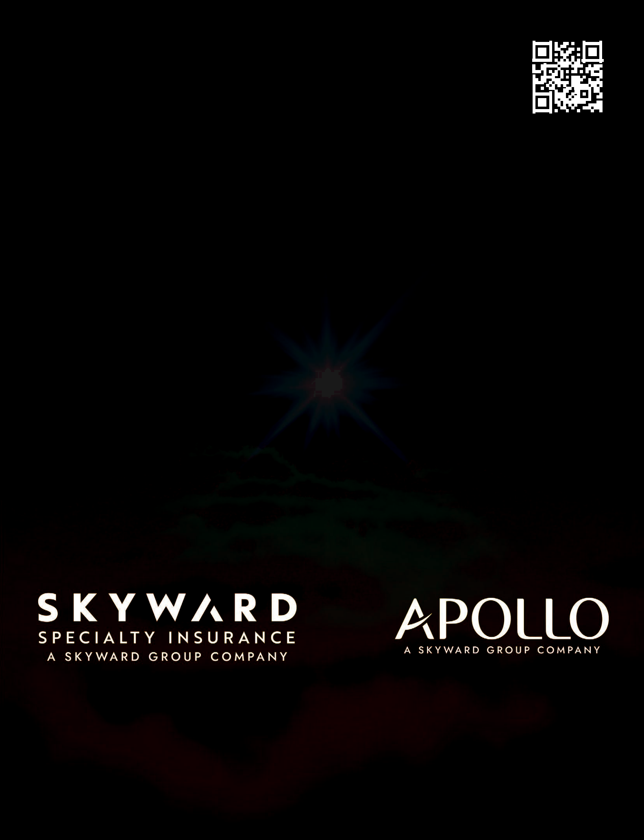
Visit skywardgroup.com to learn more

about our two high-performing specialty

insurance businesses.

Reimagining insurance to create greater resilience in an increasingly risky world.

+

INVESTOR RELATIONS
Kevin Reed
Vice President, Investor Relations
kreed@skywardinsurance.com

713-206-7860

MEDIA RELATIONS
Haley Doughty
Chief Marketing Officer & Vice
President, Communications
hdoughty@skywardinsurance.com

713-935-4944

